- What is Git, write atleast 5 points?
- Git is a distributed version-control system (VCS) for tracking changes in source code during software development.
- Git was created in 2005 by Linus Torvalds, the developer who started the Linux kernel.
- Git is designed for coordinating work among programmers.
- Git can be used to track changes in any set of files.
- Git supports rapid branching and merging, and includes specific tools for visualizing and navigating a non-linear development history.
- Git gives each developer a local copy of the full development history, and changes are copied from one such repository to another.

- What is the advantage & disadvantage of Git?
Advantages:
- Branching and merging are easy: They are cheap (fast and consume very little space).
- Data integrity is assured: Because git uses SHA1 trees, data corruption due to external reasons can be easily detected.
- Staging area: Make sure your commits have logically grouped changes and not everything else you are working on.
- Free: It is free of cost.

Disadvantages:
- Steep learning curve: Many commands with many options, some commands are non-intuitive and need a level of understanding the internals of git, commands and arguments are inconsistent to some degree.
- Binary files: If your project has non-text files that are updated frequently (images for websites or MS Office documents), then git becomes bloated and slow.

- Git is written in which language?
Git is written predominantly in C. The other languages used are:
- Shell
- Perl
- Tcl
- Python
- C++

- How will you create a repository in git?
- Create a directory to contain the project.
- Go into the new directory.
- Type git init
- Write some code.
- Type git add to add the files.
- Type git commit

- What does “git push” command do in Git?
The “git push” is used to transfer or push the commit, which is made on a local branch in your computer to a remote repository like GitHub.

- What is a commit message in Git?
The git commit command is used to save changes to a local repository after staging in Git. Commits usually contain a commit message which is a brief description of what changes were made.

- What's the difference between a "pull request" and a "branch"?
- A “branch” is just a separate version of the code.
- A “pull request” is when someone takes the repo, makes their own branch, does some changes, then tries to merge that branch in (put their changes in the other person's code repository).

- What is the difference between "git pull" and "git fetch"?
- A “git fetch” will just fetch all the changes in the remote repository and move the origin/master pointer to HEAD. Meanwhile your local branch master will keep pointing to where it has.
- A “git pull” will do basically fetch and merge any new changes to your master branch and move the pointer to HEAD.

So, “git pull” = “git fetch” + “merge”

- How to revert previous commit in git?
To revert the previous commit, just do git revert <unwanted commit hash>; then you can push this new commit, which undid your previous commit.

- How to remove a file from Git without removing it from your file system?
- To remove a file from Git without removing it from our file system, just do git rm --cached <filename>
- To remove multiple files from Git without removing it from our file system, just do git rm --cached <filename1> <filename2> <filename3> and so on.

- When do you use "git rebase" instead of "git merge"?
- Let's say you have created a branch for the purpose of developing a single feature. When you want to bring those changes back to master, you probably want to use “git merge”. We use “git merge” in cases where we want a set of commits to be clearly grouped together in history.
- With rebase, what happens is we use another branch as the new base for our current branch. To avoid spaghetti in the log file we use “git rebase” so that a linear clean commit history is maintained.

- Explain the Gitflow workflow with neat diagram?
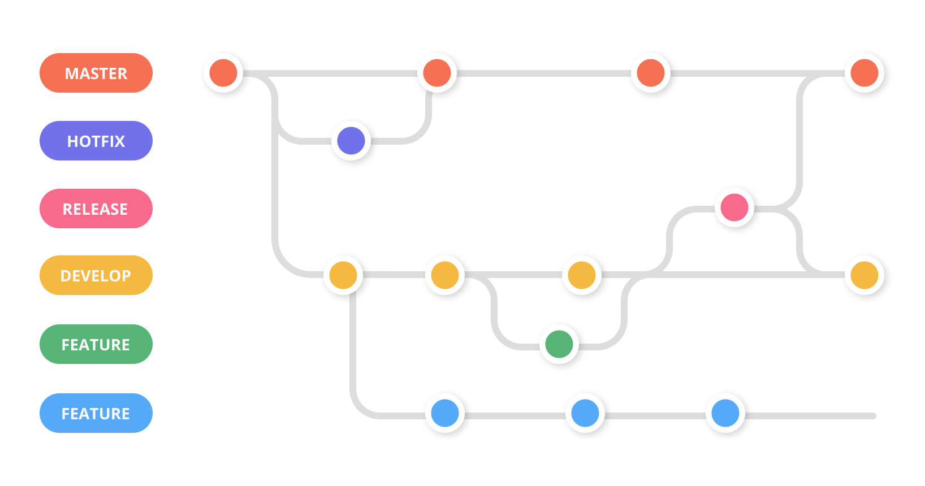
GitFlow is a branching model for Git, created by Vincent Driessen. It is very well suited to collaboration and scaling the development team. Gitflow utilizes the core feature of Git, which is the power of branches. In this model, a repository has two core branches:
- Master/Main: This is a highly stable branch that is always production-ready and contains the last release version of source code in production. (For the purposes of this article, we will be referring to this branch as “main”).
- Develop: Derived from the main branch, the development branch serves as a branch for integrating different features planned for an upcoming release. This branch may or may not be as stable as the main branch. It is where developers collaborate and merge feature branches.
Apart from those two primary branches, there are other branches in the workflow:
- Feature: This derives from the develop branch and is used to develop features.
- Release: This also derives from develop branch but is used during releases.
- Hotfix: This derives from the main branch and is used to fix a bug in the production branch that was identified after a release.

- How can we see 'n' most recent commits in Git?
We can see ‘n’ most recent commits using the git log -n n command.

- How can we know if a branch is already merged into master in Git?
We can know if a branch is already merged into master in Git by running the command git branch --merged master. The command lists branches merged into the master branch.

- What is the most popular branching strategy in Git?
The most popular branching strategy in Git is Gitflow. It is a Git workflow design that was first invented and described by Vincent Driessen in 2010.
Gitflow workflow employs two parallel long-running branches:
- Master : It is always ready to be released on LIVE, with everything fully tested and approved (production-ready). It's also convenient to tag all commits in the master branch with a version number.
- Develop : It is the branch to which all feature branches are merged and where all tests are performed. Only when everything’s been thoroughly checked and fixed it.
- How to delete a branch in Git?
- To delete the local branch use one of the following:
git branch -d <branch_name>
git branch -D <branch_name>

- To delete a remote branch use:
git push <remote_name> --delete <branch_name>

- How do you clean unwanted files from working directory in Git?
The git clean command is used to clean unwanted files from working directory in Git. Some options to delete directories, files, ignored and non-ignored files:
- To remove directories, run git clean -f -d or git clean -fd
- To remove ignored files, run git clean -f -X or git clean -fX
- To remove ignored and non-ignored files, run git clean -f -x or git clean -fx

- How can we determine the commit that is the source of bug in Git?
We can determine the commit that is the source of bug in Git using the git bisect command. We first run the git bisect start command and then git bisect good or bad according to the branch we’re currently working in. It is basically very similar to divide and conquer algorithm.
- How can we see differences between two commits in Git?
The git diff command is commonly used to get the unstaged changes between the index and working directory. It can be also be used to show changes between two arbitrary commits using git commit <commit-id1> <commit-id2>

- What is cherry-pick in Git?
Cherry picking is the act of picking a commit from a branch and applying it to another. git cherry-pick is a powerful command that enables arbitrary Git commits to be picked by reference and appended to the current working HEAD. git cherry-pick can be useful for undoing changes.

- What is the use of Git log command?
The git log tool allows you to view information about previous commits that have occurred in a project. The simplest version of the log command shows the commits that lead up to the state of the currently checked out branch. These commits are shown in reverse chronological order (the most recent commits first).

- What is the purpose of stash command in Git?
In Git, the stash operation takes your modified tracked files, stages changes, and saves them on a stack of unfinished changes that you can reapply at any time.

- What is the use of status command in Git?
The git status command displays the state of the working directory and the staging area. It lets you see which changes have been staged, which haven't, and which files aren't being tracked by Git. Status output does not show you any information regarding the committed project history.

- Explain the use of git rerere?
The git rerere functionality is a bit of a hidden feature. The name stands for “reuse recorded resolution” and, as the name implies, it allows you to ask Git to remember how you've resolved a hunk conflict so that the next time it sees the same conflict, Git can resolve it for you automatically.

- Name atleast 5 GUI used for working on Git?
GUI used for working on Git are:
- GitHub
- QGit
- Gitg
- Sourcetree
- GitUp
- GitBox

