 | 
MINI PROJECT REPORT
Project Phase – 1 REPORT
Analysis of HTTP and HTTPS Traffic Using Wireshark
Subject: Computer Networks
Submitted by
Patel Vasvi [202407020076]
Vishva Patel [202407020531]
in partial fulfilment for the award of the degree of
BACHELOR OF TECHNOLOGY
COMPUTER SCIENCE ENGINEERING
Project Mentor
Ms. Pragya Vats
UNITEDWORLD INSTITUTE OF TECHNOLOGY
KARNAVATI UNIVERSITY
Uvarsad, Gandhinagar, Gujarat – 382422
July – November, 2026
Table of Contents
1. Abstract 3
2. Introduction 4
a) Problem Statement 4
b) Aim and Objectives 4
c) Scope of the Project 4
3. System Requirements and Design 5
a) Hardware Requirements 5
b) Software Requirements 5
c) System Architecture 5
d) Diagrams 6
4. Implementation 8
a) Technologies Used 8
b) Screenshots and Outputs 9
5. Conclusion 18
6. Future Scope 19
References 20

1. Abstract
Web traffic travels across a network as packets, and whether a third party can read those packets depends on the protocol in use. This project uses Wireshark, a network protocol analyser, to capture and study HTTP and HTTPS traffic generated from a Windows laptop connected to a Wi-Fi network.
Two captures were recorded. In the first, plain HTTP websites (neverssl.com and httpbin.org) were visited and a test form was submitted. In the second, HTTPS websites (example.com and wikipedia.org) were visited. Display filters were used to isolate the relevant packets, and a Python script built on tshark, the command-line version of Wireshark, was written to summarise each capture automatically.
The results show that HTTP requests, responses and submitted form fields were fully readable in the capture, while HTTPS traffic exposed only the TCP and TLS handshake and the requested server name; the data itself was encrypted. All 23 TLS handshakes in the HTTPS capture negotiated TLS 1.3. The project demonstrates, with packet-level evidence, why HTTPS protects the confidentiality of web traffic and why plain HTTP should not be used for sensitive information.

2. Introduction
The Hypertext Transfer Protocol (HTTP) is the application-layer protocol used to request and deliver web pages. Standard HTTP sends its messages in plain text, usually over TCP port 80, so anyone able to observe the traffic can read it. HTTP Secure (HTTPS) carries the same HTTP messages inside a Transport Layer Security (TLS) session, normally over TCP port 443. TLS provides encryption, integrity checking and server authentication through digital certificates.
Wireshark is a free, open-source packet analyser that captures network packets and displays them layer by layer. Its display filters allow a user to focus on a single protocol, host or port, which makes it well suited to comparing how HTTP and HTTPS behave on the wire. This project applies Wireshark to real traffic and documents what can and cannot be seen in each case.

a) Problem Statement
Many users assume that visiting a website is private, but the level of protection depends on whether the site uses HTTP or HTTPS. Without direct observation, the difference between the two is abstract. The problem addressed by this project is to capture real HTTP and HTTPS traffic, analyse it at packet level, and demonstrate clearly what information is exposed to a network observer in each case.

b) Aim and Objectives
Aim: To analyse HTTP and HTTPS traffic using Wireshark and to compare the security of the two protocols on the basis of captured evidence.
Objectives:
- Install and configure Wireshark and capture live traffic from a Wi-Fi interface.
- Capture and inspect HTTP requests, responses and a form submission (POST).
- Capture and inspect the TLS handshake (Client Hello and Server Hello) and the encrypted Application Data of HTTPS sessions.
- Use Wireshark display filters to isolate protocol-specific traffic.
- Develop a Python script, using tshark, that summarises a capture automatically.
- Compare HTTP and HTTPS using the observed evidence.

c) Scope of the Project
The project covers traffic captured on a single Windows laptop over Wi-Fi, the analysis of HTTP/1.1 requests and responses, TLS handshake information (version, cipher suite and server name), and protocol hierarchy statistics. Only the laptop’s own traffic and public test websites were used, and the form was submitted with made-up test data.
The project does not cover decrypting TLS traffic, man-in-the-middle attacks, an in-depth analysis of HTTP/2 or HTTP/3 (QUIC), or the capture of any other person’s traffic.

3. System Requirements and Design

a) Hardware Requirements
The tools used are lightweight, but captures on a busy Wi-Fi network can grow quickly (the HTTP capture in this project contains 399,135 packets), so adequate memory and storage are useful.
Table 1: Hardware requirements
Component | Requirement
Computer | Laptop or desktop running Windows
Processor | Dual-core processor or better
RAM | 4 GB minimum (8 GB recommended for large captures)
Storage | 500 MB free for tools, plus space for capture files
Network adapter | Wi-Fi or Ethernet adapter supported by Npcap
Internet connection | Required to reach the test websites

b) Software Requirements
Table 2: Software requirements
Software | Purpose
Windows operating system | Platform on which captures were recorded
Wireshark with Npcap | Live packet capture, display filters, stream following and statistics
TShark | Command-line component of Wireshark used by the analysis script
Python 3 | Runs the analysis script (analyze_pcap.py)
Google Chrome | Browser used to generate HTTP and HTTPS traffic
GitHub | Hosting the source code, captures and results
Microsoft Word and PowerPoint | Preparing the report and presentation
Test websites | http://neverssl.com, http://httpbin.org (pizza order form), https://example.com, https://www.wikipedia.org

c) System Architecture
The architecture of the project is a simple capture-and-analysis pipeline, shown in Figure 1. The web browser generates traffic that leaves the laptop through the Wi-Fi interface. The Npcap driver gives Wireshark a copy of every packet passing through the interface, and Wireshark saves the packets into capture files. The Python script then reads each capture file through tshark and produces a text summary, which together with the screenshots forms the results of the project.
The work was carried out in five stages:
- Traffic generation: browsing HTTP and HTTPS test websites and submitting a form.
- Packet capture: recording the traffic with Wireshark on the Wi-Fi interface.
- Filtering and inspection: applying display filters and following streams.
- Automated analysis: running analyze_pcap.py on each capture.
- Documentation: collecting screenshots and results for the report and presentation.
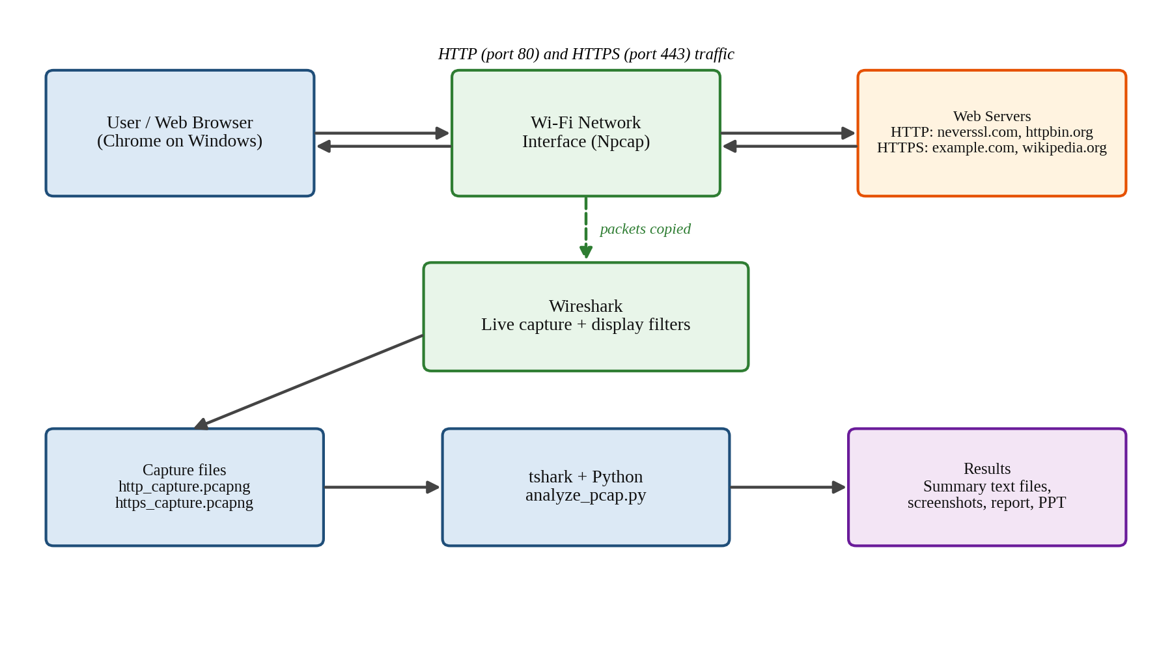
Figure 1: System architecture and workflow

d) Diagrams
Figure 2 shows the message exchange of a normal HTTP session. After the TCP three-way handshake the client sends its request directly, and both the request and the response travel as readable text.
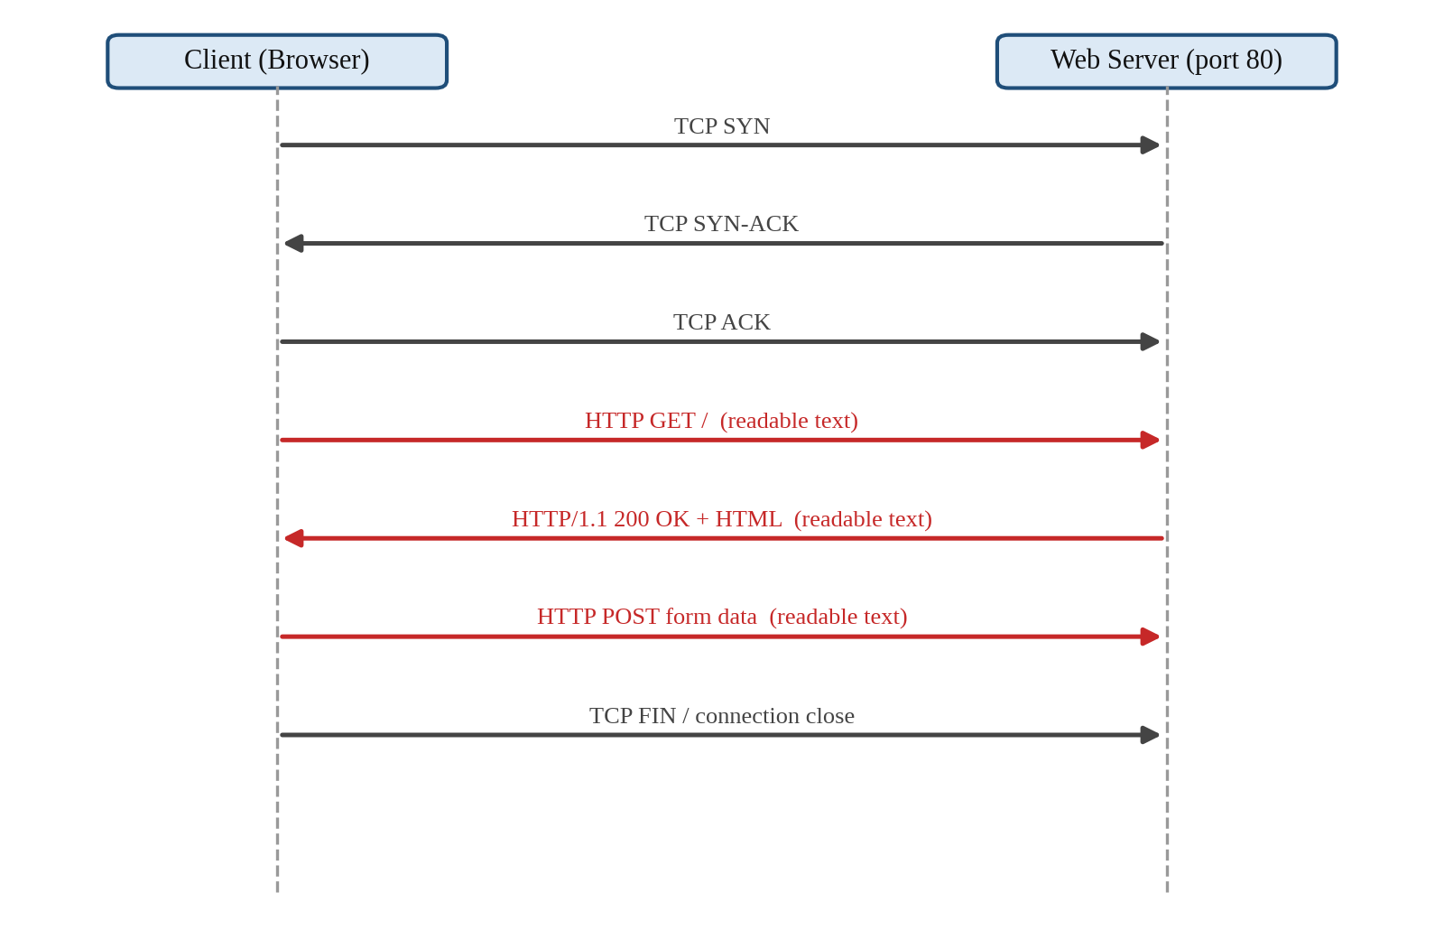
Figure 2: HTTP request and response exchange (red = readable by an observer)
Figure 3 shows an HTTPS session using TLS 1.3. The Client Hello and Server Hello are still visible, but the remaining handshake records and all HTTP data are encrypted. Wireshark labels these encrypted records as Application Data.
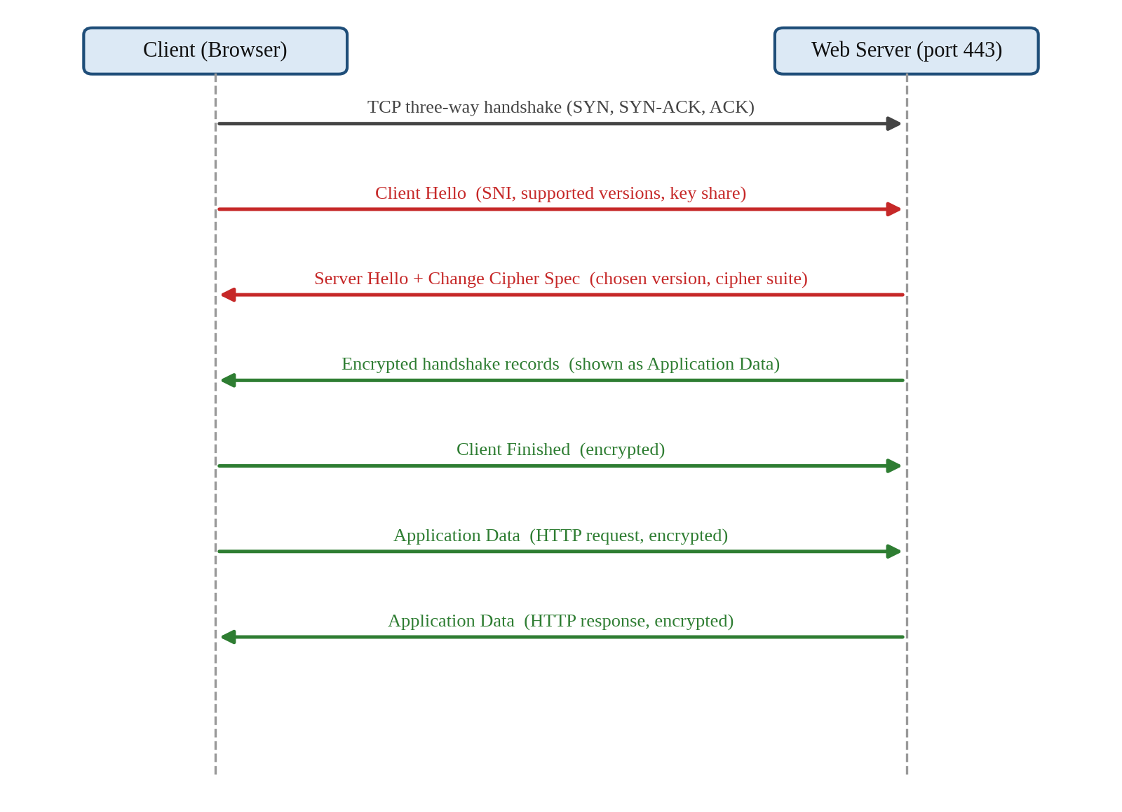
Figure 3: TLS 1.3 handshake for HTTPS (red = visible, green = encrypted)

4. Implementation

a) Technologies Used
Table 3: Technologies used
Technology | Use in this project
Wireshark | Capturing and inspecting packets; Statistics → Protocol Hierarchy; Follow HTTP Stream and Follow TCP Stream
Npcap | Packet capture driver used by Wireshark on Windows
TShark | Exports packet fields from a capture file for the script
Python 3 | analyze_pcap.py reads the tshark output and prints a summary
HTTP/1.1 | Plain-text web protocol analysed on TCP port 80
TLS 1.3 | Encryption layer analysed in HTTPS on TCP port 443

Capture procedure. The following steps were carried out in Wireshark:
- The active Wi-Fi interface was selected and a new capture was started.
- For the HTTP capture, http://neverssl.com and http://httpbin.org were visited and the pizza order form on httpbin was submitted with made-up test data. The capture was stopped and saved as http_capture.pcapng.
- For the HTTPS capture, a new capture was started, https://example.com and https://www.wikipedia.org were visited, and the capture was saved as https_capture.pcapng.
- The display filters listed in Table 4 were applied to isolate the relevant packets.
- Follow HTTP Stream and Follow TCP Stream were used to view complete conversations.
- Statistics → Protocol Hierarchy was opened for both captures.
- The analysis script was run on both capture files.

Table 4: Display filters used
Filter | Purpose
http | Show all HTTP packets
http.request.method == "POST" | Show form submissions
tcp.port == 80 | Show plain HTTP traffic by port
tcp.port == 443 | Show HTTPS traffic by port
tls | Show all TLS packets
tls.handshake.type == 1 | Show TLS Client Hello messages
tls.handshake.type == 2 | Show TLS Server Hello messages
tcp.stream eq N | Show one complete TCP conversation

Analysis script. The script analyze_pcap.py calls tshark to export selected fields from a capture file, such as the protocol stack of each frame, HTTP method, host and response code, submitted form fields, TLS handshake type, server name, cipher suite and negotiated version. It then counts and summarises them and checks whether form fields that look like credentials are visible in plain text. HTTP statistics are counted only for TCP traffic, because the local network discovery protocol SSDP (UDP port 1900) also uses HTTP-style messages: an initial run counted 14,828 such messages as HTTP requests, and excluding them gave the correct figures of 19 GET and 2 POST requests. The source code, captures and results are available in the project repository: https://github.com/vasvi1310/wireshark-project.

b) Screenshots and Outputs

HTTP Traffic
Figure 4 shows the capture filtered with http. The selected packet is a GET request for /connecttest.txt sent from the laptop to 23.212.0.43 on destination port 80. The hex pane at the bottom shows the request in readable ASCII, including the Host header www.msftconnecttest.com. This request is a Windows connectivity check, which shows that even background operating-system traffic can use unencrypted HTTP.
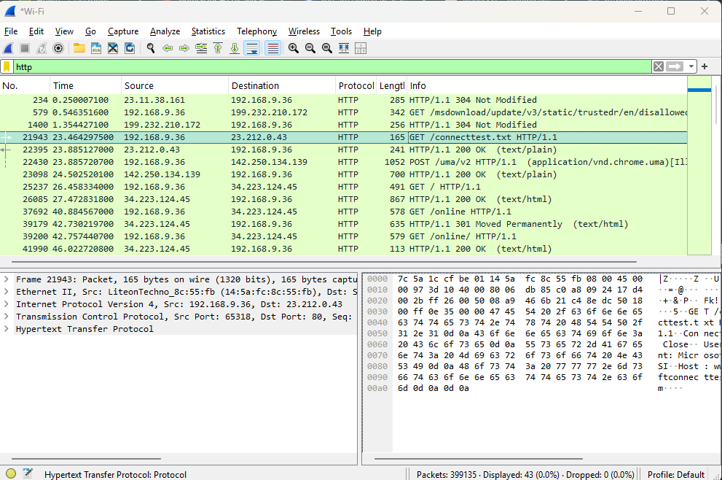
Figure 4: HTTP GET request and responses (filter: http)
Figure 5 shows Follow HTTP Stream for the same conversation. The whole exchange of 298 bytes is readable: the client request with its User-Agent and Host headers, and the server response HTTP/1.1 200 OK with the text body “Microsoft Connect Test”.
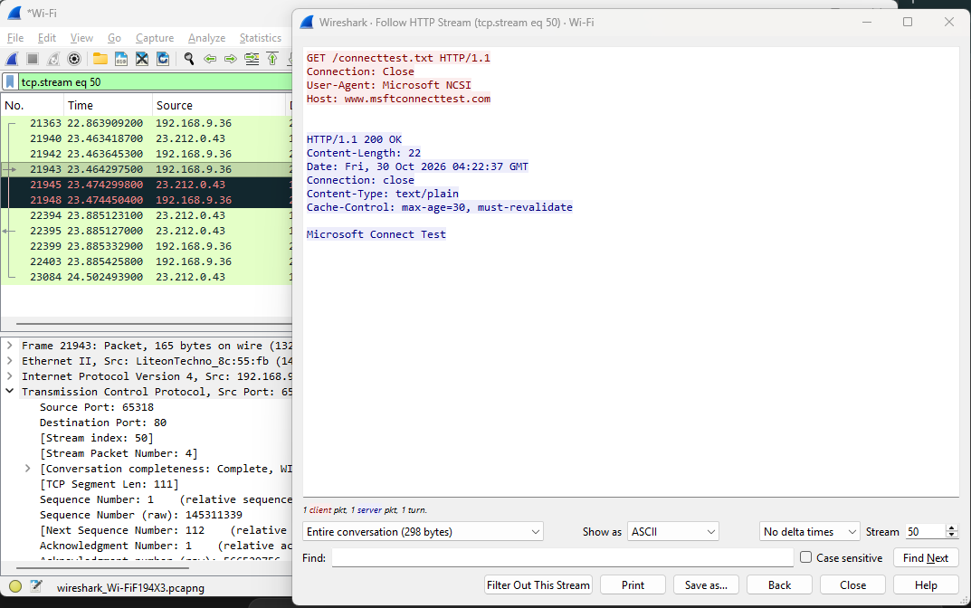
Figure 5: Follow HTTP Stream showing readable request and response
Figure 6 shows the filter http.request.method == "POST". The second request, POST /post, was sent with the content type application/x-www-form-urlencoded. Expanding the HTML Form URL Encoded section reveals every submitted field in clear text: custname, custtel, custemail, size, the toppings, delivery time and comments. Only test data was entered, but on a real login page a username and password would be exposed in exactly the same way.
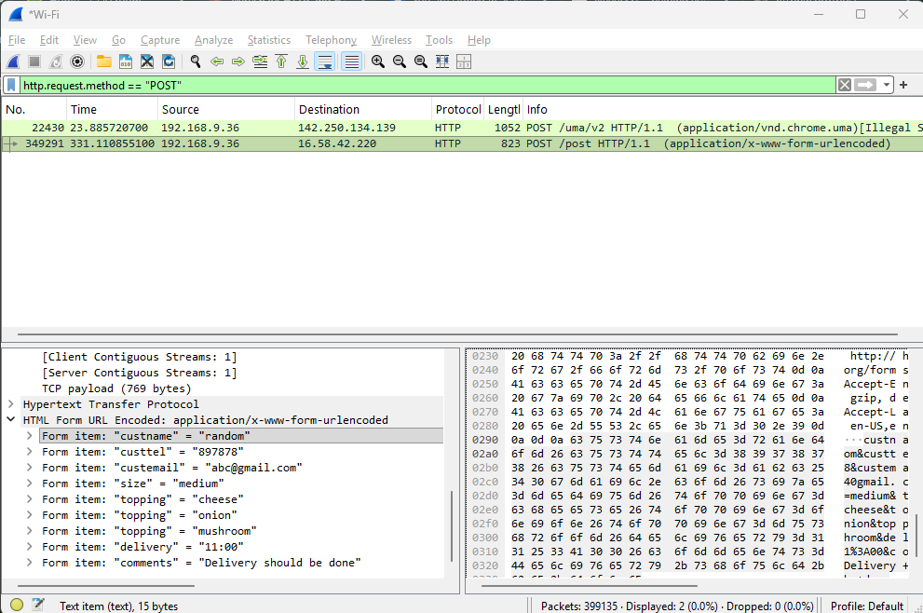
Figure 6: HTTP POST request with form data visible in plain text

HTTPS Traffic
Figure 7 shows the HTTPS capture filtered with tls. Each connection begins with a Client Hello that names the server (SNI), followed by a Server Hello, a Change Cipher Spec record and then only Application Data packets. QUIC packets also appear in the list because QUIC carries its TLS 1.3 handshake inside its Initial packets.
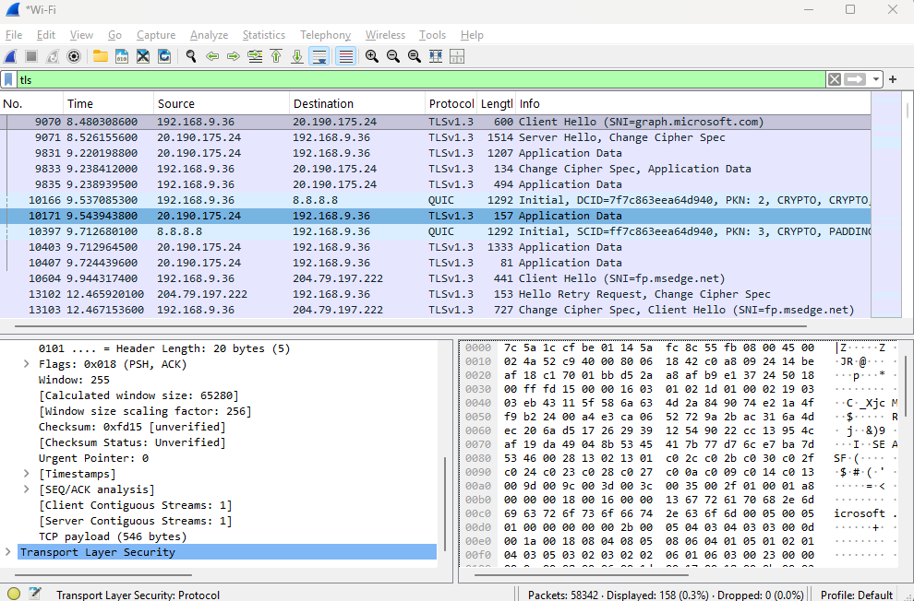
Figure 7: TLS packets in the HTTPS capture (filter: tls)
Figure 8 shows the Client Hello of a connection to graph.microsoft.com with the server_name extension expanded. The name of the site is visible even with HTTPS because the Client Hello is sent before encryption starts. The supported_versions extension offers TLS 1.3 and TLS 1.2, and the key_share extension carries the client’s key exchange information.
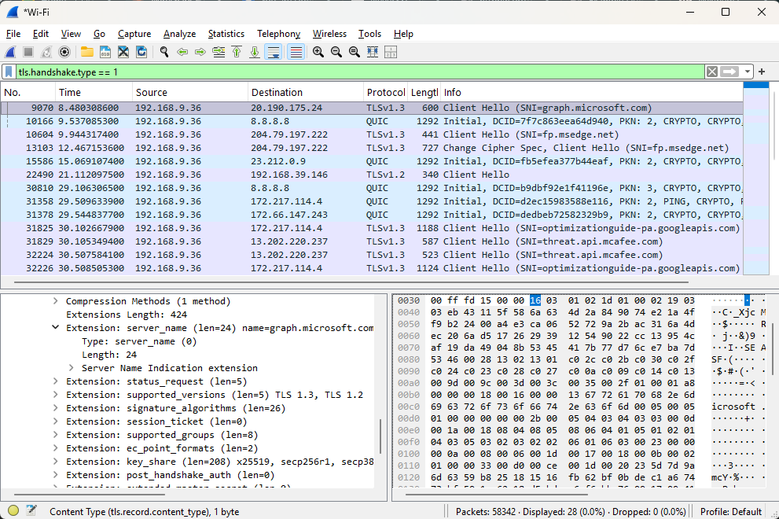
Figure 8: Client Hello with the server name (SNI) visible
Figure 9 shows the server’s answer, a Server Hello with a Change Cipher Spec record, coming from port 443 of the server. From this point the server’s further messages are encrypted.
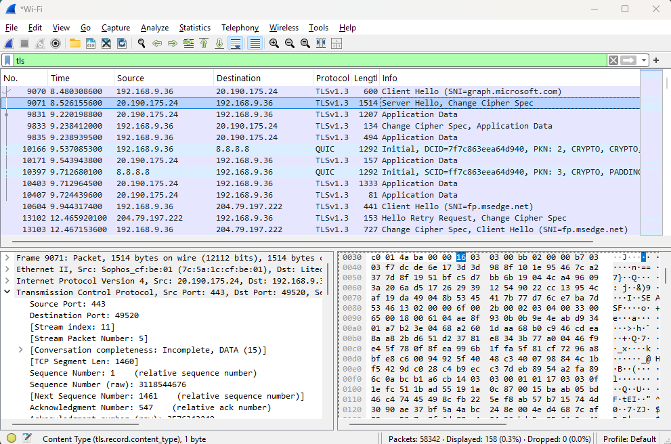
Figure 9: Server Hello and Change Cipher Spec
Figure 10 shows the Server Hello details using the filter tls.handshake.type == 2, which matched 23 handshakes in the HTTPS capture. The chosen cipher suite is TLS_AES_256_GCM_SHA384 (0x1302). The record shows Version: TLS 1.2 (0x0303) because TLS 1.3 keeps this legacy value for compatibility with older network equipment; the real version is given in the supported_versions extension, which shows TLS 1.3.
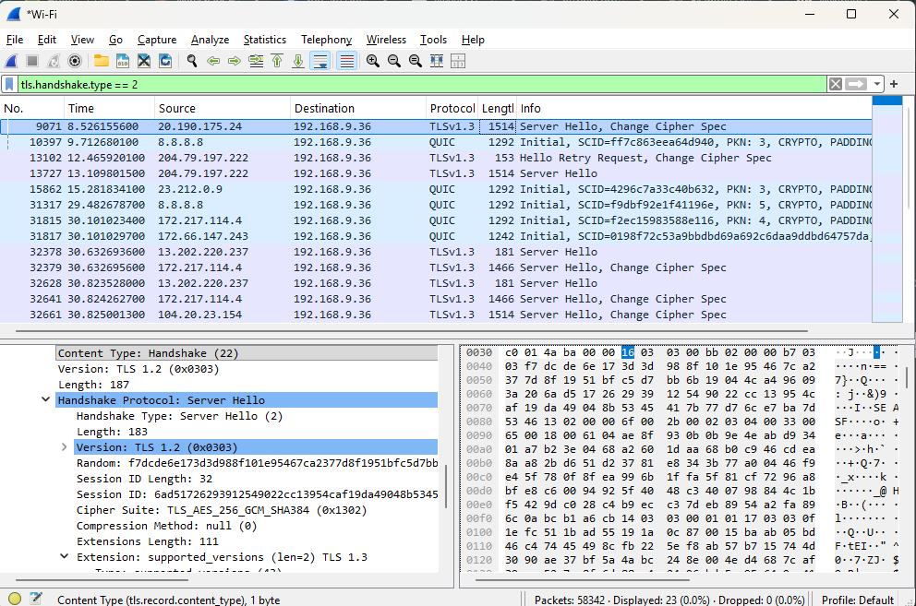
Figure 10: Server Hello showing cipher suite and negotiated TLS version
Figure 11 shows an Application Data packet. The details pane shows Opaque Type: Application Data (23) and an encrypted payload, and the hex pane contains random-looking bytes with no readable words, URLs or form fields. In TLS 1.3 even the server certificate and the remaining handshake messages are sent in this encrypted form, which is why Wireshark shows them as Application Data.
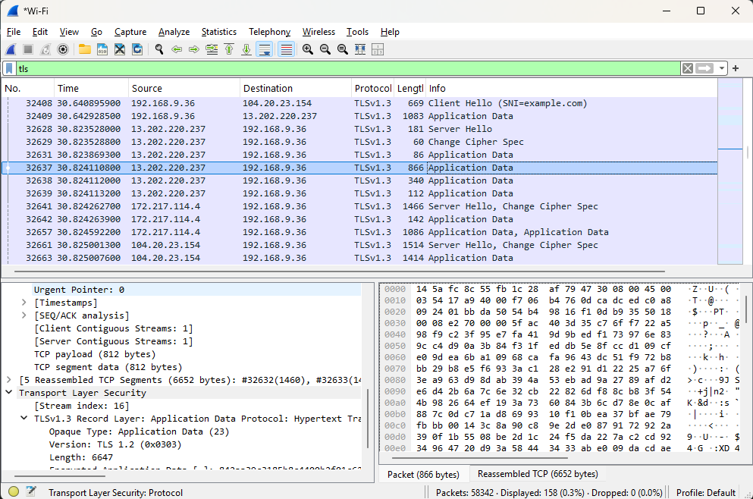
Figure 11: Encrypted Application Data packet
Figure 12 shows Follow TCP Stream for an HTTPS connection of 9,154 bytes. Almost all of the content is unreadable. The only readable fragments are the server name (threat.api.mcafee.com) and the protocol names h2 and http/1.1 sent in the Client Hello. This is in direct contrast to Figure 5, where the whole HTTP stream could be read.
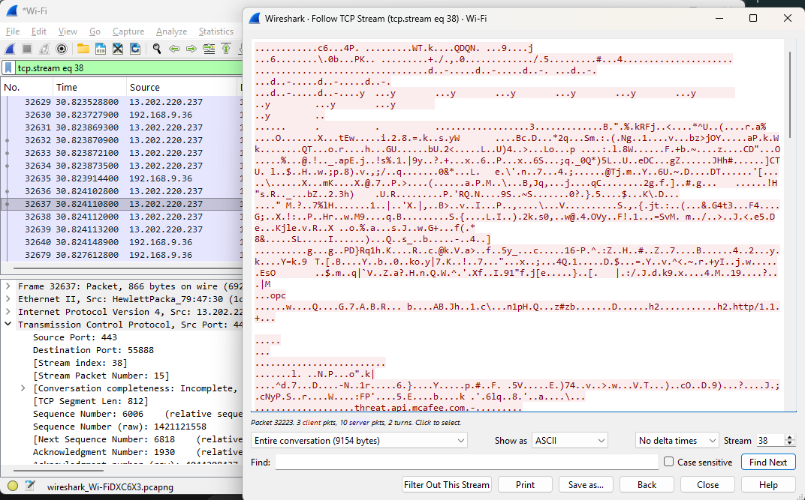
Figure 12: Follow TCP Stream of an HTTPS connection

Protocol Hierarchy
Figures 13 and 14 show the protocol hierarchy statistics of the two captures. In the HTTP capture of 399,135 packets, TCP accounts for 4,878 packets, TLS for 1,228 packets and HTTP for only 43 packets. The HTTP packets contain line-based text (18), HTML form data (1), JSON (1), media (1) and PNG (1) content. In the HTTPS capture of 58,342 packets, UDP makes up 98.1% of the packets, TCP has 669 packets and TLS has 135 packets.
Most of the packets in both captures are not web traffic at all: multicast DNS (mDNS) alone accounts for about 85% of the packets, followed by SSDP, NetBIOS and ARP. These are local network discovery messages sent by other devices on the Wi-Fi network. This is why display filters were needed to isolate the HTTP and HTTPS traffic.
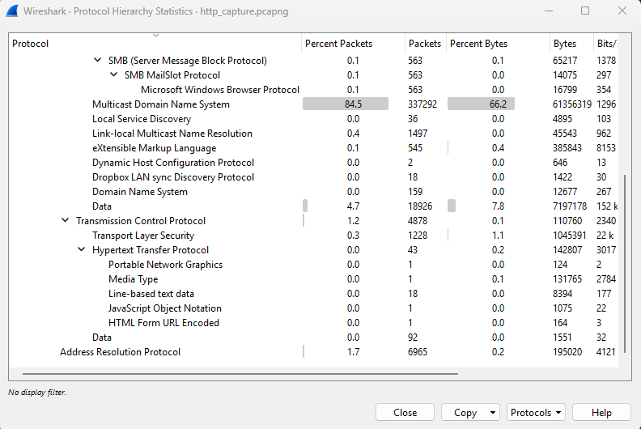
Figure 13: Protocol hierarchy of the HTTP capture
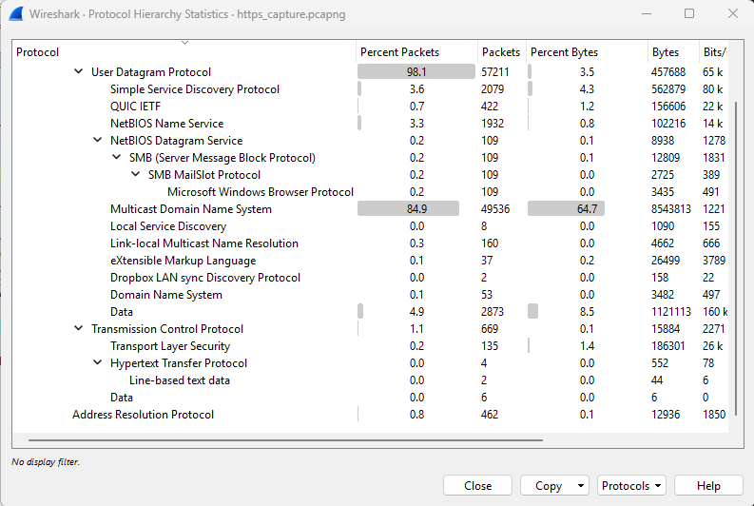
Figure 14: Protocol hierarchy of the HTTPS capture

Results of the Automated Analysis
Tables 5 and 6 summarise the output of analyze_pcap.py for the two captures.
Table 5: Summary of the HTTP capture (http_capture.pcapng)
Item | Result
Total packets | 399,135
HTTP requests | 19 GET and 2 POST
HTTP response codes | 200 (18), 304 (2), 301 (1), 404 (1)
Hosts contacted over HTTP | www.msftconnecttest.com (12), neverssl.com and its subdomain (4), httpbin.org (3), ctldl.windowsupdate.com (1), clientservices.googleapis.com (1)
Form data visible in plain text | Yes (custname, custtel, custemail, size, toppings, delivery, comments)
TLS Client Hello messages | 99 (background HTTPS traffic of other applications)
Negotiated TLS version | TLS 1.3 in 82 handshakes; TLS 1.2 or older in 7
Cipher suites | 0x1301 (56), 0x1302 (26), 0xc030 (3), 0xc02f (2), 0xc02b (2)

Table 6: Summary of the HTTPS capture (https_capture.pcapng)
Item | Result
Total packets | 58,342
HTTP requests | 2 GET (Windows connectivity check only)
Credentials or form data visible | No
TLS Client Hello messages | 28
Server names (SNI) seen | example.com (3), www.wikipedia.org (2), upload.wikimedia.org (1), www.bing.com (1) and other background services
Negotiated TLS version | TLS 1.3 in all 23 handshakes
Cipher suites | 0x1301 TLS_AES_128_GCM_SHA256 (15), 0x1302 TLS_AES_256_GCM_SHA384 (8)

HTTP and HTTPS Compared
Table 7: Observed differences between HTTP and HTTPS
Aspect | HTTP | HTTPS
Port | 80 | 443
Request line and headers | Readable (GET, Host, User-Agent) | Not readable (inside encrypted TLS records)
Response content | Readable (for example, “Microsoft Connect Test”) | Not readable
Submitted form fields | Visible in plain text | Not visible
Server name | Visible in the Host header | Visible only in the Client Hello (SNI)
Handshake | TCP handshake only | TCP handshake followed by TLS handshake
Wireshark Info column | HTTP/1.1 GET, 200 OK | Client Hello, Server Hello, Application Data
Protection | None | TLS 1.3 encryption in all captured handshakes

5. Conclusion
This project captured and analysed real HTTP and HTTPS traffic with Wireshark. The HTTP capture showed requests, headers, response bodies and a complete form submission in readable text, so any observer on the network could have read them. The HTTPS capture showed only the TCP and TLS handshakes and the server name; the HTTP data itself was hidden inside encrypted Application Data records, and all 23 captured HTTPS handshakes used TLS 1.3.
The results confirm that HTTPS should be used for every website, and in particular for any page that handles logins, personal details or payments. The analysis script also showed how packet captures can be summarised automatically instead of being inspected packet by packet.
The project has some limitations. HTTPS still reveals the server name, the IP addresses, and the size and timing of the traffic. The captures come from one device on one network and include background traffic from other applications and devices, which is why display filters were necessary.

6. Future Scope
- Decrypt the captured TLS traffic of the laptop’s own browser by using a TLS key log file, to show exactly what HTTPS protects.
- Study HTTP/2 and HTTP/3 (QUIC) traffic in more detail, since many sites now use them.
- Analyse server certificates and certificate chains, and compare TLS 1.2 and TLS 1.3 handshakes.
- Extend the script to produce charts and automatic warnings when credentials are sent over HTTP.
- Examine DNS-over-HTTPS traffic, since dns.google appears as a server name in the captures.
- Study Encrypted Client Hello (ECH), which aims to hide the server name that is currently visible in the Client Hello.

References
[1] Wireshark Foundation, “Wireshark User’s Guide,” https://www.wireshark.org/docs/
[2] R. Fielding, M. Nottingham and J. Reschke, “HTTP Semantics,” RFC 9110, IETF, 2022.
[3] E. Rescorla, “The Transport Layer Security (TLS) Protocol Version 1.3,” RFC 8446, IETF, 2018.
[4] Cisco Networking Academy, “Lab: Using Wireshark to Examine HTTP and HTTPS Traffic,” CyberOps Associate course.
[5] 0xrajneesh, “Wireshark Projects for Beginners: Analyzing HTTP Traffic with Wireshark,” GitHub.
[6] NeverSSL, http://neverssl.com; httpbin, http://httpbin.org

