Report
Of
EduMind AI – AI-Powered Study Assistant
Submitted
To
School of Computer Science and Engineering
IILM University, Greater Noida, U.P.
In partial fulfilment of the requirement of degree of
B.Tech CSE

By
Roll Number of Student: CS-23411359
Name of Student: VASVI BALI
Batch: 2023-27
2026-27
CANDIDATE'S DECLARATION
I, VASVI BALI, do hereby declare that the internship report titled “EduMind AI – AI-Powered Study Assistant” has been completed by me to fulfil the requirement for the award of the degree of Bachelor of Technology in CSE. All the references have been quoted and I have not taken as such any material from any other source. I affirm to you that this report is my own and has not been submitted to any other institute for any degree/diploma requirement and further I shall be solely responsible for any kind of copyright violation in this regard.
Student Name: VASVI BALI
Roll No.: CS-23411359



ACKNOWLEDGMENT
I am using this opportunity to express my gratitude to everyone who supported me throughout the Internship Program. I am thankful for their aspiring guidance, invaluably constructive criticism and friendly advice during this work. I am sincerely grateful to them for sharing their truthful and illuminating views on a number of issues related to this work.
I express my gratitude to my parents for their blessings
Student Name: VASVI BALI
Roll No.: CS-23411359


INTERNSHIP COMPLETION CERTIFICATE

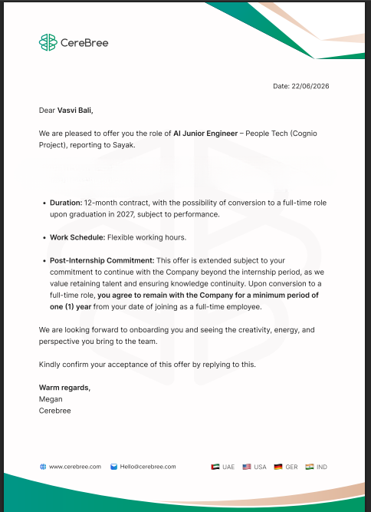
TABLE OF CONTENTS
Chapter No. | Chapter Name | Page Nos.
 | Cover Page | ----
1. | Candidate's Declaration | i
2. | Acknowledgment | ii
3. | Internship Completion Certificate | iii
4. | Project Description  4.1 Introduction  4.2 Organization Profile  4.3 Problem Statement  4.4 Project Objectives  4.5 Scope of the Project  4.6 Technologies and Tools Used  4.7 System Architecture  4.8 Methodology  4.9 Expected Outcomes  4.10 Certificates of completion and other communication mail proof | 1
5. | Bibliography/References

4. Project Description

4.1 Introduction
EduMind AI is an Artificial Intelligence-based study assistant designed to support students in their academic learning. The system uses Generative AI and Natural Language Processing to provide students with interactive and personalized learning assistance.
Traditional learning methods often require students to search through multiple books, websites, videos, and other resources to find answers to their questions. This can be time-consuming and may make it difficult for students to obtain explanations suited to their level of understanding.
EduMind AI addresses this problem by providing an interactive platform where students can ask questions and receive AI-generated responses. The system aims to make learning more accessible, interactive, and personalized while helping students understand concepts more effectively.

4.2 Organization Profile
CereBree is a decentralized technology platform that integrates artificial intelligence with blockchain infrastructure to build a unified data ecosystem. Rather than offering a standalone chat-bot, it uses its proprietary large language model, Cognie, to securely bridge data gaps across healthcare, enterprise workflows, and personal wellness applications. The company powers live, real-world solutions, including an enterprise human resources system called HRX and a wellness tracking platform called Heel Opera. By utilizing the Oracle Blockchain Platform and its native utility token ($CRX), CereBree ensures secure data management, automated workflows, and decentralized governance across its entire network.

4.3 Problem Statement
Students often face difficulties while learning due to limited access to personalized guidance, difficulty finding relevant study material, and the time required to search for answers across different sources.
Existing educational platforms generally provide predefined content and may not always provide immediate, conversational explanations according to an individual student's query.
Therefore, there is a need for an intelligent educational assistant that can interact with students, understand their questions, and provide relevant and understandable responses.

4.4 Project Objectives
The primary objectives of EduMind AI are:
- To develop an AI-powered study assistant for students.
- To provide instant responses to academic queries.
- To make learning interactive through conversational AI.
- To provide easy-to-understand explanations.
- To reduce the time required to search for learning resources.
- To explore the application of Generative AI in education.
- To support personalized and self-paced learning.

4.5 Scope of the Project
EduMind AI can be used as a digital learning assistant for students across different academic subjects.
The system can assist students with concept explanations, question answering, study-related queries, learning guidance, revision assistance, and academic discussions.
The project can be further extended to include personalized study plans, automated quizzes, performance analysis, document-based question answering, voice interaction, and multilingual support.

4.6 Technologies and Tools Used
Programming Languages: Python was used for backend development and integration of AI functionality, while JavaScript, HTML, and CSS were used for developing the user interface and enabling interaction with the application.
Artificial Intelligence: The system uses Generative AI and Large Language Models (LLMs) to understand user queries and generate contextual responses.
Backend: The backend manages user requests, communicates with the AI service, and sends generated responses back to the frontend.
Development Tools: Git, GitHub, Visual Studio Code, the Python development environment, and REST APIs.
System Requirements: Development and use of the application requires a dual-core or higher processor, a minimum of 4 GB RAM (8 GB recommended), at least 1 GB of free storage, a modern web browser, Python 3.x, and a stable internet connection to communicate with the AI model.

4.7 System Architecture
The proposed system consists of an interactive user interface connected to a backend application responsible for processing user requests. The system follows a client-server architecture.
When a student enters a question, the request is sent to the backend. The backend processes the request and communicates with the AI model. The generated response is then returned to the user through the application interface.
Major components include the User Interface, which allows students to enter questions and view AI-generated responses; the Backend Server, which receives requests from the frontend and manages communication with the AI model; the AI Model, which processes the student's query and generates an appropriate response using natural-language understanding and generative AI capabilities; and the Response Layer, which returns the generated response from the backend to the user interface.
Student → User Interface → Backend API → AI / LLM → Generated Answer → Student
This architecture allows students to interact with the system in a conversational manner rather than searching manually for every question.

4.8 Methodology
The development of EduMind AI was carried out in several stages, described below.
Phase 1 — Requirement Analysis: The educational challenges faced by students were identified, and the major requirements of the system were defined.
Phase 2 — System Design: The overall architecture, user interaction flow, frontend, backend, and AI integration were planned.
Phase 3 — Development: The frontend and backend components were implemented. The backend was integrated with the AI model to process student queries.
Phase 4 — AI Integration: Generative AI capabilities were incorporated into the system to understand user questions and generate responses.
Phase 5 — Testing: The application was tested using different types of queries to evaluate its functionality, response generation, and interaction between the frontend and backend.
Phase 6 — Evaluation: The system was evaluated based on its ability to respond to user queries, provide relevant explanations, and provide a smooth interaction experience.

4.9 Expected Outcomes
The developed EduMind AI system successfully demonstrates the use of Generative AI as an educational assistant. It allows students to interact with an AI-based assistant through a conversational interface and receive responses to their academic queries, providing a foundation for a more comprehensive personalized learning platform.
The system provides instant learning assistance, is interactive and conversational, reduces time spent searching for information, supports self-paced learning, can be extended to different academic domains, and demonstrates a practical application of Generative AI in education.

Table 4.1: Summary of test cases executed during system evaluation
Test Case | Description | Expected Result | Status
TC-01 | Enter a valid academic question | AI generates a relevant response | Passed
TC-02 | Send a simple question | Response is displayed correctly | Passed
TC-03 | Send multiple questions | System processes requests correctly | Passed
TC-04 | Empty input | System handles invalid input | Tested
TC-05 | Backend unavailable | Appropriate error handling | Tested
TC-06 | AI service response | Response is returned to the frontend | Passed

Advantages: The system provides instant learning assistance, is interactive and conversational, reduces time spent searching for information, supports self-paced learning, can be extended to different academic domains, and demonstrates a practical application of Generative AI in education.
Limitations: AI-generated responses may occasionally contain inaccurate information, response quality depends on the underlying AI model, the system requires internet connectivity, it does not replace teachers or professional academic guidance, and advanced personalization or performance tracking would require additional development.
Future Scope: EduMind AI can be enhanced through personalized study plans, an AI quiz generator, performance analysis, document-based learning, a voice assistant, multilingual support, and adaptive learning that adjusts explanations to a student's progress.
Conclusion: EduMind AI demonstrates how Artificial Intelligence and Generative AI can be applied to improve the learning experience for students, and provides a foundation for developing intelligent educational systems capable of offering personalized and accessible learning support.

4.10 Certificates of completion and other communication mail proof


5. Bibliography/References
1. OpenAI. "GPT Models and API Documentation." https://platform.openai.com/docs
2. Python Software Foundation. "Python Language Reference." https://docs.python.org
3. Mozilla Developer Network. "JavaScript, HTML, and CSS Documentation." https://developer.mozilla.org
4. GitHub Docs. "Git and GitHub Documentation." https://docs.github.com
5. Vaswani, A., et al. "Attention Is All You Need." Advances in Neural Information Processing Systems, 2017.
6. Course materials and lecture notes on Artificial Intelligence & Machine Learning, B.Tech CSE (AI & ML) curriculum.

