

Project 2011-1-RO1-LEO05-15321 (Contract LLP-LdV/ToI/2011/RO/008)
A web-based e-training platform for Extended Human Motion Investigation in Orthopedics ORTHO-eMAN

User/Trainee Guide for
ORTHO-eMAN e-learning platform

www.ortho-eman.ro

This project has been funded with support from the European Commission.
This communication reflects the views only of the author, and the Commission cannot be held responsible for any use which may be made of the information contained therein.
www.ortho-eman.ro = ORTHO-eMAN project web site

Table of Contents
1 Introduction 3
2 Software Requirements 3
3 Entering Moodle 3
4 Display Tool 8
4.1 First Contact 8
4.2 Pages Type 9
4.2.1 Image – Text 10
4.2.2 Image – Quiz 12
4.2.3 Image – Range Quiz 13
4.2.4 Video – Text 13
4.2.5 Video – Quiz 14
4.2.6 Text – Quiz 14

Introduction

Software Requirements
The OrthoEMan plugin and its modules have been developed with the newest W3C standards in mind in order to provide a modern experience to all faculty members including both the teacher and the students. Thus any HTML5 compatible browser should be enough for working with the OrthoEMan plugin. Furthermore the plugin has been explicitly tested with
- Firefox 19
- Chrome 23
- Internet Explorer 10

It is strongly advised to keep the computer which will access to the OrthoEMan facility in good shape with the latest updates applied.

Entering Moodle
The e-learning platform (Moodle) will be finally hosted at www.orthoe-eman.ro.
You can access the OrthoEMan's project development moodle site you have to startup your browser and visit the above URL. It should look like the picture below.

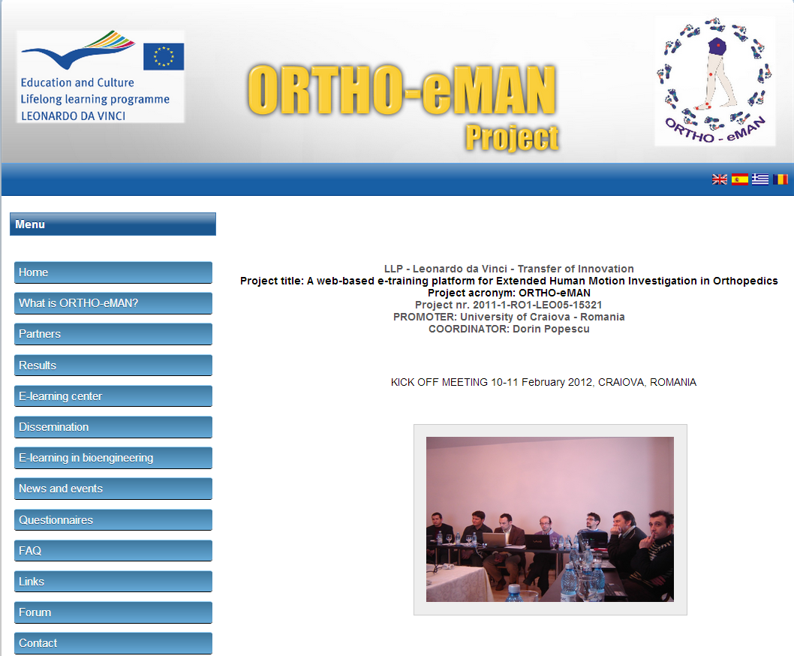
Moodle

Click on “E-learning center” to access the e-learning platform/center.
You will see the next window:
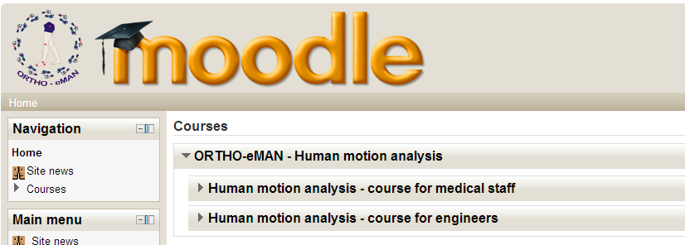

On this page you have to select which type of course you want: for medical staff or for engineers.
If you select the course for medical staff you will see the next window: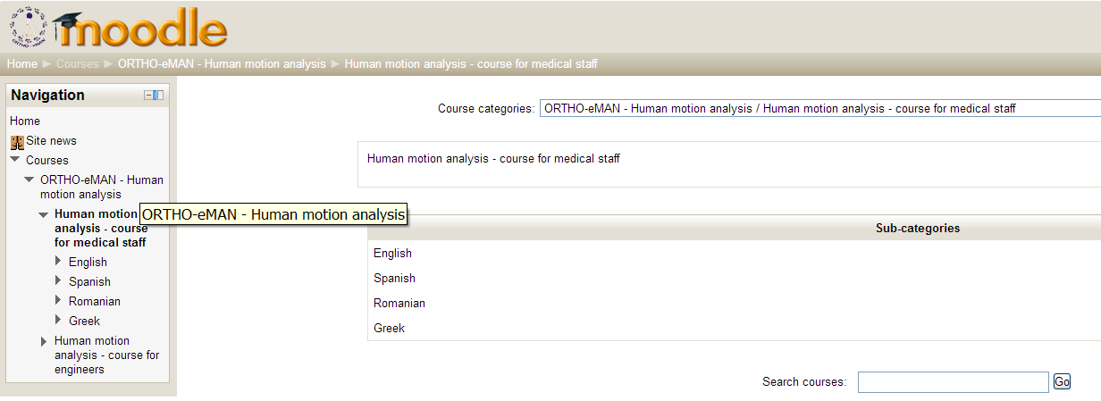

Now you can select your desired module. For example, for Module 1 (as medical staff) you will see the next window (a similar one for engineers):

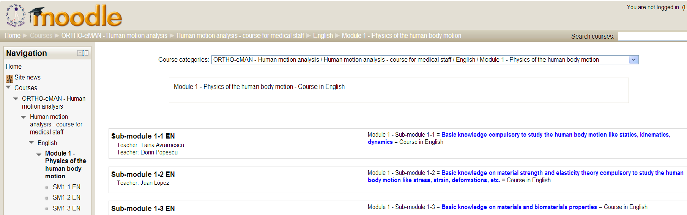

If you choose a sub-module you have to login to the e-learning platform. Note that if you are not already registered with the system you will be given (in the right side) the opportunity to register. In the registration form you need to fill your name, surname and e-mail address. There are more elements of information that you can add at a later stage like detailed contact info in social networks and such.

The system will sent you an e-mail at the address you gave and you have to follow the instructions in order to complete your registration.
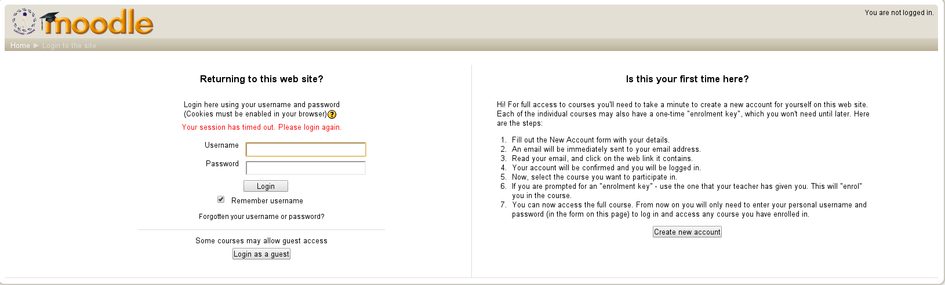

To gain access to the resources and tools you have first to log in. Type your user name and password in the corresponding fields and press Enter.

If you don’t remember your password, click on the link “Forgotten your username or password?” which redirects you to the next page.

To reset your password, submit your username or your email address below. If we can find you in the database, an email will be sent to your email address, with instructions how to get access again.

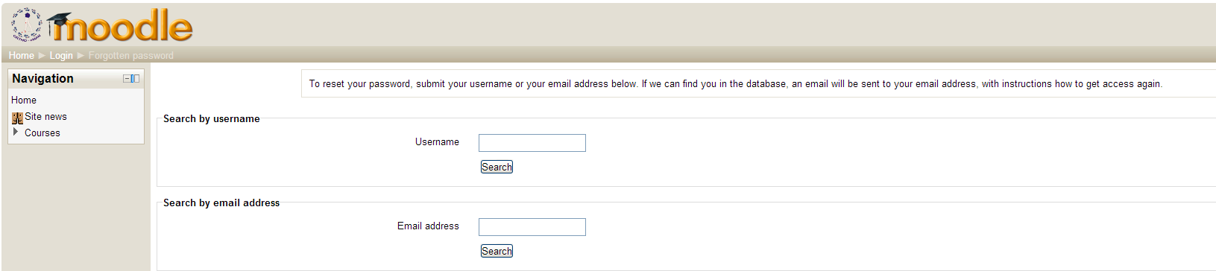

After a successful login the page redirects you to the “My Courses” page. To enter the course just click on its name. However if this is your first time in moodle it is possible that “My Courses” is empty. After your registration and login you can proceed to enroll your self to the various offered courses.

The self enrollment procedure is very simple but you will need on enrollment key per course. The enrollment keys are one time passwords in order to confirm that you have the credentials to take that course. The enrollment keys must be distributed by your teacher either in person or via electronic means.

Click on the course you wish to enroll yourself. The following picture will appear (if you haven't already enrolled yourself).
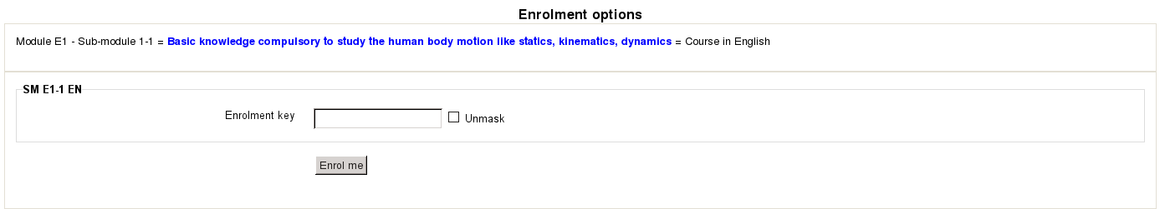
After a successful self enrollment you can enter the course

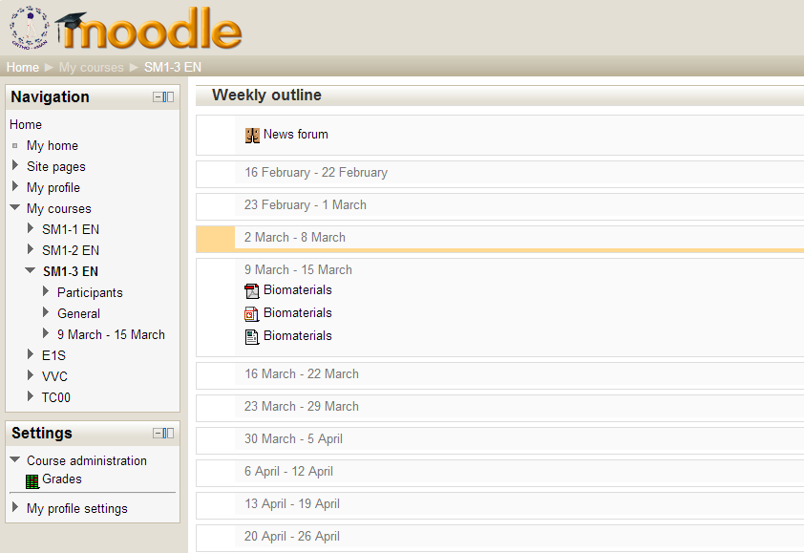

In this example where you choose sub-module 1-3, the schedule of it is one week from March and you can see for this sub-module the lecture notes (a brief presentation of this sub-module), this specific course (as pdf file) and a small quiz for self-testing (after you have learned this subject).

In this example you can see a weekly outline with one OrthoEMan activity. The outline of the course, meaning the way the time slots are allocated, is entirely decision of the course creator. The course creator depending on the administrator may be different than the course author (editing teacher).

Display Tool
The Display Tool is the main interface point with the student. The student evokes the Display Tool by just selecting the appropriate lesson.

First Contact
The title and the case's description that are displayed in the initial screen of the Display Tool have been entered in case configuration page as it is illustrated at Illustration Error: Reference source not found.

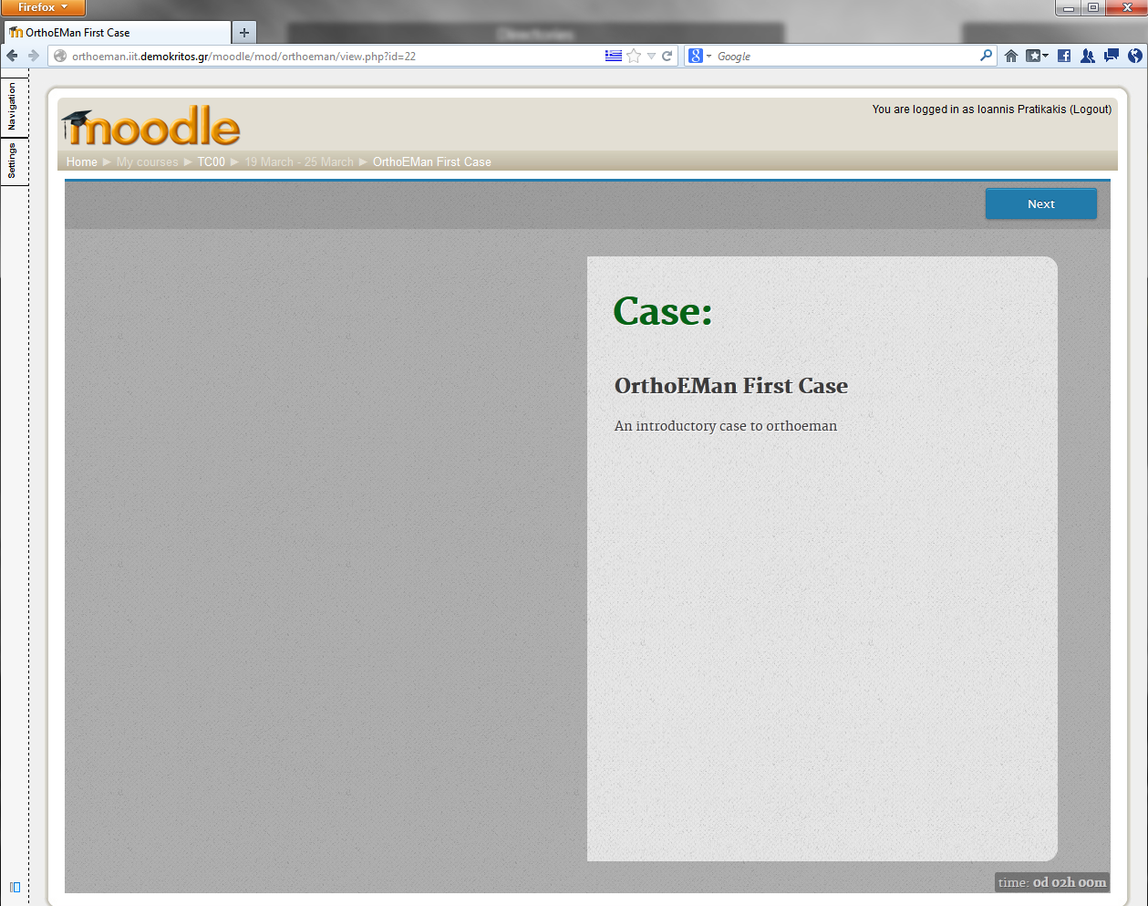Illustration 1: Display Tool: First Contact
Remaining Time
Case Description
Case Title
Navigate to the
Next Page

The student can navigate between pages by using the buttons on the upper part of the screen. The clock that shows the remaining time for the lesson completion is displayed in the lower-right part of the screen. It has two mode: the compact mode which it is the default and the expanded mode which it is evoked by clicking the compact clock. Illustration 2(a) and 2(b) shows these two clock versions.
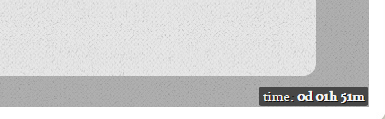 | 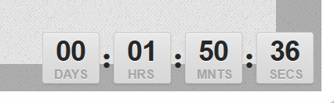
(a) | (b)
Illustration 2: Clock showing the remaining time until the lesson completion (a) compact version (b) expanded version

Pages Type
A lesson consists of a collection of pages as section Error: Reference source not found describes. Each page may contain theory or questions towards the students. The pages that are compose of questions expect feedback from the student. Depending of the page type the answers are ranging from selecting the correct hotspots in an image to picking up the correct phrases(quiz). Then, the Display Tool informs the student if his answer is correct or wrong (Illustration Error: Reference source not found(a) and Error: Reference source not found(b)). The Display Tool may provide the correct answer if the student answer it wrong but only by the teacher consent.

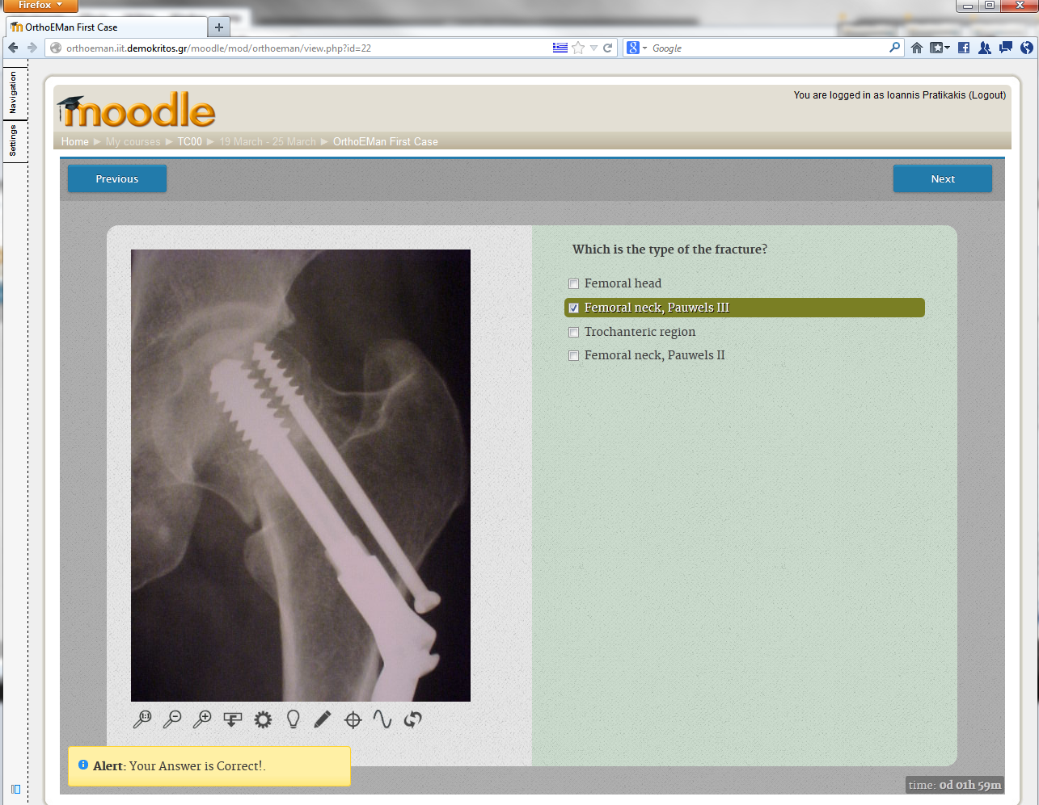 | 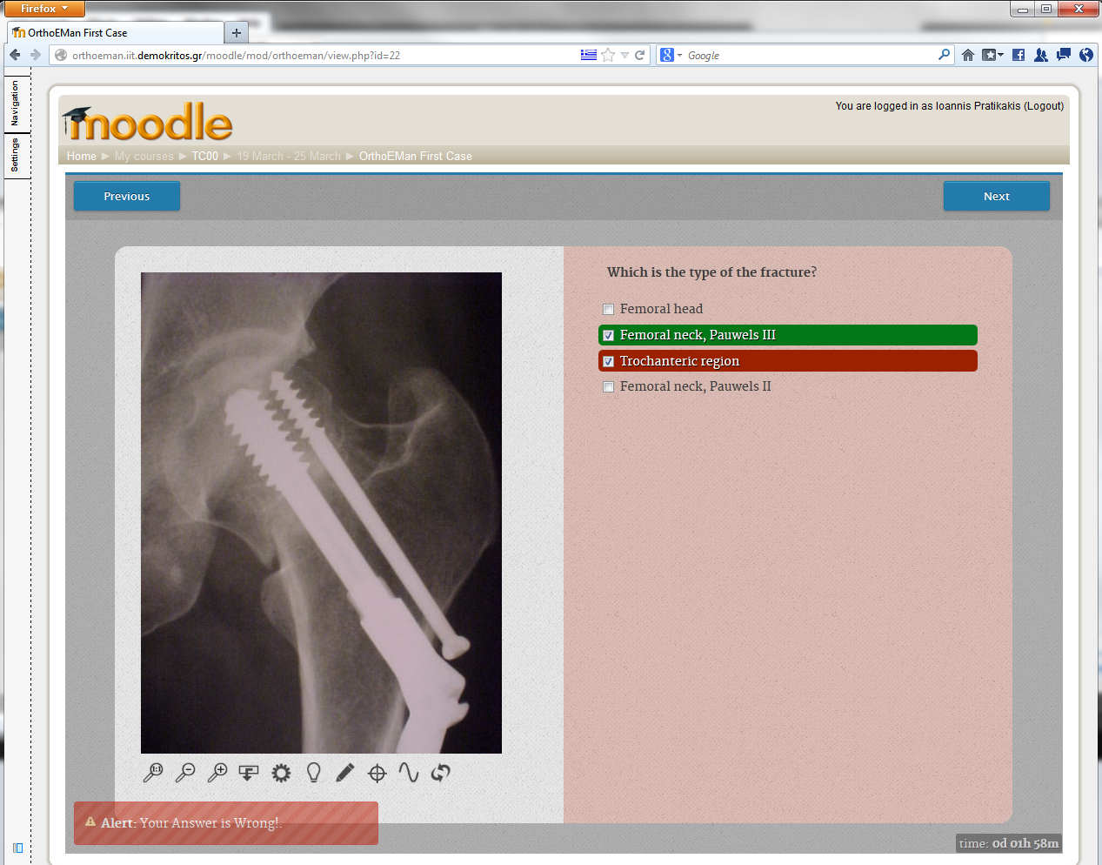
(a) | (b)
Illustration 3: Responses to the students answers (a) response to a correct answer (b) response to a wrong answer

Image – Text
The Image – Text page type is used to present theory pages which they contain just an image and text. Moreover, it may used for hotspot identification by the students.
Illustration 4: Image Tools
When a page contains an image, the student has in his disposal a number of tools in order to manipulate the image to help him answer the question. Illustration 4 depicts those tools. From left to right:
- 1-1: Removes zooming scaling. Resets images dimensions to the original values.
- Zoom In:. Zooms in by 20%.
- Zoom Out: Zooms out by 20%.
- Invert: Invert the image colors.
- Brightness: Change the image brightness.
- Contrast: Change the image contrast.
- Hotspot Selector: By pressing this button, the student will be able to create points in the image suitable for the hotspot identification questions.
- Crosshair Tool: Draws a crosshair tool across the image.
- Line: Draws a line. Lines are helper elements for the students and they are painted with a yellow pen. If multiple lines are drawn and the mouse hovers over an intersection the automatic angle calculation tool kicks in and displays the angle in degrees (Illustration 5).
- Reset: Resets the image to original state. Removes the Brightness/Contrast and Invert effects.

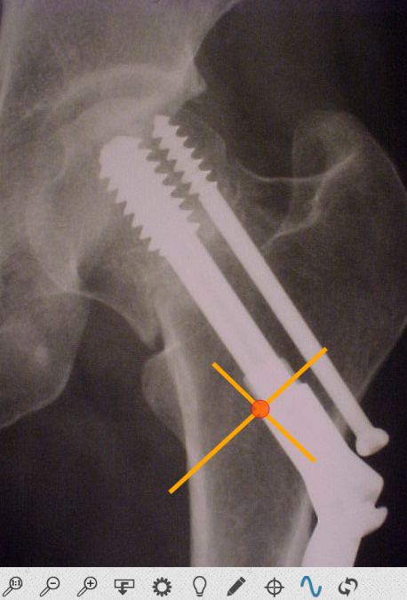 | 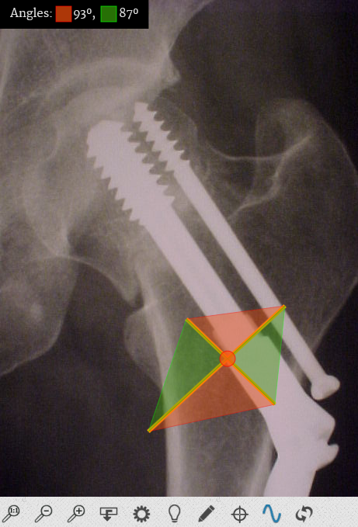
Illustration 5: Line drawing and angle calculation

The Illustration 6 shows the image – text page type when involves hotspot identification. The student by pressing the Hotspot Drawing Tool must point in the image the correct area. The number of required hotspots are defined from the question. The hotspot can be deleted by hovering the mouse cursor over it and pressing the left button. When the required hotspots are created by the student, the “Submit your Answer” button appears and the answer is ready to be send.
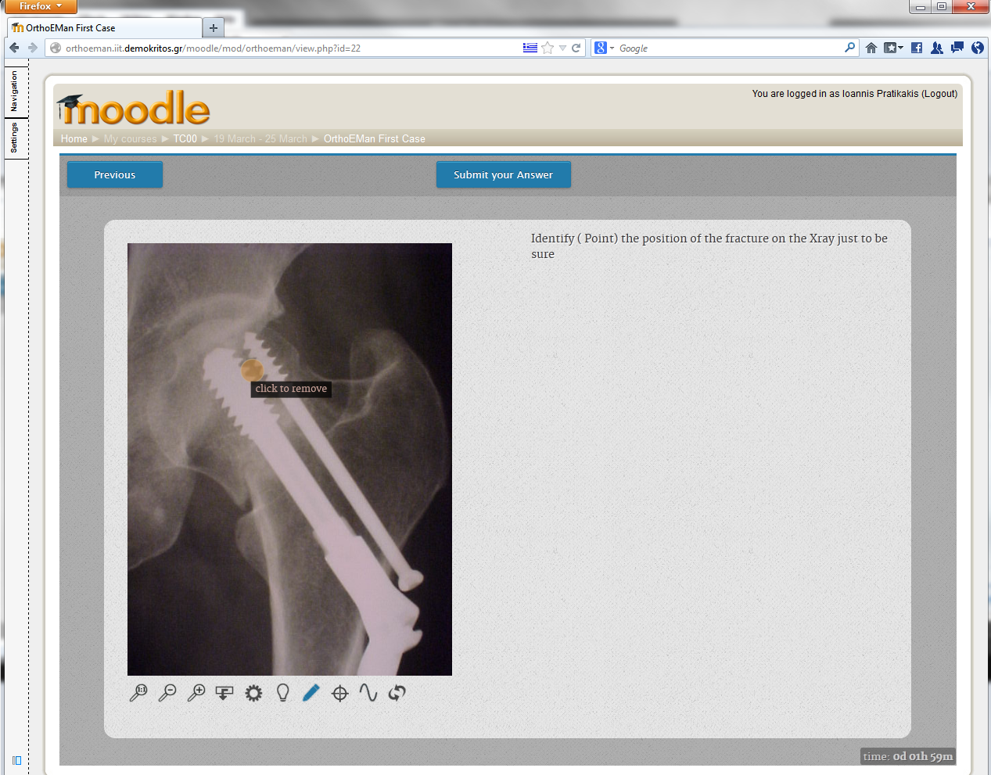Illustration 6: Image - Text

Image – Quiz
The image below (Illustration 7) shows how Display Tool illustrates the Image – Quiz page type. The student can select one or more choices from the available answers. When at least one answer is selected, a button labeled “Submit your Answer” will appear. The student by pressing this button, he submit his answer.
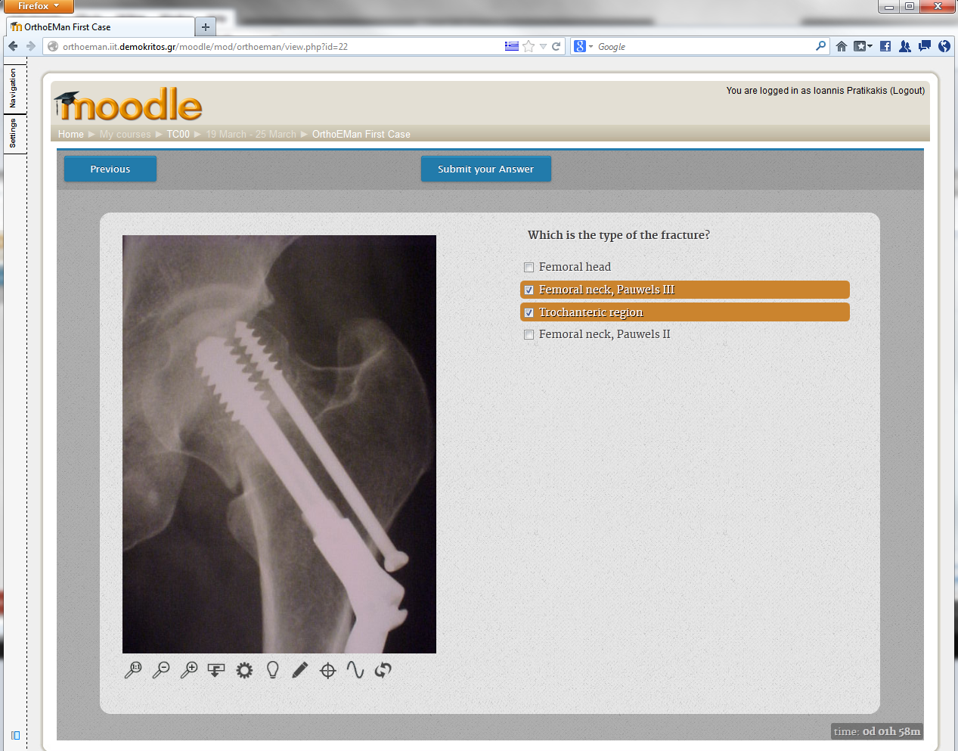Illustration 7: Image - Quiz
Submit your Answer
Select one or more
answers

Image – Range Quiz
The Image – Range Quiz page type requires the student to submit a value by studying the associate image and deduce from it the correct answer. He has in his disposal all the image tools that are described earlier (including the cross-line mode) to figure out the answer. When he enters a value the “Submit your Answer” button appears so that he may submit it.

Video – Text
The Video – Text page type is used only for theory and not for student's evaluation. It is not requires any action from the student. The authoring teacher provides a video and a text that highlights the more relevant points of it.
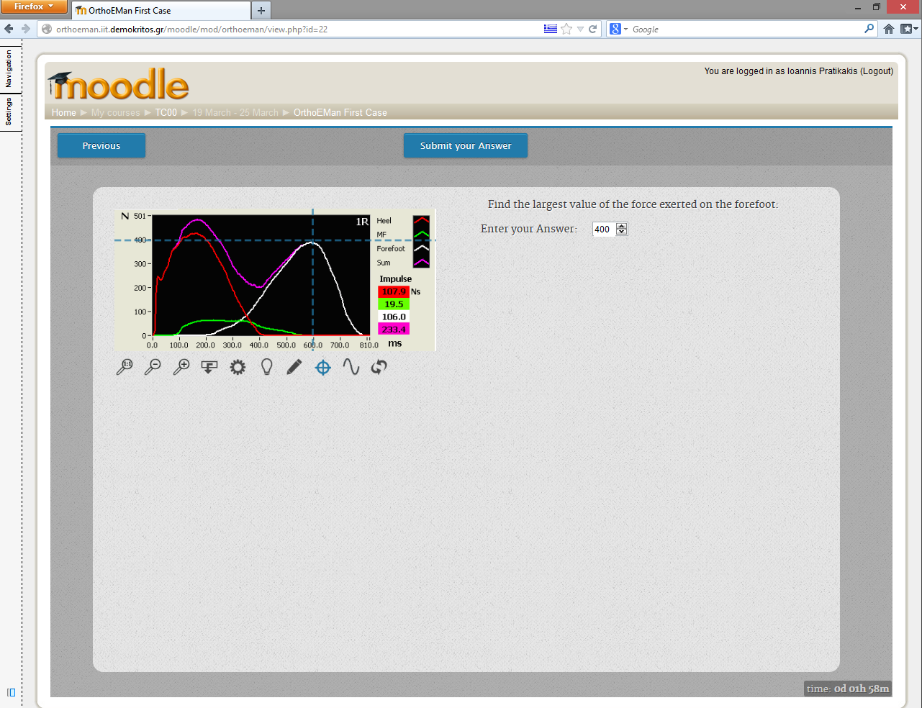Illustration 8: Image – Range Quiz
Submit the Answer
Enable/Disable
Cross – Line Mode
Enter the correct value

Video – Quiz
The Video – Quiz page type is like the Image – Quiz, where instead of an image there is a video. The student can watch the accompany video and then, he must select one or more choices from the available answers. When at least one answer is selected, a button labeled “Submit your Answer” will appear. The student by pressing this button, he submit his answer.

Text – Quiz
The Text – Quiz page type is a classic non-multimedia quiz where the student reads the question and the accompany theory and selects one or more answers from the provided answers.
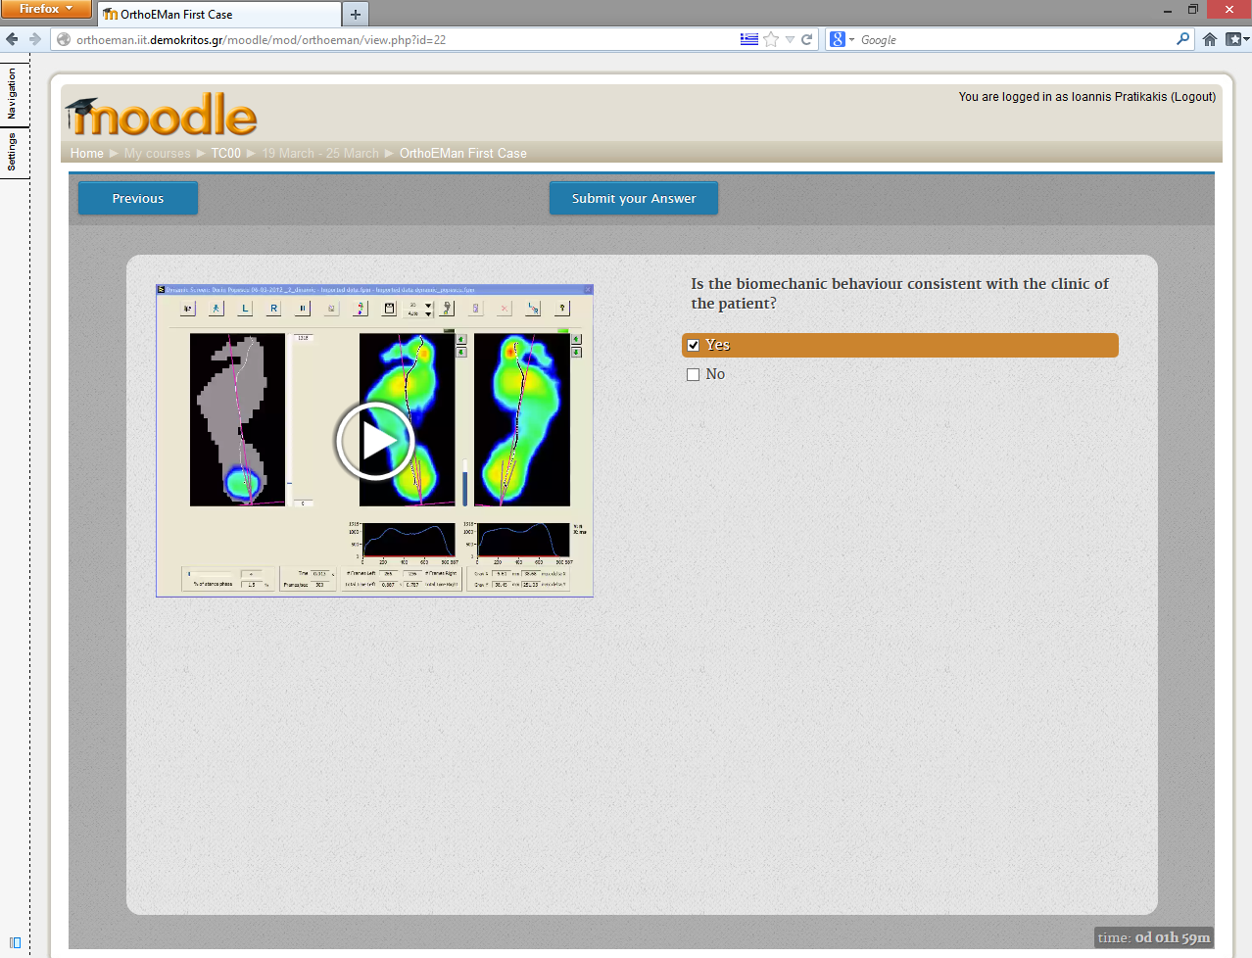Illustration 9: Video – Quiz
The Video
One or more answers
for the student to select

