

Project 2011-1-RO1-LEO05-15321 (Contract LLP-LdV/ToI/2011/RO/008)
A web-based e-training platform for Extended Human Motion Investigation in Orthopedics ORTHO-eMAN

STUDENT
GUIDE

Table of Contents
1 Introduction 3
2 Software Requirements 3
3 Entering Moodle 3
3.1 Getting Moodle Accounts 4
3.2 Course Hierarchy 5
4 Display Tool 7
4.1 First Contact 7
4.2 Pages Type 8
4.2.1 Image – Text 8
4.2.2 Image – Quiz 11
4.2.3 Image – Range Quiz 12
4.2.4 Video – Text 12
4.2.5 Video – Quiz 13
4.2.6 Text – Quiz 13

Introduction

Software Requirements
The OrthoEMan plugin and its modules have been developed with the newest W3C standards in mind in order to provide a modern experience to all faculty members including both the teacher and the students. Thus any HTML5 compatible browser should be enough for working with the OrthoEMan plugin. Furthermore the plugin has been explicitly tested with
- Firefox 19
- Chrome 23
- Internet Explorer 10

It is strongly advised to keep the computer which will access to the OrthoEMan facility in good shape with the latest updates applied.

Entering Moodle
In order to visit the OrthoEMan's project development moodle site you have to startup your browser and type http://orthoeman.iit.demokritos.gr/moodle/ in the browser's location (URL) bar. Your browser's window should look like the following picture.
Login here by clicking the link,
Left Panel
Main Area
Right Panel
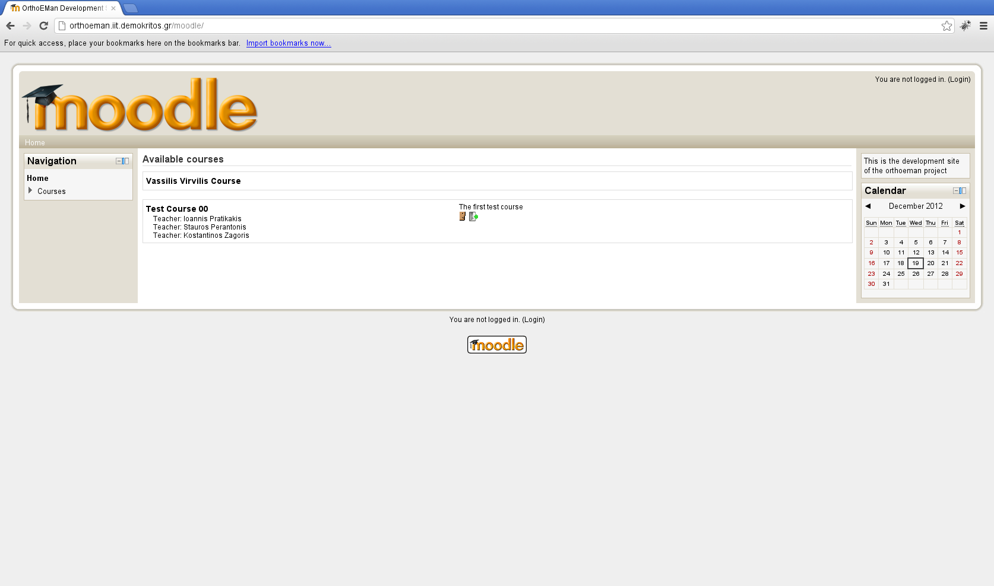Illustration 1: Moodle first contact

The screen estate is divided in 3 main columns. Let's name it left panel, right panel and main area.The left panel is used mainly for navigation while the right panel has mostly informational or context specific actions. In the main area moodle displays the current activity's content.

Getting Moodle Accounts
While it is possible to visit the moodle development site without logging in you will not be able to see most of the interesting things. Therefore it is imperative to log in in order to fully use the system.

In order to get a valid account please sent an e-mail to mailto:orthoeman-devel@iit.demokritos.gr asking for a teacher account.

This is the typical screen you see after a successful login.

You can customize your profile
and environment
Directly navigate to available courses
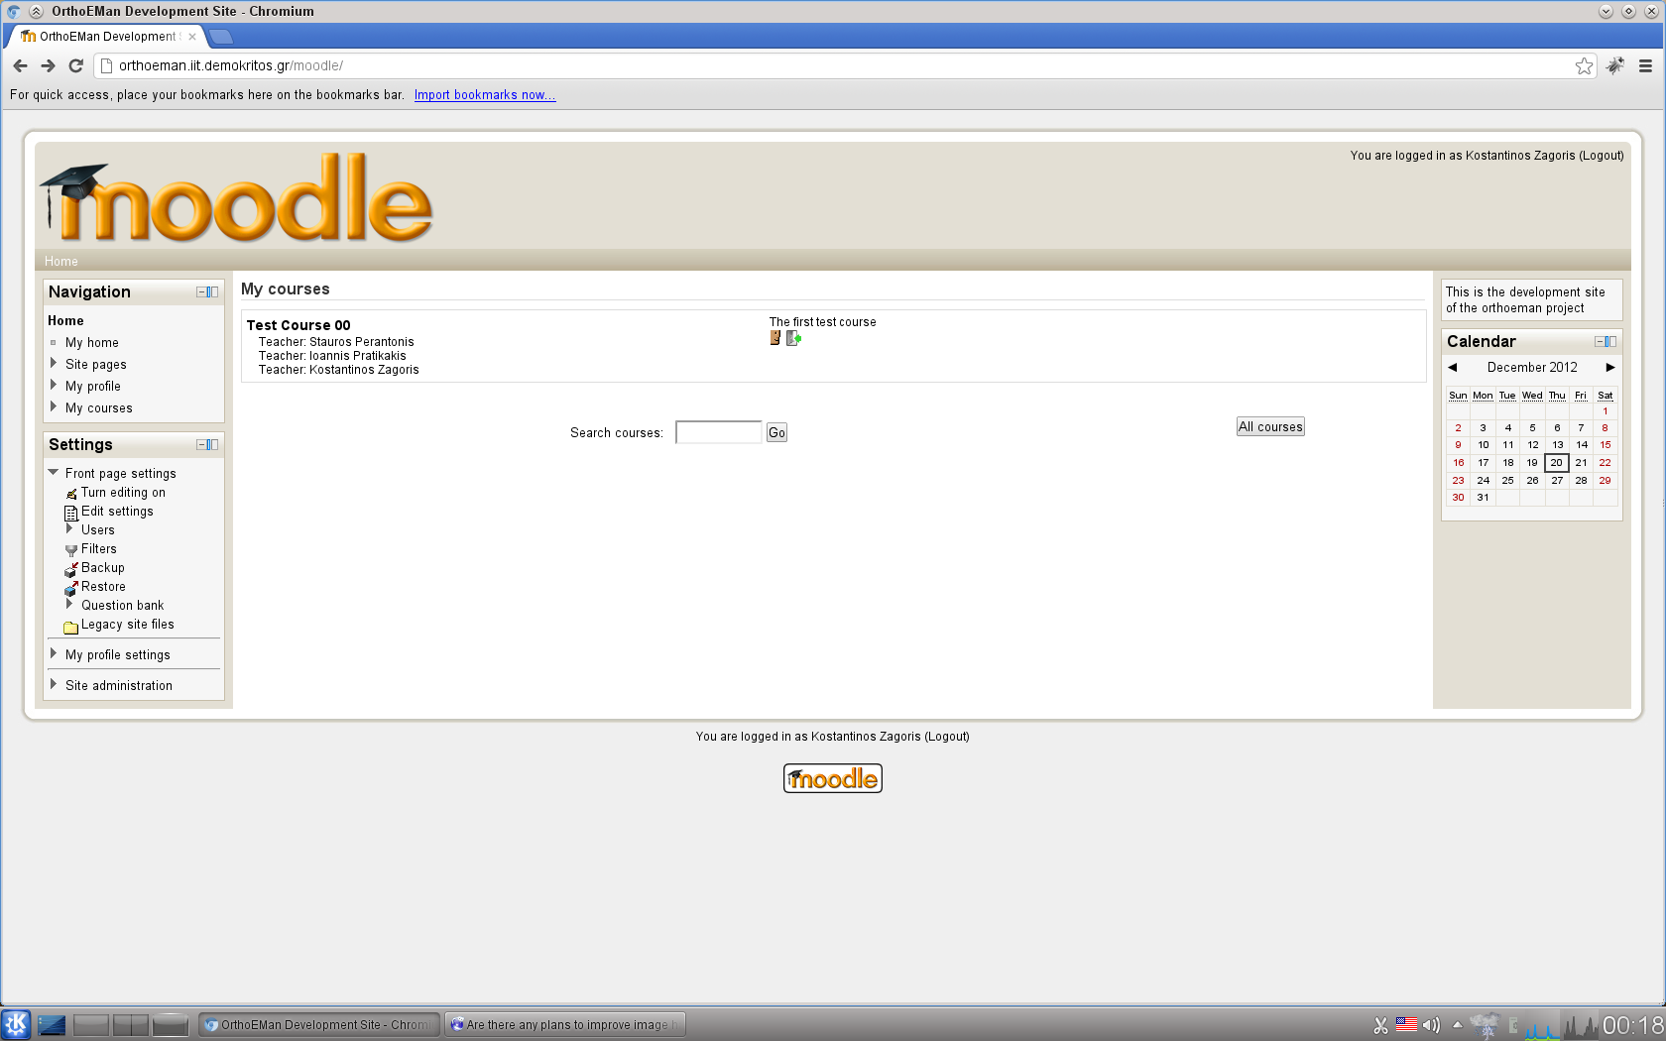Illustration 2: Moodle Navigation

Course Hierarchy
In moodle speak we have Course Categories which are groups of courses, In each category it is possible to have multiple courses. Each course may have one or more authors (editing teachers in moodle speak). Each course is divided in time slots and in each time slot it is allowed to have multiple activities. One such activity is the OrthoEMan activity and it corresponds to one case (in OrthoEMan speak.). In order to depict the above relationships graphically imagine the following tree.
- Course Category
- Course
- Time Slot
- Activity – OrthoEMan activity (case)
Navigate to the course of interest and you should see something like this.

Turn editing on
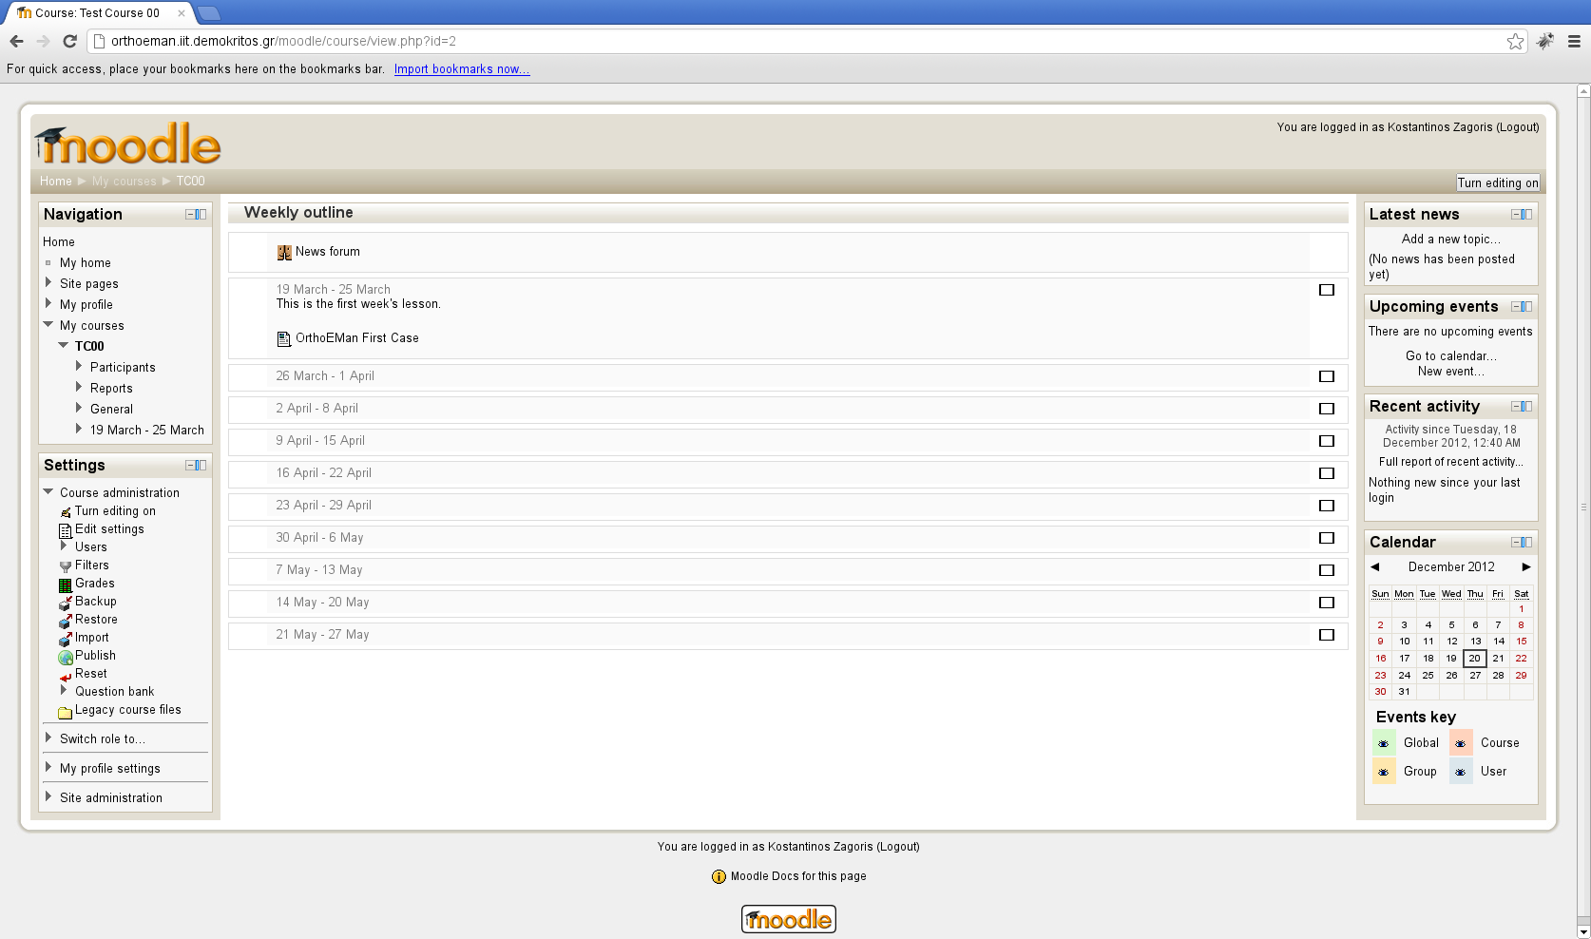Illustration 3: Course Outline

In this example you can see a weekly outline with one OrthoEMan activity. The outline of the course, meaning the way the time slots are allocated, is entirely decision of the course creator. The course creator depending on the admininistrator may be different than the course author (editing teacher).

Display Tool
The Display Tool is the main interface point with the student. The student evokes the Display Tool by just selecting the appropriate lesson.

First Contact
The title and the case's description that are displayed in the initial screen of the Display Tool have been entered in case configuration page as it is illustrated at Illustration .

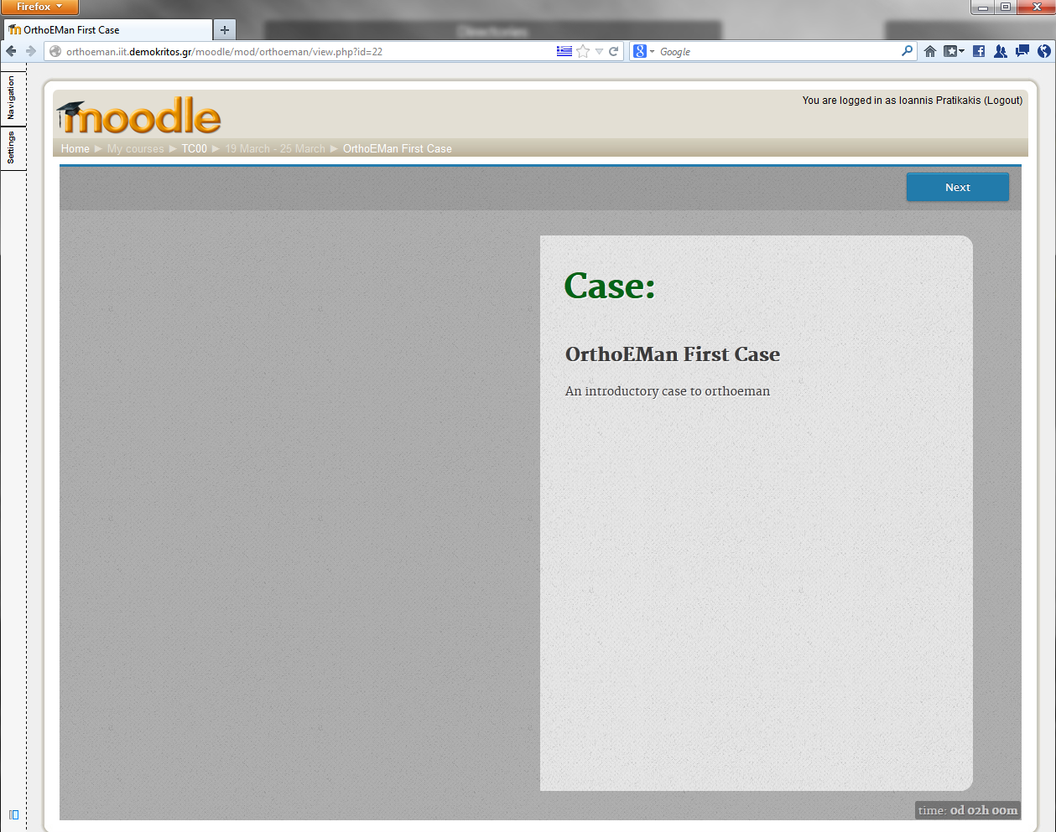Illustration 4: Display Tool: First Contact
Remaining Time
Case Description
Case Title
Navigate to the
Next Page

The student can navigate between pages by using the buttons on the upper part of the screen. The clock that shows the remaining time for the lesson completion is displayed in the lower-right part of the screen. It has two mode: the compact mode which it is the default and the expanded mode which it is evoked by clicking the compact clock. Illustration 5(a) and 5(b) shows these two clock versions.
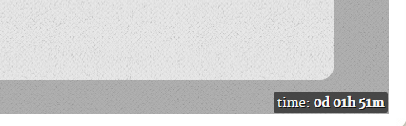 | 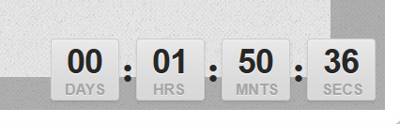
(a) | (b)
Illustration 5: Clock showing the remaining time until the lesson completion (a) compact version (b) expanded version

Pages Type
A lesson consists of a collection of pages as section Error: Reference source not found describes. Each page may contain theory or questions towards the students. The pages that are compose of questions expect feedback from the student. Depending of the page type the answers are ranging from selecting the correct hotspots in an image to picking up the correct phrases(quiz). Then, the Display Tool informs the student if his answer is correct or wrong (Illustration 12(a) and 12(b)). The Display Tool may provide the correct answer if the student answer it wrong but only by the teacher consent.

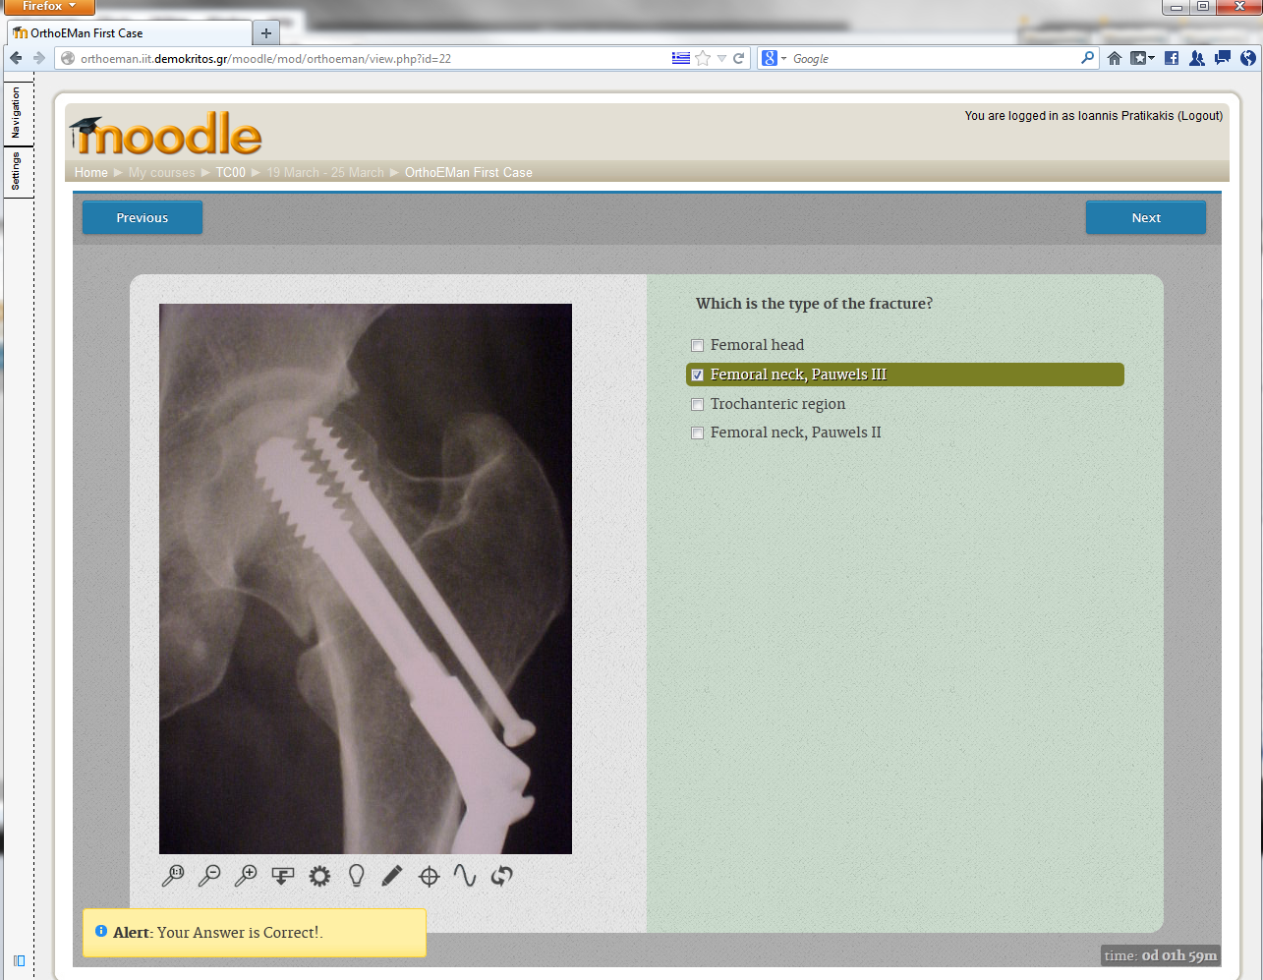 | 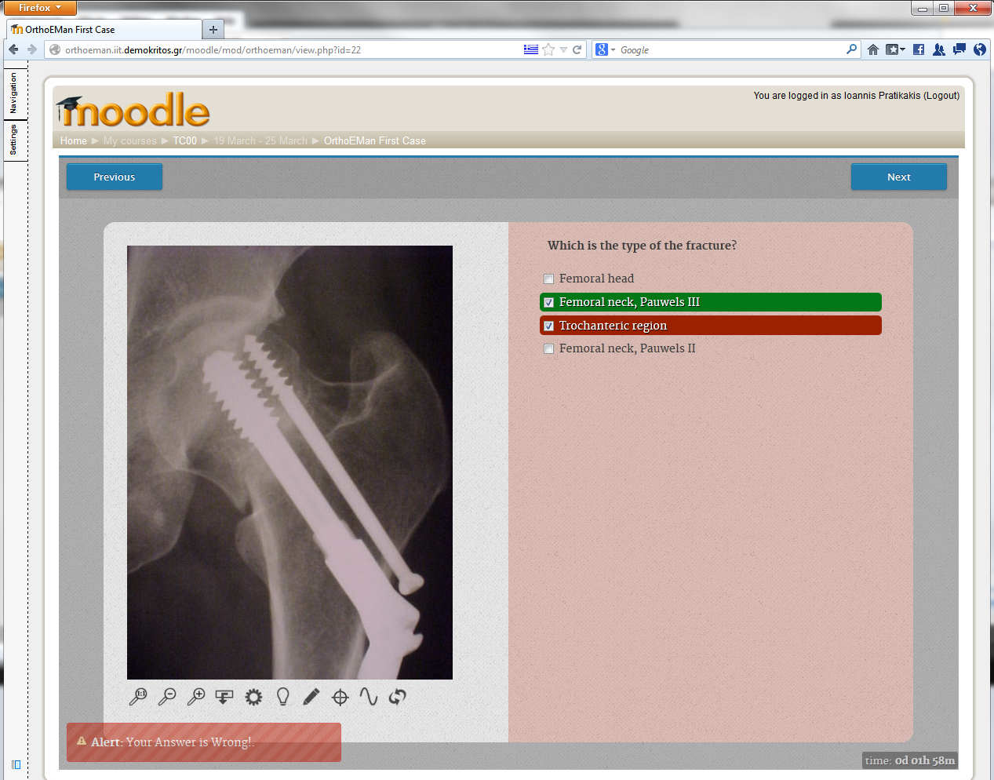
(a) | (b)
Illustration 6: Responses to the students answers (a) response to a correct answer (b) response to a wrong answer

Image – Text
The Image – Text page type is used to present theory pages which they contain just an image and text. Moreover, it may used for hotspot identification by the students.
Illustration 7: Image Tools
When a page contains an image, the student has in his disposal a number of tools in order to manipulate the image to help him answer the question. Illustration 7 depicts those tools. From left to right:
- 1-1: Removes zooming scaling. Resets images dimensions to the original values.
- Zoom In:. Zooms in by 20%.
- Zoom Out: Zooms out by 20%.
- Invert: Invert the image colors.
- Brightness: Change the image brightness.
- Contrast: Change the image contrast.
- Hotspot Selector: By pressing this button, the student will be able to create points in the image suitable for the hotspot identification questions.
- Crosshair Tool: Draws a crosshair tool across the image.
- Line: Draws a line. Lines are helper elements for the students and they are painted with a yellow pen. If multiple lines are drawn and the mouse hovers over an intersection the automatic angle calculation tool kicks in and displays the angle in degrees (Illustration 8).
- Reset: Resets the image to original state. Removes the Brightness/Contrast and Invert effects.

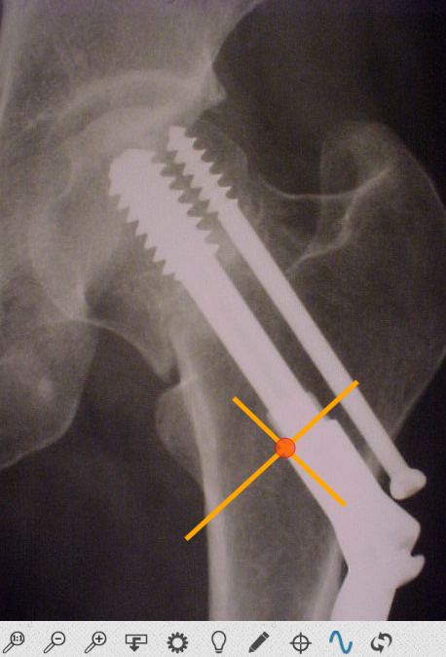 | 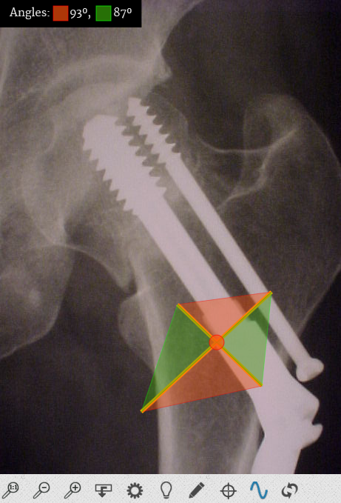
Illustration 8: Line drawing and angle calculation

The Illustration 9 shows the image – text page type when involves hotspot identification. The student by pressing the Hotspot Drawing Tool must point in the image the correct area. The number of required hotspots are defined from the question. The hotspot can be deleted by hovering the mouse cursor over it and pressing the left button. When the required hotspots are created by the student, the “Submit your Answer” button appears and the answer is ready to be send.
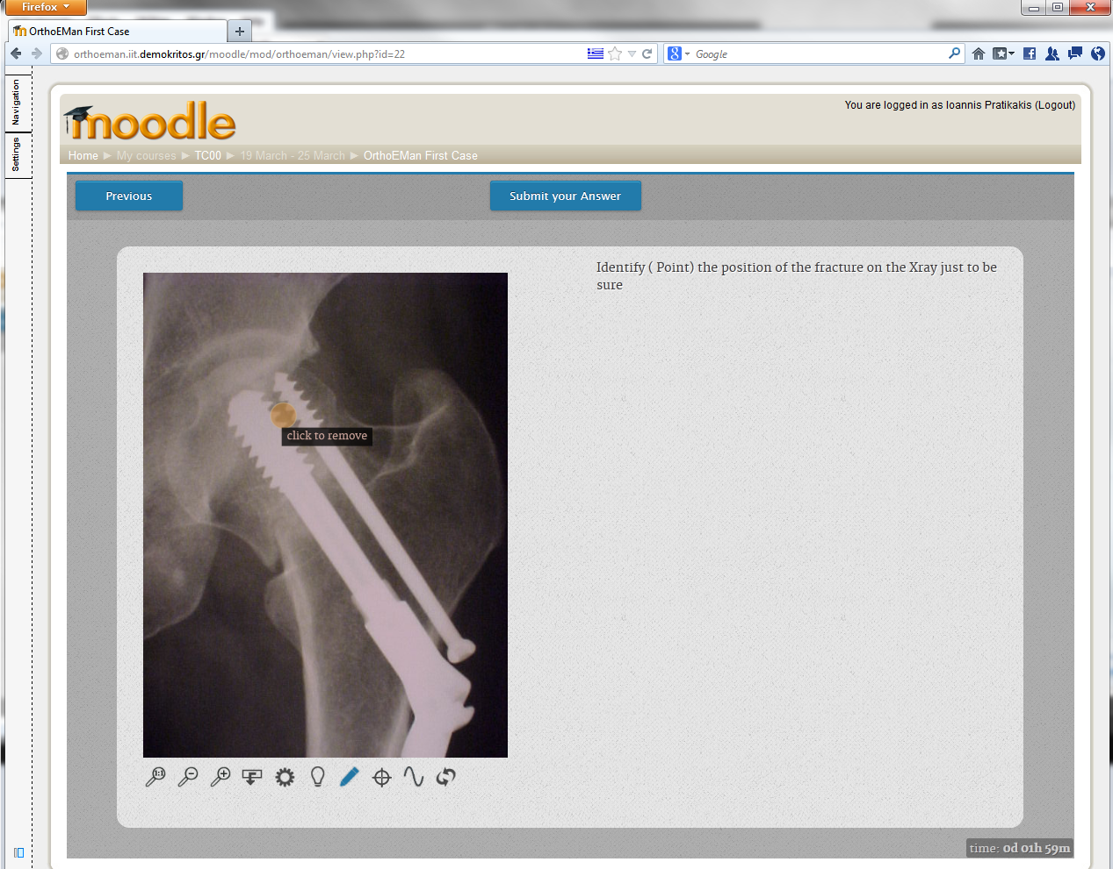Illustration 9: Image - Text

Image – Quiz
The image below (Illustration 10) shows how Display Tool illustrates the Image – Quiz page type. The student can select one or more choices from the available answers. When at least one answer is selected, a button labeled “Submit your Answer” will appear. The student by pressing this button, he submit his answer.
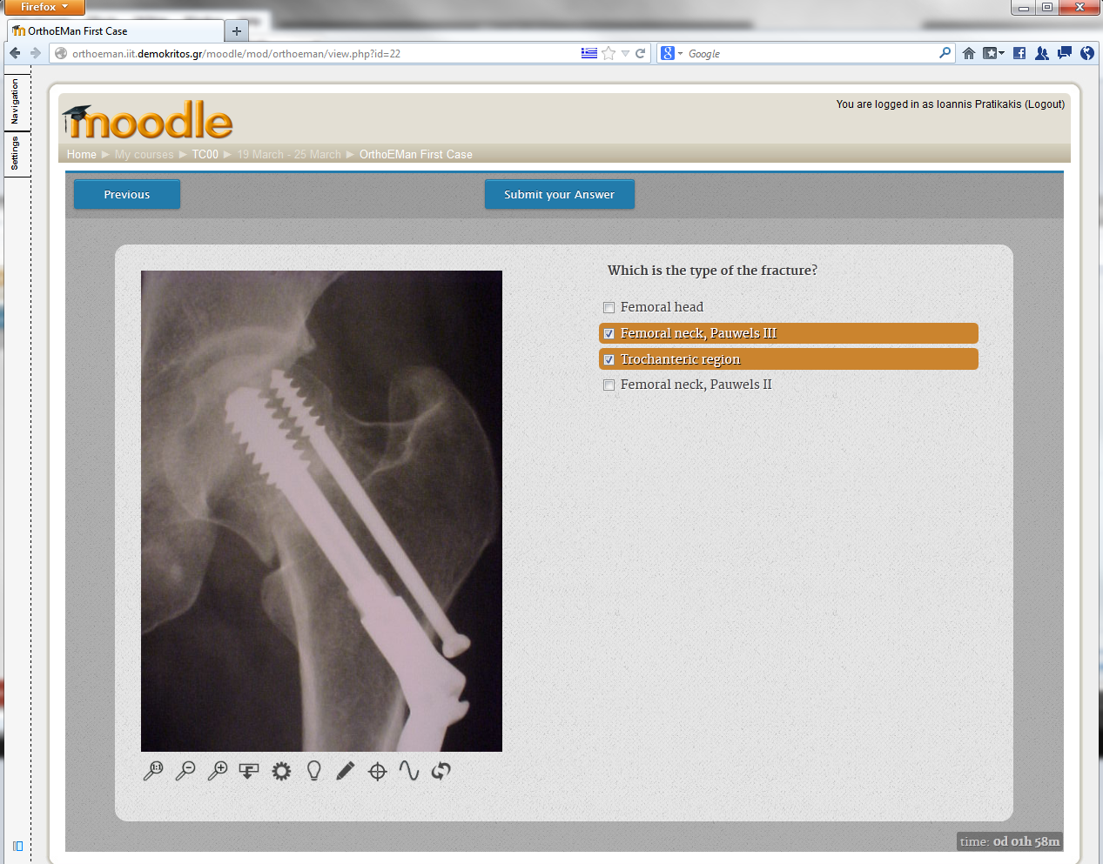Illustration 10: Image - Quiz
Submit your Answer
Select one or more
answers

Image – Range Quiz
The Image – Range Quiz page type requires the student to submit a value by studying the associate image and deduce from it the correct answer. He has in his disposal all the image tools that are described earlier (including the cross-line mode) to figure out the answer. When he enters a value the “Submit your Answer” button appears so that he may submit it.

Video – Text
The Video – Text page type is used only for theory and not for student's evaluation. It is not requires any action from the student. The authoring teacher provides a video and a text that highlights the more relevant points of it.
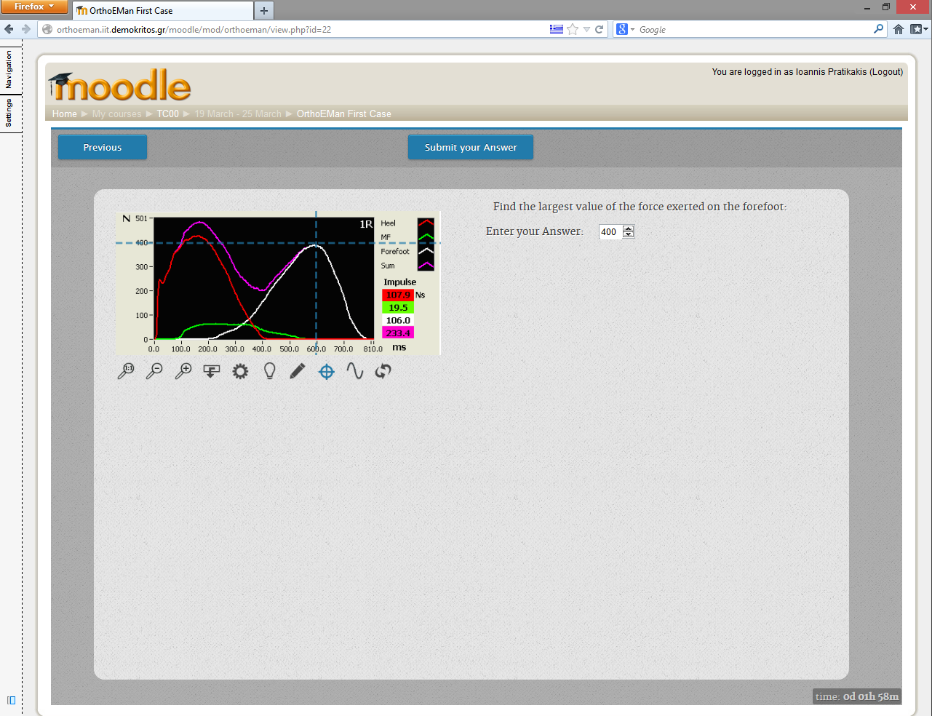Illustration 11: Image – Range Quiz
Submit the Answer
Enable/Disable
Cross – Line Mode
Enter the correct value

Video – Quiz
The Video – Quiz page type is like the Image – Quiz, where instead of an image there is a video. The student can watch the accompany video and then, he must select one or more choices from the available answers. When at least one answer is selected, a button labeled “Submit your Answer” will appear. The student by pressing this button, he submit his answer.

Text – Quiz
The Text – Quiz page type is a classic non-multimedia quiz where the student reads the question and the accompany theory and selects one or more answers from the provided answers.
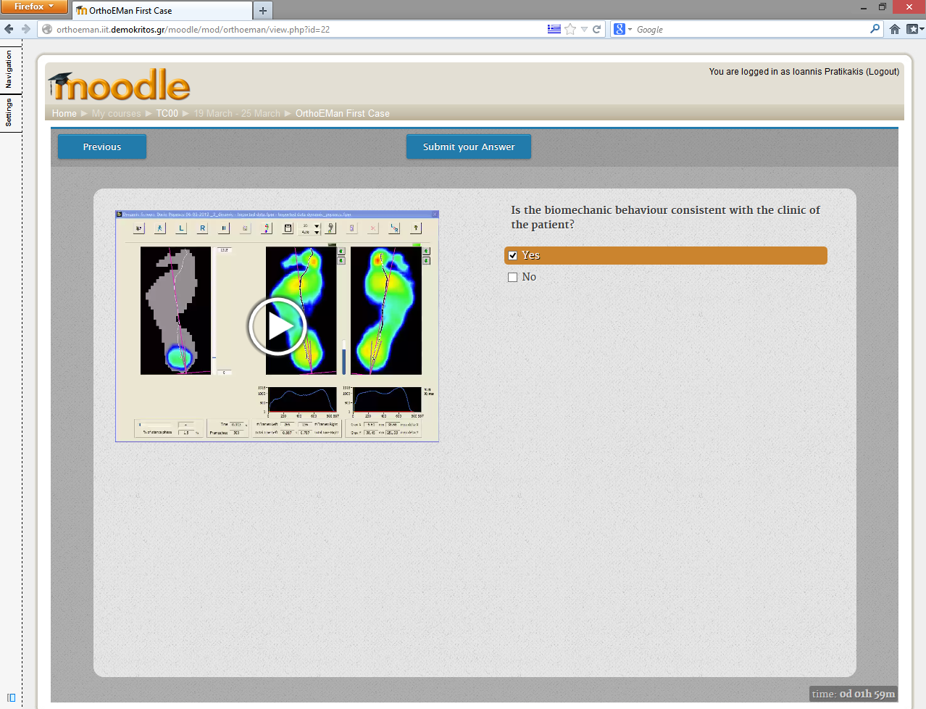Illustration 12: Video – Quiz
The Video
One or more answers
for the student to select

Note that the moodle installation has to be transferred from NCSR Demokritos to University of Craiova in Romania.

