

Project 2011-1-RO1-LEO05-15321 (Contract LLP-LdV/ToI/2011/RO/008)
A web-based e-training platform for Extended Human Motion Investigation in Orthopedics ORTHO-eMAN

TEACHER
GUIDE

Table of Contents
1 Introduction 3
2 Software Requirements 3
3 Entering Moodle 3
3.1 Getting Moodle Accounts 4
3.2 Course Hierarchy 5
3.3 Creating an OrthoEMan activity 7
4 Authoring Tool 10
4.1 Entering Authoring Tool 10
4.2 First Contact 10
4.2.1 Toolbar 11
4.2.2 Pages Container 12
4.2.3 Page Area 13
4.2.4 Media Container 13
4.2.5 Non Media Container 13
4.3 Case structure 14
4.3.1 Image – Text 14
4.3.2 Image – Quiz 18
4.3.3 Image – Range Quiz 19
4.3.4 Video – Text 20
4.3.5 Video – Quiz 20
4.3.6 Text – Quiz 20

Introduction
The OrthoEMan Project is a technology transfer project based on a previous Leonardo project named e-Medi. The goal of the project is to integrate orthopedic content with a presentation and an evaluation aspect in order to be used in a e-Learning environment. To that end the chosen e-Learning system is moodle (http://www.moodle.org), and naturally the OrthoEMan has been developed as a moodle plug-in.

The OrthoEMan plugin has 3 aspects
- Authoring Tool
- Display Tool
- Moodle Administration
The aim of this document is to provide simple guidelines for all parties interested in using the OrthoEMan plugin, including the authors (teachers) and the examinees (students),

Software Requirements
The OrthoEMan plugin and its modules have been developed with the newest W3C standards in mind in order to provide a modern experience to all faculty members including both the teacher and the students. Thus any HTML5 compatible browser should be enough for working with the OrthoEMan plugin. Furthermore the plugin has been explicitly tested with
- Firefox 19
- Chrome 23
- Internet Explorer 10

It is strongly advised to keep the computer which will access to the OrthoEMan facility in good shape with the latest updates applied.

Entering Moodle
In order to visit the OrthoEMan's project development moodle site you have to startup your browser and type http://orthoeman.iit.demokritos.gr/moodle/ in the browser's location (URL) bar. Your browser's window should look like the following picture.
Login here by clicking the link,
Left Panel
Main Area
Right Panel
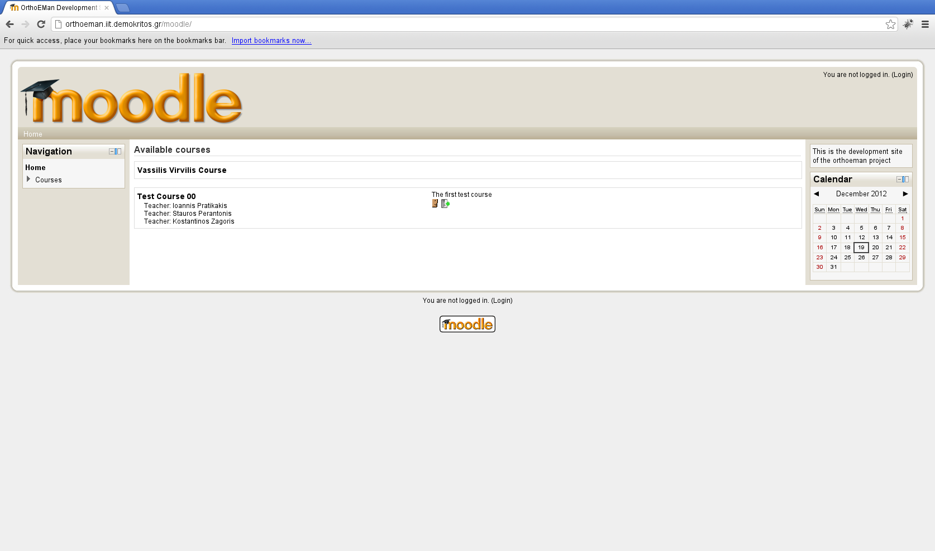Illustration 1: Moodle first contact

The screen estate is divided in 3 main columns. Let's name it left panel, right panel and main area.The left panel is used mainly for navigation while the right panel has mostly informational or context specific actions. In the main area moodle displays the current activity's content.

Getting Moodle Accounts
While it is possible to visit the moodle development site without logging in you will not be able to see most of the interesting things. Therefore it is imperative to log in in order to fully use the system.

In order to get a valid account please sent an e-mail to mailto:orthoeman-devel@iit.demokritos.gr asking for a teacher account.

This is the typical screen you see after a successful login.

You can customize your profile
and environment
Directly navigate to available courses
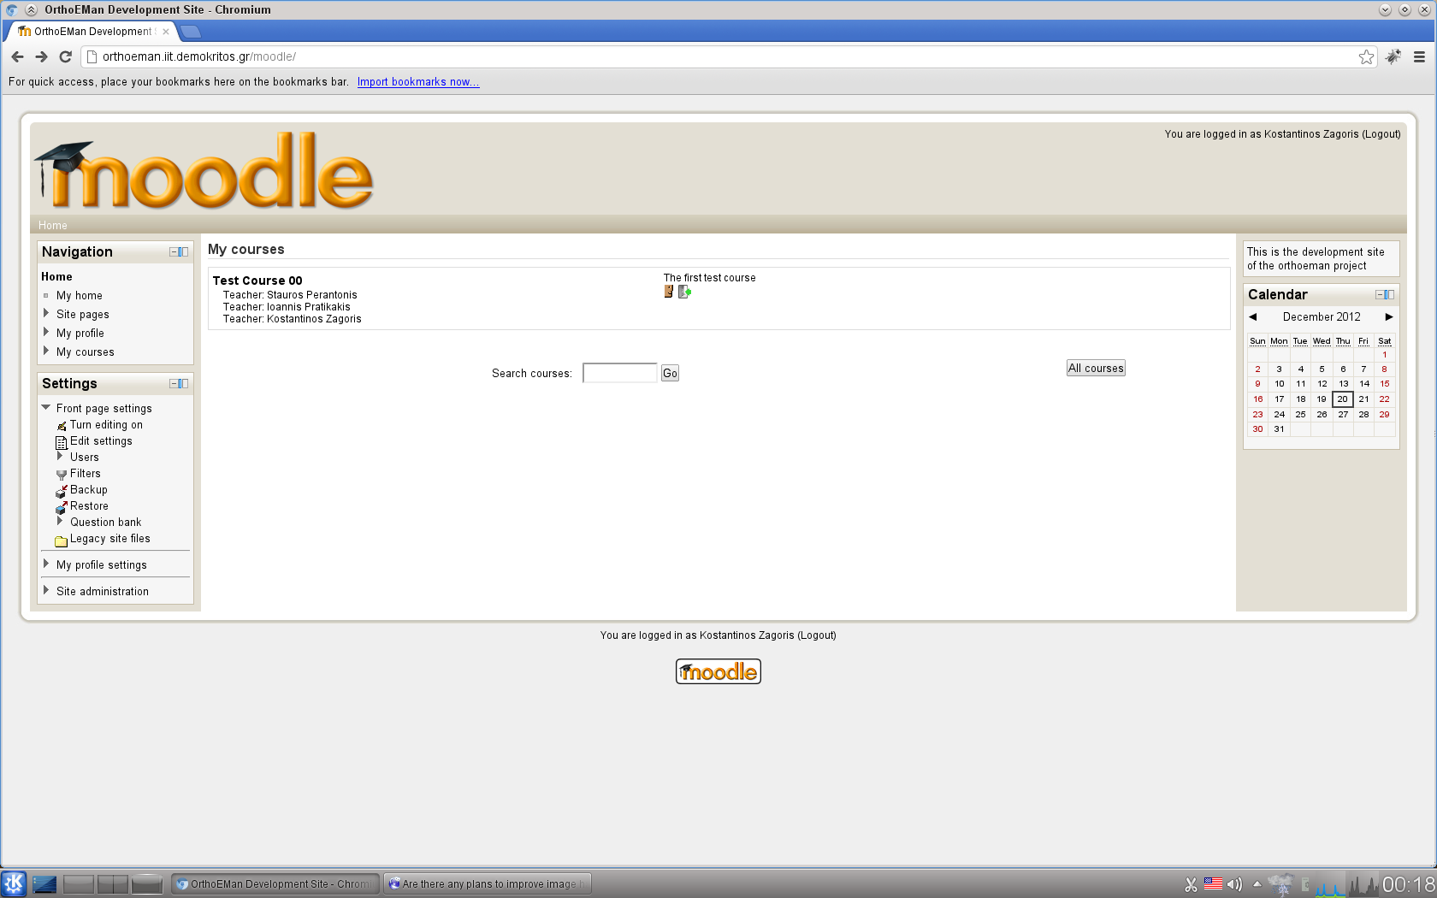Illustration 2: Moodle Navigation

Course Hierarchy
In moodle speak we have Course Categories which are groups of courses, In each category it is possible to have multiple courses. Each course may have one or more authors (editing teachers in moodle speak). Each course is divided in time slots and in each time slot it is allowed to have multiple activities. One such activity is the OrthoEMan activity and it corresponds to one case (in OrthoEMan speak.). In order to depict the above relationships graphically imagine the following tree.
- Course Category
- Course
- Time Slot
- Activity – OrthoEMan activity (case)
Navigate to the course of interest and you should see something like this.

Turn editing on
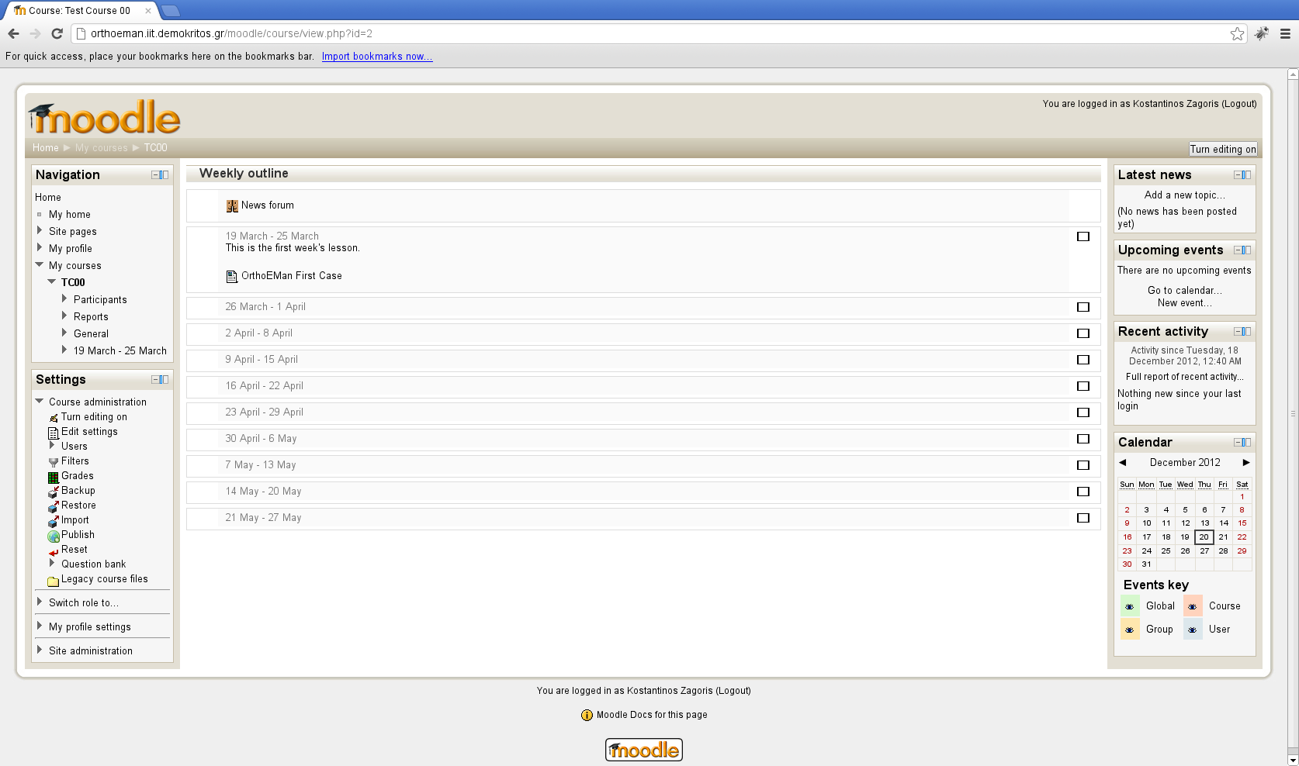Illustration 3: Course Outline

In this example you can see a weekly outline with one OrthoEMan activity. The outline of the course, meaning the way the time slots are allocated, is entirely decision of the course creator. The course creator depending on the admininistrator may be different than the course author (editing teacher).

One can think of this situation where the faculty decides about the format of the course (duration, exams, etc.) and the current teacher provides the content.
Add an activity
Edit Case
Add a resource
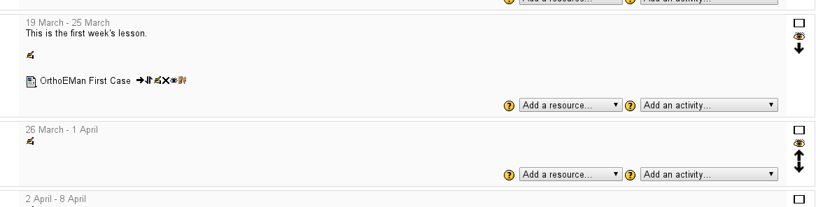Illustration 4: Turn Editing On to edit an OrthoEMan case

If you are a teacher a button in the right upper corner will prompt you to turn editing on. You have to press it in order to turn the editing on. This will allow you to enter the Authoring Tool. After you turn the editing on a series of icons should populate each activity in course's main area.

You can add resources such as links, documents, images and HTML labels with the first combobox at the right side. You can also add various activities. One such activity is the OrthoEMan activity.

Creating an OrthoEMan activity
Let' s create an OrthoEMan activity. Click on the right combobox in the desired time slot like the picture below:

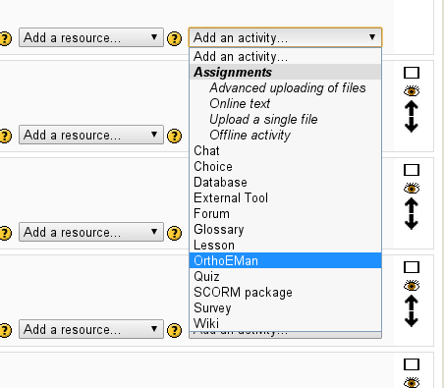Illustration 5: OrthoEMan case creation

After that step a title and a brief description will be requested in order to fully qualify the lesson. The window's contents should look like the picture below.

Title
Description of the case
Cruize mode
Time out duration
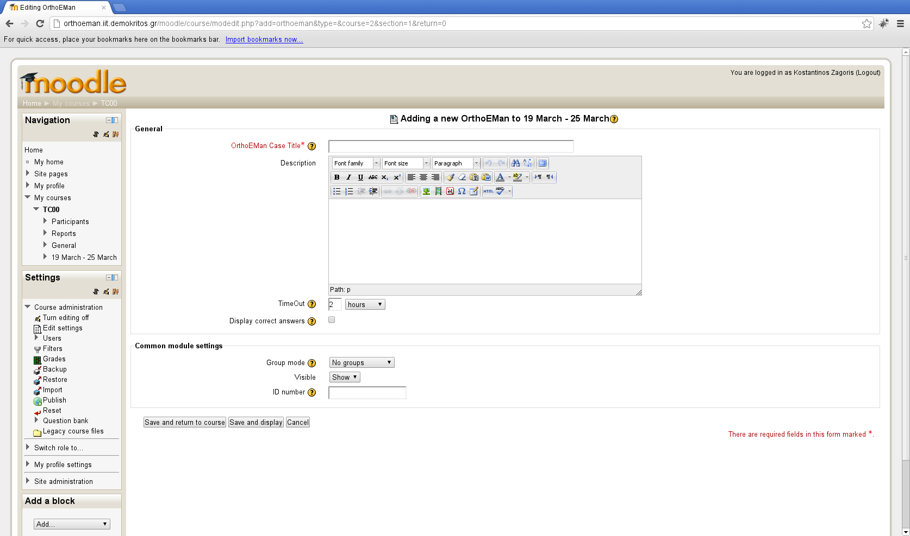Illustration 6: OrthoEMan case initial configuration

The author has to enter the following pieces of information.
- Title: That is the title of the case. It should be short and descriptive. The title will be visible from the course outline.
- Description: A more detailed description of the case. This text may include HTML formatting elements and it will be displayed in the first page of the Display Tool.
- TimeOut: The amount of time a student is allowed to spend in a case. The Display Tool will prevent further access or answer submissions from the student after the timeout duration has been passed.
- Cruize Mode: The Label has description ''Display Correct Answers''. This checkbox instructs Display Tool to display the correct answer to all authorized students. This can be used for a grace period after the exams have finished.

When you are done configuring the case, press the button ''Save and Return to Course''. In order to be able to alter the configuration you just entered from the Course Outline you have to click on the little icon that depicts a hand holding a pencil (update).

Illustration 7: Edit Case

In order to visit the Authoring Tool and actually edit the case you have to again click the update icon.

Authoring Tool

Entering Authoring Tool
The second time you visit the case configuration page you encounter a page similar to the picture 6 but with one important difference. In the main area, at the start of the page, there is a link.

Illustration 8: Edit OrthoEMan case
Click here to enter
Authoring Tool

By clicking the link Authoring Tool will start in a frame inside moodle. If screen estate proves to be scarce we may consider of having a way starting Authoring Tool in a new page. Note also, that the way of Authoring Tool invocation may change in general e.g. the link may become a button in the middle of the page etc.

First Contact
The Authoring Tool is a web based application that helps the author to create or edit an OrthoEMan compatible case. In the figure below you can see the opening screen for the program.
Illustration 9: Authoring Tool: First Contact
5
1
4
3
2

1 | Toolbar
2 | Pages Container
3 | Page Area
4 | Media Container
5 | Non Media Container (Text, Quiz, RangeQuiz)
Table 1: Authoring Tool

Toolbar
The toolbar hosts 3 visible buttons. From left to right the buttons are Save, Preview (left aligned), and Send a bug report (right aligned). With the Save button one can save in the database the case. A teacher may choose to quickly preview the case in order to get an idea what students will face when they take the exam. When the Preview button is clicked Authoring Tool will invoke the Display Tool in a different tab (or window) or reloads it if it already exists.

The button at the right side, with the warning sign and the envelop, is for the user to inform the OrthoEMan plugin authors about an unintended behavior of the program (namely a bug). See the picture below for an illustration of the bug reporting dialog. When you are filing a bug report try to be concise, short, and to the point. In the subject type the problem type you experience. In the body of message make sure you mention:
- What are you trying to do (intention of the user)
- What are you actually doing (series of events and user actions)
- How the computer responds (erratic (buggy) behavior)
- How the computer should respond (expected (correct) behavior)

Finally there is one hidden button aimed at advancing debugging users. The button can be made visible by the Moodle administrator or by a user's browser with debug facilities (such as firebug). The button toggles a console with debug messages representing user events and program internal state. The button is positioned left of the Report a bug button.

Illustration 10: Report a bug dialog

Pages Container
The pages container contains the pages (slides) the author creates. There are 4 buttons. The Add / Remove button pair helps the author to create new pages and remove unneeded ones. The Up / Down buttons helps the author to properly position the current page with respect to the other slides. The pages are identified by their title. The Display Tool may not display the page title. Nevertheless a concise page title is strongly advised to be entered in order to help author organize the case and keep the overall overview. Note that the page title inside the slide will be updated when the Page Title textbox looses its input focus.

Page Area
The page area has the following elements
- Page Title: identifies the page and it is displayed in the Pages Container slide area for each page. It is strongly advised to enter a short descriptive page title that will organize the case flow. Note that the Display Tool may not display the Page Title text.
- Page Type: a combobox that identifies the page type. See below for a discussion of the available page types.
- Grade: The grade of the page. The sum of all pages will be normalized at the end anyway so it is possible to use any relative value without worrying about normalization issues.
- Negative Grade: The punishment value that is subtracted from the positive grade for a wrong answer.

Media Container
The media container is the place where the image or the video is displayed. There is an upload button that initiates the upload procedure. In the case of image only PNG and JPEG image formats are allowed. In case of video the following video types are allowed (MPEG, MOV, AVI,and MP4). Note that AVI is not a video format itself, but a container format meaning it may include different video and audio encoding formats such as divx, xvid, theora, etc... In order for the video to be visible in modern HTML5 browsers it has to be trans-coded to mp4 and to webm formats. This operation may take several minutes and it is being done during video upload. For a 10 second video a 90 second upload and trans-coding time may be required depending on the server load. Also the operation may fail if the original video format is not understandable by the ffmpeg which is used on the server to perform the trans-coding. In such a case you will have to resubmit the video using an alternative format.

Non Media Container
The Non Media Container contains the following widgets
- Text: A text area for theory text, or instructions for the image hotspots.
- Quiz: A multiple choice quiz. The widget supports arbitrary number of possible questions and arbitrary number of correct questions.
- Range Quiz: A quiz that accepts as correct any answer in the specified range.

Case structure
A lesson consists of a collection of pages. Currently there are no limits in the number of pages a lesson can have. Each page has a a title and two items that should be edited and populated with the author's content. The left panel of the application is responsible for the management of the pages. There are buttons for adding and removing pages and buttons for page reordering. The content item can be of the following type:
- Text
- Image
- Video
- Quiz
- RangeQuiz

However not all item type combinations are valid. A page can only have one the following item type combinations.
- Image – Text
- Image – Quiz
- Image – Range Quiz
- Video – Text
- Video – Quiz
- Text – Quiz

A page is characterized by its title and by its type (the combination of item types)

Image – Text

The Image – Text page type used for two types of pages:
- Theory pages with informational areas pointed
- Hotspot identification by the students as it is depicted in the picture below.

Illustration 11: Image - Text
Hotspot or Info
The hotspots are drawn with a orange pen while the informational areas are drawn with blue pen. (consult the color map table below for reference). The choice where a drawing will be hotspot or informational is selected with the combobox in the middle of the tools as it is shown above. The difference is that hotspots are expected to be found by the students during the exam while the informational areas are shown to exemplify aspects of the theory.

Hotspot | Orange
Informational | Blue
Helper | Yellow
Eraser | Red
Other uses | Black
Table 2: Color Map Table

The image container sports several tools in order to help the author properly annotate the image.

Illustration 12: Image Tools

From left to right:
- 1-1: Removes all scaling. Every pixel of the image corresponds to one pixel of your viewing area.
- Zoom In:. Zooms in by 20%.
- Zoom Out: Zooms out by 20%.
- Zoom To Fit width: Scales the image to fit in the width of your client area of your browser. This is the default behavior when an image is uploaded.
- Zoom To Target: Requests from the user to draw a rectangle and then zooms to it.
- Drawing Type combobox: Select if the next drawing area will be a hotspot or an informational area.
- Rectangle: Draws a rectangle.
- Ellipse: Draws an ellipse.
- Polygon: Draws a polygon as a series of points. When the mouse hovers over the first point (within a range of 20 pixels) then a circle is drawn to indicate that the polygon will be closed. Although it is possible to create non convex polygons with this freehand drawing they should be avoided as it is possible to confuse the hotspot detection algorithm of the plugin.
- Line: Draws a line. Lines are helper elements and they are painted with a yellow pen. Lines are not displayed in the Display Tool. If multiple lines are drawn and the mouse hovers over an intersection the automatic angle calculation tool kicks in and displays the angle in degrees.

Illustration 13: Angle calculation
- Crosshair Tool: Draws a croshair tool. Again this is a helper tool and it is painted with a yellow color meaning it is not displayed in the Display Tool.
- Eraser: Paints with red every drawing when mouse hovers near it. When in red a click remove the drawing from the image. In order to remove multiple drawings a repeated selection of the eraser tool is required.
- Image Editing Tools: Allows for brightness, contrast and image inversion control in order for medical finding to become apparent.
Illustration 14: Brightness, Contrast and Inversion Control
- Show Regions checkbox: Specifies if the hotspots will be displayed from the Display Tool during the exam after student's answer submission.

Image – Quiz
In the image below the Image – Quiz combination is depicted. When the quiz is selected the hotspot functionality is disabled. Existing hotspots are converted to informational drawings. The quiz widget is shown in the right side of the Authoring Tool. The quiz supports arbitrary number of possible questions and arbitrary number of correct questions. The widget supports addition and removal of questions but not reordering of the questions.
Illustration 15: Image - Quiz

Image – Range Quiz
Illustration 16: Image - Range Quiz
The Image – Range Quiz page type asks from the student to submit a value. The authoring teacher specifies in the right side panel the range of acceptable answers. Before entering the range the teacher should also type in a descriptive question just above the range. Make sure that units are properly specified in the question and in the entered region since the student can only type raw numbers.

Video – Text
The Video – Text page type can be used only for theory and not for student's evaluation. The authoring teacher provides a video (be patient during upload and trans-coding) and a text description highlighting the relevant points.

Video – Quiz
The Video – Quiz page type is like the Image – Quiz where the authoring teacher specifies a multiple choice for the student to answer.

Text – Quiz
The Text – Quiz page type is a classic non multimedia quiz where the student can be examined in theory.

Note that the moodle installation has to be transferred from NCSR Demokritos to University of Craiova in Romania.

