Executive Summary
InstaHelp, Urban Company's 15-minute on-demand housekeeping vertical, loses ₹447 on every order (Q4 FY26) even though demand is strong. The cause is reliability: partners cancel at the last minute, customers are left in an unresolvable chatbot loop, and some bookings are marked complete without a professional arriving. This undermines the 30–40% price premium InstaHelp charges over Snabbit and Pronto.
This PRD proposes AI Real-Time Recovery (P0): detect a partner cancellation, automatically rematch the booking to an eligible professional within a 30-second target, and where no replacement exists give the customer an immediate refund or a human handoff. A verified-completion check (OTP at the door) stops bookings from being closed without service delivery.
Success is measured by Contribution Margin per Order moving from –₹447 toward ₹0 in phases, with Day-30 retention as the test of whether trust is rebuilt. Guardrails: Partner Acceptance Rate and Support Cost per Order must not worsen. Out of scope: supply acquisition and the profitable core scheduled-services business.

- Problem statement -
InstaHelp, Urban Company's 15-minute on-demand housekeeping vertical, is losing ₹447 on every order (₹9 Cr revenue against a ₹119 Cr loss in Q4 FY26), while its core scheduled-services business remains profitable. The root cause is not demand — InstaHelp has scaled to meaningful order volume — but reliability: partners cancel bookings at the last minute, customers get stuck in an unresolvable chatbot loop when this happens, and some bookings are marked "complete" despite no professional arriving. This erodes the 30–40% price premium InstaHelp charges over competitors like Snabbit and Pronto, since that premium is only justified if the service is meaningfully more dependable — which today it is not.

- Goals and Non Goals -
Goals
- Eliminate the unresolvable chatbot loop — every cancellation must resolve to either an automated rematch or a human handoff, not a dead end.
- Stop bookings from being marked "complete" without verified service delivery.
Non-Goals
- Not a supply-acquisition effort — don’t require hiring more partners.
- Not touching Core Services — the scheduled-booking business is already profitable and stays out of scope here.

3. Success metric
North Star: Contribution Margin/Order — –₹447 (Q4 FY26) → toward ₹0, phased.
L1: Partner Cancellation Rate, Post-Cancellation Resolution Rate, Verified Completion Rate, CSAT after Cancellation Recovery — all TBD baseline, targets set once instrumented.
Counter: Partner Acceptance Rate and Support Cost/Order — must not decline/spike as fixes roll out.
D30 (Day-30 Retention): TBD baseline, target set once instrumented; this is your real test of whether recovery rebuilds trust, not just resolves the immediate booking.
4. User Persona
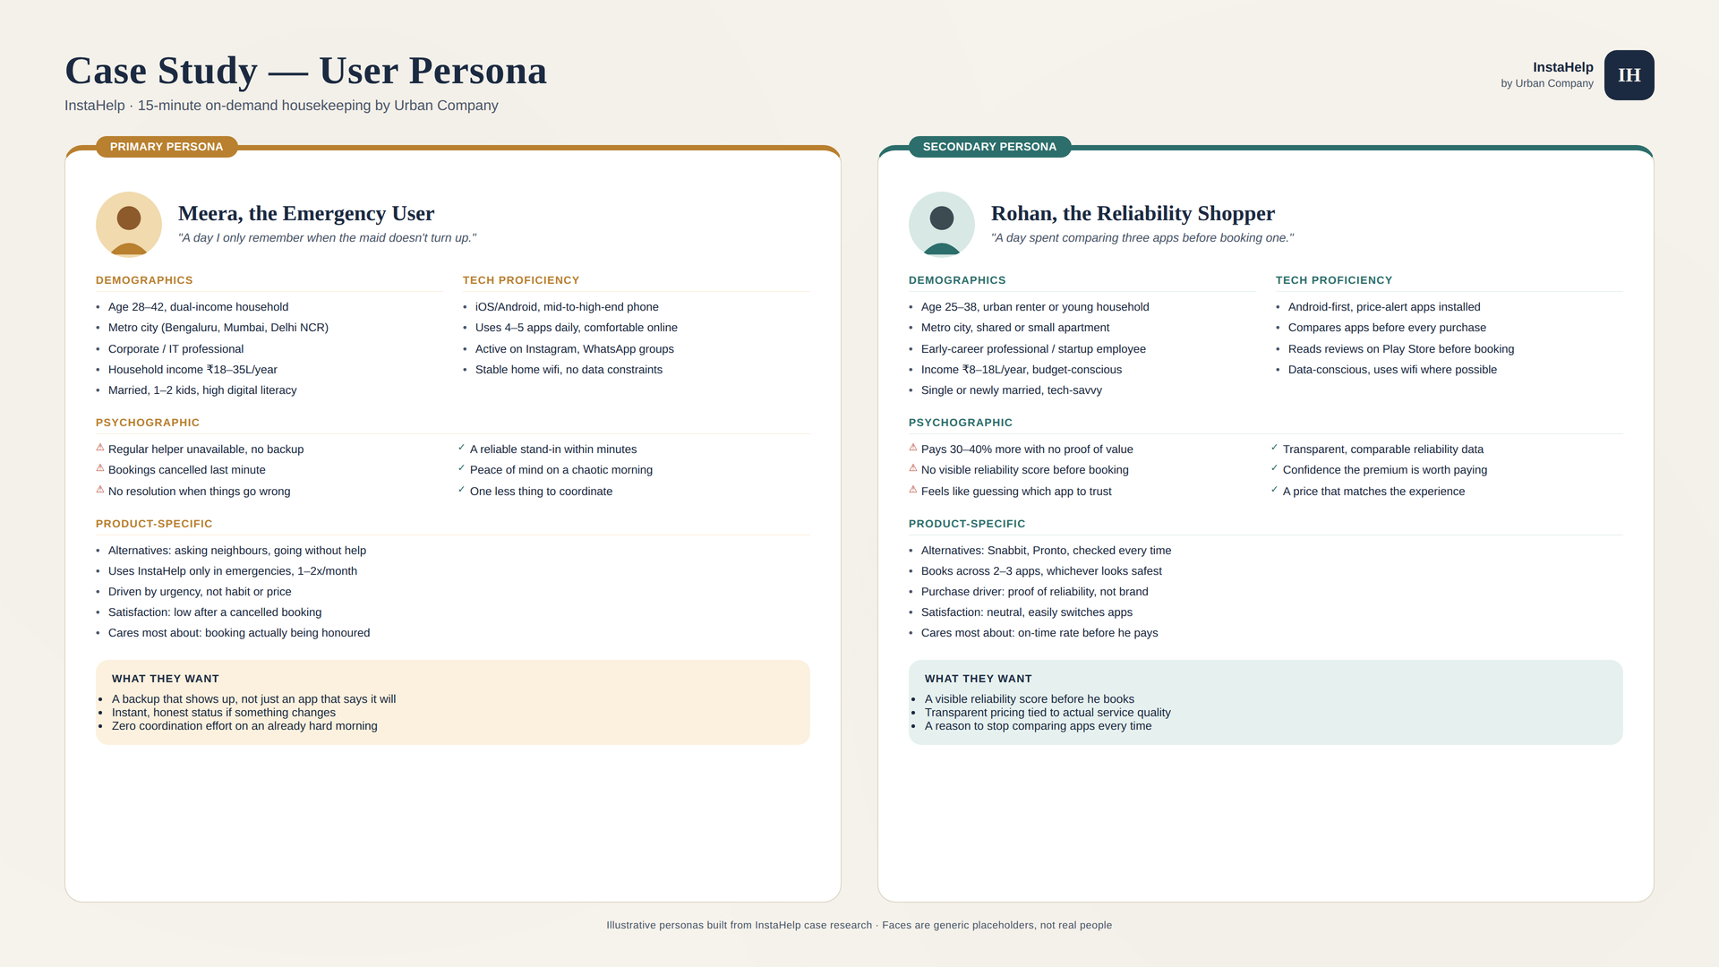

5. User Journey - Empathy Map
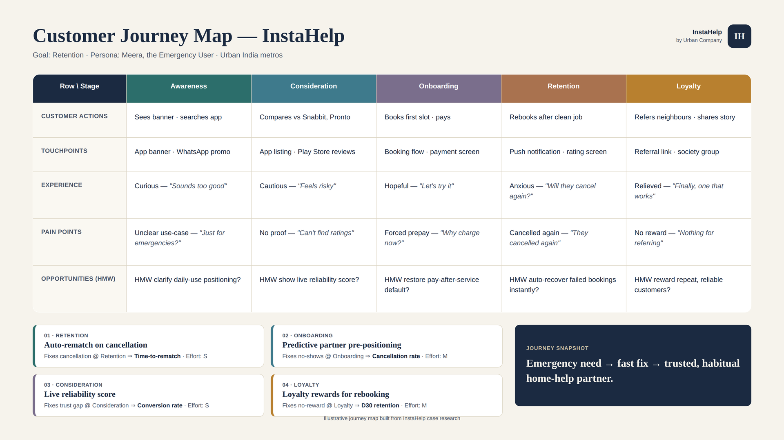

6. Solution options and prioritisation
- AI Real-Time Recovery — Automatically recover a booking when a professional cancels by finding an alternative professional without requiring the customer to rebook.
- Reliability-Tiered Subscription — Offer customers reliability-focused subscription plans with benefits tied to consistent service fulfillment and recovery.
- Partner Incentive & Reliability Model — Reduce partner cancellations by aligning partner incentives with booking acceptance, fulfillment, and reliability.
Competitor context: the direct competitors referenced in this PRD are Snabbit and Pronto, against whom InstaHelp carries a 30–40% price premium. A feature-by-feature competitor comparison is not included here and should be added from verified sources.

Opportunity / Solution | Reach (1–10) | Impact (0.25–3) | Confidence | Effort (person-months) | RICE Score | Priority
AI Real-Time Recovery | 8 | 3 | 80% | 3 | 6.4 | P0
Reliability-Tiered Subscription | 7 | 2 | 50% | 5 | 1.4 | P1
Partner Incentive & Reliability Model | 5 | 1 | 50% | 3 | 0.8 | P2
RICE Score = (Reach × Impact × Confidence) ÷ Effort. Reach is a 1–10 relative scale, Impact uses the standard 0.25–3 scale, Effort is in person-months. All inputs are team estimates (assumptions) and should be replaced with instrumented data. AI Real-Time Recovery ranks highest because it addresses both stated goals directly at the lowest effort.

7. FUNCTIONAL AND ACCEPTANCE CRITERIA / NON-FUNCTIONAL REQUIREMENTS
  - Functionals -

- Cancellation Detection — The system must detect when an assigned professional cancels an active booking before service starts.
- Automatic Booking Recovery — The system must automatically identify and assign an eligible alternative professional without requiring the customer to rebook.
- Failure Recovery & Customer Resolution — If no suitable replacement is available, the system must clearly notify the customer and provide an immediate resolution, such as cancellation and refund.
- Verified Completion — The system must not mark a booking complete unless service delivery is verified (for example, an OTP shared by the customer at the door). Bookings without verification must be flagged for review, not auto-completed.
- Human Handoff — When automated recovery cannot resolve a booking, the customer must be connected to a human support agent (for example, an instant call-back) instead of being returned to the chatbot.
- Partner Cancellation Capture — The system must record the reason and timing of every partner cancellation so patterns can be measured by city, service and partner cohort without lowering partner acceptance rate.

  - Non-functional requirement -

Performance | 95% of eligible cancellation events should trigger a recovery attempt within 30 seconds.
Quality | The recovery system should successfully recover ≥80% of eligible cancelled bookings, subject to professional availability.
Reliability | The recovery process should operate without requiring the customer to restart or manually recreate the booking.
Security | Customer and professional information used during recovery must be protected using Urban Company’s existing authentication, authorization, and data-security controls.
Transparency | Every cancellation, recovery attempt, reassignment, failure, and final booking outcome must be recorded in an auditable event log.
Usability | A customer should require no more than 2 interactions to accept or decline an available recovery option.
Acceptance criteria
- Rematch: Given an assigned professional cancels an active booking, when an eligible professional is available, then the booking is reassigned automatically within the original slot and the customer does not rebook or pay again.
- Speed: Given a cancellation event, then a recovery attempt starts within 30 seconds in at least 95% of eligible cases.
- No dead end: Given no eligible replacement exists, then the customer sees a clear message with an immediate refund option and a human-support option, reachable in no more than 2 interactions.
- Verified completion: Given a professional marks a job finished, when no OTP/verification was completed, then the booking stays open and is flagged for review.
- Audit trail: Given any cancellation, attempt, reassignment, failure or outcome, then it is written to the event log with a timestamp and booking ID.

8. MOCK-UP
Five mobile screens cover the recovery journey end to end. Source files (PNG and HTML) are in the repository under mobile screen/.
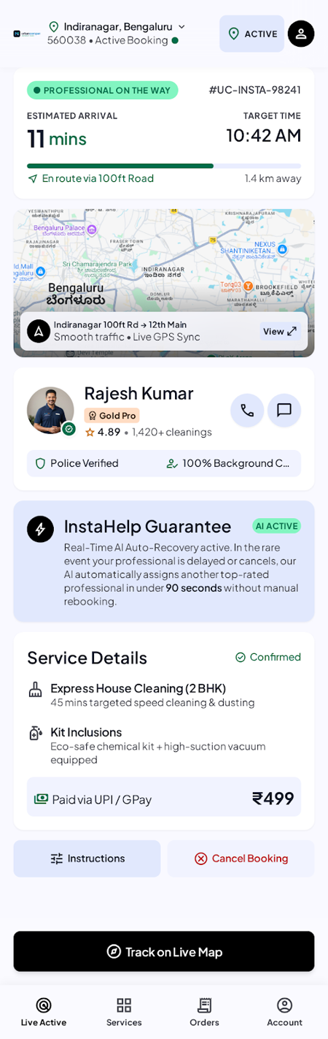  1. Booking confirmed | 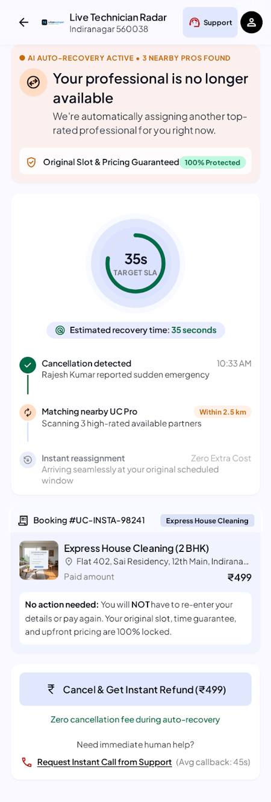  2. Auto-recovery in progress | 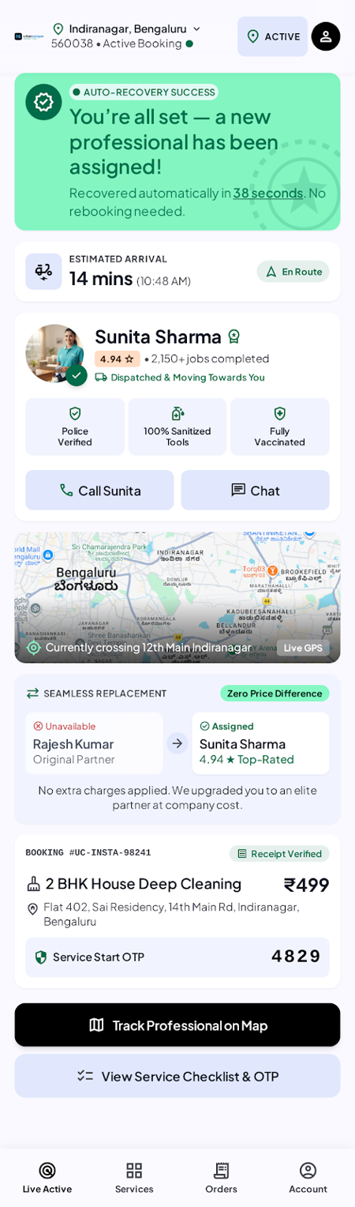  3. Booking recovered
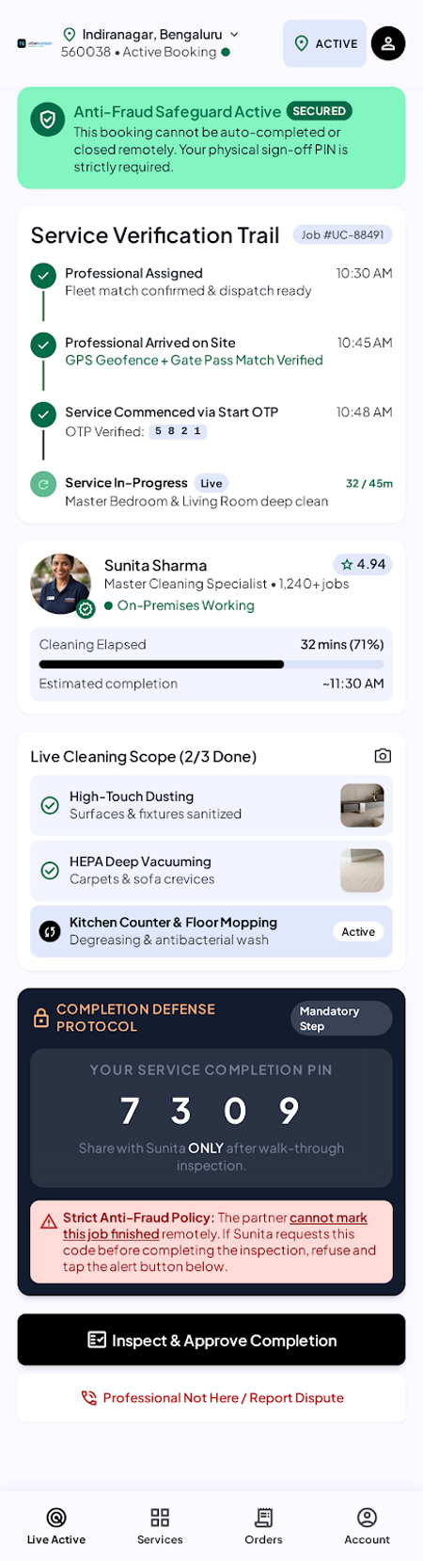  4. OTP verification | 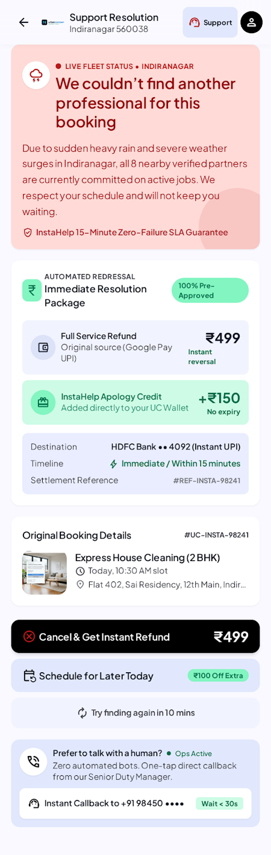  5. Recovery failed: refund

9. PROTOTYPE
The repository contains a mobile-first prototype built with Vite, HTML, CSS and JavaScript (src/main.js). It renders the “auto-recovery in progress” state: cancellation detected, nearby professionals being matched, original slot and price protected, and a refund / human-support fallback.
Current limitations: it is a single static screen with no state; buttons are not wired and booking data is hard-coded. The other four screens exist as design exports only.
Next step: a clickable flow across the five screens (recovery → recovered or failed → verification), using mock data to demonstrate each outcome in the acceptance criteria.
10. REPOSITORY AND DELIVERY
The PRD, design exports and prototype are published as a portfolio case study at github.com/vaswanipranjal/Instahelp-PRD.
- PRD.docx: this document
- README.md, context.md, plan.md, portfolio-summary.md: case-study narrative and plan
- mobile screen/: five Stitch screen exports and DESIGN.md
- src/, index.html, vite.config.js: runnable prototype (npm install, npm run dev)
11. ASSUMPTIONS AND OPEN QUESTIONS
- RICE inputs in section 6 are estimates, not measured data.
- Baselines for the L1 metrics are TBD until instrumented, as stated in section 3.
- The Q4 FY26 figures (₹447 loss per order; ₹9 Cr revenue; ₹119 Cr loss) and the 30–40% price premium need a cited source before this PRD is shared externally.
- The personas and journey map are illustrative, built from case research, and are not based on user interviews.
- Open: what should happen when the customer declines the offered replacement? What is the refund timeline? Which partner-side incentives or penalties apply after a cancellation?

