1. 2.
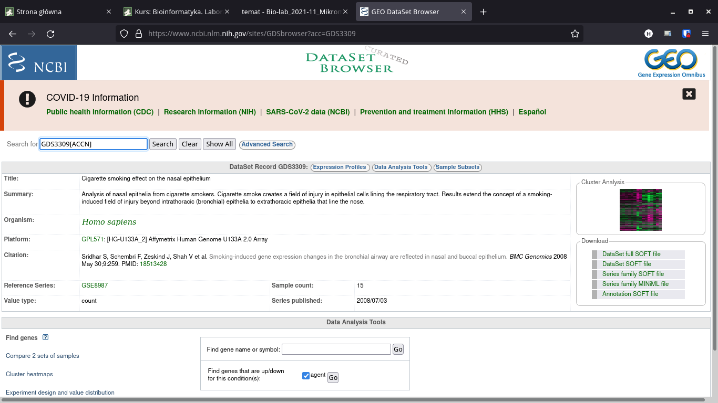
Tytuł: Cigarette smoking effect on the nasal epithelium

3.
Analyzes the expression level of 18,400 transcripts and variants, including 14,500 well-characterized human genes.
Sekwencje pochodziły z organizmu czlowieka.
Tabela Data table zawiera odnośniki do stron NCBI sekwencji.

4.
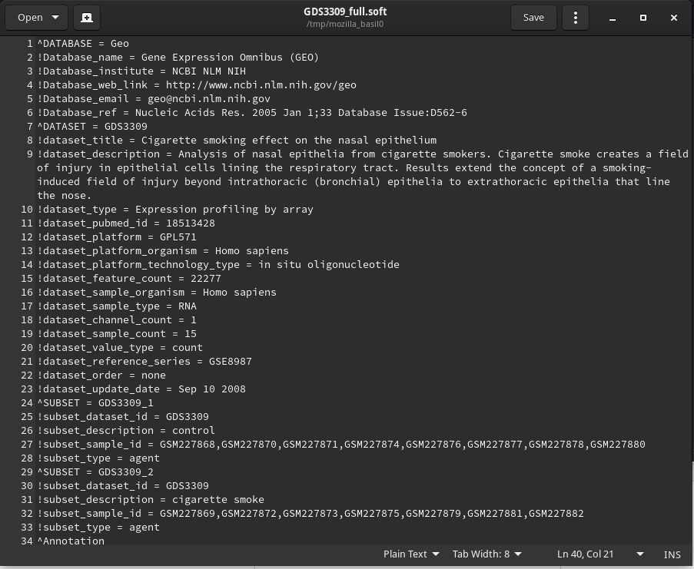

5.
Mamy 15 eksperymentów. Część dotyczy osób niepalących, część aktywnych palaczy.

6.
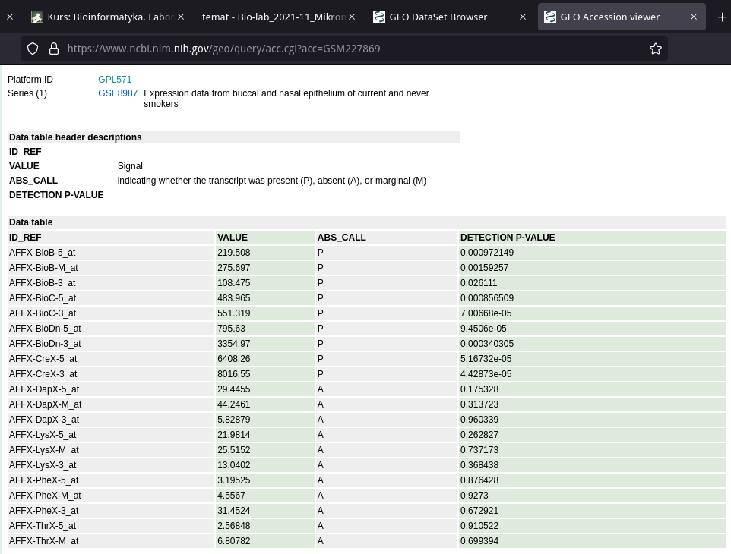
7.
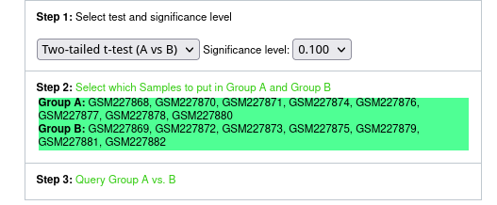
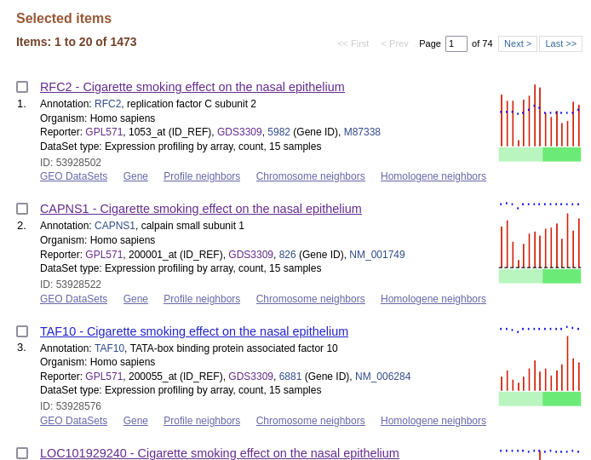
RFC2 replication factor C subunit 2 [ Homo sapiens (human) ] - This gene encodes a member of the activator 1 small subunits family.
CAPNS1 calpain small subunit 1 [ Homo sapiens (human) ] - This gene is a member of the calpain small subunit family. Calpains are calcium-dependent cysteine proteinases that are widely distributed in mammalian cells. Calpains operate as heterodimers, comprising a specific large catalytic subunit (calpain 1 subunit in Calpain I, and calpain 2 subunit in Calpain II), and a common small regulatory subunit encoded by this gene.

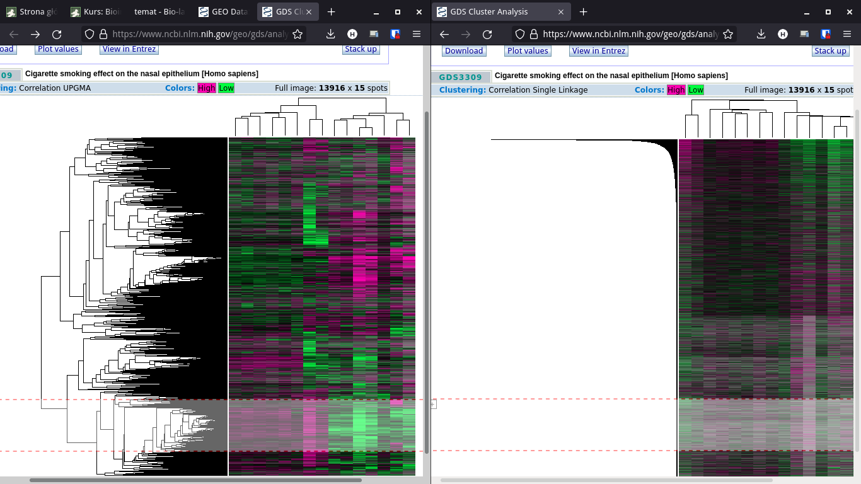
8.
a)

b)
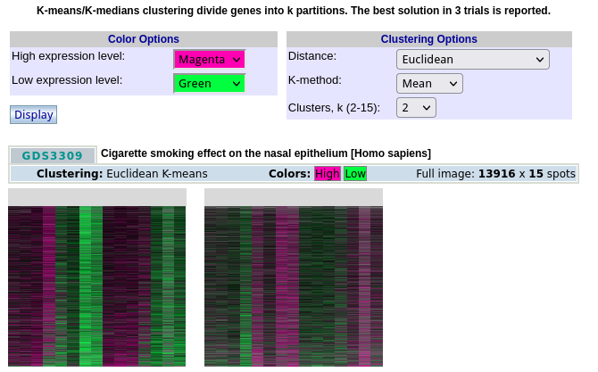
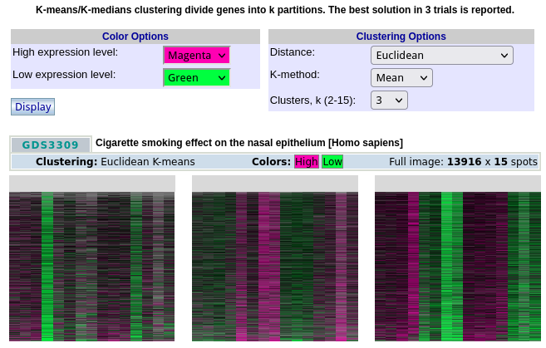

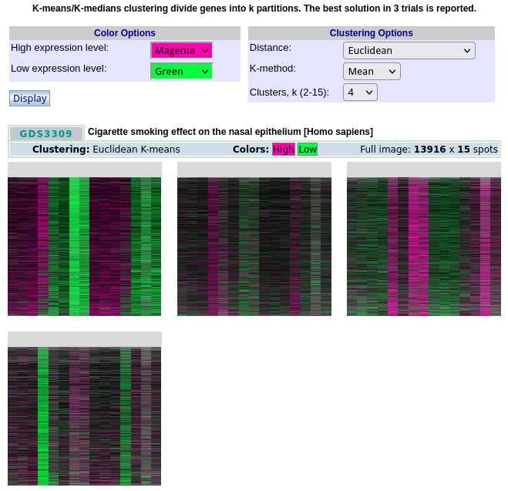
c)
