Progress Report
SAFE AI Evaluation and Portfolio Optimization
Steps 10c and 10h

Anila Vata
MSc Quantitative Finance
University of Pavia
Supervisor: Prof. Paolo Giudici
June 2026

Section 1 — Step 10c: SAFE–performance frontier (50×3 configurations)
1.1 What this step does and why
Step 10c runs the full portfolio optimisation pipeline across 150 model configurations — 50 per model family — and records both the SAFE compliance score and the portfolio performance metrics for each one. Three configurations per family were enough to verify that the frontier exists, but not enough to test statistically whether compliance predicts performance or to find Pareto-dominant points.
1.2 Grid construction
The Ridge grid varies the regularisation parameter α across 50 values on a log scale from 10⁻⁴ to 10⁴. Log spacing is used because the coefficient structure changes slowly at very small α and changes rapidly near the transition zone, so equal spacing on the log scale gives more resolution where it matters.

The XGBoost grid draws 50 configurations by random search with seed 42. The parameters and their ranges are:

1. max_depth ∈ {2, 3, 4, 5, 6, 8}
2. learning_rate ∈ {0.005, 0.01, 0.03, 0.05, 0.1, 0.15}
3. n_estimators ∈ {50, 100, 150, 200, 300, 500}
4. subsample ∈ {0.6, 0.8, 1.0}
5. colsample_bytree ∈ {0.6, 0.8, 1.0}
6. reg_alpha ∈ {0.0, 0.01, 0.1, 1.0}
7. reg_lambda ∈ {0.1, 1.0, 5.0, 10.0}

The MLP grid also draws 50 configurations by random search with seed 42. The parameters sampled are:

1. Hidden layer architecture (1–3 layers, widths from 32 to 256 neurons)
2. L2 penalty α ∈ {0.0001, 0.001, 0.01, 0.1}
3. Initial learning rate ∈ {0.0001, 0.0005, 0.001, 0.005}
4. Batch size ∈ {64, 128, 256}

Activation function and solver are fixed for MLP. All 150 configurations share the same portfolio settings: SAFE weight λ = 1.0, top-K = 10, weight bounds [1%, 20%], sector cap 30%, Gurobi solver.
1.3 Compliance score calculation
The compliance score (CS) aggregates the four SAFE dimensions — RGA, RGR, RGE*, RGF* — into one number. Three aggregation methods are used in parallel because the choice between them is a normative one, and I want conclusions that hold across all three.

1. Arithmetic mean: the straight average of the four dimension scores. A weakness on one dimension can be offset by strength on another.
2. Geometric mean: the fourth root of the product of the four scores. A single dimension score near zero pulls the whole CS close to zero, so no dimension can be ignored.
3. Root-mean-square: penalises configurations whose four scores are uneven, even if their arithmetic mean is high.
1.4 xgboost_47: the Pareto-dominant configuration
Configuration xgboost_47 (max_depth = 5, learning_rate = 0.15, n_estimators = 500, subsample = 0.6, colsample_bytree = 0.6) achieves CS = 0.629 (arithmetic), Sharpe = 1.812, MaxDD = 16.3%, and Sortino = 2.599. No other configuration in the 150-point grid has a higher compliance score without also having a lower Sharpe. It is therefore strictly Pareto-dominant in the CS–Sharpe plane.

Its one weakness is turnover. Average monthly rebalancing is 92.0%, the highest in the sample. In a high-transaction-cost setting this must be factored into any net-of-cost performance comparison.

Config ID | Family | Key parameters | CS arith | Sharpe | Max DD | Avg TO | Sortino
xgboost_47 | XGBoost | md=5, lr=0.15, ne=500,  ss=0.6, cb=0.6 | 0.629 | 1.812 | 16.3% | 92.0% | 2.599
xgboost_43 | XGBoost | md=5, lr=0.05, ne=500,  ss=0.8, cb=0.6 | 0.613 | 1.601 | 18.4% | 86.2% | 2.341
xgboost_14 | XGBoost | md=6, lr=0.15, ne=150,  ss=1.0, cb=0.6 | 0.618 | 1.321 | 18.0% | 89.6% | 2.033
xgboost_46 | XGBoost | md=5, lr=0.1, ne=300,  ss=1.0, cb=1.0 | 0.617 | 0.809 | 18.1% | 90.6% | 1.212
ridge_01 | Ridge | α = 0.0001 | 0.549 | 0.635 | 22.5% | 79.9% | 0.821
mlp_15 | MLP | layers=(64,32),  α=0.0001, lr=0.001 | 0.607 | 0.498 | 17.4% | 96.7% | 0.701
mlp_06 | MLP | layers=(64,32),  α=0.001, lr=0.0001 | 0.607 | 0.496 | 23.2% | 95.6% | 0.723

Table 1. Selected configurations from the 150-point frontier. xgboost_47 is Pareto-dominant on CS and Sharpe. md = max_depth, lr = learning_rate, ne = n_estimators, ss = subsample, cb = colsample_bytree. Max DD and Avg TO expressed as percentages.

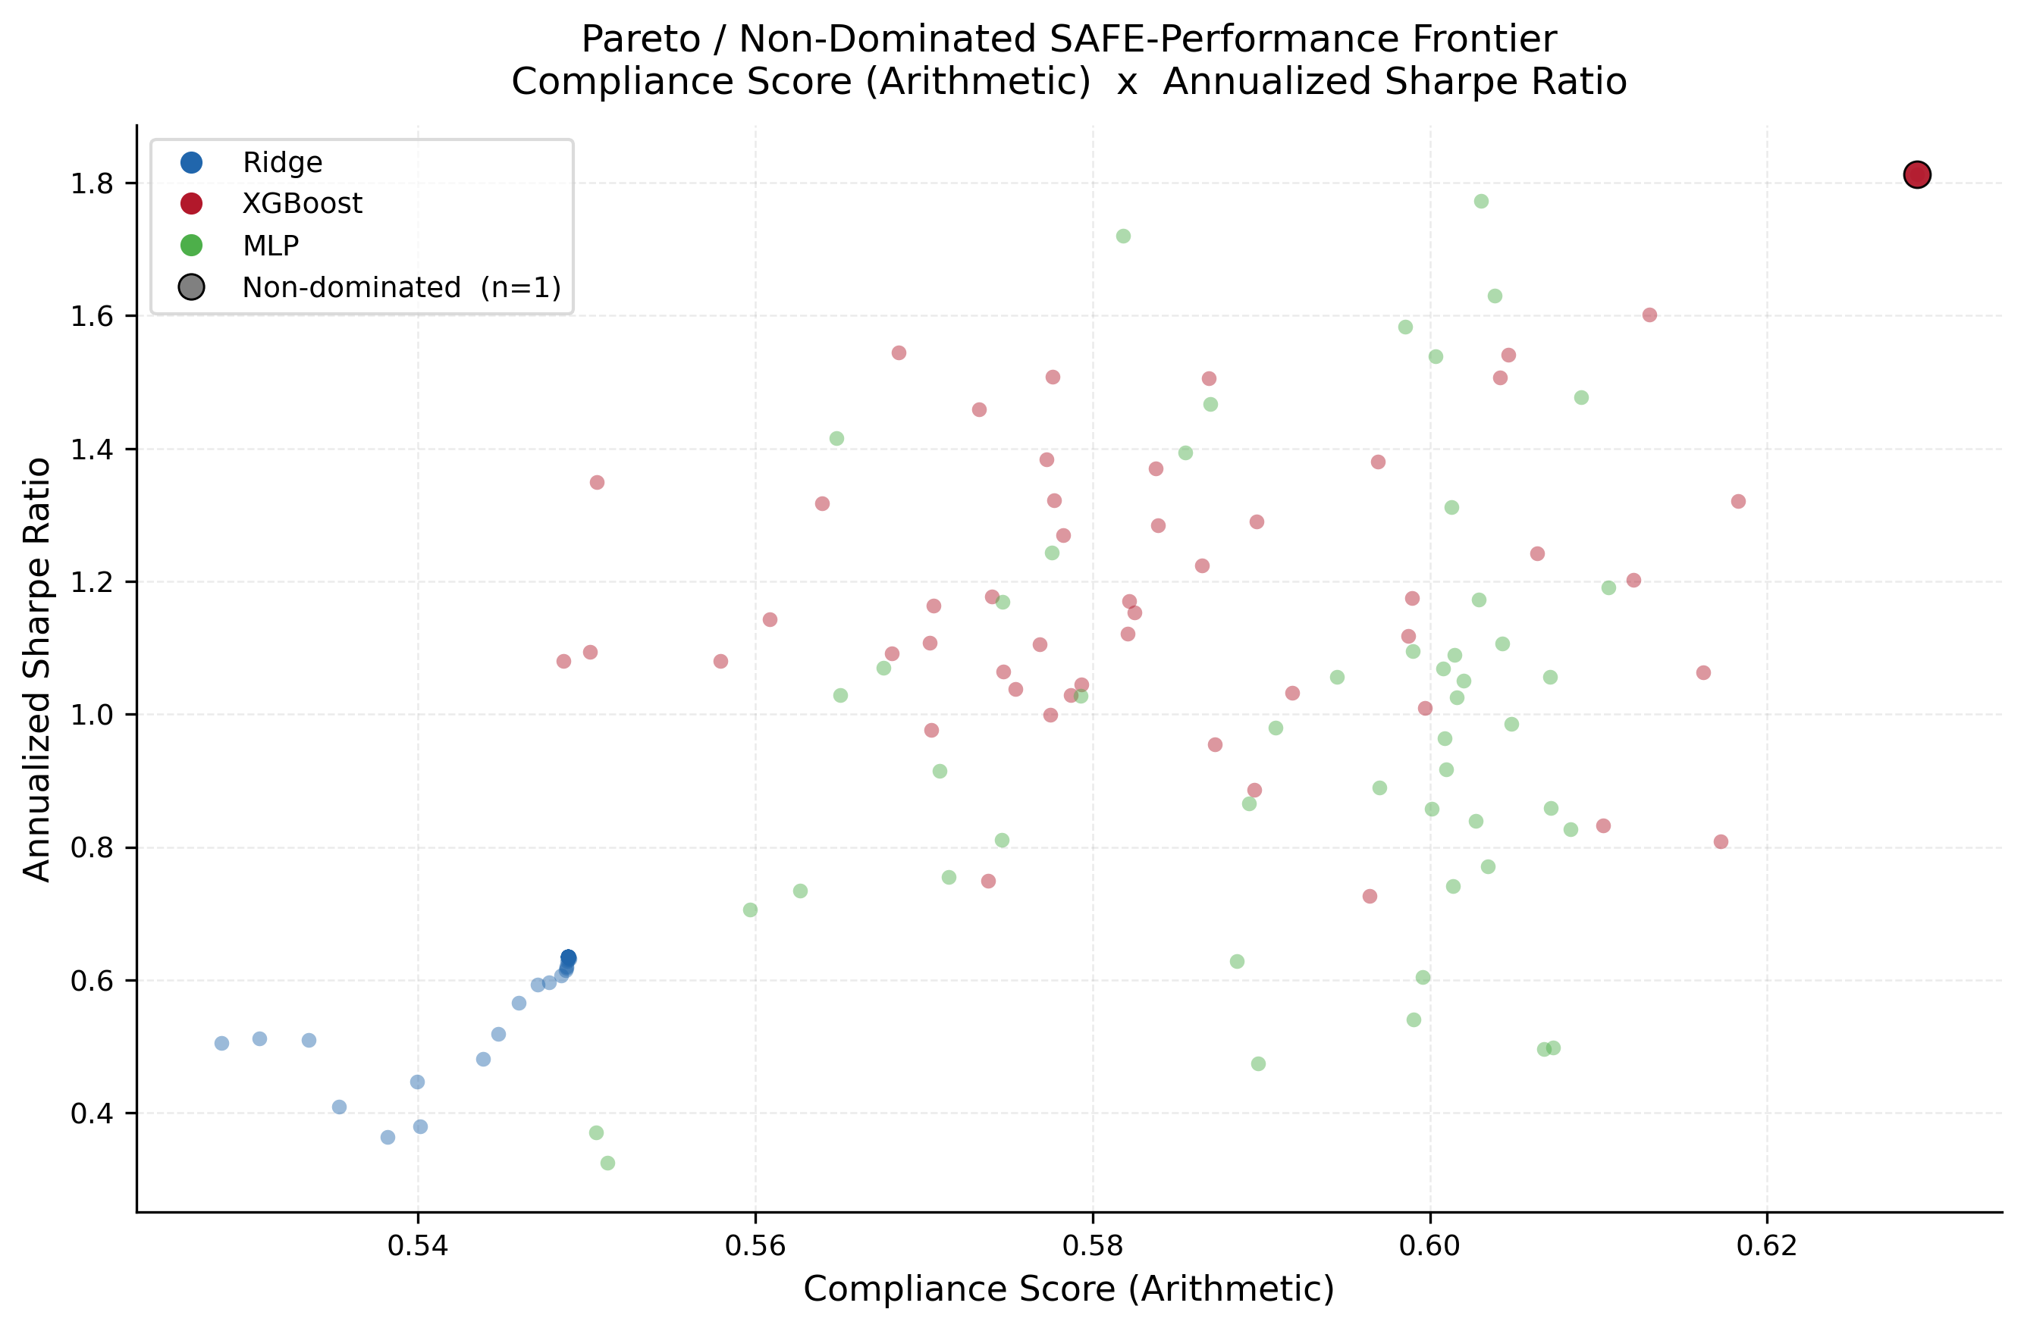
Figure 1. Pareto frontier in the compliance score (arithmetic)–Sharpe plane across 150 configurations. xgboost_47 is the Pareto-dominant point.

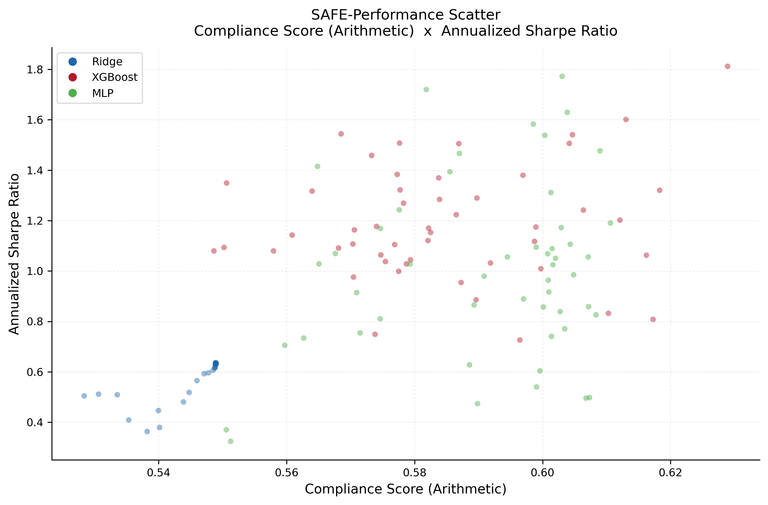
Figure 2. Scatter of compliance score (arithmetic) vs Sharpe ratio for all 150 configurations. Colour indicates model family.

Section 2 — Step 10h: SAFE–performance scatter analysis
2.1 What the analysis does
Step 10h tests whether the compliance score is statistically associated with portfolio performance across the 150-configuration frontier. For each combination of compliance type (arithmetic, geometric, RMS) and performance metric (Sharpe, maximum drawdown, average turnover), the analysis computes a Spearman rank correlation — both pooled across all 150 configurations and separately within each model family. Each scatter plot adds a LOWESS curve to show the conditional mean trend without assuming linearity.
2.2 Sharpe ratio
2.2.1 Pooled result
Pooled across all 150 configurations, higher compliance is associated with higher Sharpe: ρ = 0.597 (arithmetic, p < 0.001), ρ = 0.618 (geometric, p < 0.001), ρ = 0.417 (RMS, p < 0.001). The relationship is moderate to strong and holds across all three aggregation methods. This is the main headline result.
2.2.2 Within-family results
The pooled correlation is driven by the gap between model families, not by variation within them. XGBoost configurations dominate Ridge and MLP on both CS and Sharpe simultaneously, which inflates the pooled number. Within XGBoost, ρ = 0.090 (p = 0.537, not significant). Within MLP, ρ = 0.152 (p = 0.291, not significant). Within Ridge, ρ = 0.498 (p < 0.001, significant), but this reflects the regularisation path rather than a clean compliance–return relationship. For a practitioner choosing among configurations of the same model family, compliance score alone does not reliably predict which will deliver a higher Sharpe.
2.3 Maximum drawdown
2.3.1 Pooled result
Pooled, the compliance–drawdown correlation is negative and significant: ρ = −0.350 (arithmetic, p < 0.001). A negative value is the right direction: higher compliance goes with lower drawdown. The magnitude is weaker than the Sharpe result.
2.3.2 The Ridge anomaly
Within Ridge the correlation is positive: ρ = +0.393 (p = 0.005). This is an artefact of the regularisation path. At high α, Ridge shrinks all coefficients towards zero, making the ranking nearly uniform across stocks. A uniform ranking scores well on robustness and fairness because there is no cross-group variation to flag, but it also loses predictive power, so drawdown increases. This is not a genuine alignment between compliance and risk control.

Within MLP, ρ = −0.543 (p < 0.001) — the strongest within-family result in the analysis. More compliant MLP configurations genuinely achieve lower drawdowns. Within XGBoost, ρ = −0.248 (p = 0.082), negative in direction but not significant.
2.4 Average turnover
2.4.1 Pooled result
Pooled, compliance and turnover are strongly and positively correlated: ρ = 0.611 (arithmetic, p < 0.001), ρ = 0.598 (geometric), ρ = 0.669 (RMS). Higher compliance comes with more frequent rebalancing. This is the main practical trade-off: better fairness and robustness properties cost more in transaction frequency.
2.4.2 Within-family results
Within XGBoost, the trade-off is the sharpest in the sample: ρ = 0.779 (arithmetic, p < 0.001), ρ = 0.836 (geometric). The configurations that score highest on compliance within XGBoost are the most aggressive rebalancers. Within MLP the same direction holds: ρ = 0.772 (arithmetic, p < 0.001). Within Ridge, the sign reverses (ρ = −0.339, p = 0.016) because heavy regularisation simultaneously reduces turnover and inflates some SAFE scores mechanically.
2.5 Summary of results
Table 2 summarises the Spearman rank correlations for arithmetic CS.

Performance metric | Pooled ρ | Sig. | Ridge ρ | Sig. | XGBoost ρ | Sig. | MLP ρ | Sig.
Sharpe | +0.597 | *** | +0.498 | *** | +0.090 | n.s. | +0.152 | n.s.
Max DD | −0.350 | *** | +0.393 | ** | −0.248 | n.s. | −0.543 | ***
Avg TO | +0.611 | *** | −0.339 | * | +0.779 | *** | +0.772 | ***

Table 2. Spearman rank correlations between compliance score (arithmetic) and performance metrics, pooled and by model family (n = 150 pooled, n = 50 per family). *** p < 0.001, ** p < 0.01, * p < 0.05, n.s. not significant. For Max DD, a negative ρ means higher compliance → lower drawdown.

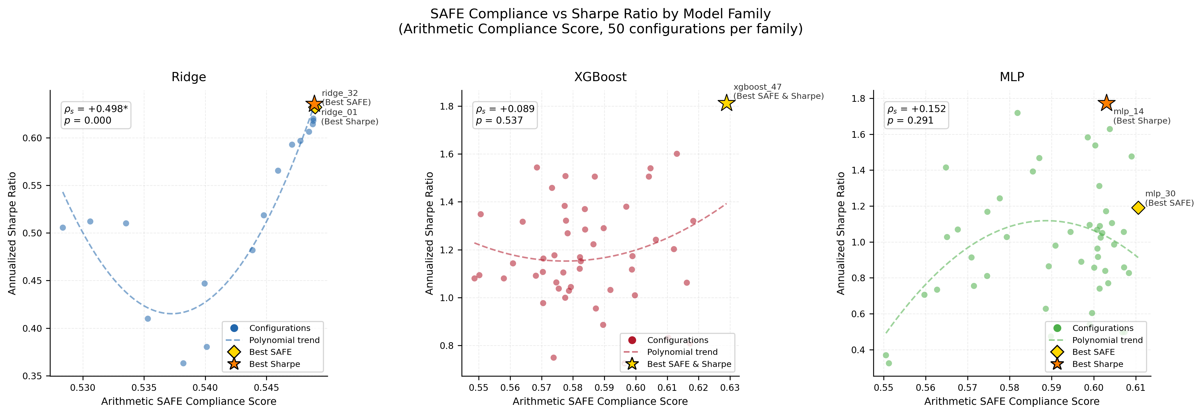
Figure 3. Compliance score (arithmetic) vs Sharpe ratio by model family. LOWESS curves fitted separately per family.

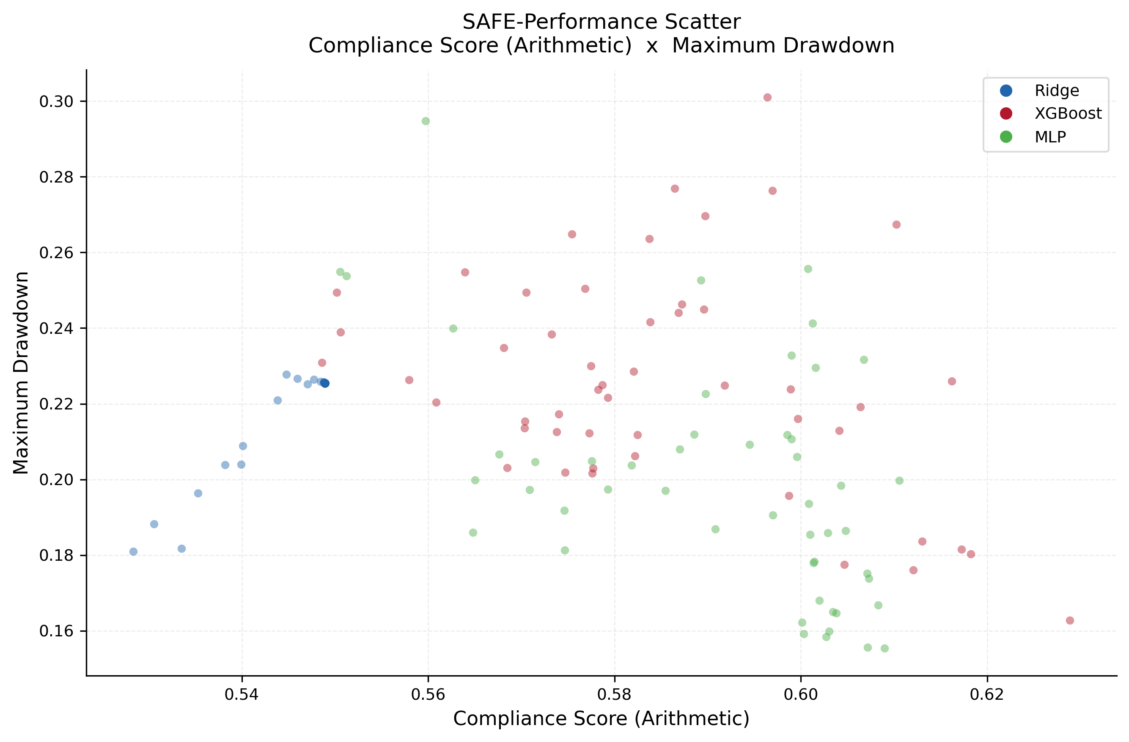
Figure 4. Compliance score (arithmetic) vs maximum drawdown for all 150 configurations.

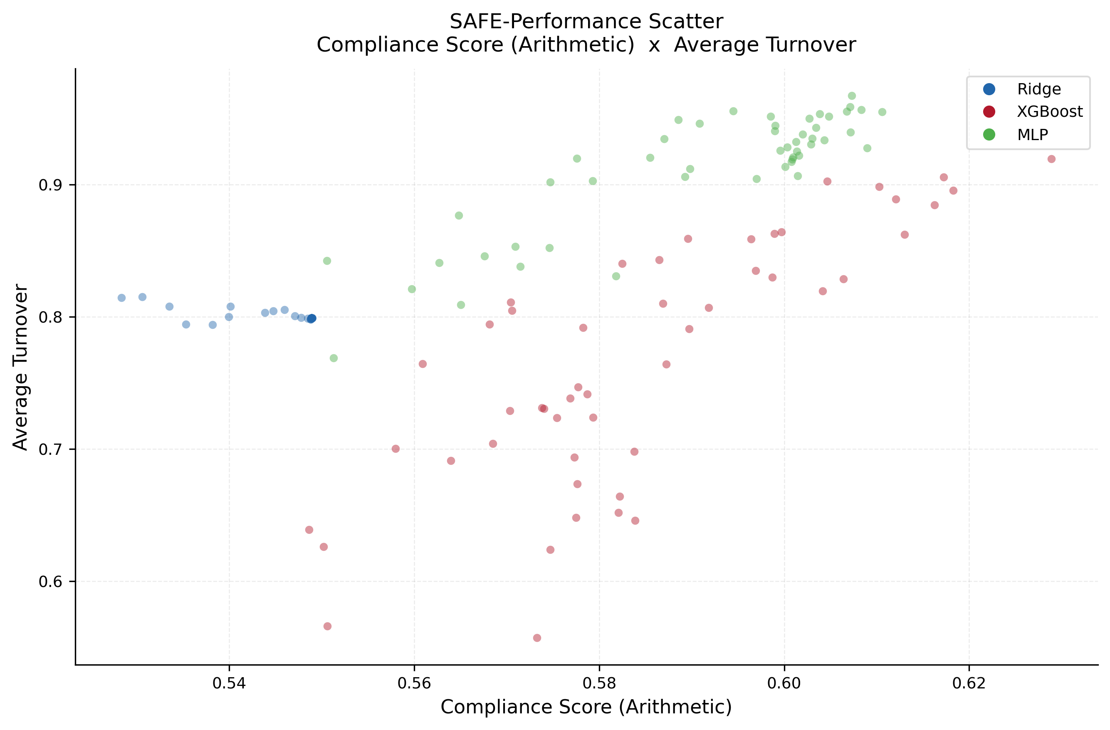
Figure 5. Compliance score (arithmetic) vs average turnover for all 150 configurations.
2.6 What the results mean
Three findings summarise the analysis:

1. The pooled compliance–Sharpe correlation (ρ = 0.597) shows that SAFE-compliant models tend to produce better-performing portfolios when comparing across model families. Designing a model to be fairer and more robust does not come at a systematic cost in risk-adjusted return.

2. Within a model family, compliance score is not a reliable predictor of Sharpe ratio. The within-XGBoost and within-MLP correlations are not statistically significant. A practitioner cannot pick a better-performing configuration simply by choosing the one with the highest SAFE score within a given family.

3. The compliance–turnover trade-off is real and consistent. Higher compliance goes with higher rebalancing frequency for both XGBoost (ρ = 0.779) and MLP (ρ = 0.772). Whether this is acceptable depends on the transaction cost environment.

xgboost_47 is the recommended configuration for deployment. It is Pareto-dominant on compliance and gross Sharpe, achieves the lowest drawdown within the XGBoost family, and its compliance advantage is consistent across all three aggregation methods (CS arith = 0.629, CS geom = 0.528, CS RMS = 0.661). Its high turnover should be accounted for in any cost-adjusted evaluation.

