F\* ---------

- ----------

--------

------

->

p ->whole -> x= $t^{k}$- k=commonZ(e,i)

whole->

->whole->

*🡪*

*C - >W, pos ,f->sin(x)=t*

*S ->W,pos ,f ->cos(x)=t*

*C and s -> W,not neg ,z-> ${cos⁡(x)}^{2}=\frac{1+cos⁡(2x)}{2} ,{ sin⁡(x)}^{2}=\frac{1-cos⁡(2x)}{2}$*

*C+S ->W , neg ,z ->tg(x)=t*

**

*If ()*

*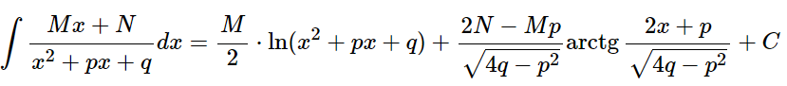*

**

**

**

длину кривой *:*

**

**

**