**About me**

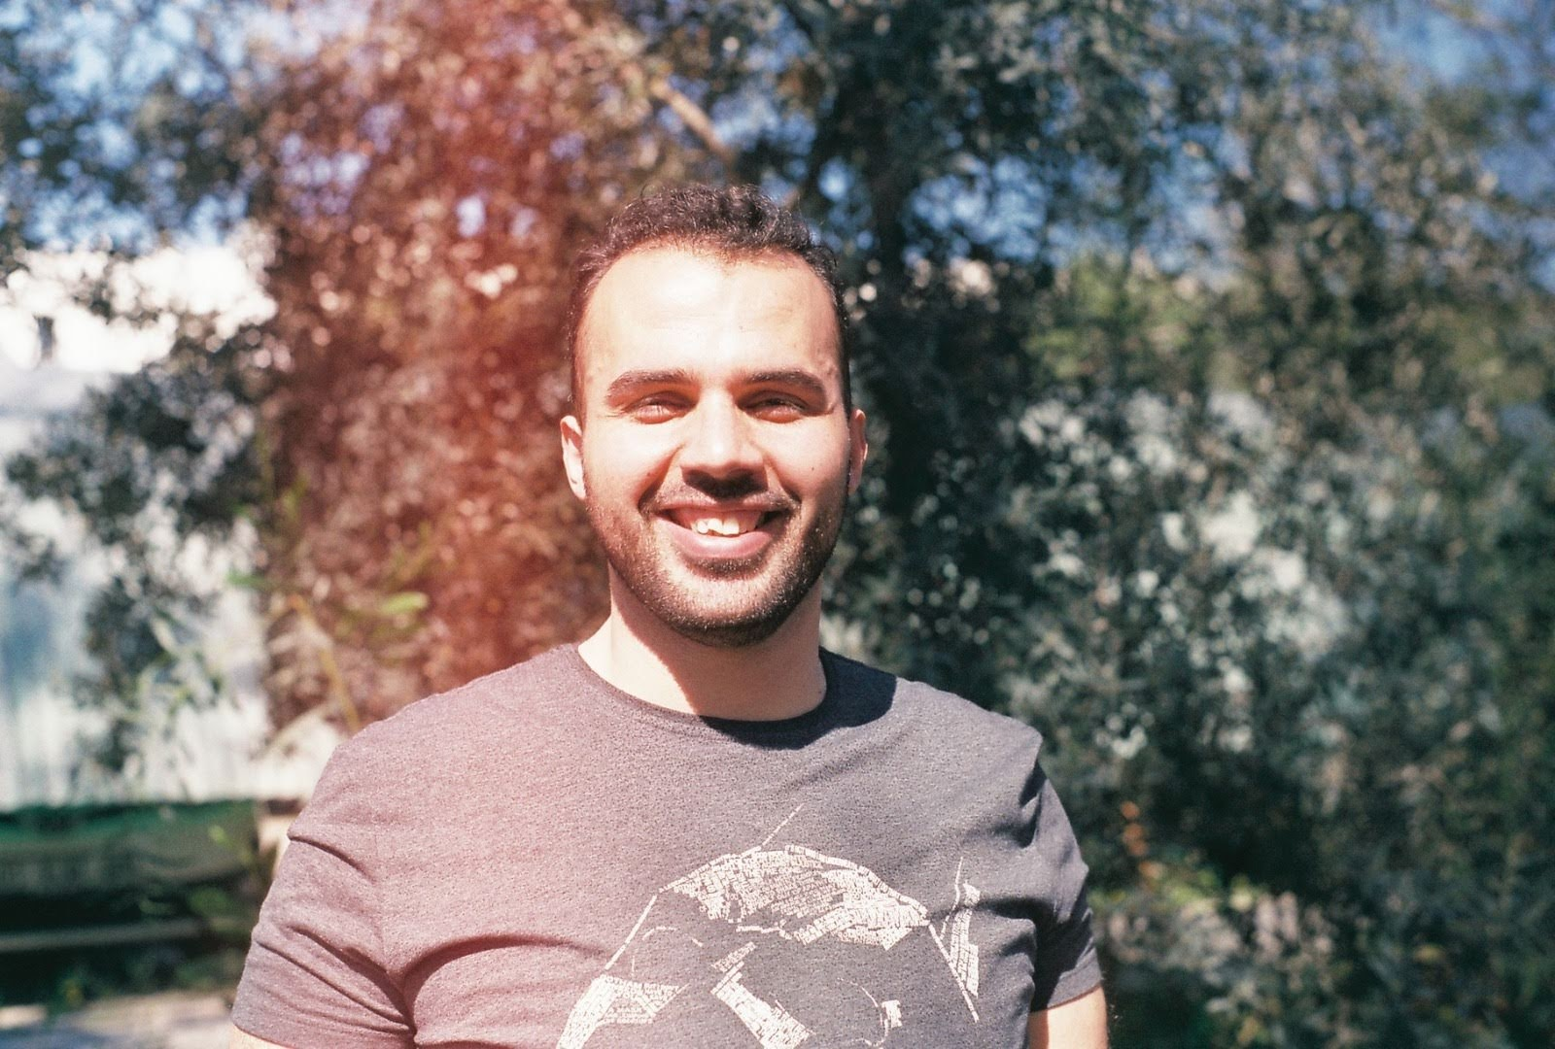

**VATAN** **OZCELIK**

COMPUTER ENGINEER

CONTACT INFORMATION

vatanozcelik91@gmail.com

+90 531 321 3889

Seyhan/ADANA

Linkedin.com/in/vatanozcelik

SKILLS

C

Java

Python

HTML5

CSS3

Microsoft word

Decision making

Teamwork

Leadership

Adaptability

LANGUAGES

Turkish

Arabic

English

German

Detail-oriented, accurate and analytical mathematician with strong grasp in computational techniques, algorithms and mathematical theory. Armed with these skills, my aim is to contribute to the resolution of the economic, engineering and business problems of the company.

**WORK EXPERIENCES**

**COMPUTER NETWORKS/INTERNSHIP**

Company / Ankara, TURKEY / June 2020 – September 2020

Website: http://sistekltd.com/contact.html

Email: info@sistekltd.com

* Automatic terminal information service, or ATIS, is a continuous broadcast of recorded aeronautical information in busier terminal areas, i.e. airports and their immediate surroundings. ATIS broadcasts contain essential information, such as current weather information, active runways, available approaches, and any other information required by the pilots.
* Successfully installed Linux servers and virtualized environments using Hyper-V, and Amazon Web Services
* Designed and implemented streamlining high-server traffic resource configuration and allocate ion

**COMPUTER TECHNICIAN AND REPAIRMAN/INTERNSHIP**

E-Commerce Agency / Samandağ,HATAY / June 2013 – August 2013

* Responsibility to repair costumers computers and selling some computer’s stuff.

**EDUCATION**

**Computer engineering**

September 2014 – June 2020

Cukurova University Seyhan, ADANA

**Computer technology**

September 2012 – June 2014

Adiyaman University Besni, ADIYAMAN

**Electrical Electronics Technician**

September 2006- June 2010

Samandag Technical and Industrial Vocational High School, HATAY

**HOBBIES**

Books Movies Travel

Kickboxing Football Table tennis

Music Laugh Dancing