**WORK EXPERIENCES**

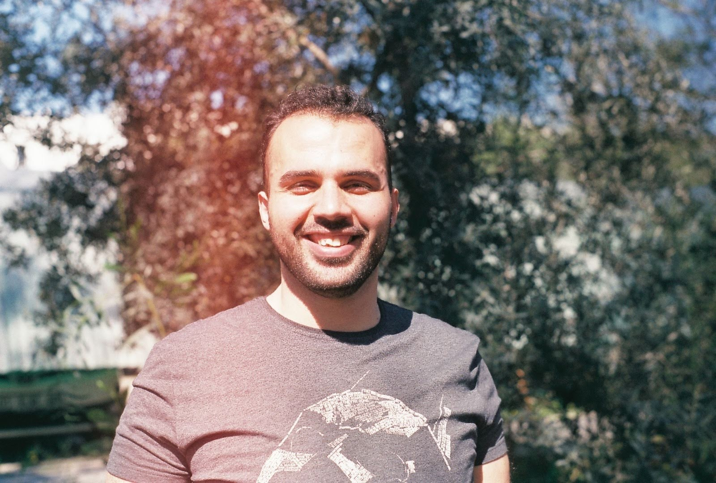

**VATAN** **OZCELIK**

Waiter

CONTACT INFORMATION

vatanozcelik91@gmail.com

+90 531 321 3889

sadadsadsadasdadsdadasdasdadsdadsadsads

SKILLS

Table service

Costumer service

Cash handling

Multi tasking

Food safety

Patience

Decision making

Teamwork

Leadership

Adaptability

LANGUAGES

Turkish

Arabic

English

German

**Server assistant & waiter (ala carte restaurant)/parkim ayaz hotel (Bodrum/TURKEY) start from 2010 to 2015**

• Take orders from and serve food and beverages to patrons.

• Perform consistent check-ins with patrons to ensure satisfaction and address complaints swiftly.

• Answer questions about the menu and make recommendations when appropriate or requested.

• Prepare appetizers, salads, and cold dishes.

• Assist a team of hosts and hostesses by greeting, seating, and thanking customers.

• Communicate with kitchen staff directly and via computers.

**Waiter ( main restaurant )/ Delta Beach Hotel (Mugla/TURKEY)**

• Cleaned tables, removed dirty dishes, and replaced table linens.

• Replenished clean linens, glassware, silverware, and dishes.

• Supplied service staff with food.

• Served patrons with water, coffee, and condiments.

• Cleaned and polished furniture, shelves, walls, and equipment.

• Stocked refrigerators with bottled beer and wines.

**Waiter ( main restaurant ) / Side Star Resort Hotel (Antalya/TURKEY)**

• Cleaned tables, removed dirty dishes, and replaced table linens.

• Replenished clean linens, glassware, silverware, and dishes.

• Supplied service staff with food.

• Served patrons with water, coffee, and condiments.

• Cleaned and polished furniture, shelves, walls, and equipment.

**Waiter ( fish & mexican restaurant ) / Turan Prens Hotel (Antalya/TURKEY)**

• Answer questions about the menu and make recommendations when appropriate or requested.

• Prepare appetizers, salads, and cold dishes.

• Assist a team of hosts and hostesses by greeting, seating, and thanking customers.

• Communicate with kitchen staff directly and via computers.

**EDUCATION**

**Computer engineering / Bachelor’s Degree**

September 2014 – June 2020

Cukurova University Seyhan, ADANA

**Computer technology / Bachelor’s Degree**

September 2012 – June 2014

Adiyaman University, Besni/ ADIYAMAN

**Electrical Electronics Technician / High School**

September 2006- June 2010

Electrical & Electronic Technology, Samandag/ HATAY

**HOBBIES**

Books Movies Travel

Kickboxing Football Table tennis