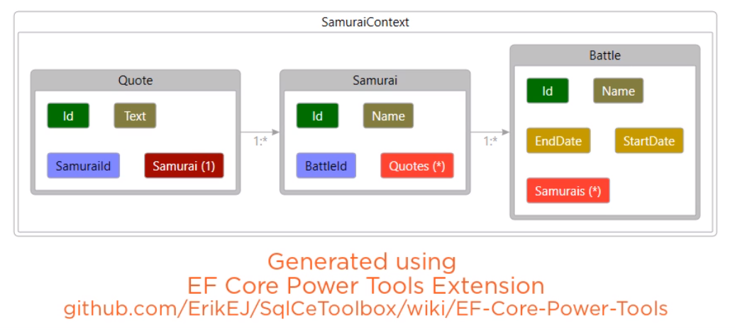

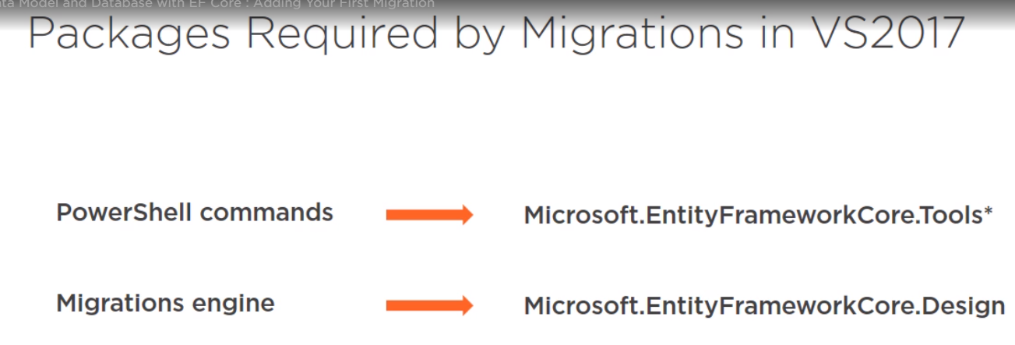

Get-help migration

Add-Migration Function EntityFrameworkCore Adds a new migration.

Update database : will update db based on latest migration.