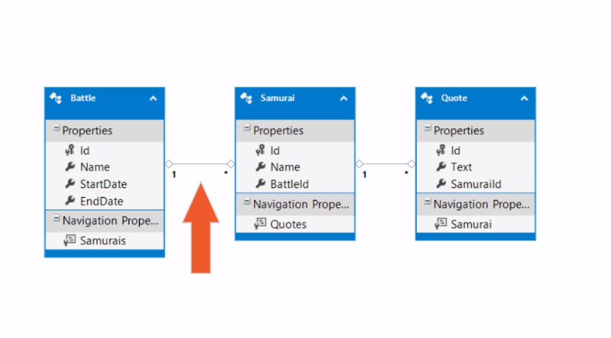

Powershell database commands:

Script-migration: will create schema sql script.

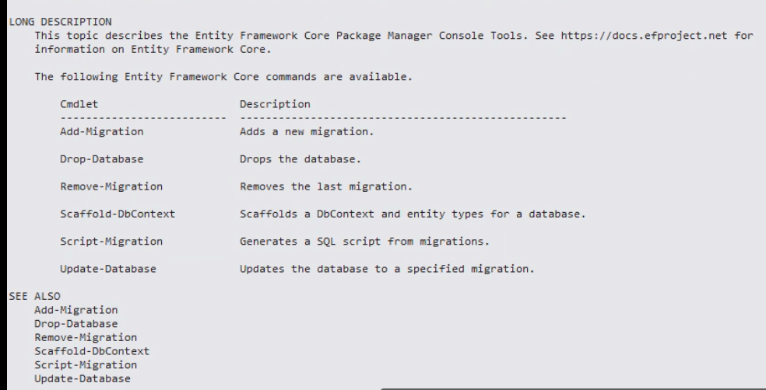

Resources:

* Create db diagram in ssms

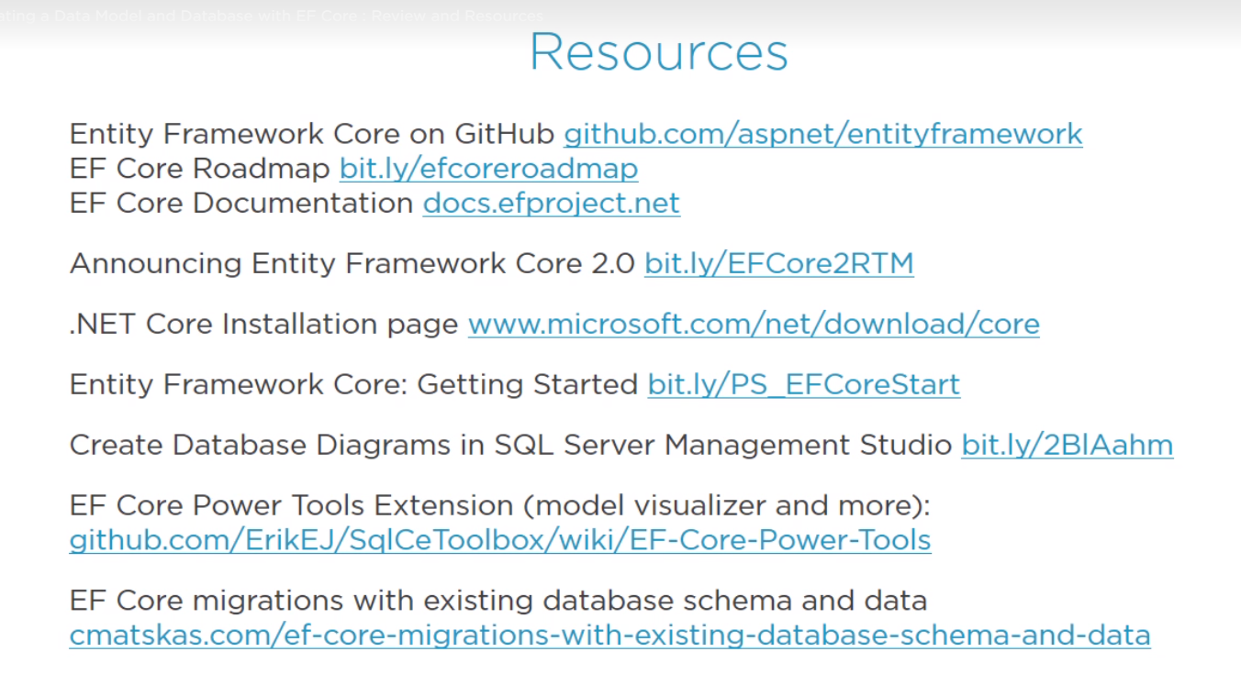

Logging extension linq to sql: microsoft.extensions.logging.console

Batch Operation Batch Size:

