MINI PROJECT
EX. NO: 14 BIKE SHARING AND URBAN MOBILITY
DATE: 08.10.2026
Aim
To develop a Bike Sharing and Urban Mobility analysis system using SQL and PL/SQL to store, manage, and analyze hourly bike rental records to examine rental demand by season, hour, weather, and user category.
Software Used
- GitHub Codespaces
- SQLite
- Oracle Database
- SQL
- PL/SQL
Description
The Bike Sharing and Urban Mobility analysis system is developed to examine hourly bike rental demand across seasons, hours of the day, weather conditions, and user categories. The system stores the rental date, season, rental hour, weather condition, temperature, casual user rentals, registered user rentals, and total rentals.
SQL queries are used to retrieve and analyze rental information, while PL/SQL functions and procedures are used to classify rental demand as Low, Moderate, or High, retrieve rental statistics for a selected date and hour, generate a seasonal and hourly demand report, and handle exceptions.
Dataset Source
- Dataset: UCI Bike Sharing Dataset (file: hour.csv)
- Author: Hadi Fanaee-T and Joao Gama, UCI Machine Learning Repository
- URL: https://archive.ics.uci.edu/dataset/275/bike+sharing+dataset
- Records used: 25 hourly records from 2011 (all 4 seasons and all 4 weather conditions)
- Added field: RECORD_ID (record number 1 to 25 used as the primary key)
- Temperature values (normalized between 0 and 1) were kept to 2 decimal places to match the NUMBER(3,2) data type.
Database Table
BIKE_SHARING
Column Name | Data Type | Constraint
RECORD_ID | NUMBER(5) | PRIMARY KEY
RENTAL_DATE | DATE | NOT NULL
SEASON | NUMBER(1) | NOT NULL, 1 to 4
RENTAL_HOUR | NUMBER(2) | NOT NULL, 0 to 23
WEATHER | NUMBER(1) | NOT NULL, 1 to 4
TEMP | NUMBER(3,2) | NOT NULL, 0 to 1
CASUAL | NUMBER(5) | NOT NULL, >= 0
REGISTERED | NUMBER(5) | NOT NULL, >= 0
TOTAL_RENTALS | NUMBER(5) | NOT NULL, = CASUAL + REGISTERED
(RENTAL_DATE, RENTAL_HOUR) | --- | UNIQUE

TABLE CREATION
Oracle
CREATE TABLE bike_sharing (
record_id NUMBER(5) PRIMARY KEY,
rental_date DATE NOT NULL,
season NUMBER(1) NOT NULL,
rental_hour NUMBER(2) NOT NULL,
weather NUMBER(1) NOT NULL,
temp NUMBER(3,2) NOT NULL,
casual NUMBER(5) NOT NULL,
registered NUMBER(5) NOT NULL,
total_rentals NUMBER(5) NOT NULL,
CONSTRAINT chk_season CHECK (season BETWEEN 1 AND 4),
CONSTRAINT chk_hour CHECK (rental_hour BETWEEN 0 AND 23),
CONSTRAINT chk_weather CHECK (weather BETWEEN 1 AND 4),
CONSTRAINT chk_temp CHECK (temp BETWEEN 0 AND 1),
CONSTRAINT chk_total CHECK (total_rentals = casual + registered),
CONSTRAINT uq_date_hour UNIQUE (rental_date, rental_hour)
);
SQLite
CREATE TABLE bike_sharing (
record_id INTEGER PRIMARY KEY,
rental_date TEXT NOT NULL,
season INTEGER NOT NULL CHECK (season BETWEEN 1 AND 4),
rental_hour INTEGER NOT NULL CHECK (rental_hour BETWEEN 0 AND 23),
weather INTEGER NOT NULL CHECK (weather BETWEEN 1 AND 4),
temp REAL NOT NULL CHECK (temp BETWEEN 0 AND 1),
casual INTEGER NOT NULL CHECK (casual >= 0),
registered INTEGER NOT NULL CHECK (registered >= 0),
total_rentals INTEGER NOT NULL,
CHECK (total_rentals = casual + registered),
UNIQUE (rental_date, rental_hour)
);
Table Created
The BIKE_SHARING table was created successfully with primary key, unique, CHECK, and NOT NULL constraints.
DATASET INSERTION
INSERT INTO bike_sharing VALUES (1, DATE '2011-01-01', 1, 0, 1, 0.24, 3, 13, 16);
INSERT INTO bike_sharing VALUES (2, DATE '2011-01-03', 1, 8, 1, 0.22, 4, 71, 75);
INSERT INTO bike_sharing VALUES (3, DATE '2011-01-26', 1, 16, 4, 0.24, 6, 17, 23);
INSERT INTO bike_sharing VALUES (4, DATE '2011-02-14', 1, 12, 2, 0.30, 12, 61, 73);
INSERT INTO bike_sharing VALUES (5, DATE '2011-02-14', 1, 17, 1, 0.32, 34, 168, 202);
INSERT INTO bike_sharing VALUES (6, DATE '2011-03-08', 1, 18, 2, 0.34, 22, 155, 177);
INSERT INTO bike_sharing VALUES (7, DATE '2011-03-10', 1, 8, 3, 0.30, 3, 54, 57);
INSERT INTO bike_sharing VALUES (8, DATE '2011-04-15', 2, 8, 1, 0.46, 22, 281, 303);
INSERT INTO bike_sharing VALUES (9, DATE '2011-04-15', 2, 17, 1, 0.56, 61, 417, 478);
INSERT INTO bike_sharing VALUES (10, DATE '2011-05-20', 2, 12, 2, 0.56, 98, 112, 210);
INSERT INTO bike_sharing VALUES (11, DATE '2011-05-20', 2, 18, 1, 0.62, 90, 355, 445);
INSERT INTO bike_sharing VALUES (12, DATE '2011-06-10', 2, 8, 1, 0.64, 27, 268, 295);
INSERT INTO bike_sharing VALUES (13, DATE '2011-06-10', 2, 14, 3, 0.62, 12, 31, 43);
INSERT INTO bike_sharing VALUES (14, DATE '2011-07-04', 3, 12, 1, 0.78, 188, 134, 322);
INSERT INTO bike_sharing VALUES (15, DATE '2011-07-15', 3, 17, 1, 0.84, 71, 497, 568);
INSERT INTO bike_sharing VALUES (16, DATE '2011-08-12', 3, 8, 1, 0.74, 29, 305, 334);
INSERT INTO bike_sharing VALUES (17, DATE '2011-08-12', 3, 20, 2, 0.70, 47, 183, 230);
INSERT INTO bike_sharing VALUES (18, DATE '2011-09-09', 3, 18, 1, 0.66, 45, 408, 453);
INSERT INTO bike_sharing VALUES (19, DATE '2011-09-09', 3, 23, 1, 0.60, 17, 61, 78);
INSERT INTO bike_sharing VALUES (20, DATE '2011-10-14', 4, 8, 1, 0.42, 16, 296, 312);
INSERT INTO bike_sharing VALUES (21, DATE '2011-10-14', 4, 17, 2, 0.48, 36, 403, 439);
INSERT INTO bike_sharing VALUES (22, DATE '2011-11-18', 4, 3, 2, 0.34, 0, 5, 5);
INSERT INTO bike_sharing VALUES (23, DATE '2011-11-18', 4, 12, 1, 0.38, 55, 178, 233);
INSERT INTO bike_sharing VALUES (24, DATE '2011-12-09', 4, 17, 3, 0.30, 7, 61, 68);
INSERT INTO bike_sharing VALUES (25, DATE '2011-12-16', 4, 7, 1, 0.26, 4, 90, 94);
Records Inserted
A total of 25 bike rental records were inserted into the BIKE_SHARING table.
Output
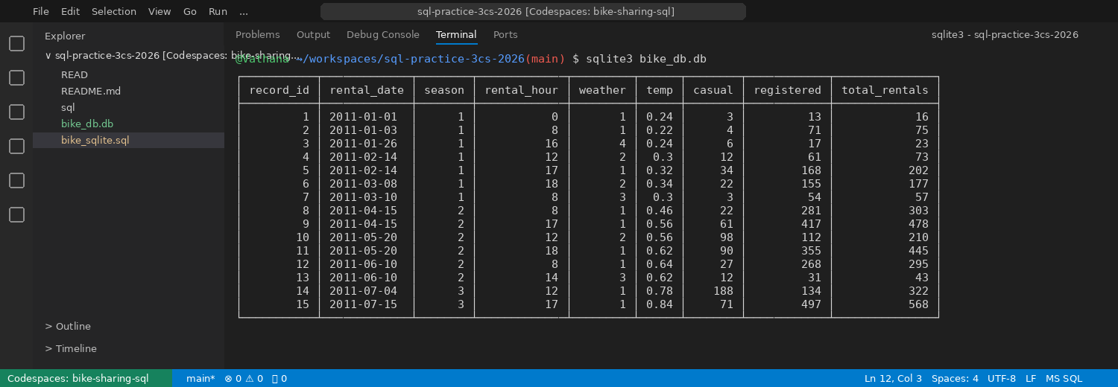
SQL Query 1: Display Bike Rental Records
SELECT rental_date, season, rental_hour, weather, casual, registered, total_rentals
FROM bike_sharing
ORDER BY rental_date, rental_hour;
Output
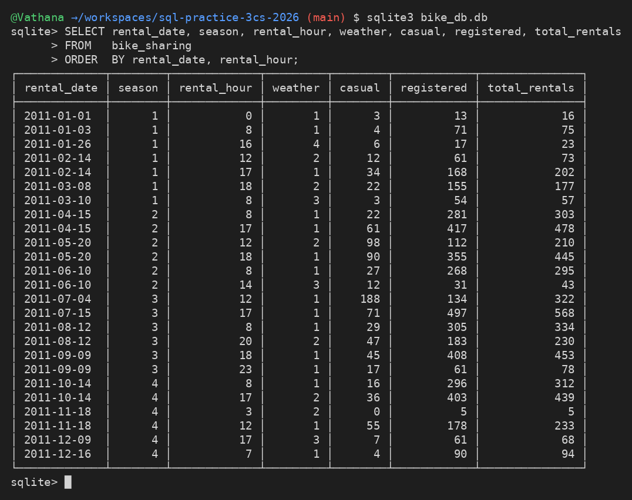
SQL Query 2: Total Bike Rentals for Each Season
SELECT season, SUM(total_rentals) AS total_rentals
FROM bike_sharing
GROUP BY season
ORDER BY season;
Output
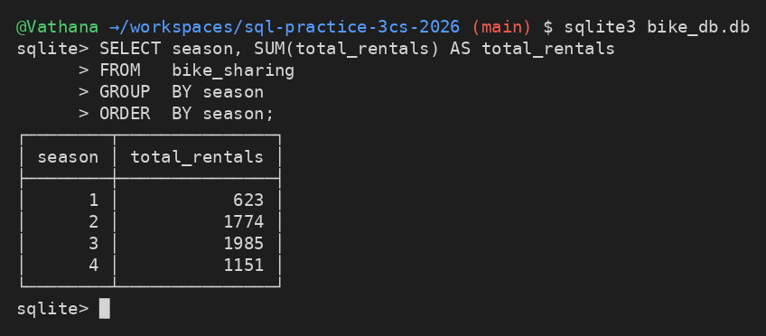
SQL Query 3: Average Rentals for Each Hour of the Day
SELECT rental_hour, ROUND(AVG(total_rentals), 2) AS avg_rentals
FROM bike_sharing
GROUP BY rental_hour
ORDER BY rental_hour;
Output
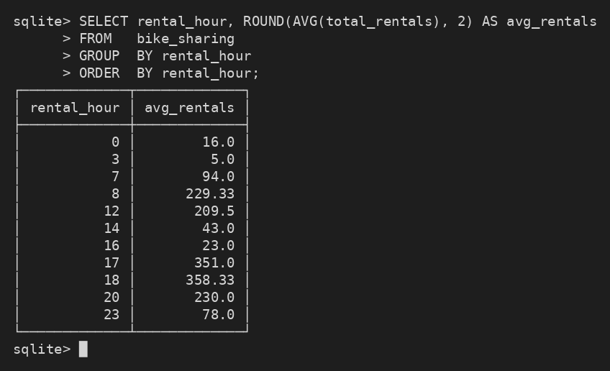
SQL Query 4: Total Casual and Registered User Rentals
SELECT SUM(casual) AS total_casual, SUM(registered) AS total_registered
FROM bike_sharing;
Output
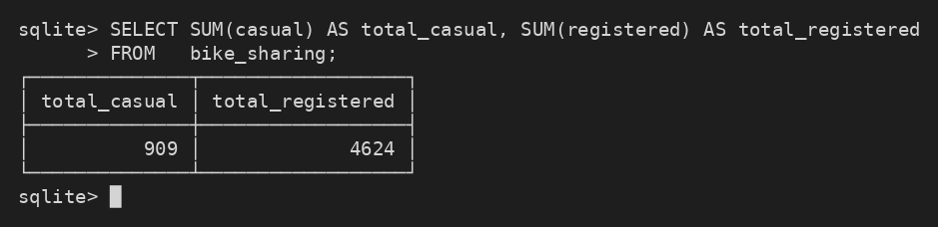
SQL Query 5: Total Rentals under Each Weather Condition
SELECT weather, SUM(total_rentals) AS total_rentals
FROM bike_sharing
GROUP BY weather
ORDER BY weather;
Output
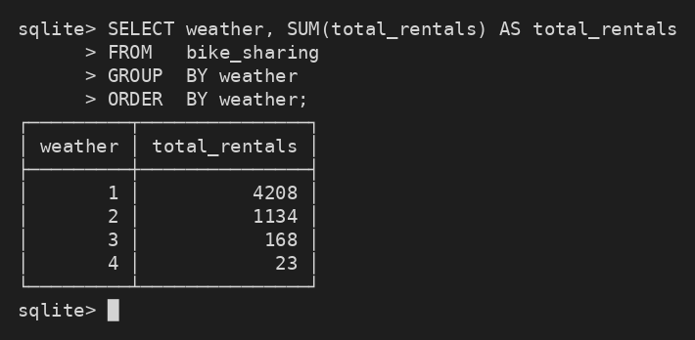
PL/SQL Function 1: Classify Bike Rental Demand
CREATE OR REPLACE FUNCTION fn_demand_level (p_rentals IN NUMBER)
RETURN VARCHAR2
IS
BEGIN
-- Thresholds: Low < 100, Moderate 100 to 299, High >= 300
IF p_rentals IS NULL THEN
RAISE_APPLICATION_ERROR(-20001, 'Rental count cannot be NULL.');
ELSIF p_rentals < 0 THEN
RAISE_APPLICATION_ERROR(-20002, 'Rental count cannot be negative.');
ELSIF p_rentals < 100 THEN
RETURN 'Low';
ELSIF p_rentals < 300 THEN
RETURN 'Moderate';
ELSE
RETURN 'High';
END IF;
END fn_demand_level;
Output
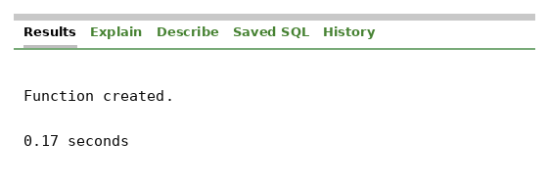
Execution
SELECT record_id, total_rentals,
fn_demand_level(total_rentals) AS demand_level
FROM bike_sharing
WHERE record_id IN (1, 5, 9, 13, 17);
Output
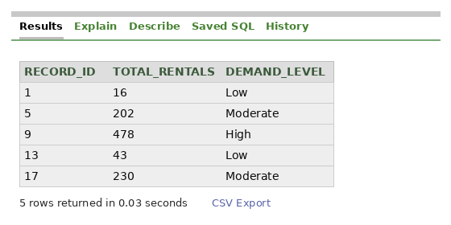
PL/SQL Procedure 2: Retrieve Rental Statistics for a Selected Date and Hour
CREATE OR REPLACE PROCEDURE sp_get_stats (p_date IN DATE, p_hour IN NUMBER)
IS
v_count NUMBER := 0;
BEGIN
IF p_date IS NULL OR p_hour IS NULL OR p_hour NOT BETWEEN 0 AND 23 THEN
RAISE_APPLICATION_ERROR(-20003, 'Invalid date or hour. Hour must be between 0 and 23.');
END IF;
DBMS_OUTPUT.PUT_LINE('Rental statistics for ' || TO_CHAR(p_date, 'DD-MON-YYYY') || ' at hour ' || p_hour);
DBMS_OUTPUT.PUT_LINE(RPAD('SEASON', 8) || RPAD('WEATHER', 9) || RPAD('TEMP', 7) ||
RPAD('CASUAL', 9) || RPAD('REGISTERED', 12) || RPAD('TOTAL', 8) || 'DEMAND');
FOR r IN (SELECT season, weather, temp, casual, registered, total_rentals
FROM bike_sharing
WHERE rental_date = p_date AND rental_hour = p_hour)
LOOP
v_count := v_count + 1;
DBMS_OUTPUT.PUT_LINE(RPAD(r.season, 8) || RPAD(r.weather, 9) || RPAD(r.temp, 7) ||
RPAD(r.casual, 9) || RPAD(r.registered, 12) ||
RPAD(r.total_rentals, 8) || fn_demand_level(r.total_rentals));
END LOOP;
IF v_count = 0 THEN
RAISE_APPLICATION_ERROR(-20004, 'No records found for the selected date and hour.');
END IF;
END sp_get_stats;
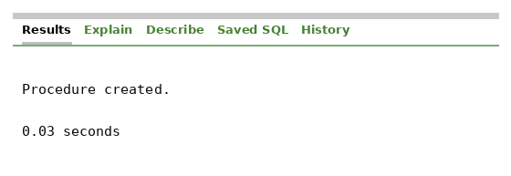
Execution
SET SERVEROUTPUT ON;
BEGIN
sp_get_stats(DATE '2011-04-15', 17);
END;
Output
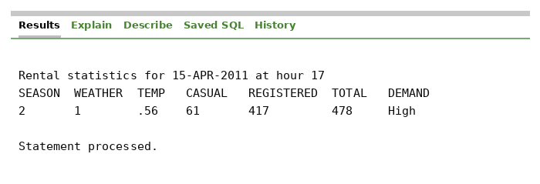
PL/SQL Procedure 3: Seasonal and Hourly Bike Rental Demand Report
CREATE OR REPLACE PROCEDURE sp_demand_report
IS
v_count NUMBER := 0;
BEGIN
DBMS_OUTPUT.PUT_LINE('SEASONAL AND HOURLY BIKE RENTAL DEMAND REPORT');
DBMS_OUTPUT.PUT_LINE(RPAD('SEASON', 10) || RPAD('RECORDS', 9) || RPAD('TOTAL', 8) ||
RPAD('AVG', 9) || 'PEAK HOUR');
FOR r IN (SELECT DECODE(season, 1, 'Winter', 2, 'Spring', 3, 'Summer', 'Fall') AS season_name,
COUNT(*) AS records,
SUM(total_rentals) AS total_rent,
ROUND(AVG(total_rentals), 2) AS avg_rent,
MAX(rental_hour) KEEP (DENSE_RANK LAST ORDER BY total_rentals) AS peak_hour
FROM bike_sharing
GROUP BY season
ORDER BY season)
LOOP
v_count := v_count + 1;
DBMS_OUTPUT.PUT_LINE(RPAD(r.season_name, 10) || RPAD(r.records, 9) ||
RPAD(r.total_rent, 8) || RPAD(r.avg_rent, 9) || r.peak_hour);
END LOOP;
DBMS_OUTPUT.PUT_LINE(' ');
DBMS_OUTPUT.PUT_LINE(RPAD('HOUR', 7) || RPAD('RECORDS', 9) || RPAD('AVG RENTALS', 14) || 'DEMAND');
FOR h IN (SELECT rental_hour, COUNT(*) AS records,
ROUND(AVG(total_rentals), 2) AS avg_rent
FROM bike_sharing
GROUP BY rental_hour
ORDER BY rental_hour)
LOOP
DBMS_OUTPUT.PUT_LINE(RPAD(h.rental_hour, 7) || RPAD(h.records, 9) ||
RPAD(h.avg_rent, 14) || fn_demand_level(ROUND(h.avg_rent)));
END LOOP;
IF v_count = 0 THEN
RAISE_APPLICATION_ERROR(-20005, 'No data available to generate report.');
END IF;
END sp_demand_report;
Execution
BEGIN
sp_demand_report;
END;
/
Output
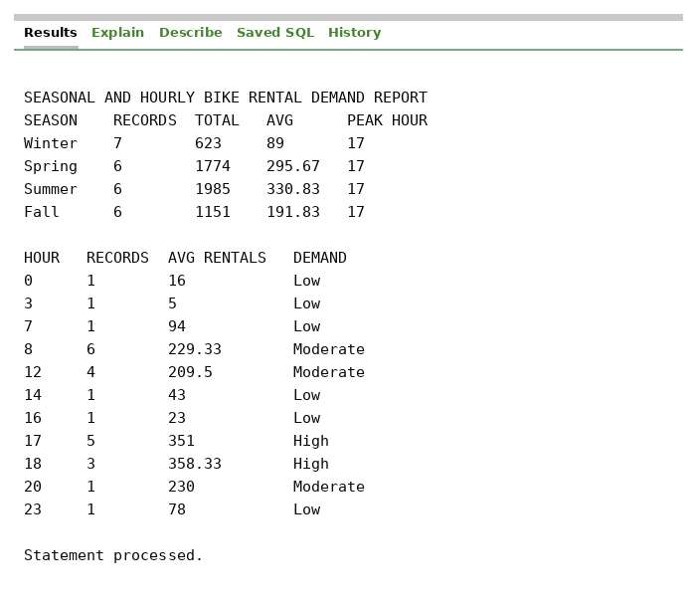
Exception Handling
Test Case 1 – Negative Rental Count
BEGIN
DBMS_OUTPUT.PUT_LINE('Result: ' || fn_demand_level(-5));
EXCEPTION
WHEN OTHERS THEN
DBMS_OUTPUT.PUT_LINE('Error caught: ' || SQLERRM);
END;
/
Output
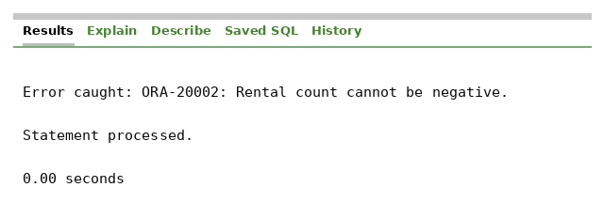
Test Case 2 – NULL Rental Count
BEGIN
DBMS_OUTPUT.PUT_LINE('Result: ' || fn_demand_level(NULL));
EXCEPTION
WHEN OTHERS THEN
DBMS_OUTPUT.PUT_LINE('Error caught: ' || SQLERRM);
END;
/
Output
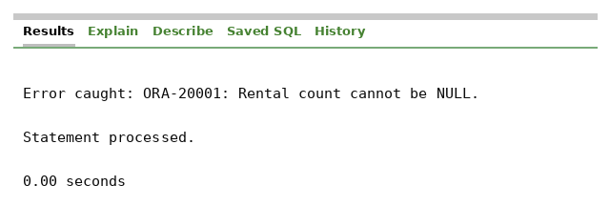
Test Case 3 – No Records for Date and Hour
BEGIN
sp_get_stats(DATE '2011-01-02', 10);
EXCEPTION
WHEN OTHERS THEN
DBMS_OUTPUT.PUT_LINE('Error caught: ' || SQLERRM);
END;
/
Output
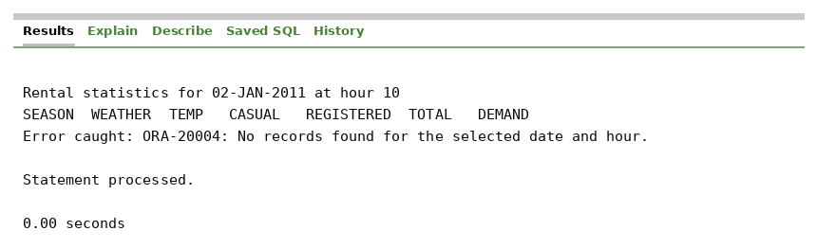
Test Case 4 – Invalid Hour
BEGIN
sp_get_stats(DATE '2011-04-15', 25);
EXCEPTION
WHEN OTHERS THEN
DBMS_OUTPUT.PUT_LINE('Error caught: ' || SQLERRM);
END;
/
Output
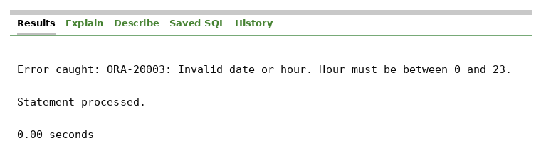
Test Case 5 – Duplicate Record ID
BEGIN
INSERT INTO bike_sharing
VALUES (1, DATE '2011-03-01', 1, 9, 1, 0.30, 5, 40, 45);
EXCEPTION
WHEN DUP_VAL_ON_INDEX THEN
DBMS_OUTPUT.PUT_LINE('Duplicate record_id not allowed.');
END;
/
Output
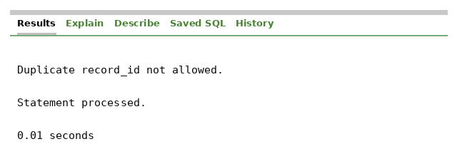
Dataset Insights
- The dataset contains 25 hourly bike rental records covering 4 seasons, 11 different hours of the day, and all 4 weather conditions.
- Summer has the highest total rentals (1985), followed by Spring (1774), Fall (1151), and Winter (623).
- Demand peaks at the evening commute hours: average rentals are highest at 18:00 (358.33) and 17:00 (351), with a smaller morning peak at 08:00 (229.33).
- Registered users account for 4624 of the 5533 total rentals (83.57%), while casual users account for 909 (16.43%).
- Clear weather accounts for 4208 rentals (76.05%), while light rain or snow (168) and heavy rain (23) sharply reduce rentals.
- Using the demand thresholds (Low below 100, Moderate 100 to 299, High 300 or more), 10 records are Low, 6 are Moderate, and 9 are High; the highest record is 568 rentals on 15-Jul-2011 at 17:00.

Result
Thus, the Bike Sharing and Urban Mobility analysis system was successfully implemented using SQL and PL/SQL. The BIKE_SHARING table was created, rental records were inserted, SQL queries were executed successfully, PL/SQL functions and procedures were implemented, and exception handling was tested successfully.

