|  |  |  |
| --- | --- | --- |
| **15/02/2022** | **SQL ASSIGNMENT** | **46120377 (Vathsala R)** |

1. Display ItemCode, ItemName and ItemCategory of items whose UnitPrice is less than INR 500.

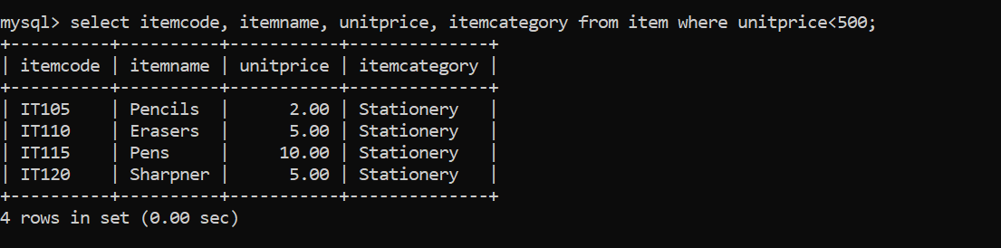  
2. Display ItemCode, ItemName and ItemCategory of items whose UnitPrice is in the range INR 10,000 to INR 20,000 (both inclusive).

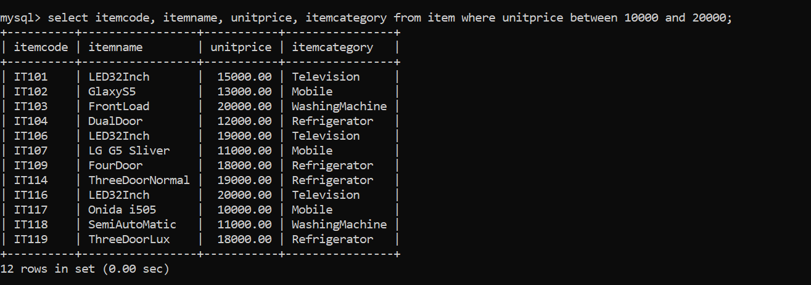  
3. Display ItemCode and ManufacturerName of Televisions that are costing more than INR 15,000 .

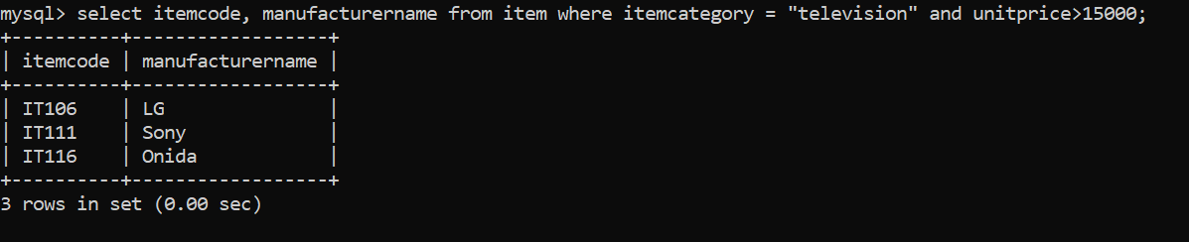  
4. Display ItemName, ManufacturerName and UnitPrice of "Televisions, Mobiles and Washing Machines".

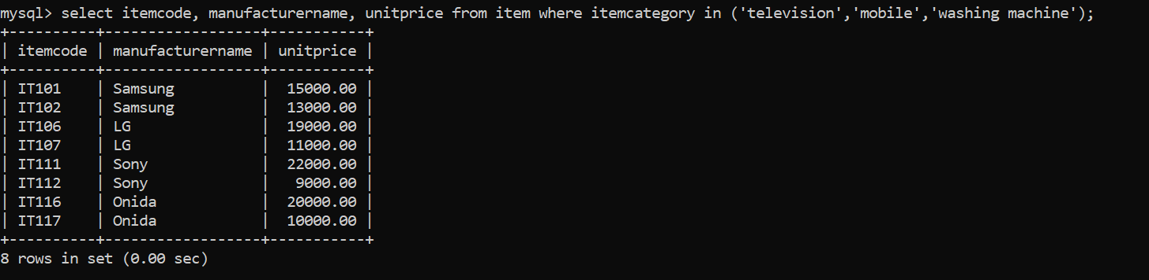  
5. Display ItemCode, ItemName and ManufacturerName of items which were manufactured in the year 2015

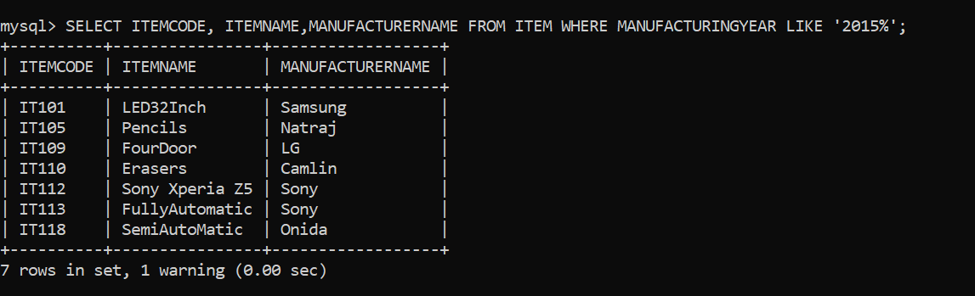  
6. Display ItemCode, ItemName and ManufacturerName of Televisions which are more than 2 years old

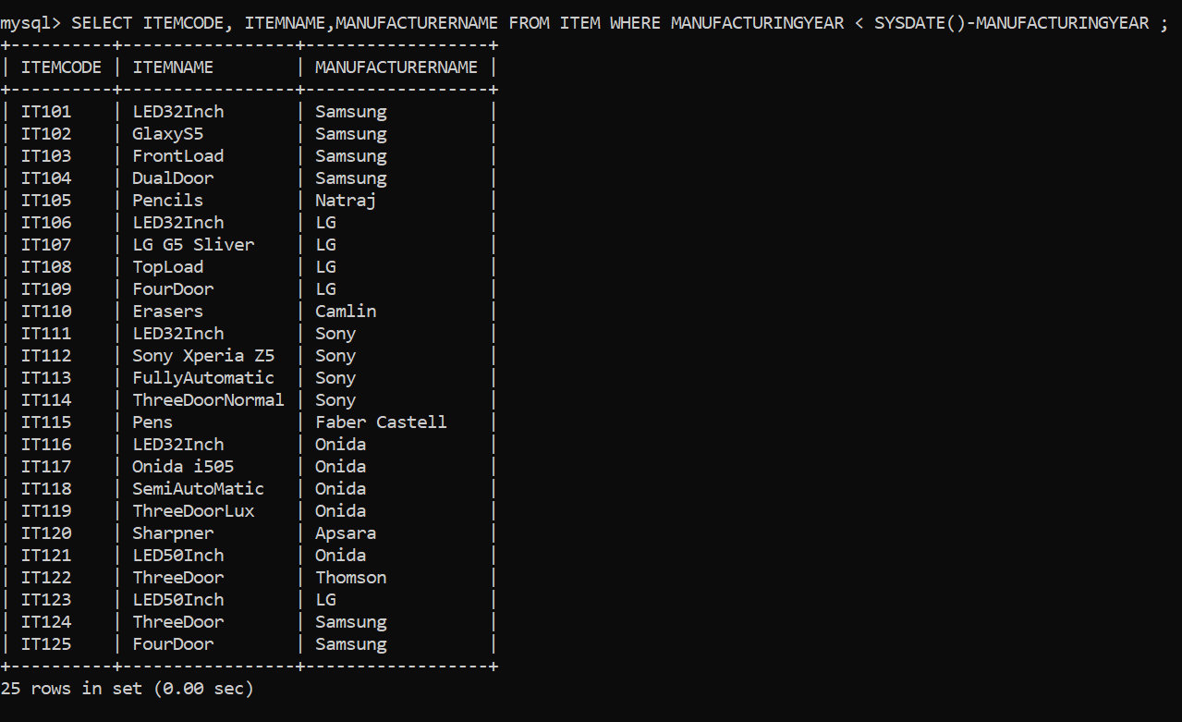  
7. Display ItemCode, ItemName, UnitPrice, UnitPrice+VAT for all "Refrigerators" (VAT to be computed as 2% of unitprice of the item).

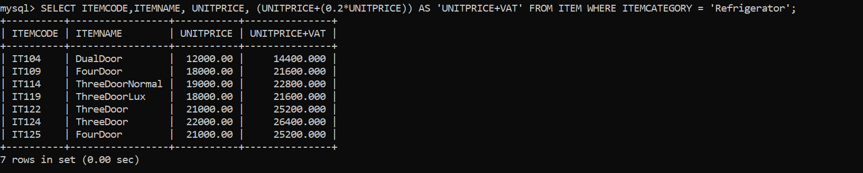  
8. Display CustomerName and PhoneNumber of Customers whose name starts with ‘J’.

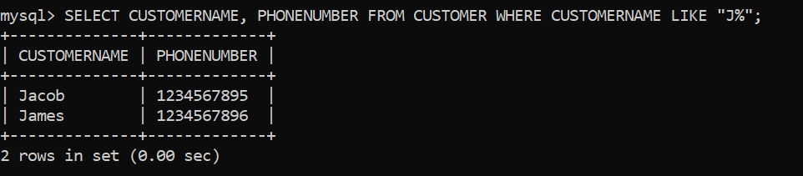  
9. Display CustomerName and Phone of Customers whose name ends with ‘an’.

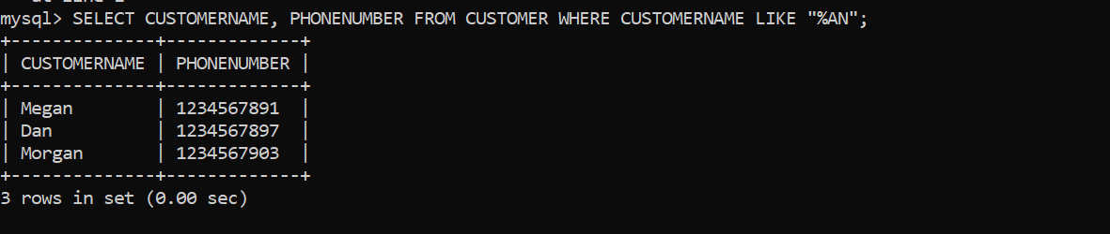  
10. Display CustomerName and Phone of Customers whose name starts with 'M' and ends with 'n'.

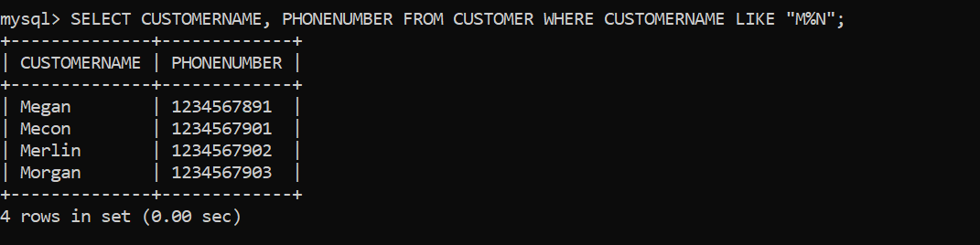  
11. Display CustomerName and Phone of Customers whose name contains only three letters.

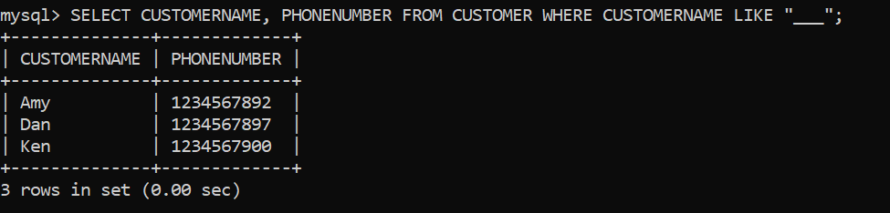  
12. Display CustomerName and Phone of Customers whose name contains 'a' as the second letter.

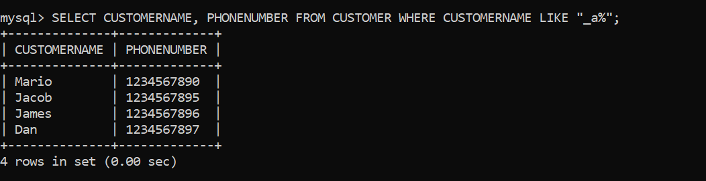  
13. Display ItemCode, ItemName, ManufacturerName and UnitPrice of ALL items in the descending order of UnitPrice.

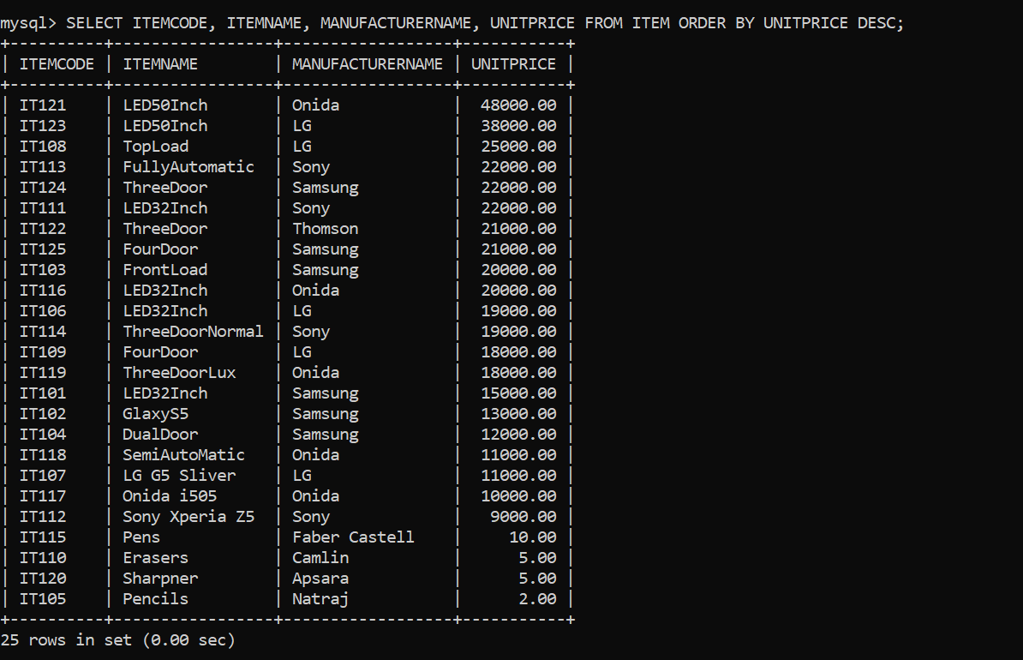

14. Display CustomerName and Address of customers in the alphabetical order (A to Z) of CustomerName.

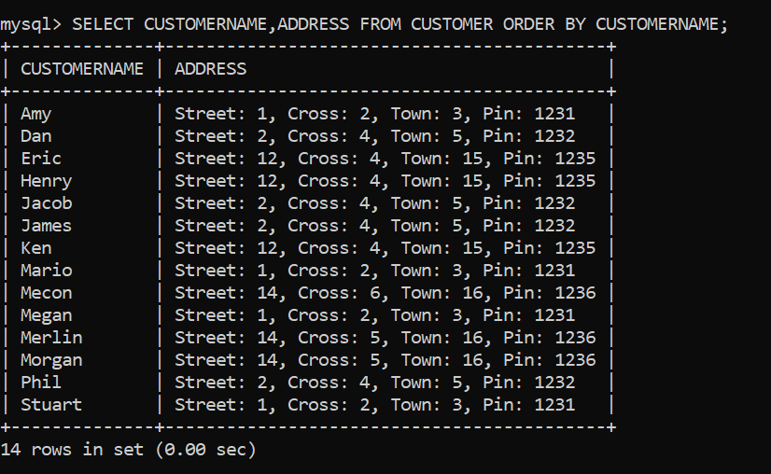

15. Display ItemCode, ItemName, ManufacturerName and UnitPrice of all items in the ascending order of UnitPrice and in the descending order of ManufacturerName (if UnitPrice is same).

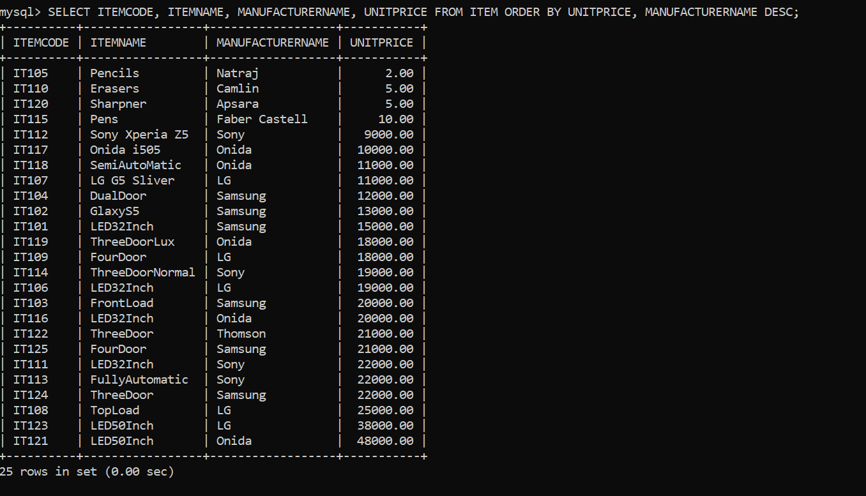

Write and execute SQL statements for the following:

1.Increase the salary of ALL employees by 5%. Save the changes done to the database table

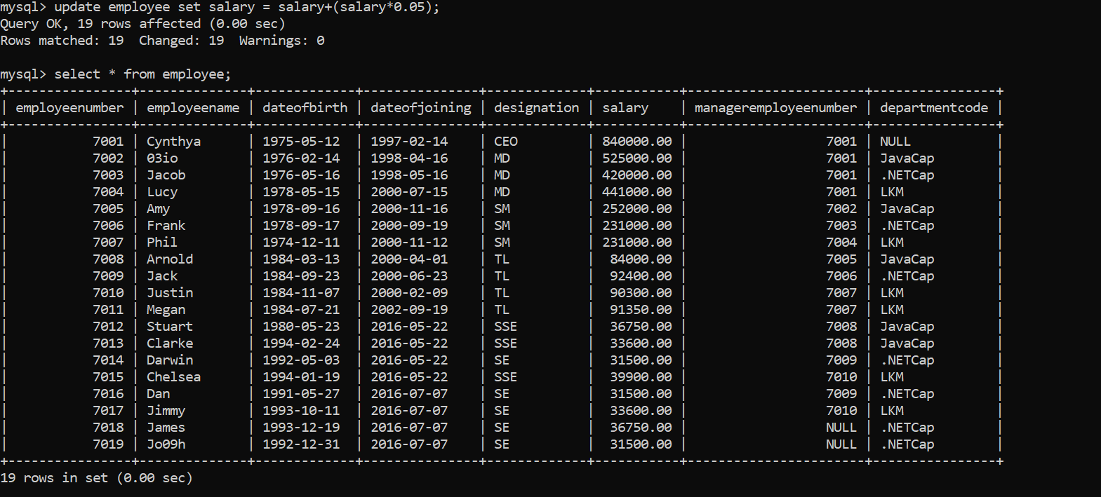  
2.Increase the salary of SSEs by 5% in addition to increase done in the previous statement. Save the changes done to the database table

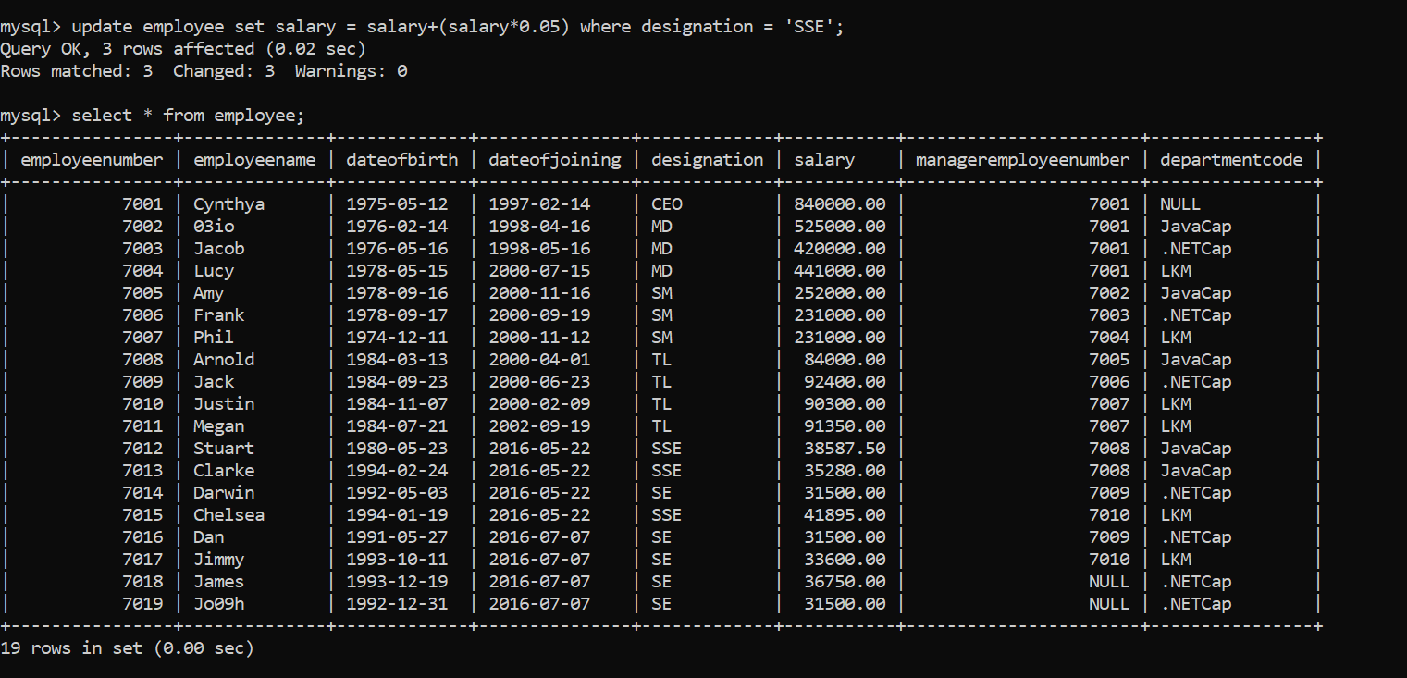  
3.Delete ALL rows from “EmployeeProject” table. Undo the changes done to the database table

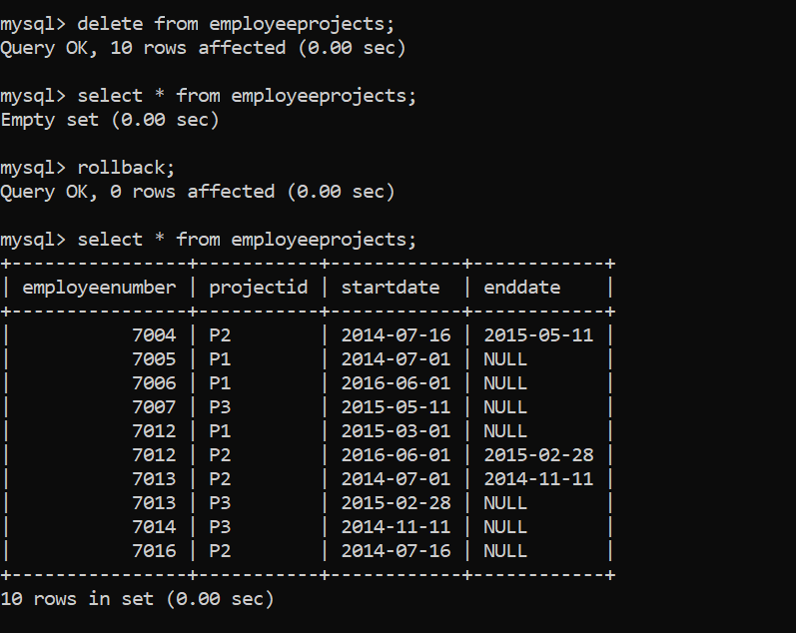  
4.Delete rows from “EmployeProject” table if the employee is working for project ‘P1’. Undo the changes done to the database table

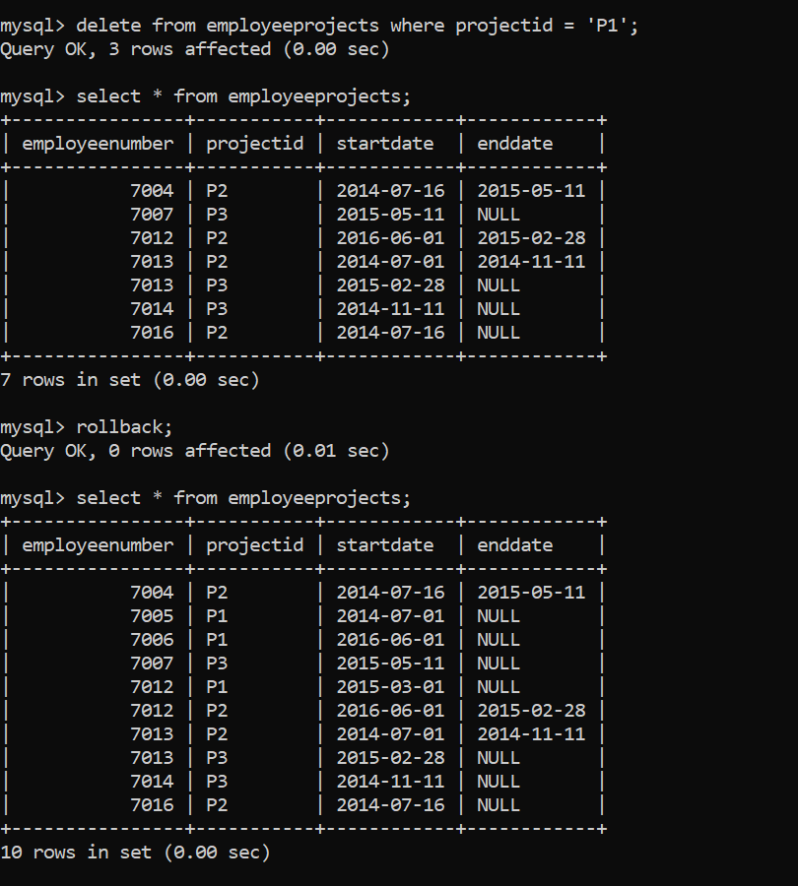  
5.Delete ALL rows from “Department” table.

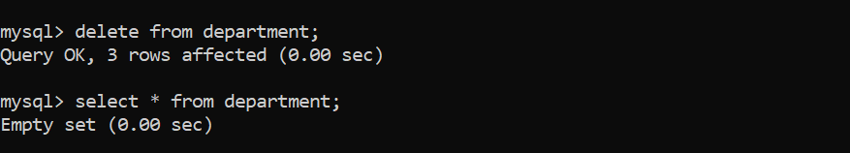

1.Display EmployeeName, Designation and Salary for ALL the employees

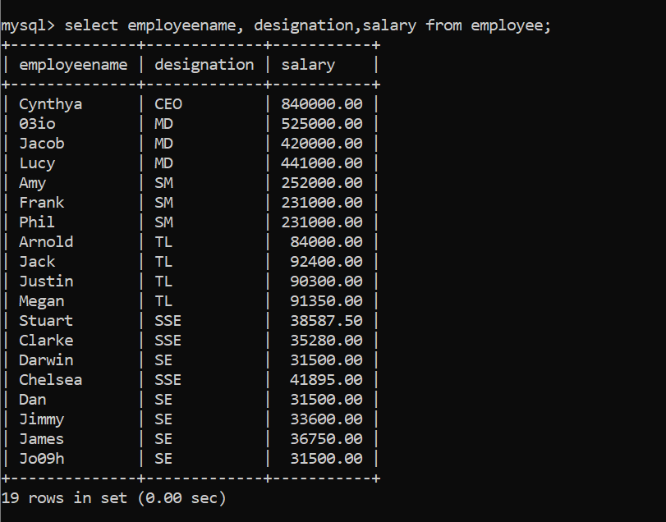  
2.Display different designations in the company (Each designation should be displayed only once)

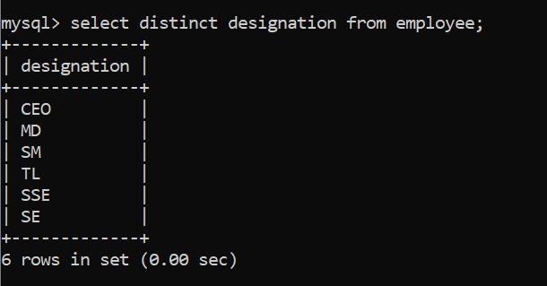  
3.Display EmployeeName and Salary of SSEs whose salary is more than 35000

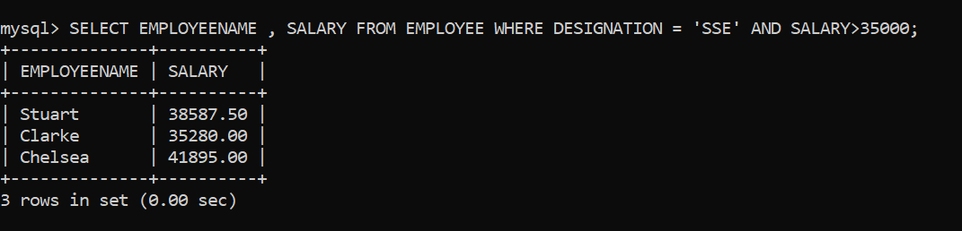  
4.Display EmployeeName, Designation and Salary of SM, SSE and SE

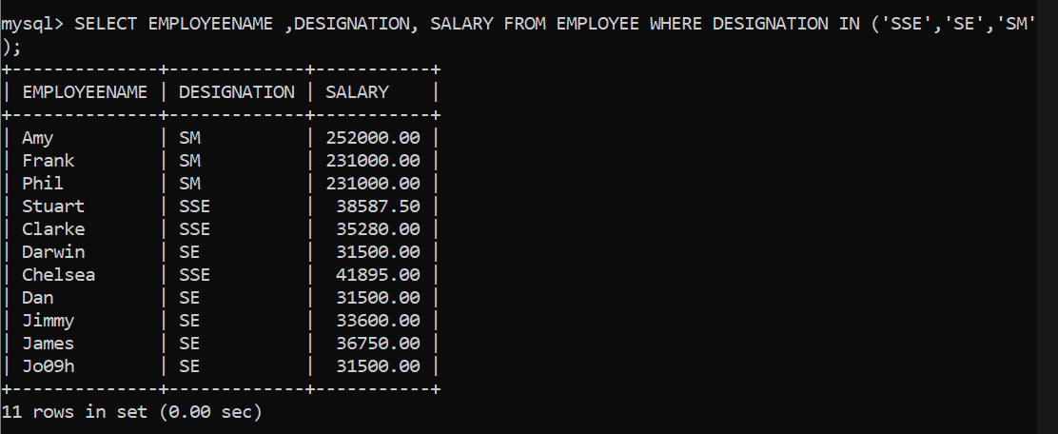  
5.Display EmployeeName and DateOfJoining of employees who have joined in the year 2000

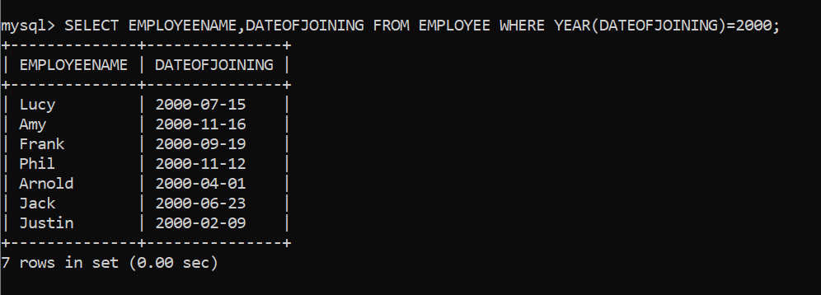

6.Display EmployeeName, DateofBirth and Age of ALL employees (Age is not a database column. Needs to be computed. In Oracle, SYSDATE contains the current date)

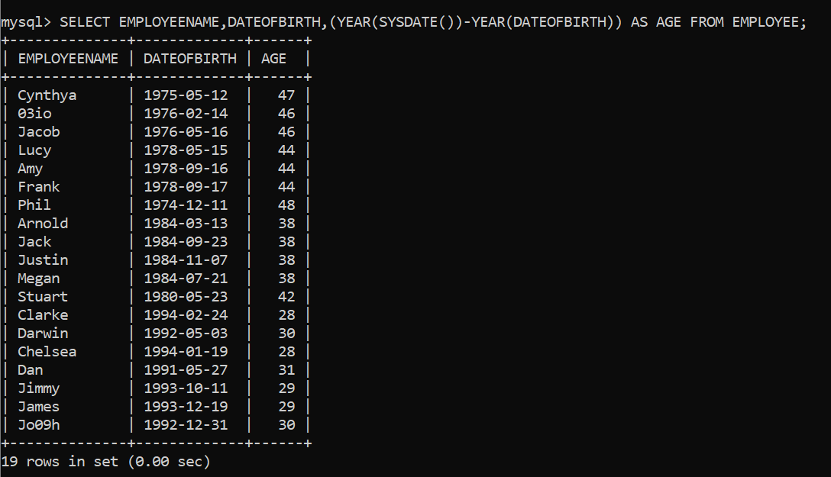

7.Display EmployeeName and Salary of employees whose salary is in the range INR 50,000 to INR 100,000

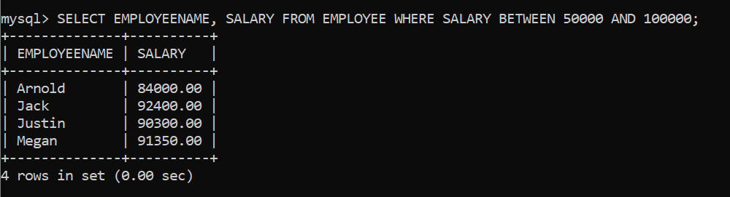

8.Display EmployeeName of employees whose name starts with ‘J’

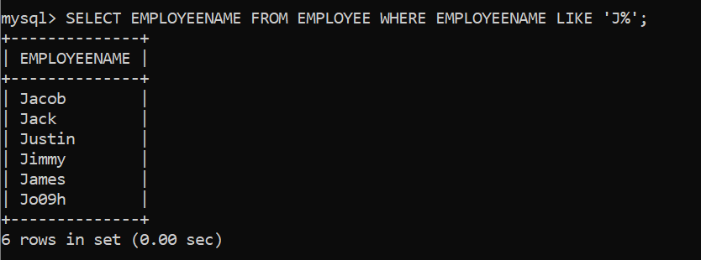  
9.Display EmployeeName of employees whose name ends with ‘k’

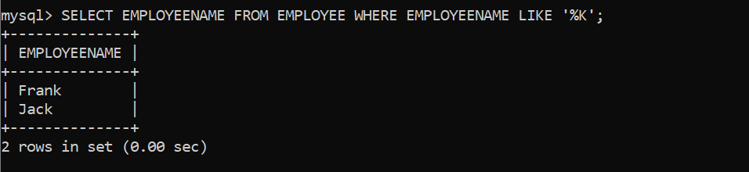  
10.Display EmployeeName of employees whose names contains ‘a’ as the second letter

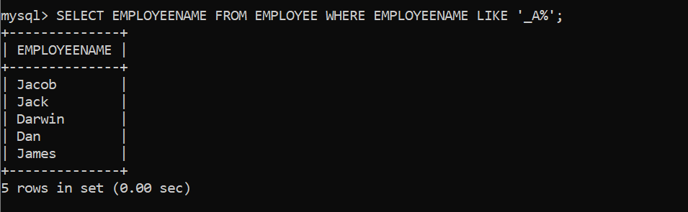  
11.Display EmployeeName of employees whose names contains only three letters

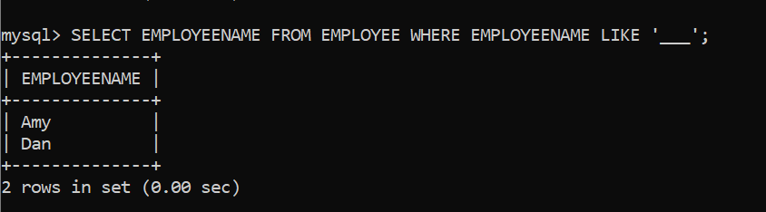  
12.Display EmployeeName and Designation of MDs whose name starts with ‘M’

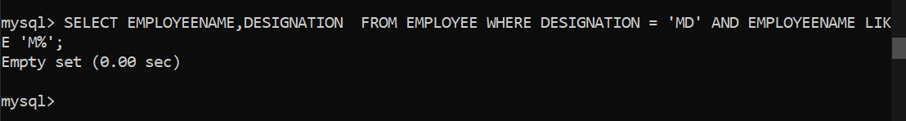  
13.Display EmployeeName and DateOfJoining of employees who have joined in the month of ‘MAY’

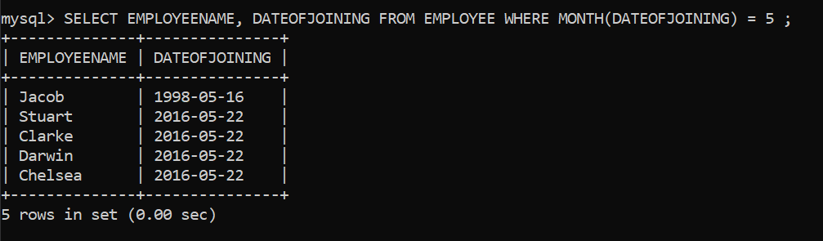

1.Display EmployeeName and Salary of ALL employees in the alphabetical order (‘A’ to ‘z’) of EmployeeName

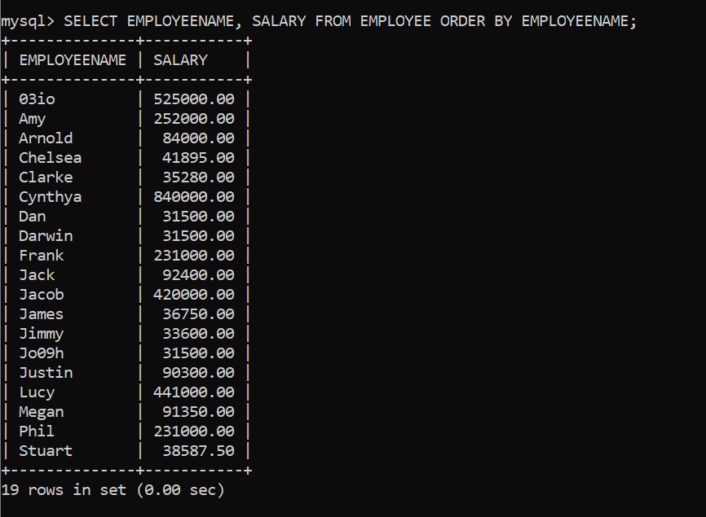  
2.Display EmployeeName and DateOfBirth of ALL employees in the order of eldest to youngest

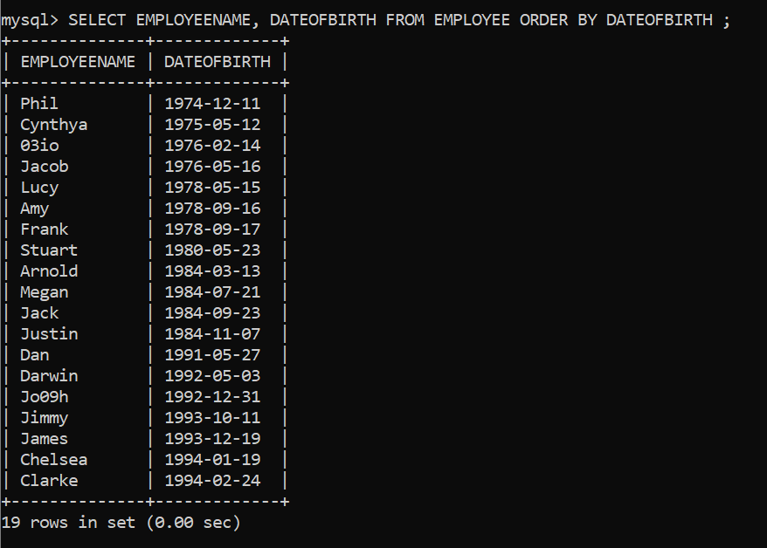  
3.Display EmployeeName and Salary of ALL employees in the decreasing order of Salary

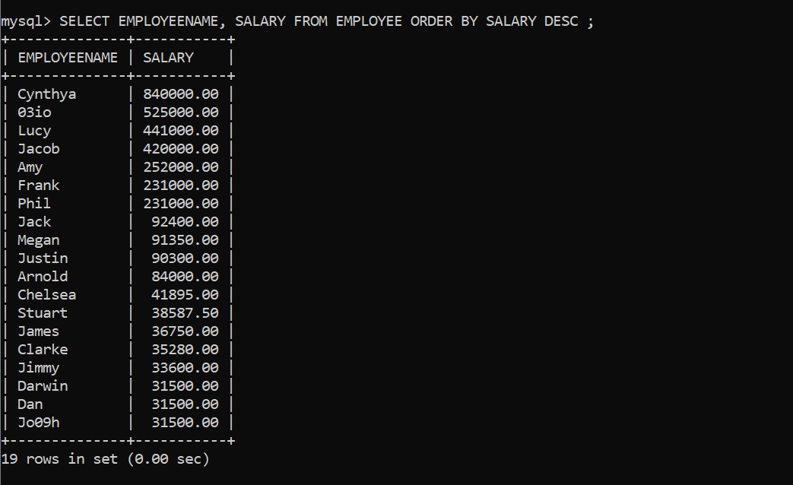  
4.Display EmployeeName and Salary of ALL employees in the decreasing order of Salary and in the alphabetical order of (‘A’ to ‘z’) EmployeeName if the salary is same

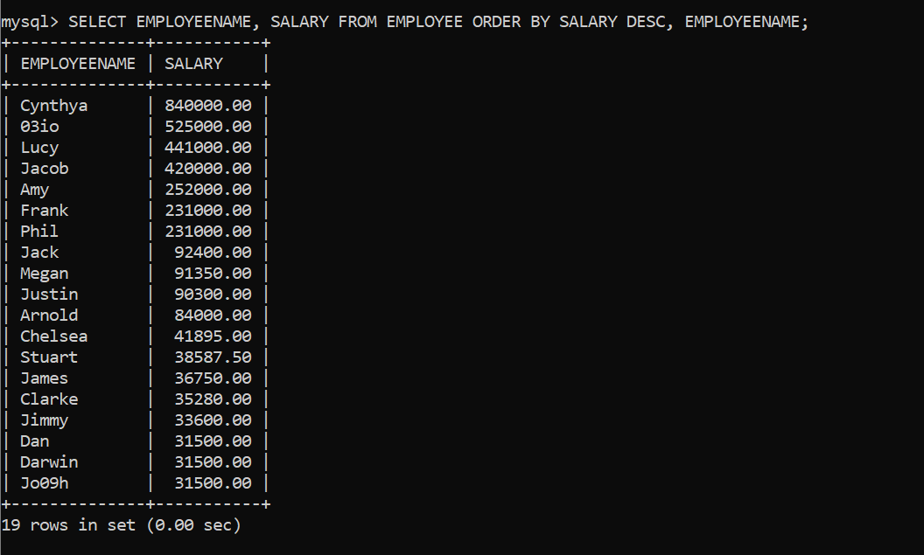  
5.Display EmployeeName,Designation and Salary of TLs in the decreasing order of Salary

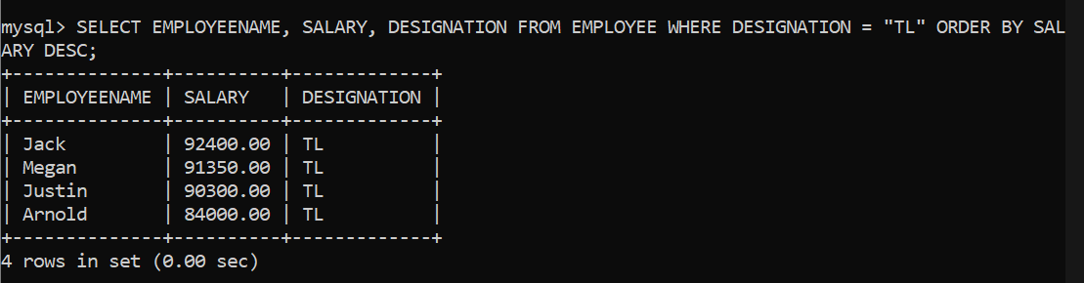

16/02/2022

1. Display UnitPrice which is the maximum in the store.

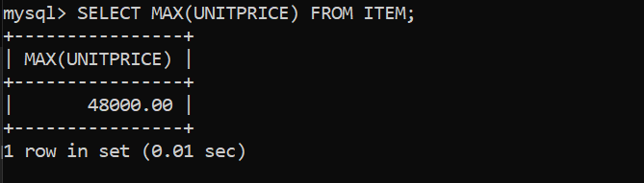  
2. Display the total number of items in the store.

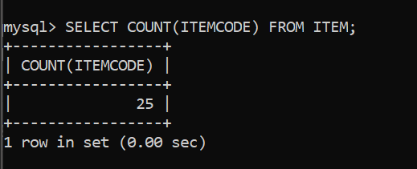  
//Using Group By in Select Statement  
3. Display customerId and total number of orders placed by each customer.

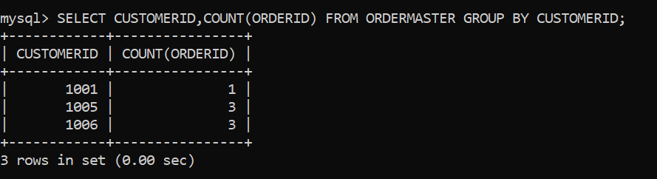  
4. Display ItemCategory and average UnitPrice in each item category.

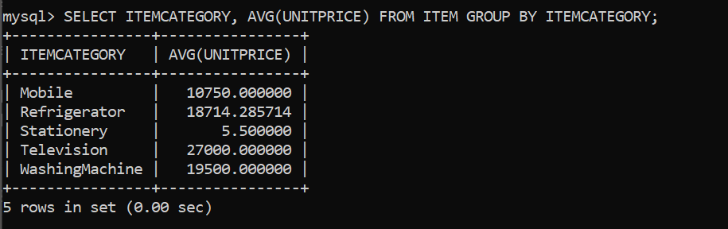  
5. Display customerId of customers who have placed more than 1 order.

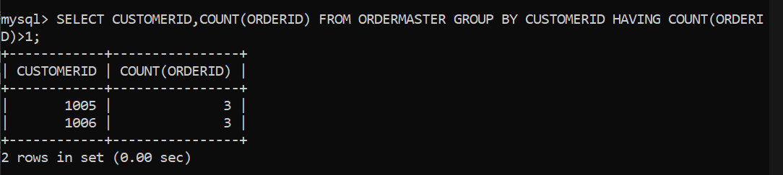  
6. Display ItemCategory of items which has the minimum unit price more than INR 10,000.

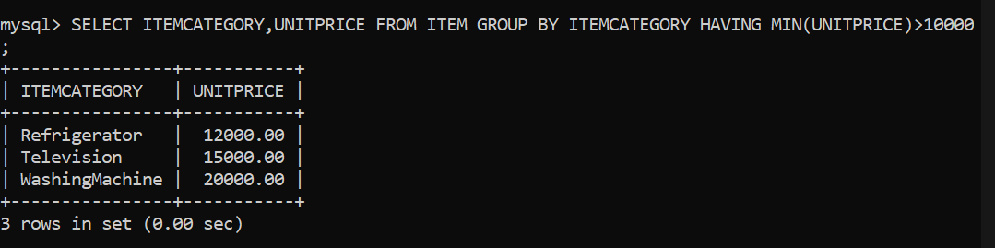

7. Display ItemCategory, total number of items for "Television" and "Refrigerator" if the total number of items exceeds 5.

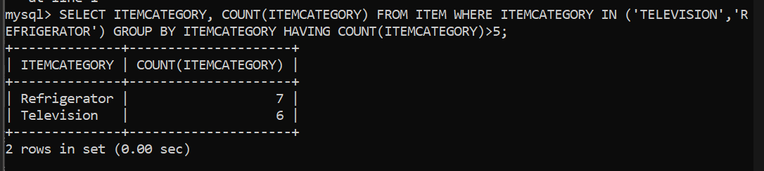

5. Display the results in the descending order of total number of items.

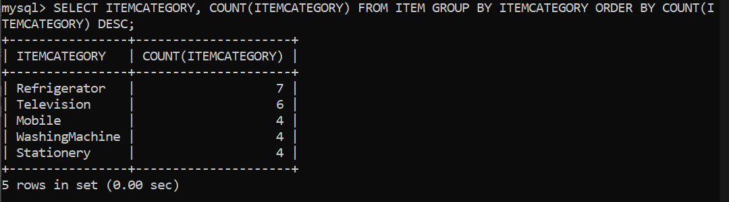

-----------------------------------------------------------------------------------------------------------

Data Retrieval Language – Subqueries and Joins

1. Display CustomerName and PhoneNumer of customers who have placed a single order of more than INR 45,000.

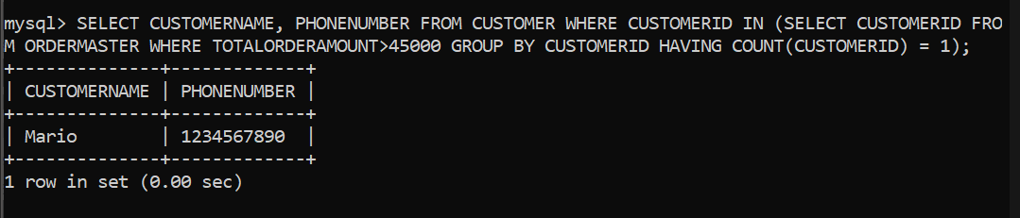  
2. Display CustomerName and PhoneNumber of Customers who have placed orders in the month of June in year 2016.

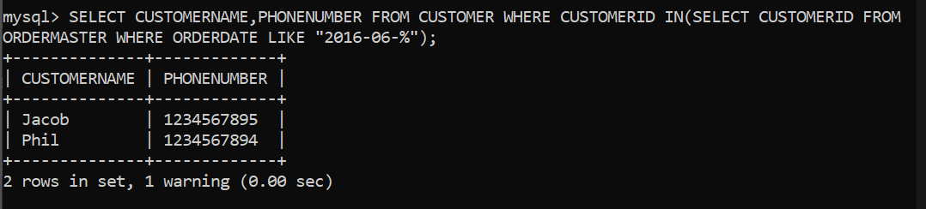  
3. Display ItemCode, ItemName and UnitPrice of items which were not ordered by any customer.

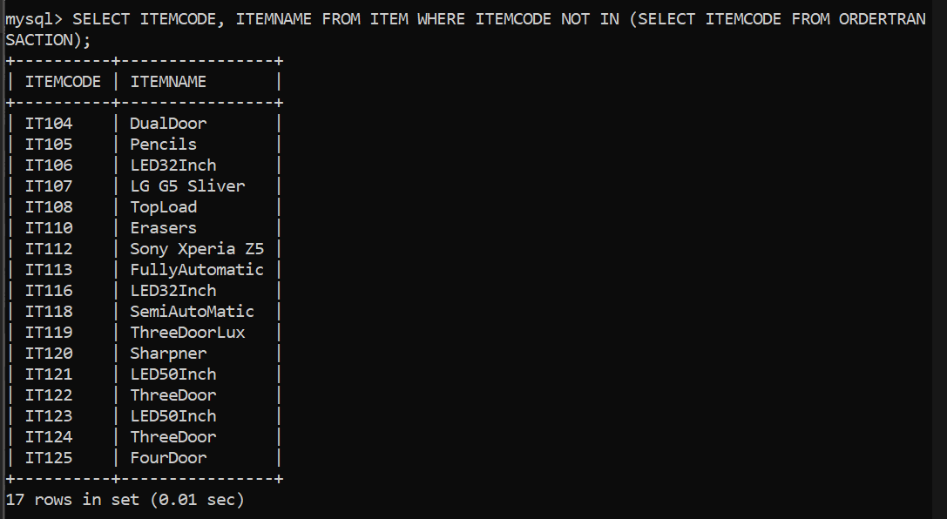  
4. Display itemCode and ItemName of items that are ordered exactly once.

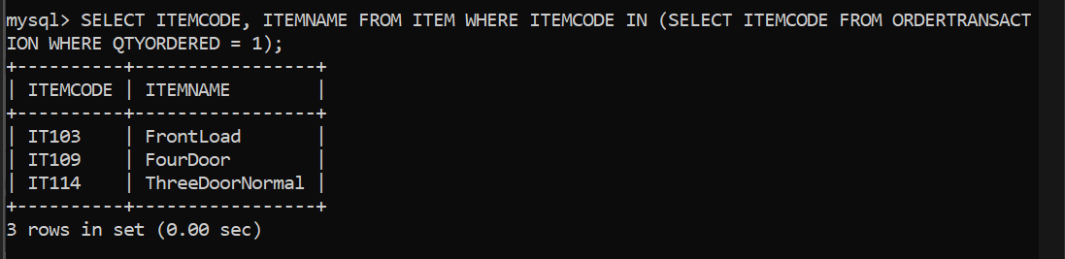  
5. Display customerId of customers who have placed more than one order.

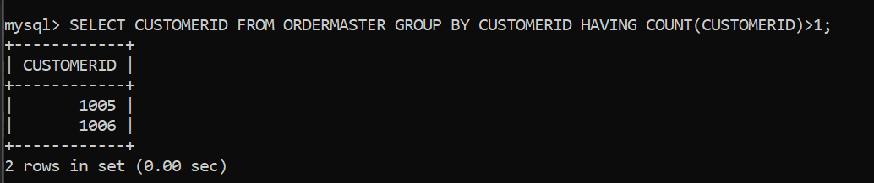

6. Display OrderId, CustomerId, CustomerName, Address and PhoneNumber for all the orders placed.

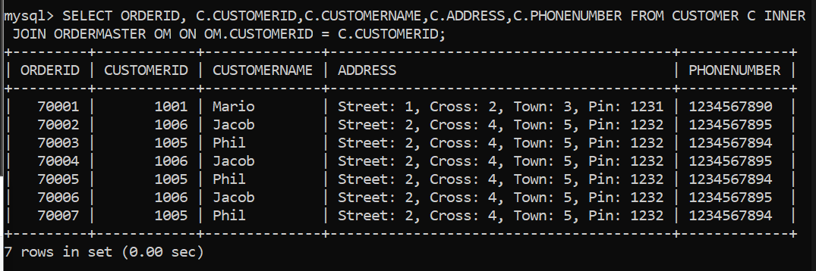

7. Display ItemCode, ItemName, QtyOrdered, UnitPrice for OrderId 70002.

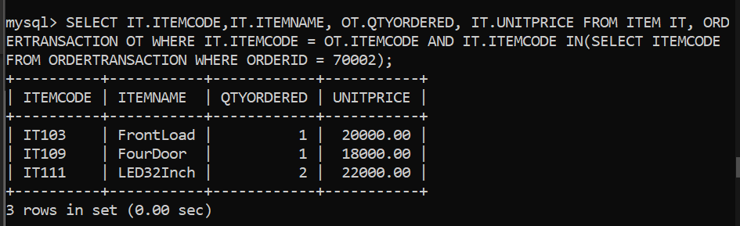  
8. Display OrderId, CustomerId, CustomerName, Address and Phone for all the orders placed. Include the details about the customer even if there are no orders placed by the customer.

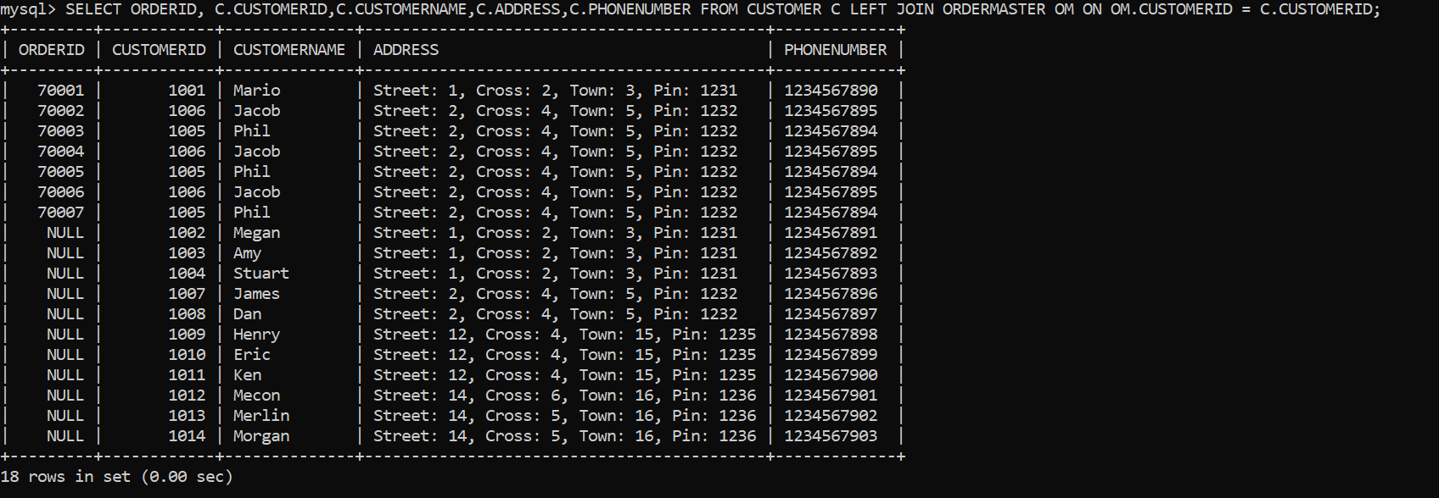  
9. Display the ItemCode, UnitPrice of the all the items in each ItemCategory where the unitprice is less than the average unitprice for the itemcategory.

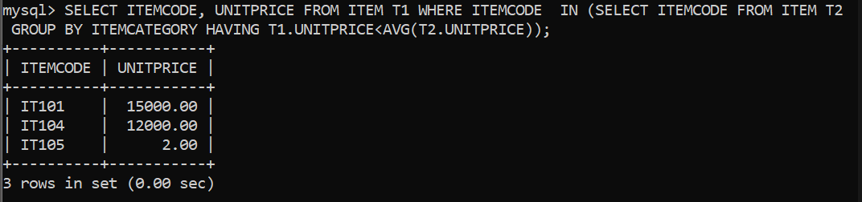

Aggregate Functions

1. Display the maximum of salary of the company.

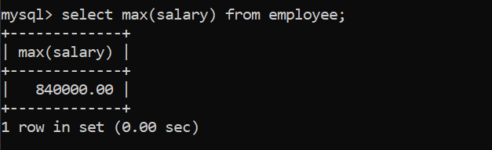

2. Display the average salary of the company.

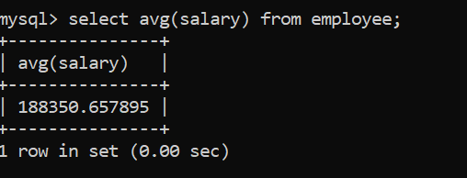  
3. Display the maximum salary of employees who are TLs.

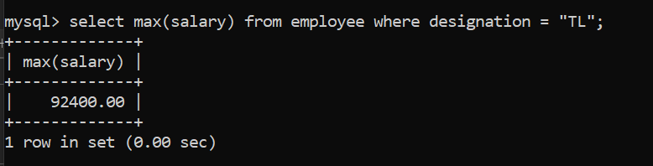  
4. Display the total number of employees in the company.

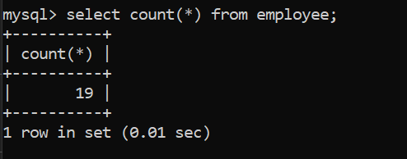  
5. Display the total number of Managers in the company. (If an employee is playing the role of the supervisor for any other employee then the employee is considered as Manager).

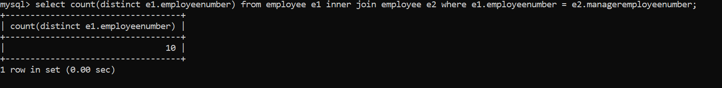  
6. Display the total number SMs in the company.

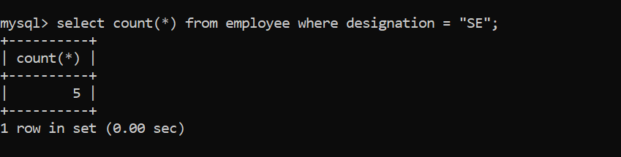  
GROUP BY

1. Display designation and number of employees in each designation.

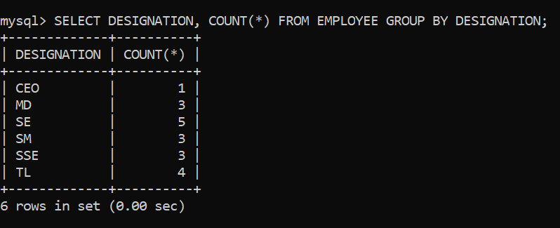  
2. Display designation and maximum salary for each designation.

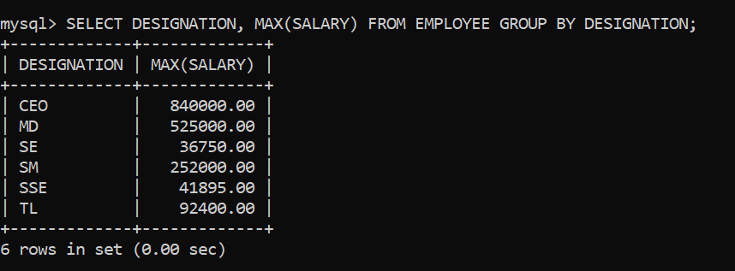  
3. Display Designation and maximum salary for each designation. Display the results in the decreasing order of maximum salary.

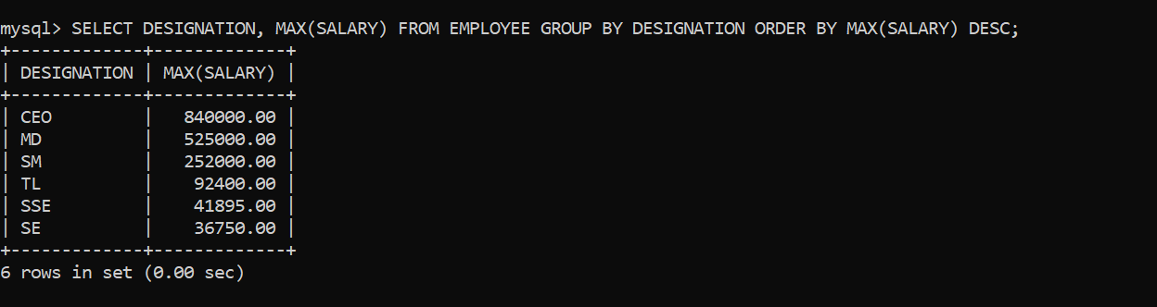

4. Display DepartmentCode and number of employees working for each department.

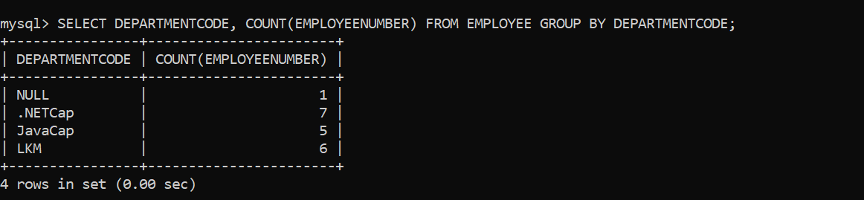

5. Display Designation and maximum salary for ‘TL’ and ‘SSE’

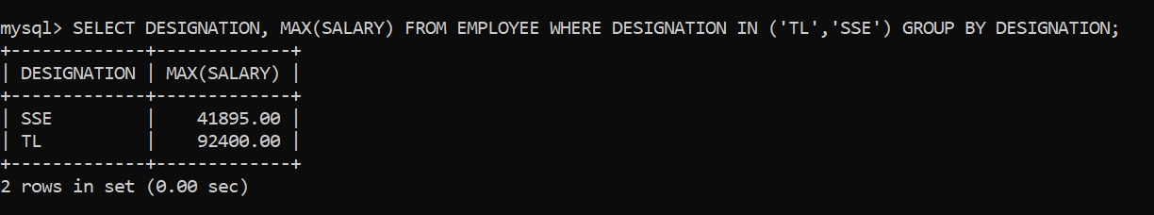

6. Display ManagerEmployeeNumber and Number of employees working under the Manager (Exclude Null from ManagerEmployeeNumber column).

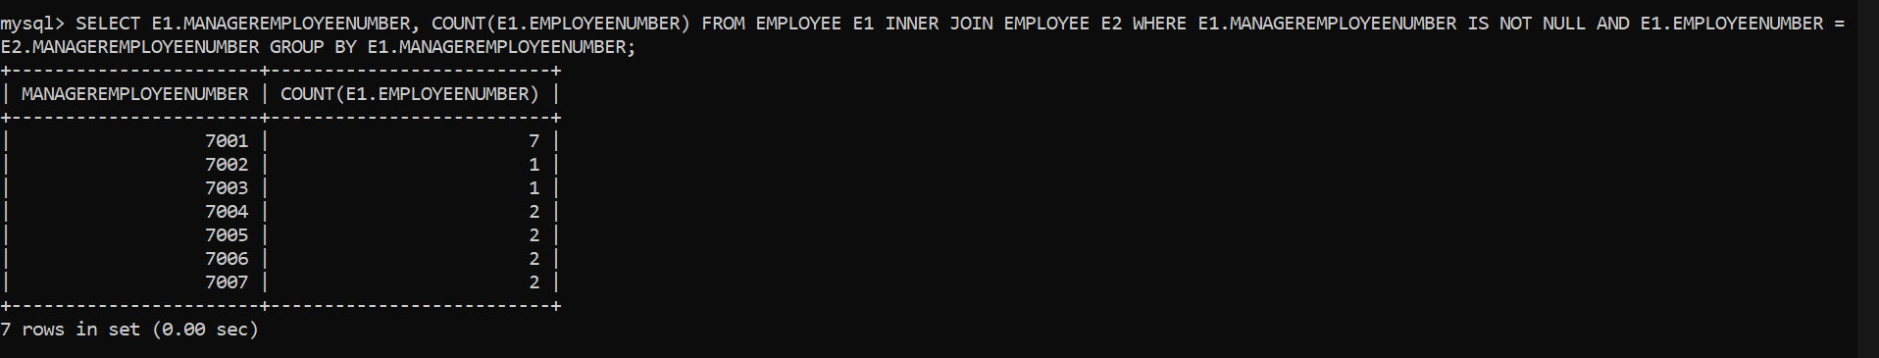  
7. Display DepartmentCode and NumberOfEmployees if the department has more than 5 employees.

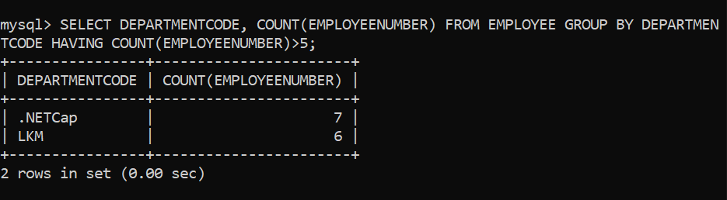  
8. Display DepartmentCode and average salary if the average salary of the department is more than INR150,000 (Exclude Null under DepartmentCode column)

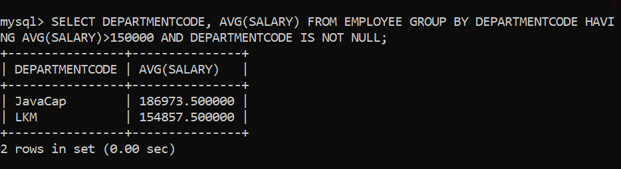  
9. Display Designation and average salary of each designation for “LKM” department if the average salary is more than INR 35,000. Display the results in the increasing order of average salary.

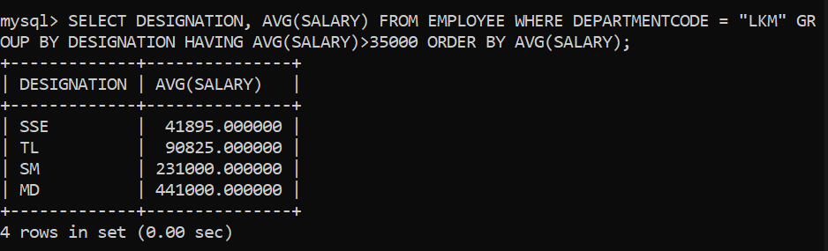  
10. Display ProjectId, number of employees working in the project. Display the results in the decreasing order of number of employees (Exclude the results if the enddate is not null).

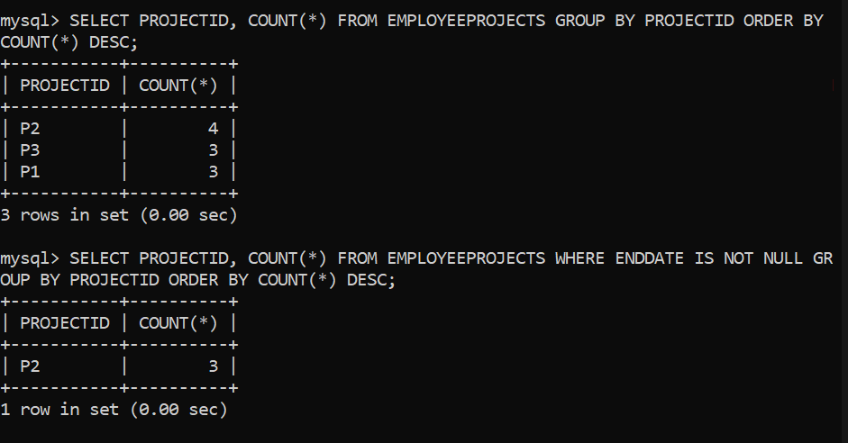

Non-Correlated Subqueries

1. Display EmployeeName, Salary of employees whose salary is more than the average salary of the company.

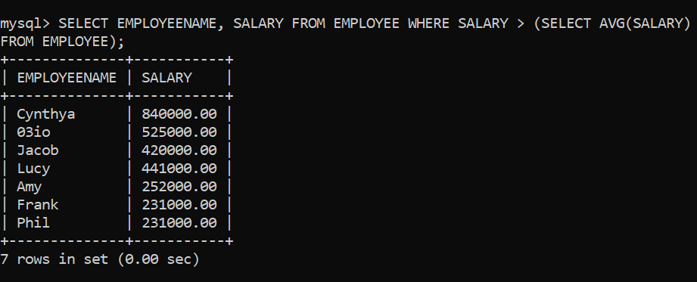  
2. Display EmployeeName, Salary of employee(s) who is getting the lowest salary in the company.

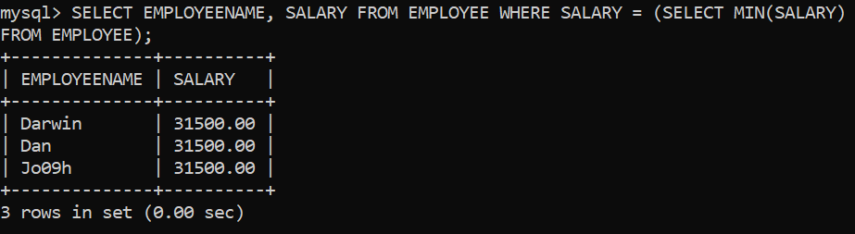  
3. Display EmployeeName of employees who are working in project ‘P1’.

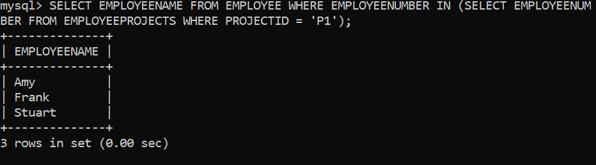  
4. Display ProjectName of projects which has more than 2 employees (Exclude rows if end date is not null).

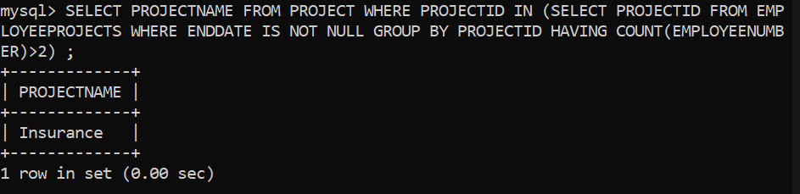  
5. Display EmployeeName of Managers who have more than three team members.

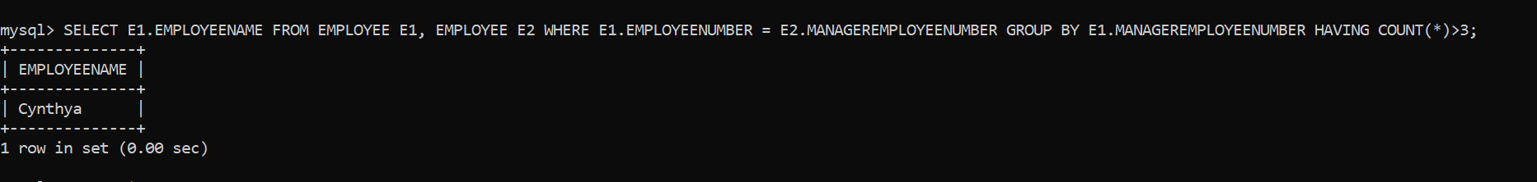  
6. Display the second maximum salary of the company.

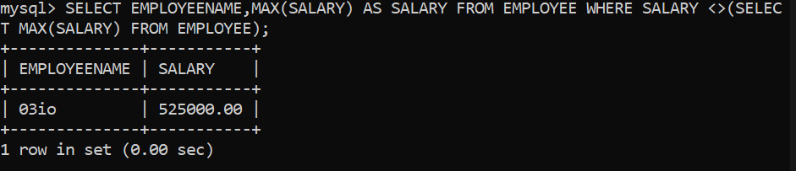  
7. Display the ProjectName of projects which currently does not have any employees.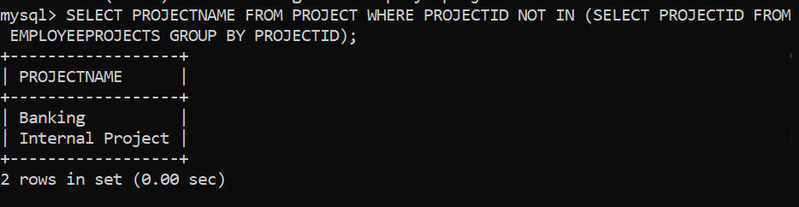

Correlated Subqueries

1. Display EmployeeName, Salary of employees whose salary is more than the average salary of the department they belong to.

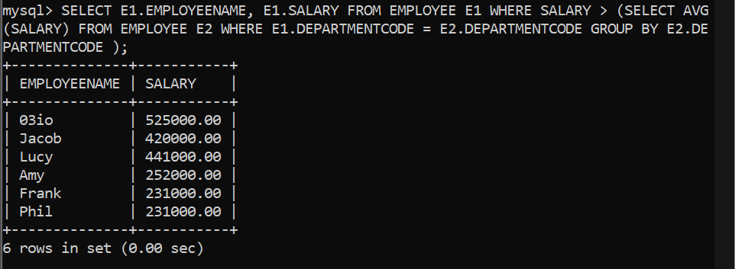  
2. Display EmployeeName of employees whose manager is younger than the employee.

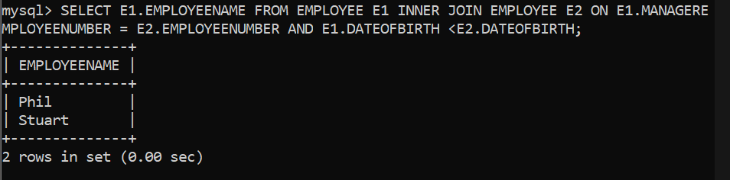

Inner Join

1. Display EmployeeName, DepartmentCode and DepartmentName of ALL employees.

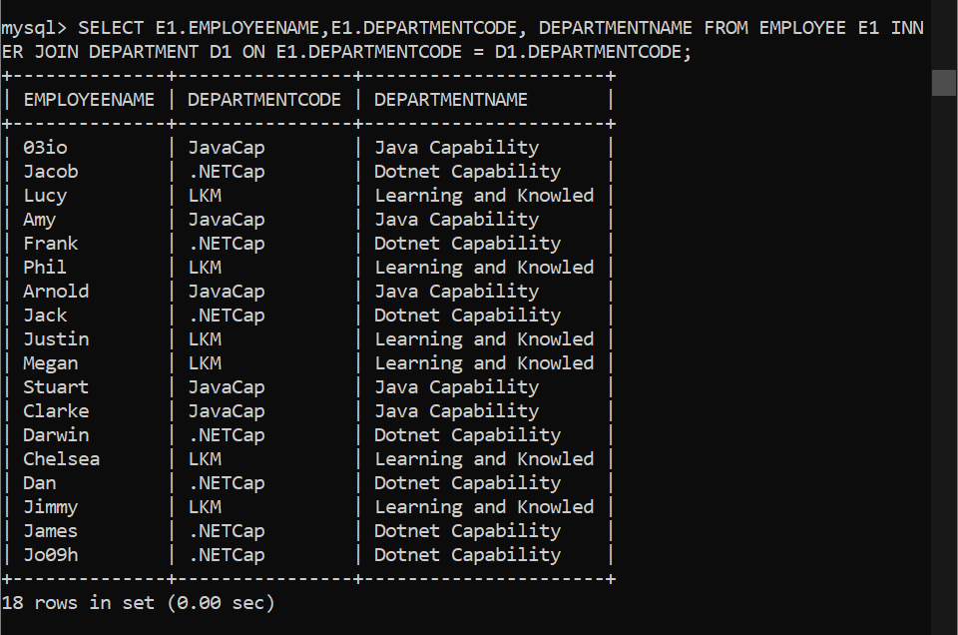  
2. Display EmployeeName, ProjectName and StartDate of employees who are currently working on the project (include only if EndDate is NULL).

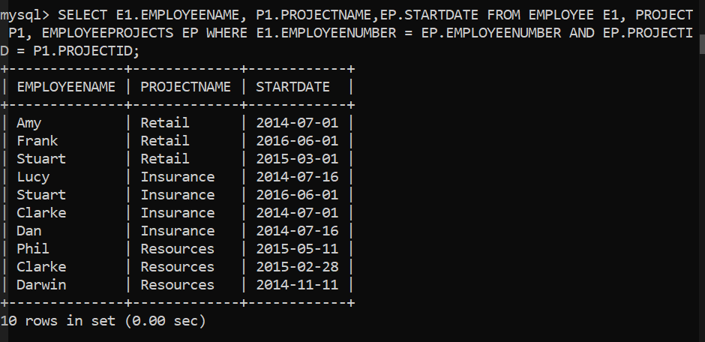

Outer Join

1. Display EmployeeName, ProjectId of ALL employees even if an employee is not assigned to any project (Include only if EndDate is Null).

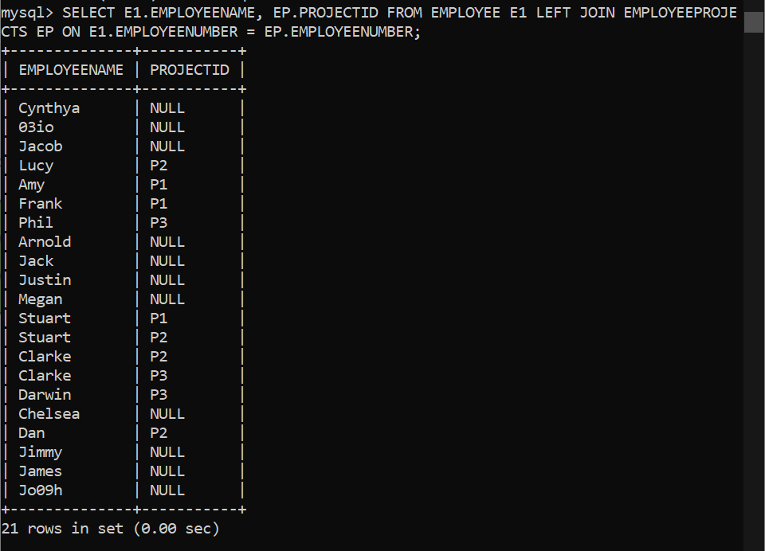

1. Display EmployeeName, ProjectId of ALL employees even if an employee not assigned to any project (Include only if EndDate is Null). Display “Not Allocated” if ProjectId is null.

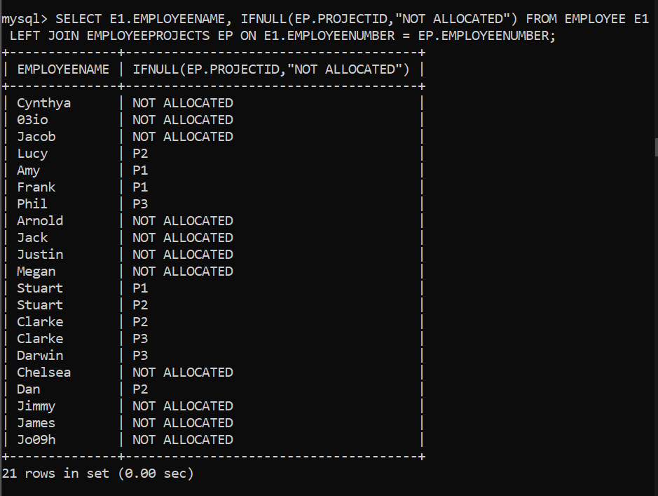

SELF Join

1. Display EmployeeName, DateOfBirth of Employee, ManagerName and DateOfBirth of Manager.

