**ENHANCED WEAPON DETECTION AND CLASSIFICATION USING YOLO-BASED OBJECT DETECTION FRAMEWORKS AND EMERGENCY ALERT SYSTEM**

**A PROJECT REPORT**

***Submitted by***

**SHAWN KUMAR RA2111003020471**

**SRIVATHSAN P RA2111003020474**

**SARVESH S.S RA2111003020645**

**Under the guidance of**

**Mr. B. Sachin Aditiya**

**Assistant Professor,**

**Department of Big Data Analytics and Cloud Computing**

***in partial fulfillment for the award of the degree of***

**BACHELOR OF TECHNOLOGY**

***in***

**COMPUTER SCIENCE AND ENGINEERING**

**of**

**FACULTY OF ENGINEERING AND TECHNOLOGY**



**S R M INSTITUTE OF SCIENCE AND TECHNOLOGY CHENNAI - 600089**

May 2025

**S R M INSTITUTE OF SCIENCE AND TECHNOLOGY**

**(Deemed to be University U/S 3 of UGC Act, 1956)**

**BONAFIDE CERTIFICATE**

Certified that this project report titled **“ENHANCED WEAPON DETECTION AND CLASSIFICATION USING YOLO-BASED OBJECT DETECTION FRAMEWORKS AND EMERGENCY ALERT SYSTEM”** is the Bonafide work of **SRIVATHSAN P [REG NO: RA2111003020474],** **SHAWN KUMAR B [REG NO: RA2111003020471], SARVESH S.S [REG NO: RA2111003020645]** who carried out the project work under my supervision. Certified further, that to the best of my knowledge, the work reported herein does not form any other project report or dissertation on the basis of which a degree or award was conferred on an occasion on this or any other candidate.

|  |  |
| --- | --- |
| SIGNATURE  **Mr.B. SACHIN ADITIYA, M.Tech.,**  **Assistant Professor**  Big Data Analytics and Cloud  Computing  S R M Institute of Science and  Technology, Chennai-89. | SIGNATURE  **Dr. J SUTHA, M.E., Ph.D.,**  **Professor & Head**  Computer Science and Engineering,  S R M Institute of Science and Technology,  Chennai-89. |

Submitted for the project viva-voce held on___________at S R M Institute of Science and Technology, Chennai -600089.

**INTERNAL EXAMINER EXTERNAL EXAMINER**

ii

**S R M INSTITUTE OF SCIENCE AND TECHNOLOGY,**

**CHENNAI - 89**

**DECLARATION**

We hereby declare that the entire work contained in this project report titled “**ENHANCED WEAPON DETECTION AND CLASSIFICATION USING YOLO-BASED OBJECT DETECTION FRAMEWORKS AND EMERGENCY ALERT SYSTEM**” has been carried out by **SRIVATHSAN P [REG NO: RA2111003020471],** **SHAWN KUMAR B [REG NO: RA2111003020471], SARVESH S.S [REG NO: RA2111003020645]** at SRM Institute of Science and Technology, Ramapuram, Chennai- 600089, under the guidance of **Mr. B. Sachin Aditiya, M.Tech., Assistant Professor**, Department of Big Data Analytics and Cloud Computing

**Place: Chennai**

**Date: SRIVATHSAN P**

**SHAWN KUMAR B**

**SARVESH S.S**

iii

 **Own Work Declaration**

Department of Computer Science and Engineering

**S R M Institute of Science and Technology**

**Own Work Declaration form**

**Degree/ Course :** B. Tech Computer Science and Engineering

**Student Name :** SRIVATHSAN P, SHAWN KUMAR B, SARVESH S.S

**Registration Number :** RA2111003020474, RA2111003020471, RA2111003030645

**Title of Work :** ENHANCED WEAPON DETECTION AND CLASSIFICATION USING YOLO-BASED OBJECT DETECTION FRAMEWORKS AND EMERGENCY ALERT SYSTEM

We hereby certify that this assessment complies with the University’s Rules and Regulations relating to Academic misconduct and plagiarism, as listed in the University Website, Regulations, and the Education Committee guidelines.

We confirm that all the work contained in this assessment is our own except where indicated, and that We have met the following conditions:

* Clearly references / listed all sources as appropriate
* Referenced and put in inverted commas all quoted text (from books, web, etc)
* Given the sources of all pictures, data etc. that are not our own
* Not made any use of the report(s) or essay(s) of any other student(s) either past or present
* Acknowledged in appropriate places any help that we have received from others (e.g., fellow students, technicians, statisticians, external sources)
* Compiled with any other plagiarism criteria specified in the Course handbook / University website

We understand that any false claim for this work will be penalized in accordance with the University

policies and regulations.

|  |
| --- |
| **DECLARATION:** |
| We are aware of and understand the University’s policy on Academic misconduct and plagiarism and we certify that this assessment is our own work, except where indicated by referring, and that we have followed the good academic practices noted above. |
| RA2111003020471 RA2111003020474 RA2111003020645 |

iv

**ACKNOWLEDGEMENT**

We place on record our deep sense of gratitude to our lionized Chairman **Dr. R. SHIVAKUMAR, MBBS., MD.,** for providing us with the requisite infrastructure throughout the course.

We take the opportunity to extend our hearty and sincere thanks to our **Dean, Dr. M. SAKTHI GANESH., Ph.D.,** for maneuvering us into accomplishing the project.

We take the privilege to extend our hearty and sincere gratitude to the Professor and Chairperson, **Dr. K. RAJA, Ph.D.,** for his suggestions, support and encouragement towards the completion of the project with perfection.

We thank our honorable Head of the department **Dr. J SUTHA, Professor & Head of Department, Department of Computer Science and Engineering** for his/her constant motivation and unwavering support.

We express our hearty and sincere thanks to our guide **Mr. B Sachin Aditiya, Assistant Professor, M.Tech, Assistant Professor** for his encouragement, consecutive criticism and constant guidance throughout this project work.

Our thanks to the teaching and non-teaching staff of the Department of Computer Science and Engineering of S R M Institute of Science and Technology, Chennai, for providing necessary resources for our project

v

**ABSTRACT**

The project titled "Enhanced Weapon Detection and Classification Using YOLO-Based Object Detection Frameworks and Emergency Alert System" is designed to strengthen public safety through the integration of artificial intelligence and real-time surveillance.

It employs the YOLOv5 algorithm, a state-of-the-art object detection model known for its speed and accuracy, to detect and classify weapons such as guns, knives, and other dangerous objects from live video feeds or static images.

By leveraging YOLOv5’s capabilities, the system can process frames in real-time, making it suitable for deployment in environments like airports, schools, public gatherings, and high-security zones. Upon identifying a weapon, the system instantly triggers an emergency alert mechanism that notifies local authorities, security personnel, or emergency responders through connected networks or integrated control systems.

This immediate response capability ensures that threats are addressed promptly, potentially preventing violence or escalation. The combination of automated detection and rapid communication significantly enhances situational awareness and safety, making the system a valuable tool in modern security infrastructures.

vi

# TABLE OF CONTENTS

## Page. No

**ABSTRACT vi**

**LIST OF FIGURES x**

**LIST OF ACRONYMS AND ABBREVIATIONS xi**

1. **INTRODUCTION 1**

1.1 Problem Statement 1

1.2 Aim of the Project 2

1.3 Project Domain 2

1.4 Scope of the Project 2

1.5 Methodology 3

1. **LITERATURE REVIEW 4**
2. **PROJECT DESCRIPTION 7**

3.1 Existing System 7

3.2 Proposed System 7

3.2.1 Advantages 7

3.3 Feasibility Study 8

* + 1. Economic Feasibility 8

vii

* + 1. Technical Feasibility 8
    2. Social Feasibility 8

3.4 System Specification 9

3.4.1 Hardware Specification 9

3.4.2 Software Specification 9

## PROPOSED WORK 10

* 1. General Architecture 10
  2. Design Phase 10
     1. Data Flow Diagram 11
  3. Module Description 12
     1. Module 1: Data Collection 12
     2. Module 2: Data Annotation 12
     3. Module 3: Data Augmentation 12
     4. Module 4: Processing of Data 13
     5. Module 5: Feature Extraction 14
     6. Module 6: Yolov5 Model Architecture 14
     7. Module 7: Training The Model 14
     8. Module 8: Real-Time Detection 15
     9. Module 9: Evaluate Custom YOLOv5 Detector

Performance 16

## IMPLEMENTATION AND TESTING 17

* 1. Input and Output 17
     1. Image of the Subject 17

viii

5.2 Testing 17

5.2.1 Unit Testing 18

Test Result 18

## RESULTS AND DISCUSSIONS 19

* 1. Efficiency of the Proposed System 19
  2. Comparison of Existing and Proposed System 19

## CONCLUSION AND FUTURE ENHANCEMENTS 20

* 1. Conclusion 20
  2. Future Enhancements 20
  3. Results 21

## SOURCE CODE & POSTER PRESENTATION 23

* 1. Sample Code 23

## References 29

## Sample screenshots

## Proof of Publication/Patent filed/ Conference Certificate

ix

**LIST OF FIGURES**

## Architecture Diagram of Weapon Detection Module 10

* 1. Data Flow Diagram of Weapon Detection 11
  2. Pre-processing of Data of weapon detection 13

## Training Model 15

* 1. Original Image of The Subject17

## 7.1 Model Predictions 21

7.2 Model Predictions21

7.3 Model Predictions22

7.4 Model Predictions 22

8 Sample Code 23

x

# LIST OF ACRONYMS AND ABBREVIATIONS

API APPLICATION PROGRAM INTERFACE

CBIR CONTENT BASED IMAGE RETRIEVAL

CNN CONVOLUTIONAL NEURAL NETWORK

xi

# CHAPTER 1

# INTRODUCTION

This project presents an advanced, real-time weapon detection and alert system designed to enhance public safety using deep learning technologies. Leveraging the YOLO (You Only Look Once) object detection model, the system accurately identifies a wide range of weapons in live video streams or static images.

Upon detection, it immediately triggers an emergency alert, ensuring rapid communication with law enforcement or security personnel. The system is trained on a diverse, multi-class weapon dataset and is engineered for deployment in high-risk environments such as schools, malls, public transport hubs, and critical infrastructure zones.

By automating the detection process and enabling instant alerts, the project addresses key limitations of traditional surveillance systems, ultimately contributing to a safer and more responsive security framework.

## PROBLEM STATEMENT

The growing incidence of armed violence in public spaces such as schools, airports, malls, and other high-risk areas has highlighted the need for faster and more reliable security solutions. Traditional surveillance systems, which depend heavily on manual monitoring and delayed response times, often fail to detect threats in real time, increasing the risk of harm.

A key challenge is the accurate and immediate identification of weapons from video streams or images, particularly under conditions such as poor lighting, occlusion, or crowded environments. Existing detection methods may suffer from low precision, high false alarm rates, or computational inefficiency, making them unsuitable for real-world deployment.

This project aims to overcome these limitations by developing a deep learning-based solution that uses the YOLO (You Only Look Once) object detection framework to provide fast, accurate, and efficient weapon recognition in real-time surveillance scenarios.

* 1. **AIM OF THE PROJECT**

The aim of this project is to develop a real-time weapon detection system using the YOLO (You Only Look Once) deep learning framework to accurately identify and classify various types of weapons from images and live video streams, thereby enhancing security and enabling faster threat detection in public and high-risk environments.

## PROJECT DOMAIN

**Domain:** Computer Vision and Deep Learning (Artificial Intelligence)This project belongs to the field of Computer Vision, a branch of Artificial Intelligence (AI) that focuses on teaching machines to process and interpret visual data from their environment. It specifically uses Deep Learning methods, applying Convolutional Neural Networks (CNNs) for real-time weapon detection. Additionally, the project fits into the broader category of Smart Surveillance and Security Systems, aiming to improve public safety through intelligent and automated monitoring technologies.

## SCOPE OF THE PROJECT

The scope of this project is to design and implement a real-time weapon detection system using the YOLO deep learning framework to enhance security in public and high-risk environments. The system is capable of identifying multiple classes of weapons—such as guns, knives, and rifles—from both static images and live video streams with high accuracy and speed.

This solution can be integrated into existing surveillance infrastructures across various domains, including educational institutions, airports, shopping malls, banks, and government facilities. By minimizing human intervention and reducing response time, the system addresses key limitations of traditional security approaches.

The project also emphasizes adaptability and scalability, allowing for future enhancements such as integration with behavioural analysis, drone surveillance, or thermal imaging, making it suitable for both indoor and outdoor deployments in diverse lighting and environmental conditions.

## METHODOLOGY

The project followed a systematic approach, starting with the creation of a custom dataset comprising images of nine different weapon types. These images were collected from various online sources and carefully filtered to eliminate duplicates and irrelevant entries. To enhance the dataset and improve model generalization, data augmentation techniques such as rotation, scaling, flipping, and brightness adjustments were applied.

Each image was annotated and converted into YOLO-compatible format, enabling the model to learn object locations effectively. Preprocessing steps including image resizing and normalization were conducted to ensure uniformity and readiness for training. The YOLO object detection model was then trained on this dataset, with hyperparameters fine-tuned to optimize both accuracy and speed.

Post-training, the model was integrated into a real-time detection pipeline using OpenCV, allowing it to process live video streams and identify weapons with bounding boxes and associated confidence scores. The system’s performance was assessed using evaluation metrics such as precision, recall, and mean average precision (mAP). It was tested under diverse conditions including low lighting, partial occlusion, and crowded scenes to validate its robustness and effectiveness for real-world deployment.

# CHAPTER 2

# LITERATURE REVIEW

This chapter provides a comprehensive review of existing research and academic publications related to real-time weapon detection using deep learning techniques. It highlights significant advancements in the field, particularly the evolution of object detection frameworks such as YOLO, and their application in security and surveillance systems. Through this review, key findings, technological progress, and various methodologies are discussed, offering insight into current state-of-the-art solutions. A critical comparison of different approaches also helps identify existing gaps, challenges, and opportunities for further improvement. This chapter is crucial in positioning the project within the broader research landscape, building upon prior work to develop a more accurate, efficient, and reliable weapon detection and alert system.

Diwan, Tausif, G. Anirudh, and Jitendra V. Tembhurne [1]

This study provides a comprehensive overview of object detection using the YOLO architecture, exploring its evolution, challenges, datasets, and applications. It highlights the progression from YOLOv1 to YOLOv5, emphasizing improvements in speed and accuracy. The authors discuss the algorithm's wide applicability, including surveillance and autonomous systems, while also acknowledging challenges in small object detection and real-time processing. This work serves as a foundation for understanding the strengths and limitations of YOLO-based detection systems.

Keerthana, S. M., R. Sujitha, and P. Yazhini [2]

The authors propose a YOLO-based weapon detection system integrated with an email alert mechanism to enhance security. Their approach aims to identify weapons in real-time from surveillance footage, demonstrating effective use of YOLO for safety-critical applications. The paper emphasizes rapid alerting and system responsiveness, while also identifying challenges in maintaining detection accuracy under varied conditions. It offers practical insights into deploying YOLO for real-world surveillance.

Narejo, Sanam, et al. [3]

This research focuses on YOLOv3 for weapon detection in smart surveillance systems. It showcases the model's potential for identifying threats in real-time and underscores its significance for automated

security. The study includes evaluation metrics that support YOLOv3’s effectiveness but also points out performance limitations in low-light and occluded environments. It contributes to the understanding of YOLOv3’s applicability in smart city surveillance.

Li, Bo, Shengbao Huang, and Guangjin Zhong [4]

The paper introduces LTEA-YOLO, an improved version of YOLOv5s optimized for small object detection. The proposed enhancements improve the model’s performance in detecting smaller weapons with higher accuracy and better localization. The study supports the idea of tailoring YOLO architectures to specific detection challenges, making it relevant for weapon recognition tasks in crowded or complex visual scenarios.

Akhila, Kambhatla, and Khaled R. Ahmed [5]

This paper examines deep learning-based weapon detection systems in the context of preventing lone wolf attacks. It evaluates multiple real-time techniques, emphasizing the critical role of detection speed and system precision. The study highlights the potential of combining deep learning and surveillance to proactively respond to emerging security threats, offering strategic insights into modern security infrastructures.

Rahil, I. M. A. N. E., et al. [6]

The authors propose an enhanced real-time handgun detection model using YOLOv5 on a newly constructed dataset. Their results show improved detection accuracy and reduced false positives. The study also emphasizes the importance of dataset quality and diversity in achieving reliable detection outcomes. This work contributes to improving handgun detection in dynamic and variable environments.

Torregrosa-Domínguez, Ángel, et al. [7]

This study investigates practical enhancements for real-time weapon detection in industrial settings. It explores optimization strategies to improve inference speed and detection accuracy. The paper offers valuable guidance on adapting YOLO models to specific use cases, such as surveillance in factories or sensitive work zones, and improving their deployment readiness.

Ashraf, Abdul Hanan, et al. [8]

The authors utilize CNN and YOLOv5s for developing a robust weapon detection system for video surveillance. Their method balances speed and accuracy, with an emphasis on lightweight deployment. The study validates the YOLOv5s model’s adaptability to different environments and surveillance angles, further proving its effectiveness in public safety scenarios.

Bhatti, Muhammad Tahir, et al. [9]

This research presents a real-time weapon detection system using deep learning in CCTV footage. The authors integrate YOLO-based models to detect firearms, highlighting improvements in detection latency and accuracy. The study supports the integration of such systems into existing surveillance infrastructure and outlines key challenges in scalability and processing overhead.

Noor, Wan Emilya Izzety and Naimah Mat Isa [10]

The study explores harmful weapon detection using YOLOv4, applying the model to surveillance video data. It demonstrates good accuracy in various testing conditions, including partial occlusions. While the system shows promise for real-time application, the authors discuss the need for further improvements in robustness and false-positive reduction. This research underscores the relevance of YOLOv4 in early weapon detection efforts.

# 

**CHAPTER 3**

**PROJECT DESCRIPTION**

## EXISTING SYSTEM

The current security and surveillance systems in most public and high-risk environments primarily rely on manual monitoring through CCTV cameras. These systems depend heavily on human operators to identify threats such as the presence of weapons, which introduces delays and the possibility of human error or oversight. Additionally, some existing automated systems use basic motion detection or single-object classification methods, which are often limited in scope and accuracy. These systems struggle to detect multiple types of weapons, especially under varying conditions like poor lighting, occlusion, or crowd density, and typically lack the ability to provide real-time response or multi-class object recognition.

## PROPOSED SYSTEM

The proposed system introduces a deep learning-based, real-time weapon detection framework using the YOLO (You Only Look Once) object detection model. Unlike traditional surveillance systems, this solution is capable of detecting and classifying multiple weapon types including handguns, rifles, knives, and more in both static images and live video feeds with high accuracy and speed. The system uses a custom-trained YOLO model, built on a diverse and augmented dataset, to ensure robust performance across different environments. By automating the detection process and reducing reliance on manual monitoring, the proposed system enables faster threat recognition, minimizes false positives, and enhances public safety through intelligent surveillance.

* + 1. **ADVANTAGES**
* Real-time weapon detection using YOLO.
* High accuracy in identifying multiple weapon types.
* Supports multi-class weapon classification (e.g., knife, rifle, handgun).
* Reduces reliance on manual surveillance.
* Effective under varying lighting and environmental conditions.
* Easily integrable with existing security systems.
* Scalable for use in public and high-risk areas.

## FEASIBILITY STUDY

A feasibility study was conducted to evaluate the viability of implementing the proposed weapon detection system. The study considered several key aspects, including technical, operational, and economic feasibility, as outlined below:

* Technical Feasibility
* Operational Feasibility
* Economic Feasibility
  + 1. **TECHNICAL FEASIBILITY**

The system is technically feasible due to the availability of mature deep learning frameworks such as YOLO, TensorFlow, and PyTorch. The project utilizes readily available hardware such as webcams and GPUs for real-time processing. Additionally, tools for data collection, augmentation, and annotation are accessible and well-documented, making development and deployment technically practical.

* + 1. **OPERATIONAL FEASIBILITY**

The system is designed to operate in real-time with minimal human intervention. Its integration into existing CCTV and surveillance infrastructure is straightforward, requiring only camera access and basic computing hardware. Automated detection and alerting reduce the burden on security personnel, improving overall operational efficiency.

* + 1. **ECONOMIC FEASIBILITY**

The proposed system is cost-effective compared to manual surveillance or proprietary commercial solutions. Most of the tools used are open-source, and the hardware requirements are moderate, allowing deployment even in budget-constrained environments such as schools and small institutions. The long-term savings from reduced manpower and enhanced threat response justify the initial investment

## SYSTEM SPECIFICATION

An effective system is crucial for any computational task. It's important to have the correct hardware and software components to ensure everything runs smoothly. From strong processors to essential software packages, each part helps create an efficient environment for data analysis and machine learning tasks

* + 1. **HARDWARE SPECIFICATION**
* Processor: Intel 10th gen or higher with i5, i7 or i9
* Ethernet connection (LAN) OR a wireless adapter (Wi-Fi)
* Hard Drive: Minimum 100 GB; Recommended 200 GB or more
* Memory (RAM): Minimum 8 GB; Recommended 32 GB or above
  + 1. **SOFTWARE SPECIFICATION**
* Python
* Anaconda
* Jupyter Notebook
* TensorFlow
* Keras
* opencv-python
* pandas
* matplotlib

**CHAPTER 4**

**PROPOSED WORK**

## GENERAL ARCHITECTURE

## Generated image

Figure 4.1: **Architecture Diagram of Weapon Detection Module**

.

## DESIGN PHASE

During the design phase, a Data Flow Diagram (DFD) is developed to represent the flow of data within the system. This diagram illustrates how data moves between different components, such as input sources, processing modules, and output systems. For this project, the DFD provides a clear visualization of the interaction between the input sources (like database images and live webcam), preprocessing steps, the YOLO-based detection model, and the final output. This helps in understanding the system’s architecture and ensures that the design aligns with the project’s objectives efficiently.

* + 1. **DATA FLOW DIAGRAM**

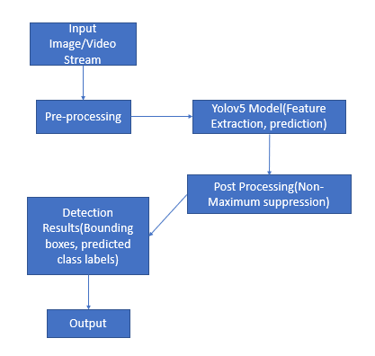

Figure 4.2: **Data Flow Diagram of Weapon Detection**

Figure 4.2 The data flow diagram illustrates the image processing pipeline used in this project. The process begins with input sources such as database images and live webcam feeds. These inputs undergo pre-processing to improve image quality and remove noise. Following this, feature extraction identifies key visual elements essential for detection. The refined features are then passed into the YOLO algorithm, which performs real-time object detection and classification. Finally, the output displays the detected objects along with their labels and confidence scores.

## MODULE DESCRIPTION

The following modules form the core components of our image processing and analysis pipeline, each serving a distinct yet interconnected role in skin lesion detection using YOLOv5: Data Collection, Data Annotation, Data Augmentation, Preprocessing, Feature Extraction, YOLOv5 Model Architecture, Training the Model, Real-time Detection.

* + 1. **MODULE-1: DATA COLLECTION**

High-quality surveillance images and video frames are collected from public datasets such as Open Images Dataset (OID), WIDER Face, and Custom Security Footage containing labeled instances of weapons like guns, knives, and explosives. These datasets encompass various environments (indoor, outdoor, crowded scenes) to ensure model robustness. Additional footage can be gathered from CCTV systems or simulated scenarios to further expand and diversify the dataset.

* + 1. **MODULE-2: DATA ANNOTATION**

Each image or video frame is manually annotated to detect and classify visible weapons. Tools such as Roboflow, LabelImg, or makesense.ai are used to draw bounding boxes around weapons and assign class labels (e.g., gun, knife). The annotations are saved in the YOLO format (class_id, x_center, y_center, width, height). Precise annotation ensures the model can accurately localize and identify weapons during training and real-time detection.

* + 1. **MODULE-3: DATA AUGMENTATION**

To improve the robustness and generalization of the weapon detection model, data augmentation techniques are applied to artificially increase the size and diversity of the training dataset. Common transformations include rotation, horizontal and vertical flipping, scaling, cropping, brightness and contrast adjustments, Gaussian noise, and blur effects. These techniques simulate real-world conditions such as varying camera angles, lighting environments, motion blur, and partial occlusions. By exposing the model to a wide range of visual scenarios during training, data augmentation helps the model learn more discriminative features, enhances detection accuracy in complex backgrounds, and reduces the risk of overfitting to specific patterns in the dataset.

* + 1. **MODULE-4: PROCESSING OF DATA**
       - The Images are standardized by resizing them to a fixed resolution, typically 640×640 pixels, and normalizing pixel values to a 0–1 range to ensure uniformity across the dataset. In the context of weapon detection, additional preprocessing steps may include background blurring, noise reduction, and sharpening to highlight object edges and improve feature clarity.
       - These steps help eliminate irrelevant artifacts and enhance the visual quality of the weapon regions, ensuring that the input data is clean and consistent before being fed into the detection model. Effective preprocessing significantly contributes to better model performance during training and inference.

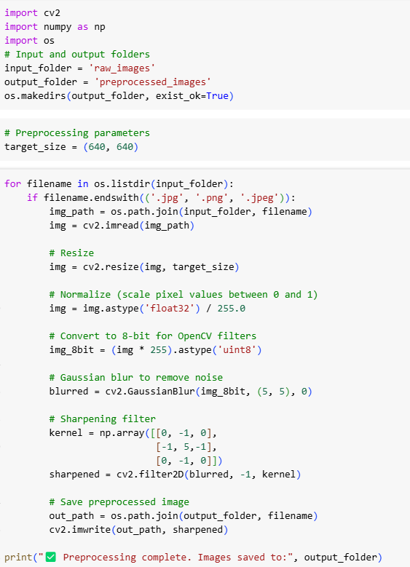

Figure 4.3: **Pre-processing of Data of weapon detection**

* + 1. **MODULE-5: FEATURE EXTRACTION**

This project focuses on developing an efficient weapon detection system using YOLOv5, an advanced object detection model. By leveraging YOLOv5’s architecture, the system can automatically extract relevant features from images, such as the shape, size, and context of objects, to accurately detect and classify various types of weapons. The model will be trained on a dataset of images containing different weapons and be able to differentiate between weapons and non-weapon objects in real-time, providing a reliable solution for security applications.

* + 1. **MODULR-6: YOLOv5 MODEL ARCHITECTURE**

YOLOv5’s The YOLOv5 model serves as the core of the weapon detection system, enabling fast and accurate real-time identification of harmful objects.

It operates through three main components:

* + - * Backbone: Utilizes convolutional layers to extract rich visual features such as object contours, textures, and shapes from input frames, essential for identifying weapons like knives or firearms.
      * Neck: Combines features at multiple scales using Feature Pyramid Network (FPN) and Path Aggregation Network (PANet), allowing the model to detect both small concealed weapons and larger, more obvious ones.
      * Head: Performs final predictions by generating bounding boxes, object classes (e.g., “Gun”, “Knife”), and associated confidence scores for each detection.

YOLOv5’s efficiency and speed make it highly suitable for real-time surveillance and security systems, enabling immediate threat recognition and alerting.

* + 1. **MODULE-7: TRAINING THE MODEL**

The annotated dataset is used to train the YOLOv5 model over 200 epochs, with a batch size of 16 and image size of 416×416 pixels. The training process fine-tunes the model’s ability to:

Classify different types of weapons, Localize them with bounding boxes, and Score detections with confidence values. It uses a composite loss function that balances classification, localization, and objectness. The model’s effectiveness is evaluated using key metrics such as:

mean Average Precision (mAP), Precision, Recall, and F1-score.

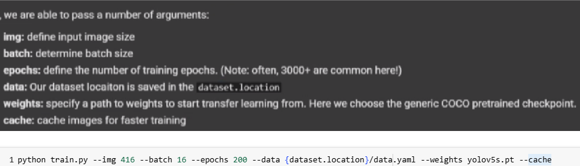

Figure 4.4: **Training Model**

* + 1. **MODULE-8: REAL-TIME DETECTION**

In the Real-Time Detection module, YOLOv5 is utilized to process live video streams, enabling the immediate detection of weapons as they appear in the footage. Each frame from the video feed is passed through the trained YOLOv5 model, which performs object detection to identify and classify weapons, such as guns or knives, in real-time. The system overlays bounding boxes around the detected objects and displays their respective labels, such as "Gun" or "Knife," along with confidence levels (e.g., “Knife: 95%”). This instant processing capability ensures that any potential threats are identified quickly, allowing security personnel or automated systems to respond immediately.

By leveraging the high-speed inference of YOLOv5, the module can handle live video feeds efficiently, providing accurate and fast weapon detection. This functionality is crucial in security settings where timely intervention is necessary, such as public spaces, airports, and surveillance systems. With real-time feedback, the system not only aids in threat detection but also supports proactive security measures.

* + 1. **MODULE-9: EVALUATE CUSTOM YOLOV5 DETECTOR PERFORMANCE**

In the Evaluate Custom YOLOv5 Detector Performance module, the trained model’s performance is assessed using the mAP_0.5 (mean Average Precision at 0.5 IoU) metric, which is a standard evaluation metric for object detection tasks. During training, losses and performance metrics are logged to both TensorBoard and a log file, allowing for a comprehensive analysis of the model's progress. To visualize and monitor the training process, TensorBoard is used, enabling easy tracking of metrics like loss curves and precision-recall trends. The code %load_ext tensorboard and %tensorboard --logdir runs is executed in the notebook to launch TensorBoard, providing real-time visual feedback on training performance. This evaluation step is crucial for identifying areas of improvement and ensuring that the custom YOLOv5 model achieves optimal accuracy for weapon detection.

# CHAPTER 5

# IMPLEMENTATION AND TESTING

## INPUT AND OUTPUT

* + 1. **IMAGE OF THE SUBJECT**
* A random gun has been selected from the 416 gun images for evaluation of the model.
* This image is fed into the Neural Network and the network gives a output of what the predicted gun would look like for the input image.
* **Figure 5.1** below shows the original, augmented image of the subject

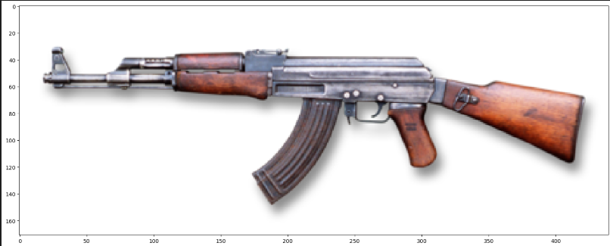

Figure 5.1: **Original Image Of The Subject**

## TESTING

In weapon detection using YOLOv5, testing serves to validate whether the trained model accurately detects and classifies weapons in unseen images or video frames. This ensures that the custom YOLOv5 detector generalizes well and performs reliably outside the training dataset. Testing is conducted to confirm whether the model can correctly identify weapons such as guns or knives, capturing key features while maintaining high detection accuracy. The process involves a detailed evaluation to verify that the model consistently meets its objective of real-time and accurate weapon detection in practical scenarios.

* + 1. **UNIT TESTING**

Unit testing ensures that individual components of the system—such as model loading, frame processing, detection logic, and output formatting—work as expected in isolation. This helps identify bugs early, verify correct function behavior, and ensure that each unit of the detection pipeline performs reliably before full-scale integration. Unit tests are especially useful for maintaining code quality and catching issues during model updates or deployment changes.

**TEST RESULT**

* The YOLOv5 model is loaded using the custom weight file best.pt.
* Dummy input of shape (1, 3, 640, 640) is used to simulate a test image for inference.
* The unit test confirms successful model loading without errors.
* Inference test validates that the model returns predictions for a given input.
* All test cases pass, verifying the core components of model loading and detection.

**CHAPTER 6**

# RESULTS AND DISCUSSIONS

## EFFICIENCY OF THE PROPOSED SYSTEM

The developed weapon detection system achieves high performance in both speed and accuracy by utilizing YOLOv5. Its real-time processing enables quick identification of weapons in live video feeds, making it well-suited for surveillance purposes. Each video frame is analysed within milliseconds, ensuring immediate threat detection and alert generation. Automating this process removes the delays and errors associated with manual monitoring, particularly those caused by human fatigue. The system's high precision and low false positive rate, driven by YOLOv5, further enhance its reliability. As a result, it is highly effective for securing sensitive areas like airports, educational institutions, and public venues.

## COMPARISON OF EXISTING AND PROPOSED SYSTEM

The proposed weapon detection system provides major advancements compared to traditional surveillance methods. Conventional systems depend heavily on manual monitoring or simple motion detection, making them slow, error-prone, and less responsive. In contrast, this system adopts a deep learning-based approach using the YOLO object detection framework, enabling rapid and accurate real-time weapon identification.

# CHAPTER 7

**CONCLUSION AND FUTURE ENHANCEMENTS**

## CONCLUSION

This project successfully demonstrates the implementation of a real-time weapon detection system using the YOLO object detection framework integrated with GSM-based emergency alerts. By training a YOLO model on a custom dataset of nine weapon categories, the system achieved fast and accurate identification of weapons in live camera feeds and static images. The use of YOLO ensures minimal computational overhead while maintaining high detection precision, making the system suitable for real-world deployments in public safety environments. Furthermore, the integration with a GSM module ensures prompt communication with law enforcement, even in areas with limited internet connectivity. Overall, this intelligent surveillance solution marks a significant step toward automated threat detection and rapid emergency response.

## FUTURE ENHANCEMENTS

1. Integration of Behavior Analysis: Extend the system to detect suspicious human behavior (e.g., aggressive postures or sudden movements) using pose estimation and action recognition models.
2. Thermal and Night Vision Support: Integrate thermal imaging and low-light camera support for accurate weapon detection in dark or adverse lighting conditions.
3. Drone Surveillance: Deploy the system on drones for real-time monitoring of large or hard-to-reach public areas during events or emergencies.
4. Scalability and API Integration: Create an API service to integrate this system with existing security platforms, enabling centralized monitoring and alert management.
5. Audio and Face Recognition Fusion: Combine weapon detection with audio (e.g., gunshot detection) and face recognition modules to build a multi-modal threat detection framework
   1. **RESULTS:**

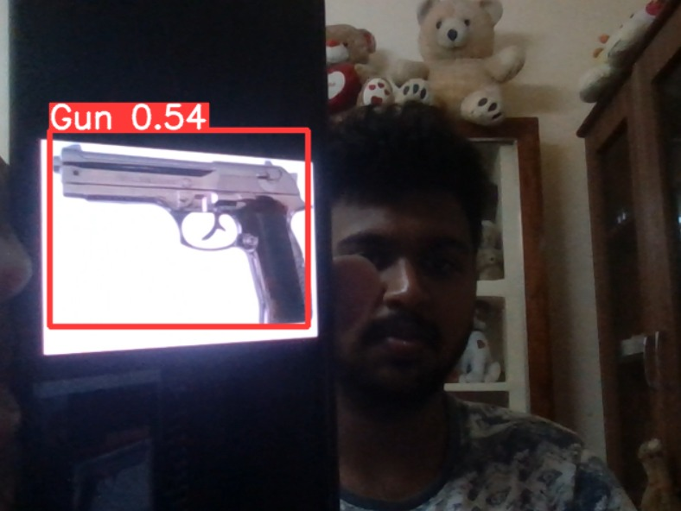

Figure 7.1: **Model** **Predictions**

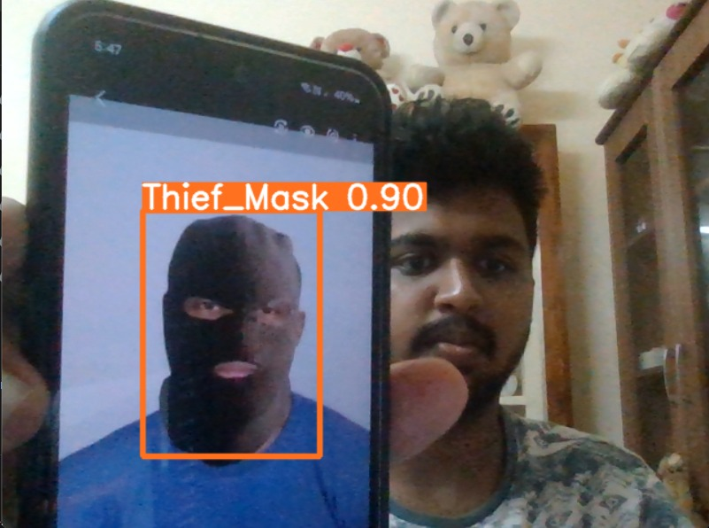

Figure 7.2: **Model Predictions**

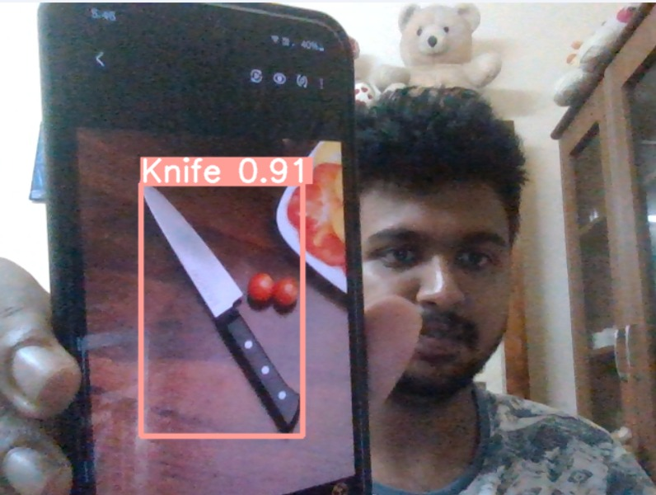

Figure 7.3: **Model Predictions**

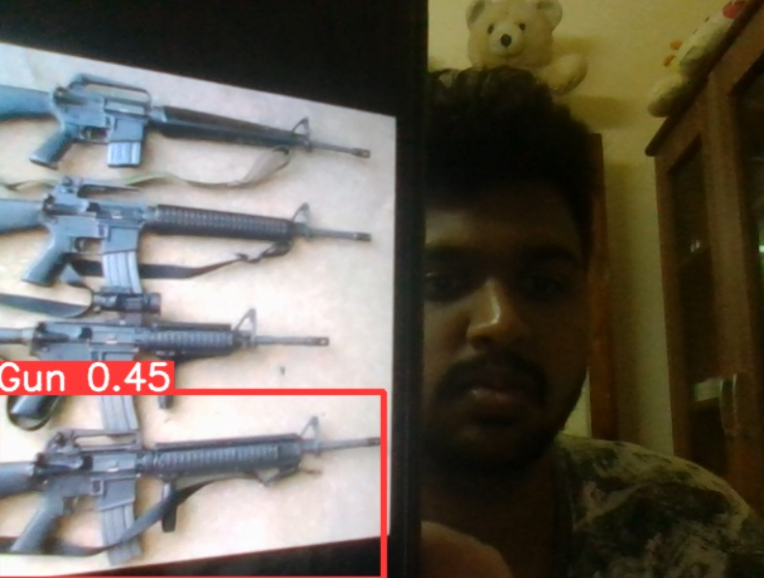

Figure 7.4: **Model Predictions**

# CHAPTER 8

**SOURCE CODE & POSTER PRESENTATION**

## 8.1 SAMPLE CODE



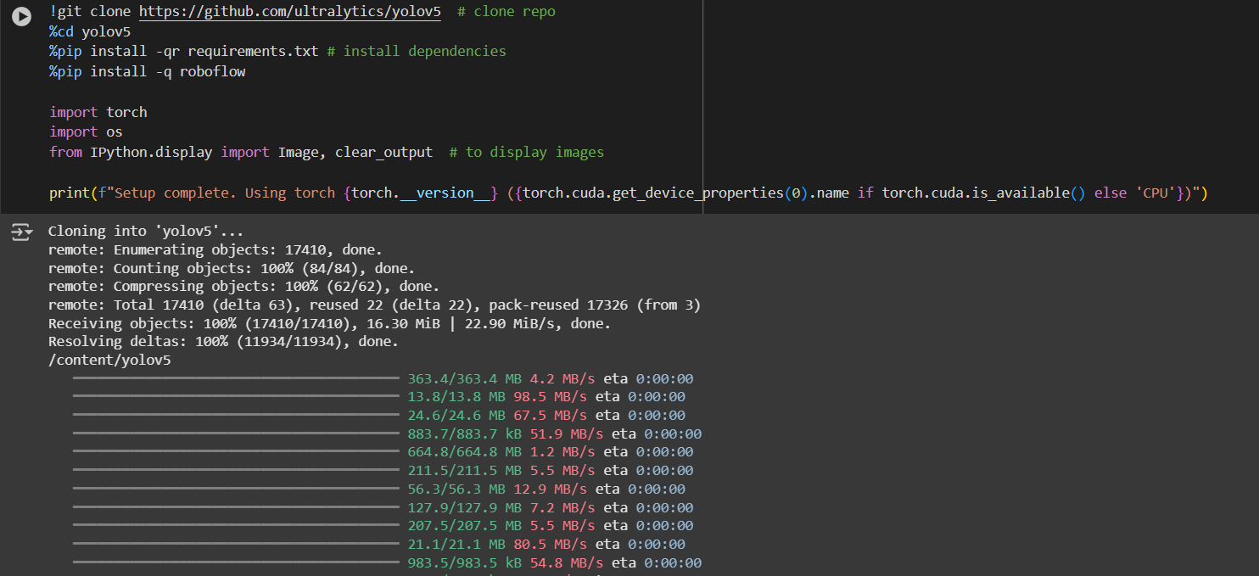

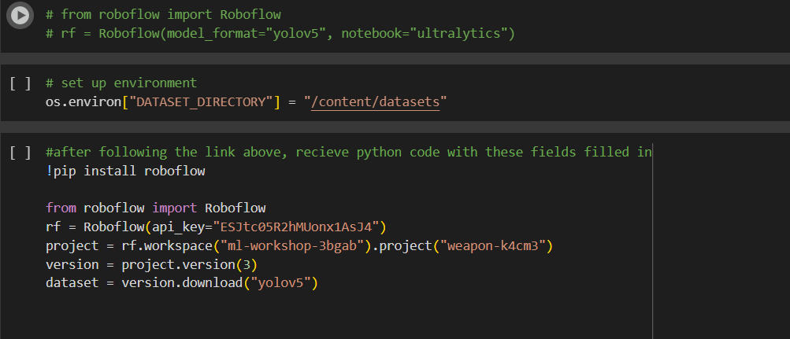





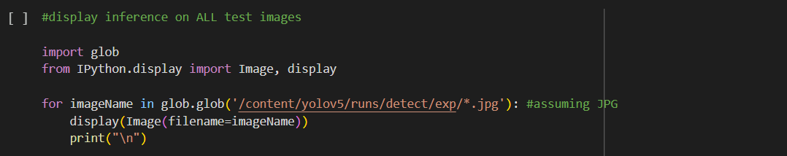

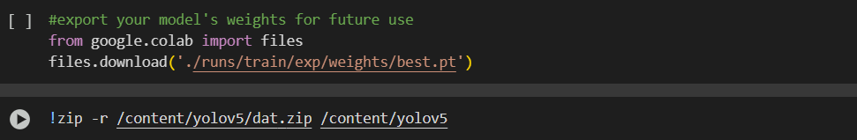

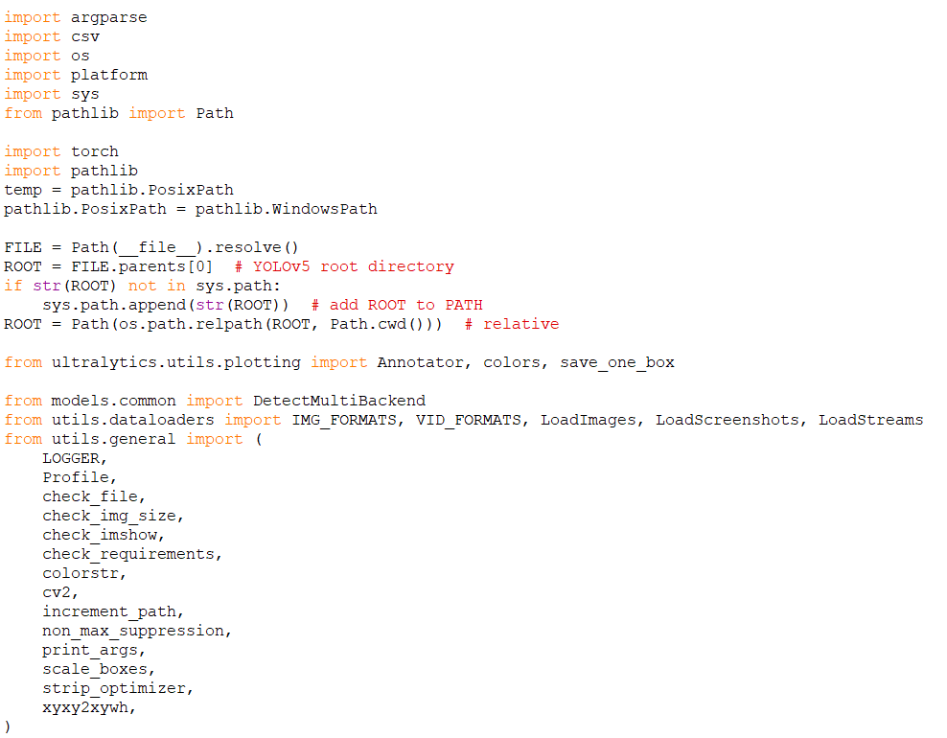

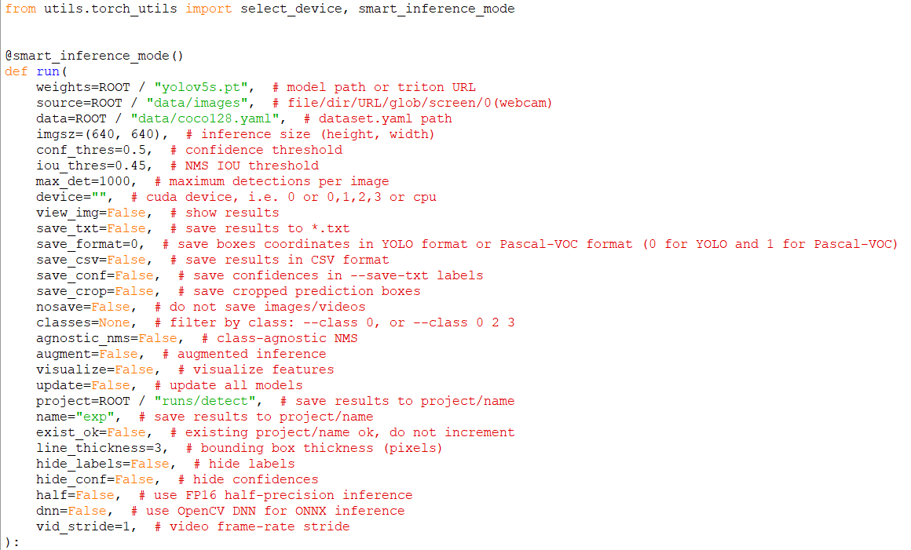

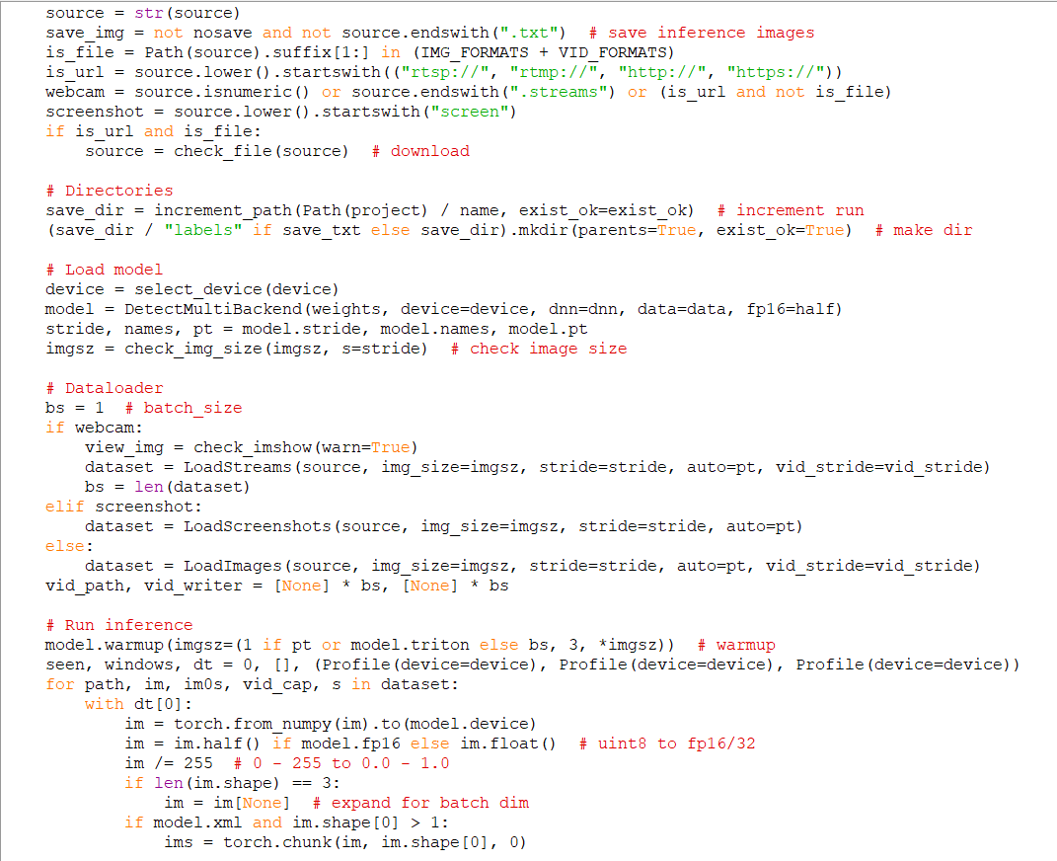

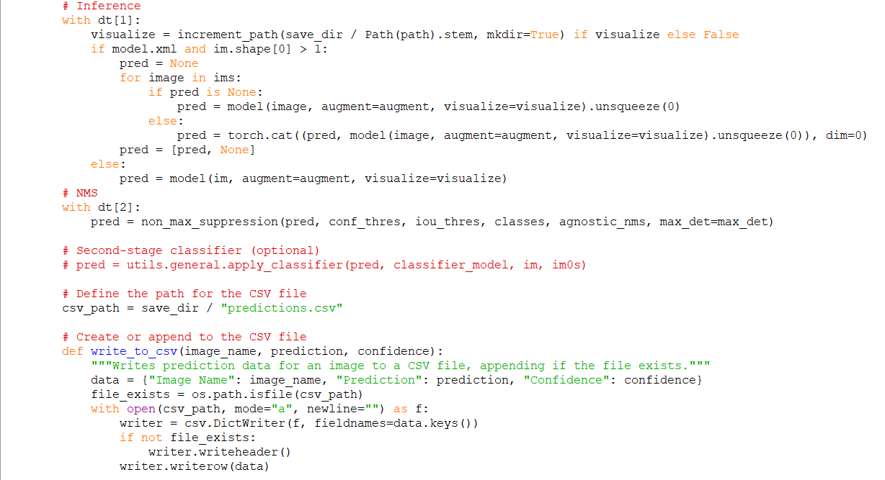

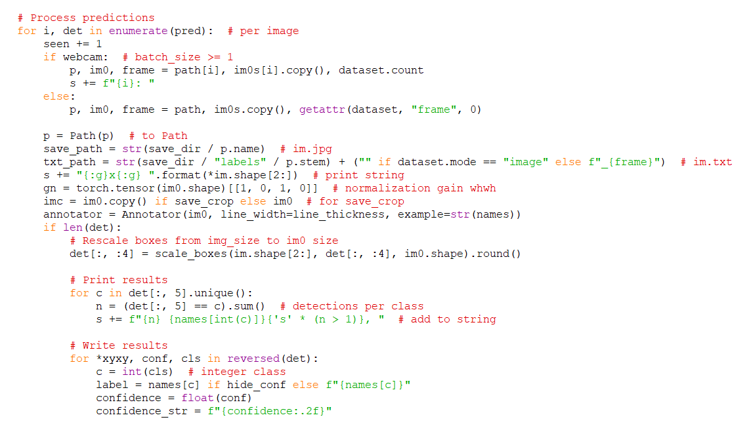

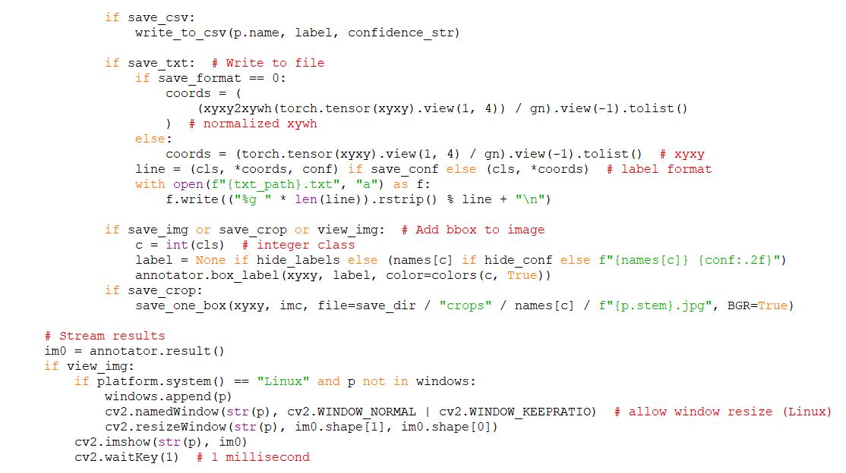

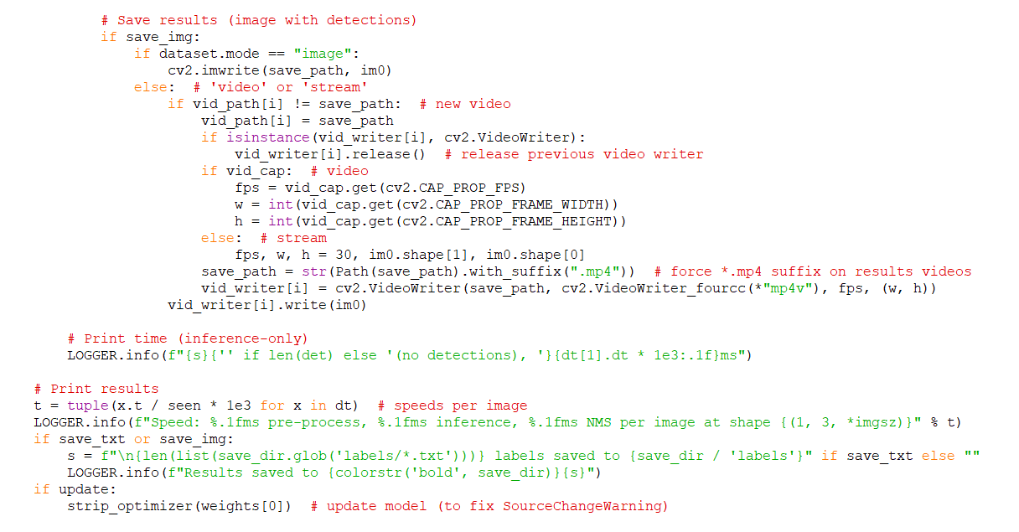

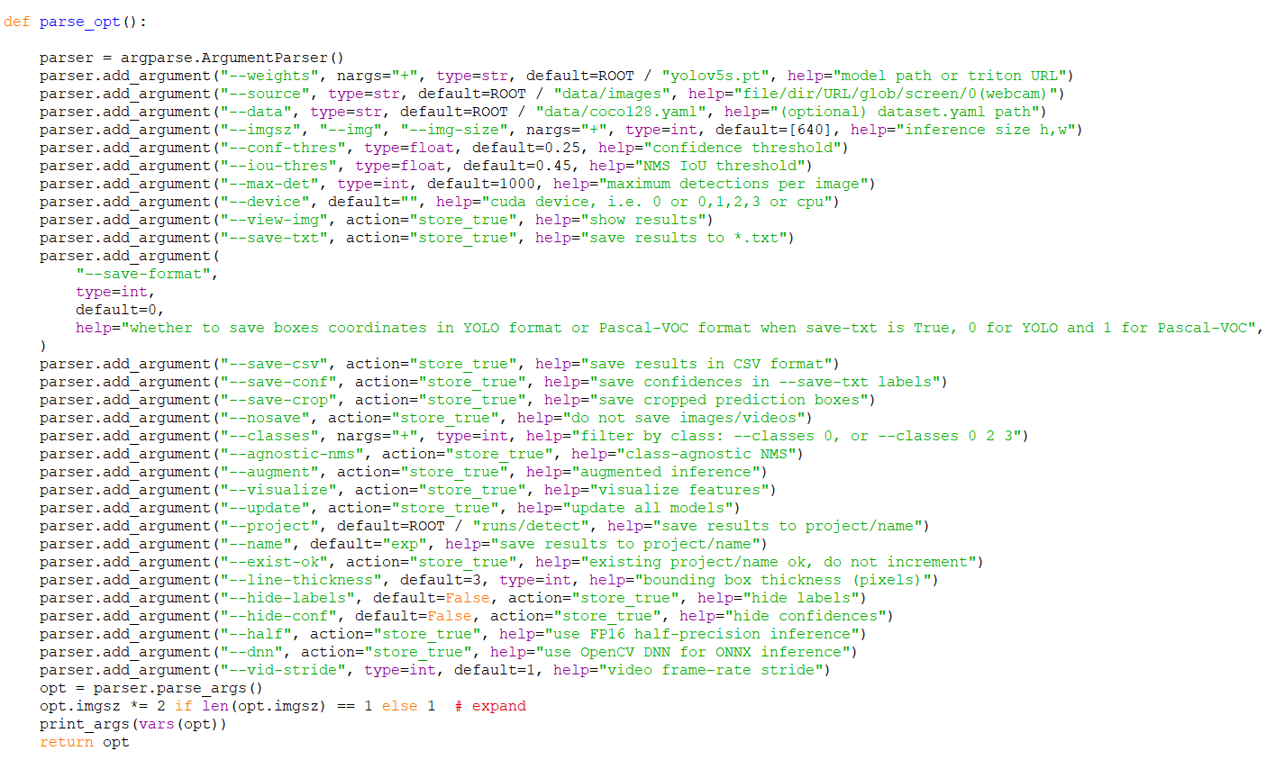

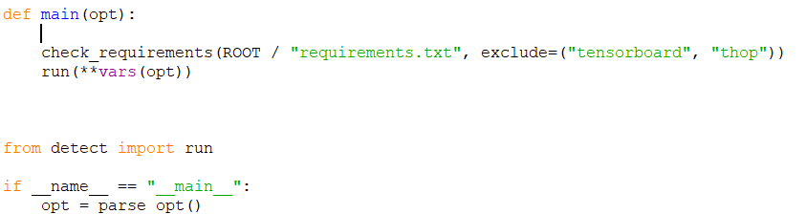

**REFERENCES**

[1] Diwan, Tausif, G. Anirudh, and Jitendra V. Tembhurne. "Object detection using YOLO: Challenges, architectural successors, datasets and applications." *multimedia Tools and Applications* 82.6 (2023): 9243-9275.

[2] S. M. Keerthana, R. Sujitha and P. Yazhini, "Weapon Detection for Security Using the Yolo Algorithm with Email Alert Notification," *2024 International Conference on Innovations and Challenges in Emerging Technologies (ICICET)*, Nagpur, India, 2024, pp. 1-6, doi: 10.1109/ICICET59348.2024.10616365.

[3] Narejo, Sanam, et al. "Weapon detection using YOLO V3 for smart surveillance system." *Mathematical Problems in Engineering* 2021.1 (2021): 9975700.

[4] Li, Bo, Shengbao Huang, and Guangjin Zhong. "LTEA-YOLO: an improved yolov5s model for small object detection." *IEEE Access* (2024).

[5] Akhila, Kambhatla, and Khaled R. Ahmed. "Real Time Deep Learning Weapon Detection Techniques for Mitigating Lone Wolf Attacks." *arXiv preprint arXiv:2405.14148* (2024).

[6] Rahil, I. M. A. N. E., et al. "an Improved Real-Time Handgun Detection System Using Yolo V5 on a Novel Dataset." *J. Theor. Appl. Inf. Technol* 101.23 (2023): 7674-7688.

[7] Torregrosa-Domínguez, Ángel, et al. "Effective strategies for enhancing real-time weapons detection in industry." *Applied Sciences* 14.18 (2024): 8198.

[8] Ashraf, Abdul Hanan, et al. "Weapons detection for security and video surveillance using cnn and YOLO-v5s." *CMC-Comput. Mater. Contin* 70.4 (2022): 2761-2775.

[9] Bhatti, Muhammad Tahir, et al. "Weapon detection in real-time cctv videos using deep learning." *Ieee Access* 9 (2021): 34366-34382.

[10] Noor, Wan Emilya Izzety Binti Wan, and Naimah Mat Isa. "Object Detection: Harmful Weapons Detection using YOLOv4." *2021 IEEE Symposium on Wireless Technology & Applications (ISWTA)*. IEEE, 2021

|  |  |  |
| --- | --- | --- |
| SRM INSTITUTE OF SCIENCE AND TECHNOLOGY  (Deemed to be University u / s 3 of UGC Act, 1956) | | |
| Office of Controller of Examinations | | |
| REPORT FOR PLAGIARISM CHECK ON THE DISSERTATION / PROJECT REPORT FOR UG / PG PROGRAMMES  **(To be attached in the dissertation / project report)** | | |
| 1 | Name of the Candidate **(IN BLOCK LETTERS)** | SHAWN KUMAR B  SRIVATHSAN P  SARVESH SS |
| 2 | Address of Candidate | Bharathi Salai, Chennai -600089  **Mobile Number: +**91 93429 42697, +91 86106 19556,  +91 93429 99755 |
| 3 | Registration Number | RA2111003020471, RA2111003020474, RA2111003020645 |
| 4 | Date of Birth | 27/05/2003, 23/05/2003, 30/11/2004 |
| 5 | Department | Computer Science and Engineering |
| 6 | Faculty | Engineering and Technology |
| 7 | Title of the Dissertation / Project | ENHANCED WEAPON DETECTION AND CLASSIFICATION USING YOLO-BASED OBJECT DETECTION FRAMEWORKS AND EMERGENCY ALERT SYSTEM |
| 8 | Whether the above project / dissertation is done by | Individual or group: Group  (Strike whichever is not applicable)   1. If the project / dissertation is done in group, then how many students together completed the project : 03 2. Mention the Name and Register number of other candidates:   SHAWN KUMAR B [RA2111003020471], SRIVATHSAN P [RA2111003020474], SARVESH SS [RA2111003020645] |
| 9 | Name and address of the Supervisor / Guide | Bharathi Salai, Chennai -600089  **Mail ID:** [sachinab@srmist.edu.in](mailto:sachinab@srmist.edu.in)  **Mobile Number:** 84282 74642 |

|  |  |  |  |  |  |
| --- | --- | --- | --- | --- | --- |
| 10 | Name and address of the Co- Supervisor /Guide | | NA  **Mail ID:** NA **Mobile Number:** NA | | |
| 11 | Software Used | | Python | | |
| 12 | Date of Verification | |  | | |
| 13 | **Plagiarism Details: (to attach the final report from the software)** | | | | |
| **Chapter** | | **Title of the Report** | **Percentage of similarity index (including self-citation)** | **Percentage of similarity index (Excluding self citation)** | **% of plagiarism after excluding Quotes,**  **Bibliography, etc.,** |
| **1** | ENHANCED WEAPON DETECTION AND CLASSIFICATION USING YOLO-BASED OBJECT DETECTION FRAMEWORKS AND EMERGENCY ALERT SYSTEM | | NA | NA | 10% |
| **Appendices** | | | NA | NA | NA |
| We declare that the above information has been verified and found true to the best of our knowledge. | | | | | |
| **Signature of the Candidate** | | | **Name and Signature of the Staff**  **(Who uses the plagiarism check software)** | | |
| **Name and Signature of the Supervisor / Guide** | | | **Name and Signature of the Co-Supervisor / Co-Guide** | | |
| Dr. J SUTHA  **Name and Signature of the HOD** | | | | | |

