Abstract
Modern cloud applications generate large volumes of logs, metrics, and diagnostic data that must be continuously monitored to ensure reliability, security, and performance. This project focuses on designing a centralized monitoring solution using Azure Monitor and Azure Log Analytics Workspace to collect and analyze logs from approximately 40 Azure resources within a unified environment. The proposed system aims to provide centralized visibility into resource health, application behavior, and operational events while reducing the complexity of monitoring individual resources.
The project also focuses on developing intelligent alert mechanisms based on meaningful failure signals rather than relying only on conventional CPU or resource-utilization thresholds. This enables faster identification of application failures, service disruptions, and abnormal behavior, allowing administrators to respond proactively. The design considers important challenges such as increasing data-ingestion costs, efficient log collection, workspace scalability, and Azure region selection. In particular, the choice of workspace region is evaluated with respect to data residency and compliance requirements.
Overall, the project demonstrates how Azure Monitor and Log Analytics can be effectively designed to provide centralized, scalable, cost-aware, and reliable cloud monitoring, helping organizations improve operational visibility and reduce downtime.

1. Create the Resource Group
- Open Azure Portal.
- Create a Resource Group for the entire monitoring project.
- Example: Monitoring-RG
2. Create the Log Analytics Workspace
- Search Log Analytics workspaces.
- Click Create.
- Select:
  - Subscription
  - Resource Group
  - Workspace name, e.g. CentralMonitoring-LAW
  - Region
- Important: Choose the region carefully because logs may contain data subject to data-residency requirements.
3. Connect Azure Resources
You have around 40 Azure resources.
For each resource:
- Open the resource.
- Go to Monitoring / Diagnostic settings.
- Create a diagnostic setting.
- Select the required logs and metrics.
- Send them to your Central Log Analytics Workspace.
The architecture becomes:
40 Azure Resources → Diagnostic Settings → Central Log Analytics Workspace → Azure Monitor → Alerts/Dashboard
4. Configure Data Collection
Don't collect everything blindly.
Decide which data is actually required:
- Application logs
- Error logs
- Audit logs
- Security events
- Performance metrics
- Availability information
This helps control the data ingestion cost.
5. Verify Logs
Go to:
Azure Portal → Log Analytics Workspace → Logs
Run a basic query such as:
AzureActivity
| take 50
You should see activity data coming into the workspace.
6. Create KQL Queries
This is one of the main parts of your project.
Use Kusto Query Language (KQL) to identify failures.
For example:
AzureActivity
| where ActivityStatusValue == "Failed"
| project TimeGenerated, ResourceGroup, ResourceId, OperationNameValue
| order by TimeGenerated desc
This shows failed Azure operations.
You can create queries for:
- Failed deployments
- Application errors
- VM failures
- Service availability
- Authentication failures
- Resource health issues

7. Create Failure-Based Alerts
Instead of doing only:
CPU > 80% → Alert
you can create meaningful alerts such as:
Multiple application failures detected → Alert
or
Azure resource operation failed → Alert
This is an important feature of your project.
8. Configure Alert Rules
In Azure Monitor → Alerts:
- Create an alert rule.
- Select the relevant resource/query.
- Define the condition.
- Set severity.
- Configure an action group.
Example:
Condition: Failed operations > 5 within 10 minutes
Severity: Critical
Action: Email/notification

9. Create Action Groups
Action groups define what happens when an alert is triggered.
For example:
Alert triggered
↓
Azure Monitor
↓
Action Group
↓
Email / SMS / Teams / Automation
10. Build a Monitoring Dashboard
Create an Azure dashboard showing:
- Total monitored resources
- Failed operations
- Critical alerts
- Application errors
- Resource health
- Log ingestion
- Alert trends
This gives administrators a single monitoring view.
11. Monitor Ingestion Costs
This is one of the bottlenecks mentioned in your problem statement.
Track:
- Amount of data ingested
- Which resources generate the most logs
- Which log categories are unnecessary
- Workspace usage
Then optimize by collecting only useful logs.
12. Test the System
Intentionally create/test failure conditions.
For example:
Resource
↓
Failure generated
↓
Diagnostic setting
↓
Log Analytics
↓
KQL detects failure
↓
Azure Monitor alert
↓
Notification
Verify that the alert is generated correctly.
13. Analyze Results
Compare the system before and after centralized monitoring:
Area | Before | After
Log location | Multiple resources | Central workspace
Failure detection | Manual/basic | Automated
Alerts | CPU-focused | Failure-focused
Visibility | Limited | Centralized
Troubleshooting | Slower | Faster
Cost control | Difficult | Monitored

14. Final Project Architecture
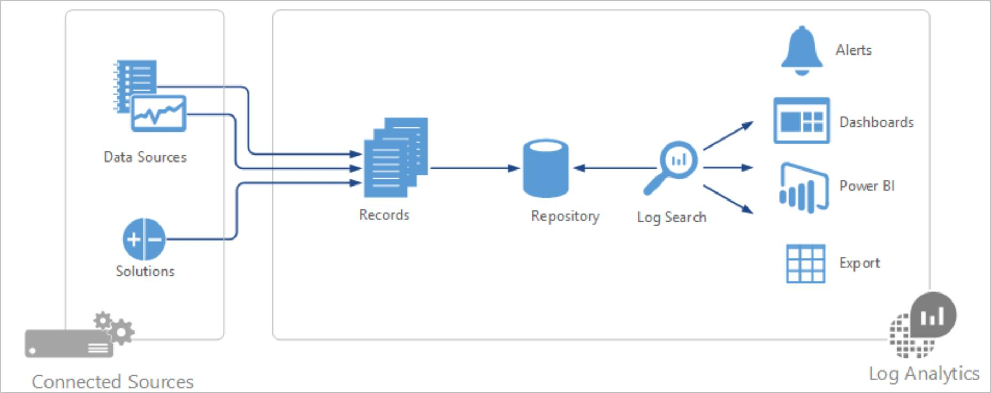
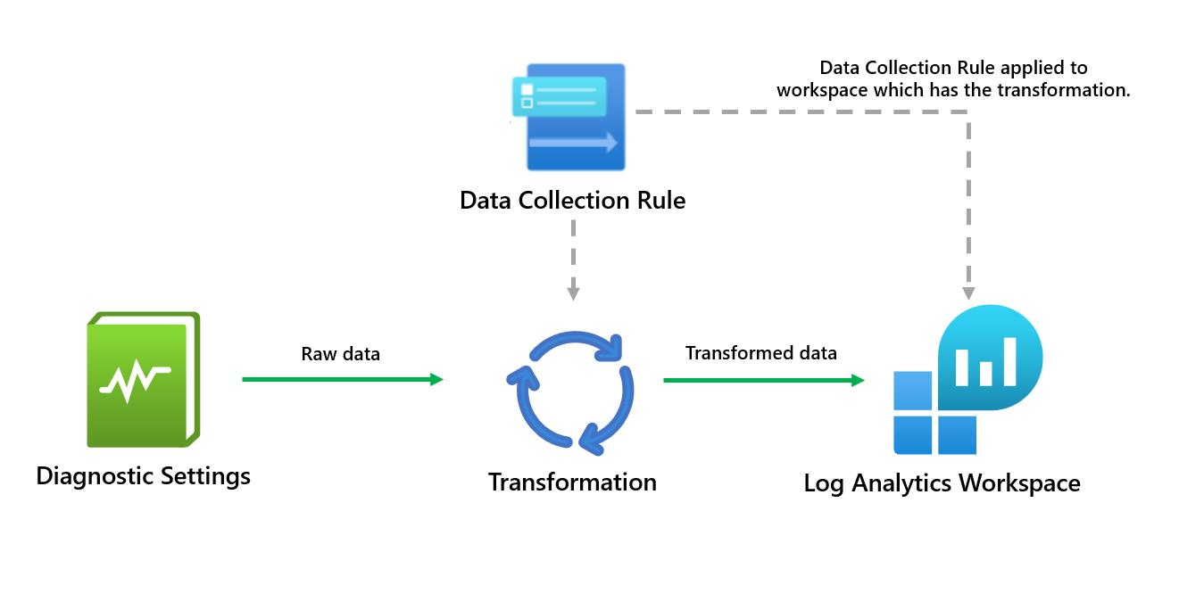
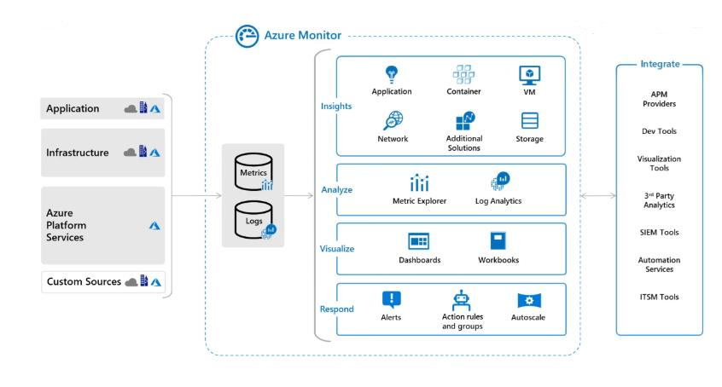
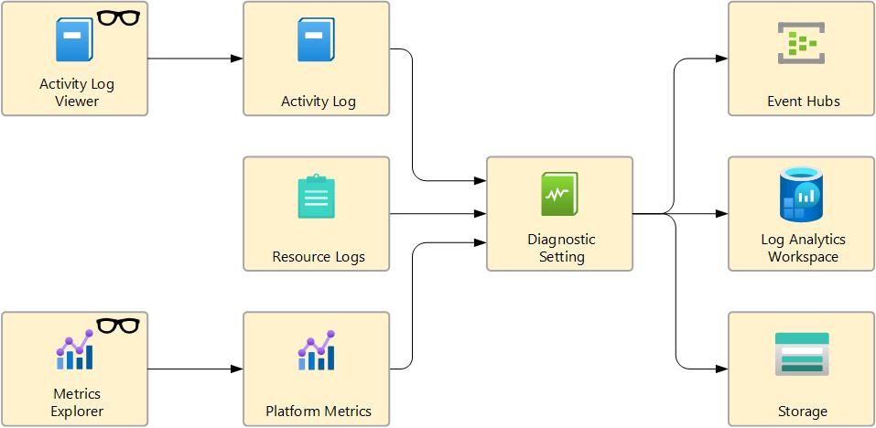
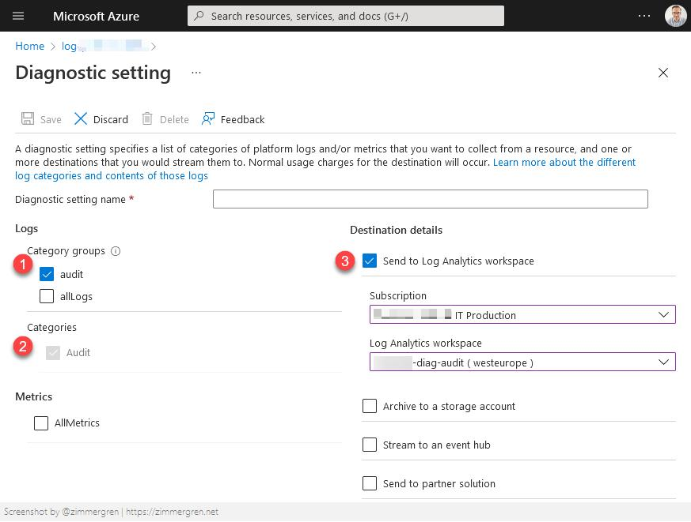
Your final architecture can be:
Azure Resources
┌──────┬──────┬──────┐
│ VM │ App │ DB │ ... 40 Resources
└──────┴──────┴──────┘
│
▼
Diagnostic Settings
│
▼
┌─────────────────────┐
│ Log Analytics │
│ Workspace │
└─────────────────────┘
│
▼
KQL Queries
│
▼
Azure Monitor
│
┌──────┴──────┐
▼ ▼
Dashboard Alerts
│
▼
Action Groups
│
▼
Notifications
For your project, the main demo should be: create a resource → send its logs to the workspace → generate a failure → show the log in Log Analytics → run KQL → trigger an alert → show the notification. That will make the project much more convincing.

