2B)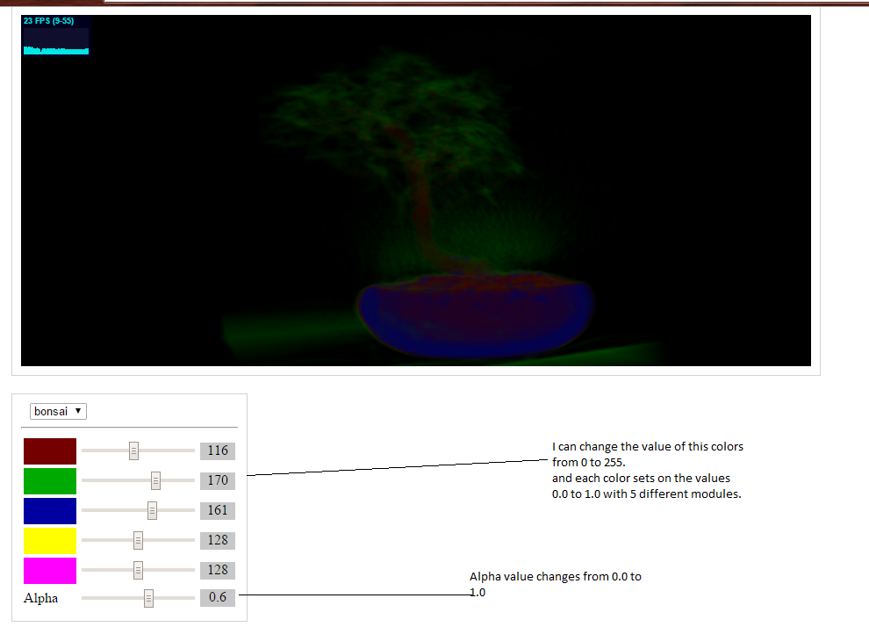

I planned to give users a option to choose which part of the region he likes to have the color. But it made little discrepancy in the values.

Question 3: Below are the interested results:

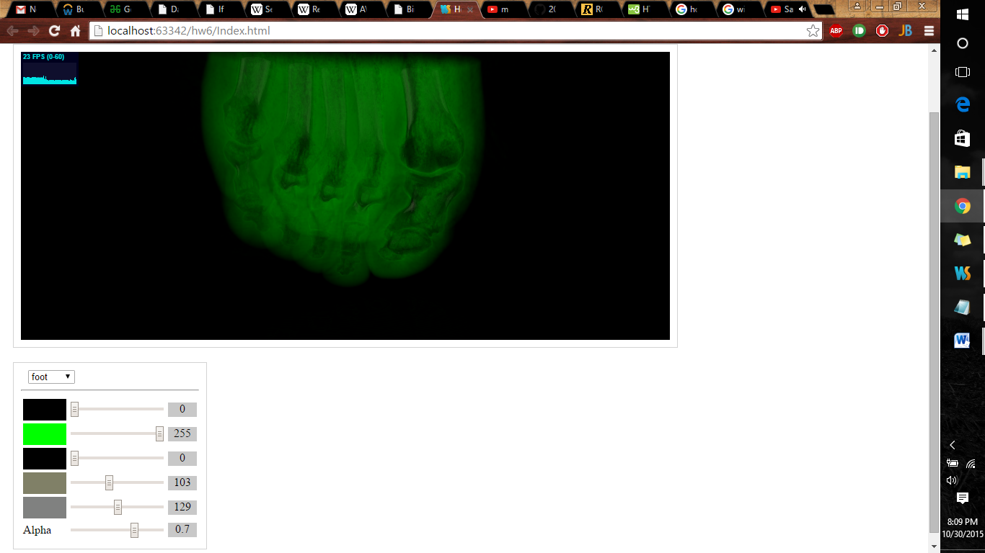

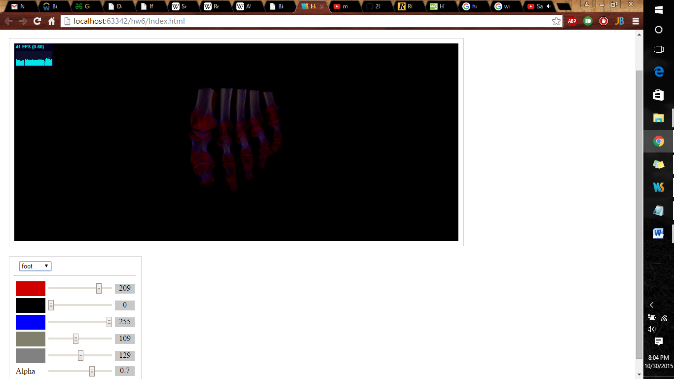

The above images shows the internal structures very clearly. When I am increasing the green I can see the exterior layers.

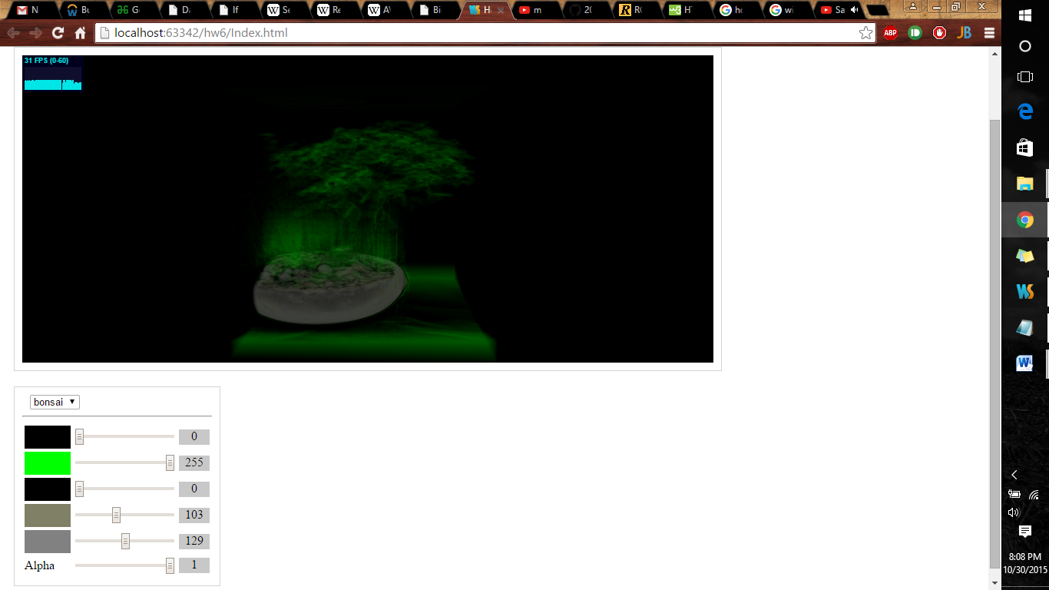

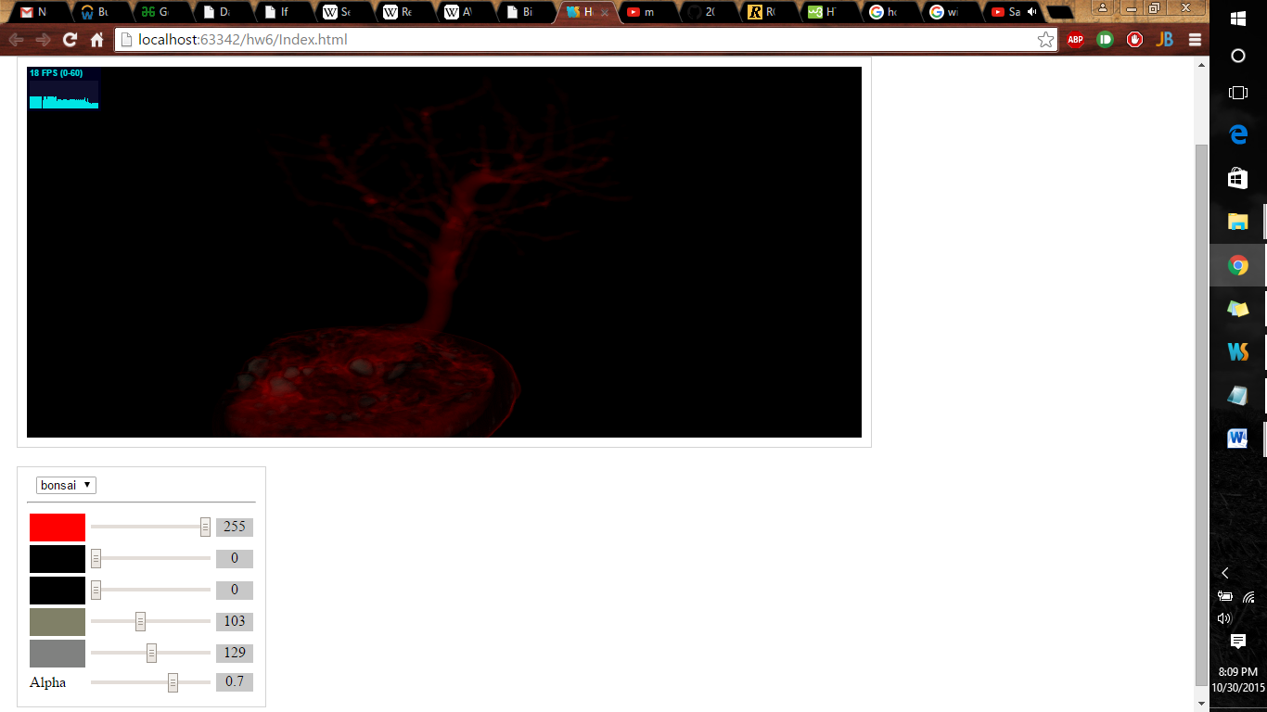

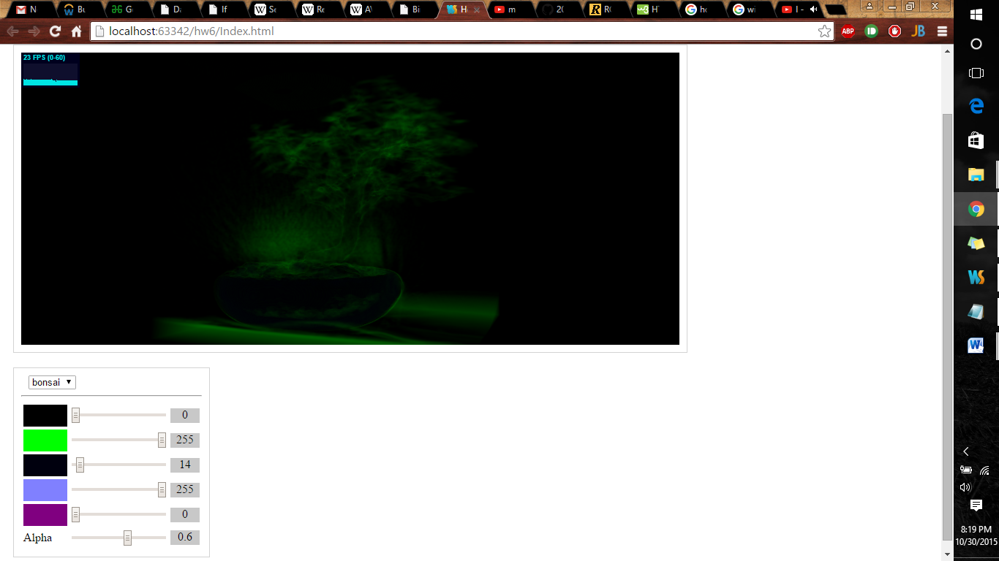

Pros:

Using this implementation

1. Can get granule level attributes clearly.

2.Can also view them in different views.

3.Can views the different densities in different colors by using noise reduction.

Cons:

1. It is not showing the overall attributes as it is mixing with noise.

2.Need better transfer function to view tiny details with more precision.