EX.No:9
DATE:

DATA FLOW DIAGRAM FOR RESTAURENT MANAGEMENT
SYSTEM

Aim
The aim of this project is to design and represent a Restaurant Management System using a structured diagram that clearly shows the interaction between different entities such as customers, staff, and the database. The objective is to streamline restaurant operations like placing orders, billing, food preparation, and managing menu details in an efficient and organized manner.

Problem Description
In traditional restaurant systems, managing customer orders, preparing bills, tracking food preparation, and maintaining menu records can be time-consuming and prone to errors. There is a need for a system that simplifies these operations and ensures smooth coordination between customers and restaurant staff. The problem involves designing a system that allows customers to place orders and view menu details, while staff manage orders, billing, and food preparation efficiently.

Given Conditions / Constraints
The system must include key entities such as Customer, Staff, and Restaurant Database. It should support basic operations like placing orders, generating bills, viewing menu items, and updating order status. The design must be simple, clear, and easy to understand. It should also ensure data consistency and proper interaction between users and the system. Additionally, the system should work within limited resources and follow a structured design approach.

Approach / Methodology
The approach followed involves designing a system diagram that represents the flow of information between entities. First, the main components of the system are identified. Then, interactions such as placing orders, processing orders, billing, and updating menu details are mapped. The system is structured using a centralized approach where the Restaurant Management System acts as the core component connecting all entities. This ensures smooth communication and efficient data handling.

Planning and Estimation
The planning phase includes identifying system requirements, defining system components, and estimating the time required for each stage of design. Tasks such as requirement analysis, diagram creation, and validation are planned in sequence. Time estimation is done based on complexity, ensuring that sufficient time is allocated for understanding the system and designing it properly.

Diagram:

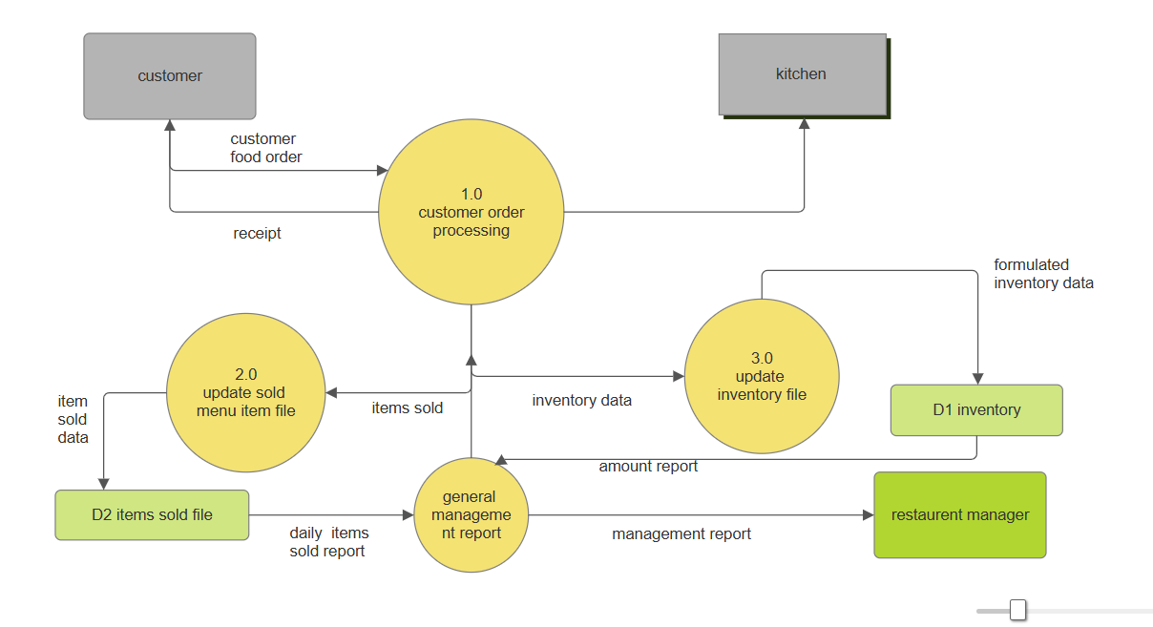Scheduling / Design Considerations
The scheduling involves organizing tasks in a step-by-step manner, starting from requirement analysis to final design completion. Design considerations include clarity of the diagram, proper representation of data flow, and inclusion of all necessary functionalities. The system must be user-friendly and logically structured so that interactions between customer, staff, and database are clearly visible.

Feasibility Analysis
The system is feasible in terms of technical, operational, and economic aspects. Technically, it can be implemented using basic software tools. Operationally, it simplifies restaurant management tasks and improves efficiency. Economically, it requires minimal resources as it is primarily a design-based solution. Hence, the system is practical and beneficial.

Result
The result is a well-structured Restaurant Management System diagram that clearly represents interactions between customers, staff, and the database. It successfully demonstrates key functionalities such as order placement, billing, food preparation, and data management.

Conclusion
The designed system effectively addresses the challenges of manual restaurant management. It improves efficiency, reduces errors, and ensures smooth communication between customers and staff. The diagram provides a clear understanding of system operations and can serve as a foundation for further implementation.

