Software Requirements Specification Document

Team Number: | Team 8
Team Name: | App8IT
Created By: | - Vatika Harlalka  - Shikha Jain  - Aryaman Gupta  - Abhijeet Kumar
Creation date: | 9/9/2014
Client: | Mr Nagarjuna, VgyanIT Services

Brief problem statement:
An Appstore that pertains to the needs of an enterprise. The basic functionality of the software must include user management techniques for developers, company officials, administrator, QA Analyst and Reviewer. The appstore should is for the use of the enterprise alone and should be compatible on multiple platforms like Mac, iPhones, iPads, android-mobiles, laptops and desktops.

System requirements
Languages required: HTML 5,CSS 3, Jquery, JavaScript, PHP, and MySQL.
Framework used: YII.

Users Profile:

- Developer:
  - Should be able to fill the details of the application and upload the Binary of the Mobile application.
- QA Analyst/ Reviewer:
  - Test the Mobile application based on the checklist.
  - Review the applications based on the checklist created by Admin.
  - Approve or Reject by giving a reason.
  - Once the reviewer approves, the public user can view the applications.
- Admin
  - Creates QA Analyst, Developer Accounts, User accounts.
  - Creates Category of Applications, Checklist for Reviewing the Application uploaded by developer/s.
- Customer
  - Visible to any user who registers in the Appstore. (Public User)
  - Can register for account.
  - Can download available apps.

Workflow:
- Developer uploads application and waits for approval
- App goes to admin who checks out details and categories and forward to the reviewer.
- Reviewer checks the app and rejects/approves it and send the confirmation to developer

Feature requirements

No. | User Case Name | Description | Release
 | Login | Users can login into their accounts | 1
 | Register | Creation of account on appstore. | 1
 | Upload App | Developer uploads his app for approval. | 1
 | Download | User can download app on his device. | 2
 | View App | User can view apps on his device depending on the type of platform he uses. | 2
 | Update App | Developer can upload new versions of his or her app. | 1
 | User-agent | The software is responsive that is it senses user agent .It also shows the applications to the customer as per user agent. | 2
 | Verify App | Analyst checks the working of the uploaded application by downloading them on their local machine. The application is tested on different points. If analyst approves each point the application is made visible to the customer. | 2
 | Rate/Comments | Customers should be able to rate or comment on the application they have downloaded | 2
 | CRUD on accounts | Admin can create , update and delete user account. | 1
 | Create checklist, category | Admin can add , delete or update categories and checklists . | 1
 | Change Password | User can change his/her password | 2

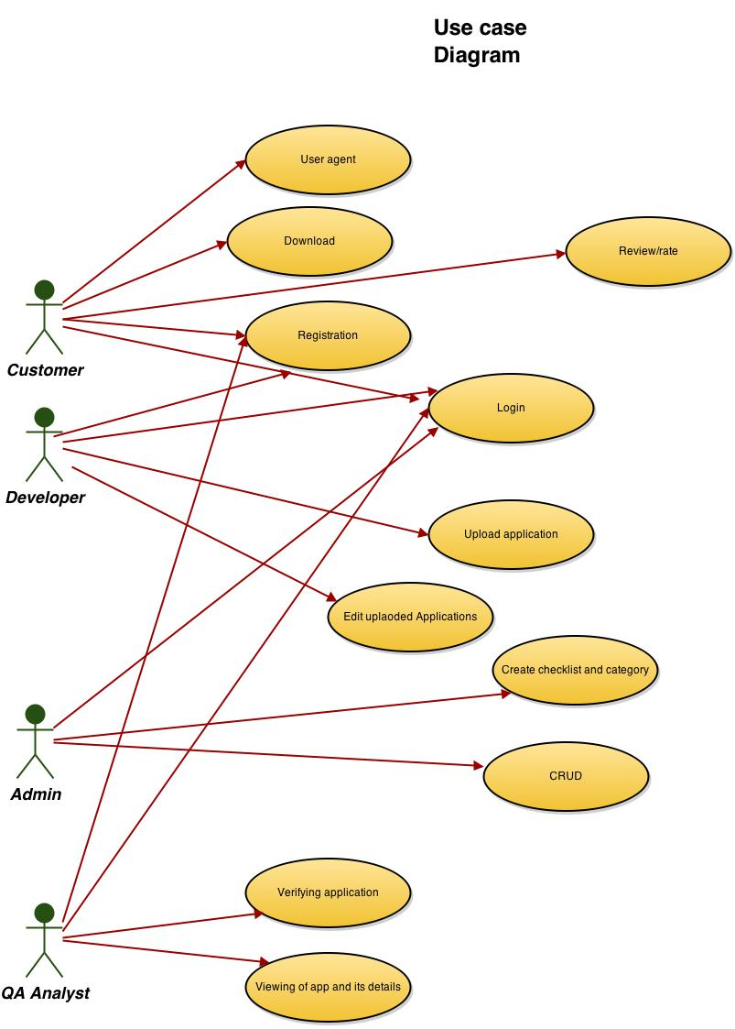
Use Case Number: | UC-01
Use Case Name: | Login
Overview: | Users can login into heir accounts
Actors: | User, Admin, Developer and QA Analyst
Pre condition: | Registered and verified by admin
Flow: | Main (success) Flow:  - Entering user name and password  - Authenticating by appstore  - Redirection to corresponding homepage
Alternate Flows:
2. If authentication fails, request for re-entering and give option for forget password if user name is correct
Post Condition: | User can view apps and his account
Use case description

Use Case Number: | UC-02
Use Case Name: | Registration
Overview: | Creation of account on appstore
Actors: | User, Admin, Developer and QA Analyst
Pre condition: | Employee of the enterprise
Flow: | Main (success) Flow:  - Entering Details  - Selecting user type  - Sending admin details of new account
Alternate Flows:
- If user name already exists, request for different
Post Condition: | Admin verifies account

Use Case Number: | UC-03
Use Case Name: | Uploading app
Overview: | Describe the purpose of the Use Case and give a 1-2 line description. This could be the same as the description provided in feature requirements section.
Actors: | Developer
Pre condition: | Logged in as developer
Flow: | Main (success) Flow:  - Entering details of app  - Submit binary file of apps  - Entering details about all developers in case of team of developer  - Preview of uploaded app in appstore
Alternate Flows:
- If file is not of required format, show error
- If developers name not in database, ask for re-entering
Post Condition: | Sent to QA Analyst for verifying

Use Case Number: | UC-04
Use Case Name: | Viewing app
Overview: | Describe the purpose of the Use Case and give a 1-2 line description. This could be the same as the description provided in feature requirements section.
Actors: | User, Admin, Developer and QA Analyst
Pre condition: | Logged in
Flow: | Main (success) Flow:  - Showing categories  - Showing apps of chosen category  - Showing details of chosen app
 | Alternate Flows: If chosen app removed or not approved, redirect to page showing apps of chosen category
Post Condition: | Enter the condition that must be true when the main flow is completed.

Use Case Number: | UC-05
Use Case Name: | Editing uploaded apps
Overview:
Actors: | Developer
Pre condition: | Logged in as developer who uploaded app or a team member
Flow: | Main (success) Flow:  - Choosing app to edit  - Choosing field to edit  - Submit edited content to QA
Alternate Flows:
- If chosen app removed or not approved, show error
Post Condition: | Edited content verified By QA Analyst

Use Case Number: | UC-06
Use Case Name: | Download of app
Overview:
Actors: | User
Pre condition: | Logged in with corresponding device or app
Flow: | Main (success) Flow:  - Choose app to download  - Request for downloading file  - Redirect to review / rate page of app  - Increase download count
Alternate Flows:
- If downloading fails, show error.
Post Condition: | Edited content verified By QA Analyst

Use Case Number: | UC -07
Use Case Name: | User-Agent
Overview: | The software is responsive that is it senses user agent .It also shows the applications to the customer as per user agent.
Actors: | Customer
Pre-condition: | None
Flow: | Main flow:  - Customer visits the home page of appstore  - Detect the device when the request to visit website is made  - Display the app store to the user as per his recorded user-agent
Alternative Flow:
- Assume default web browser (Firefox) (Error in detection of user-agent)
Post Condition: | User-agent determined and stored for the session

Use Case Number: | UC-08
Use Case Name: | Verifying App working
Overview: | Analyst checks the working of the uploaded application by downloading them on their local machine. The application is tested on different points. If analyst approves each point the application is made visible to the customer.
Actors: | Q-A Analyst /Reviewer
Pre condition: | Q-A Analyst should be logged in
Flow: | Main Flow:  - Analyst views application assigned to him for review  - Selects the application he/she wants to review  - Gets full description of application as uploaded by the developer/s.  - Download the Application.  - According to the category of the application he gets a checklist (parameters), which the application should keep up with.  - Analyst fills in the details and submits his report
Alternate Flows:
- No apps for review redirected back to home page
- Download failed.

Post Condition: | Status of the application updated

Use Case Number: | UC-09
Use Case Name: | Rate/Comments
Overview: | Customers should be able to rate or comment on the application they have downloaded
Actors: | Customers
Pre condition: | Customer should be logged in and should have downloaded the application he/she wants to comment at.
Flow: | Main Flow:  - User selects an application from list of downloaded apps  - Redirected to application page  - Can rate or/and comment on the application.  - Redirected to home.
Alternate Flows:
- Redirected to home page (no downloaded apps)
Post Condition: | Comment /Rating recorded

Use Case Number: | UC-10
Use Case Name: | Create user account
Overview: | The admin should be able to create account for user/developer/QA analyst.
Actors: | Admin
Pre condition: | The username given should not already exist in database.
Flow: | - Click on create account.  - Select user profile and other details listed.  - Submit details.  - Wait for confirmation message.
Alternate flow | - Alert that the given username is invalid.
Post Condition: | The required user account is created.

Use Case Number: | UC-11
Use Case Name: | Delete account
Overview: | The Admin can delete user account.
Actors: | Admin
Pre condition: | User must exist in database.
Flow: | Main (success) Flow:  1. Search for user  2. Check details of profile.  3. Delete account.  4. Receive confirmation of deletion.
Alternate Flows:
1.2.a. User does not exist.
Post Condition: | User account deleted from database.

