Product Design
Team | Team 8, App8IT, Shikha Jain, Aryaman Gupta, Vatika Harlalka, Abhijeet Kumar

Architectural Model

Working directory | Component state  - This maintains all the user request information in a directory. Component behavior  - The working directory provides a unique id to every user and application. This property is used to execute the simulation for that user
Css and js files | Component state  - These contain defined css classes and the javascript model used by views of the site. Used Bootstrap layout.  Component behavior  The view involves these component to help improve the user interface of the website.
Login (login.php, logout.php, submit_register.php, forgot_password.php) | Component state  - This component contains the .php files for register, login and forgot password features of the appstore and manages the information entered by the user.  Component behavior  - This component authenticates the user as an authorized user if the username and password filled in by the user is valid.  - It also maintains the profile information entered by a guest user while registering for the website.  - It also enables the user to recover the password if the authentication fails.
Database | Component state  - This component comprises of the database tables  Examples:  - The Users table assigns a user_id to each entry and stores all the user information.  - The Applications table is related to the User table by the user_id and stores the details of all the applications by developers.

Class Diagram:

Link to the Class diagram page :
https://api.genmymodel.com/projects/4b440db5-2b81-4b75-8ac1-c3f3bd79b08a/diagrams/_jILlcUxUEeS0ufKK2NnVzA/jpeg

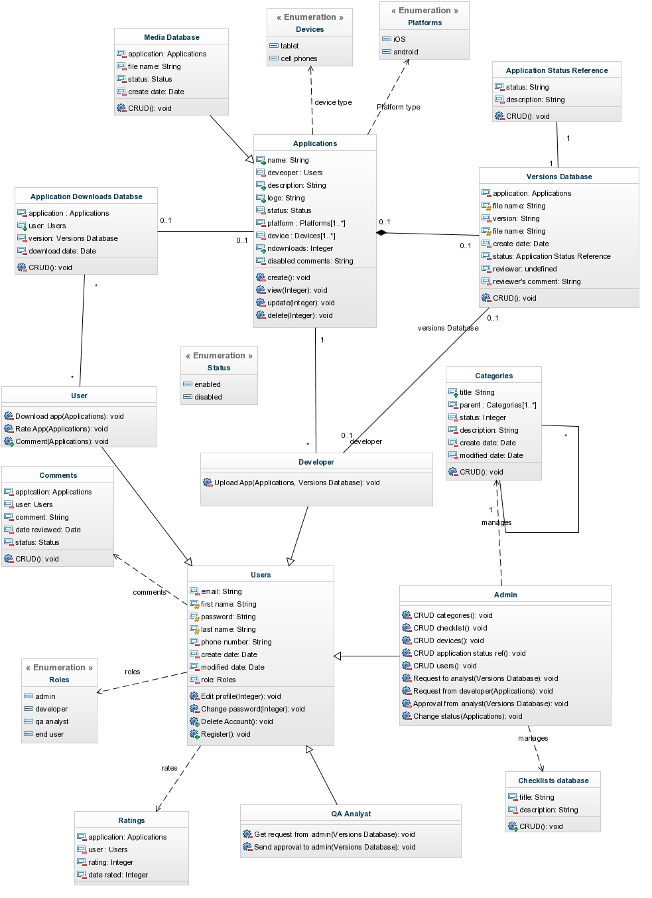

Sequence Diagram(s)
https://api.genmymodel.com/projects/_jJlAEEy2EeS9L4cMWDc7Qg/diagrams/_jJlnIky2EeS9L4cMWDc7Qg/jpeg

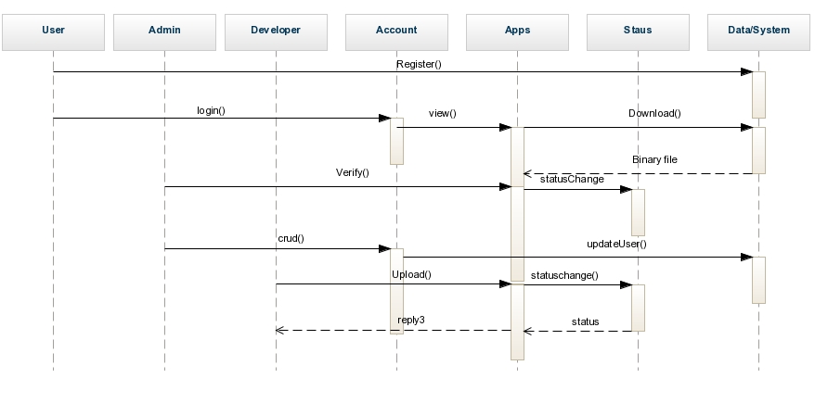

Design Rationale
In our design process, the first issue we faced was designing the database:
- Should we have separate entities for each kind of user or should we keep a flag in a single entity. –Resolved with single entity table Users ( more convenient as per framework used ).
- How should the application details be stored so as to have minimum redundancy of data. ----Resolved with data stored over multiple tables using appropriate foreign keys.
- How many versions of the same application should be stored? – Resolved with new Versions table
- Should we allow multiple roles for single user and if so, should they have the same kind of login or separate emails / role.
In our interface design, we faced the following issues:
- What kind of responsive theme to use for the application. ---Suggested by client.
- Deciding various roles, operations and tasks (as per framework conventions) – Resolved taking reference from SRS and design doc.

