Assignment-1

**SPCM**

**NAMAN VATS R171217038500061496**

**B.TECH-CSE-DEVOPS**

Steps:

1. First create a directory project-terraform and initialise terraform which is installed on your system by following command:

Terraform init

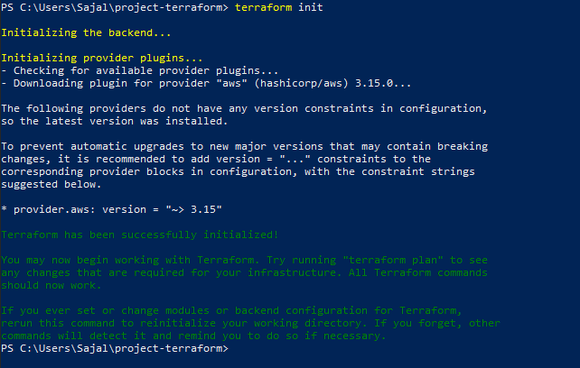

1. 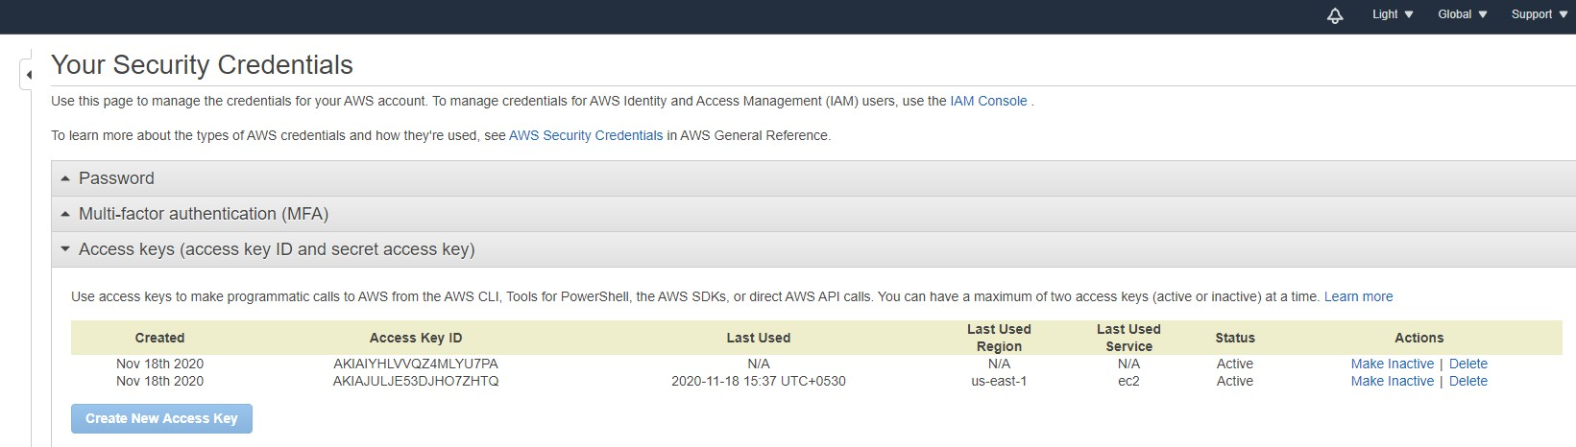Now, setup a connection to aws using the access key and secret key which you can create and download from your aws management console by clicking on your name> security credentials> access keys:

Now, create a file using vim which is will connect to aws and has the access and security key credenitials which you have downloaded and enter your region:

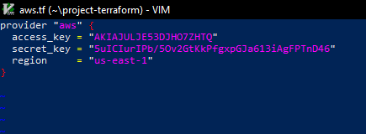

1. 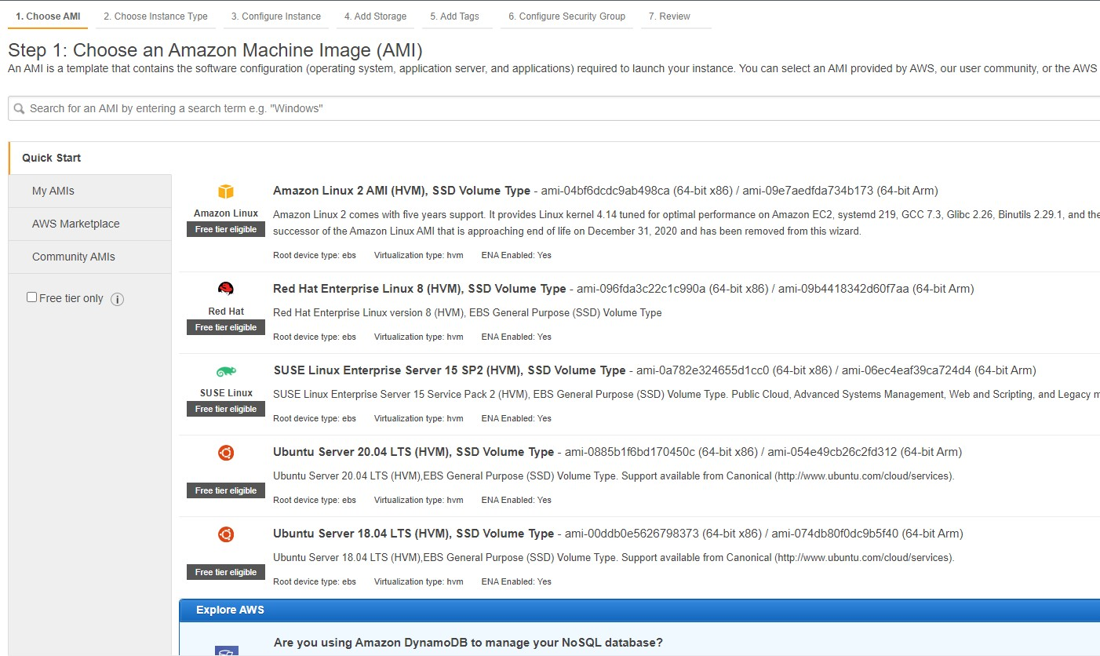Then using vim create a file in terraform with .tf extension and add below commands and set the ami from the screen as shown below amd set the instance type as t2 micro and key_name as “mykey”:

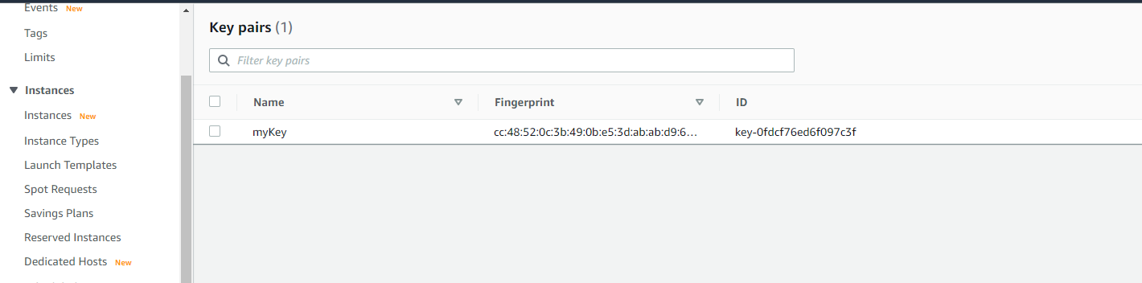

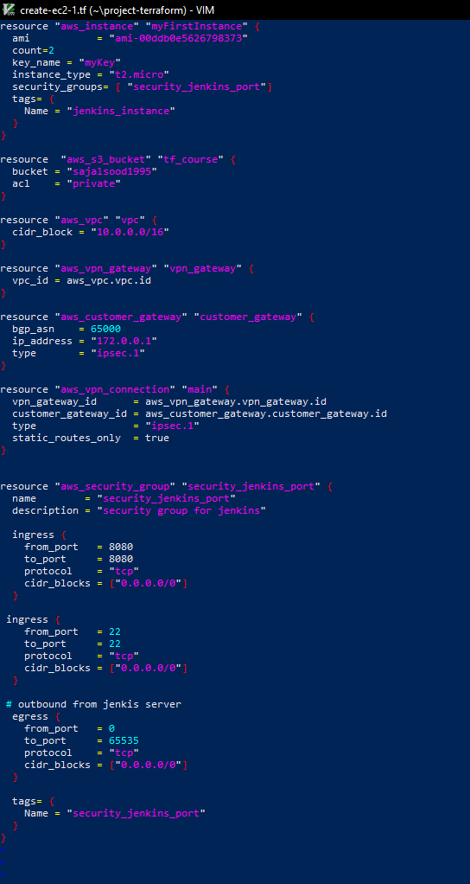

In this file, we add resources like instance creation, vpn and S3 bucket. All these steps to create these 3 added in this file.

1. Now, apply the command terraform plan which depicts all the plans that the file has to perform:

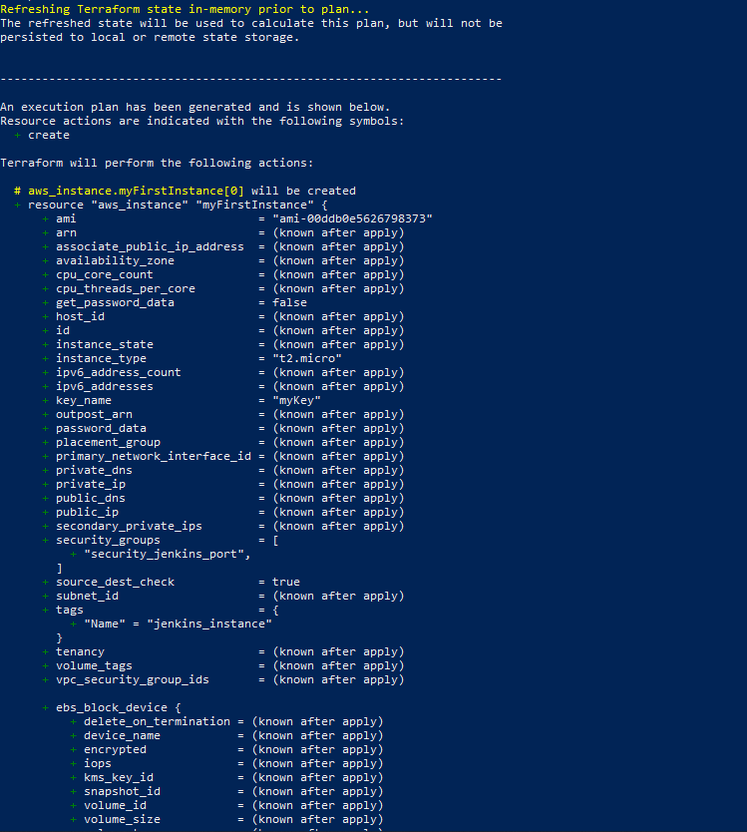

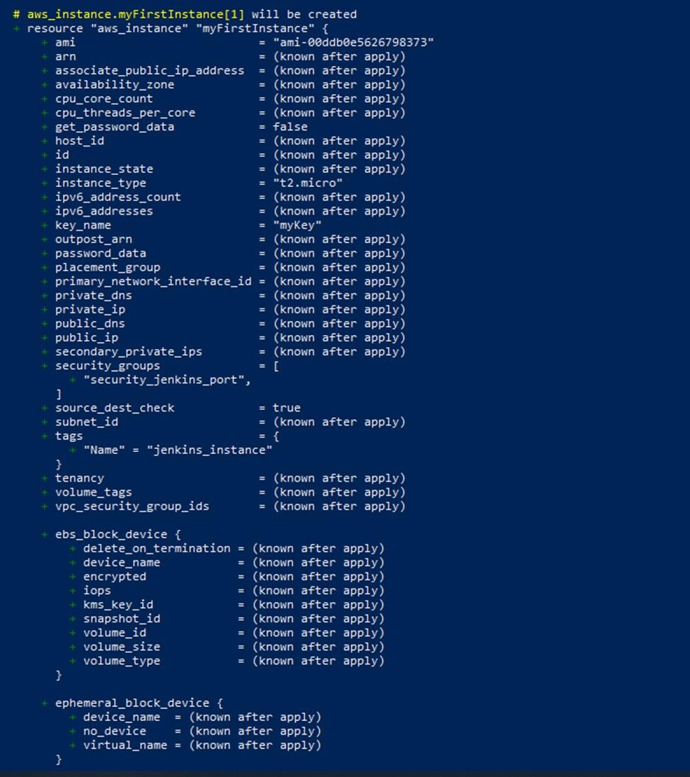

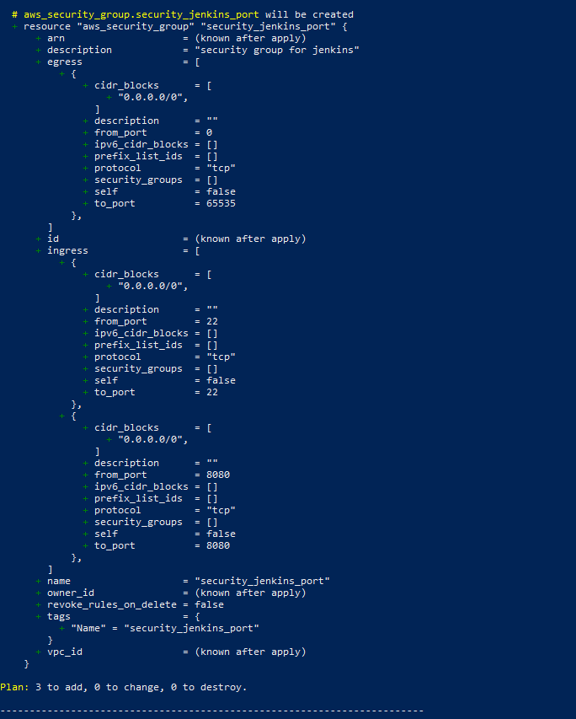

As we can see plans are added :

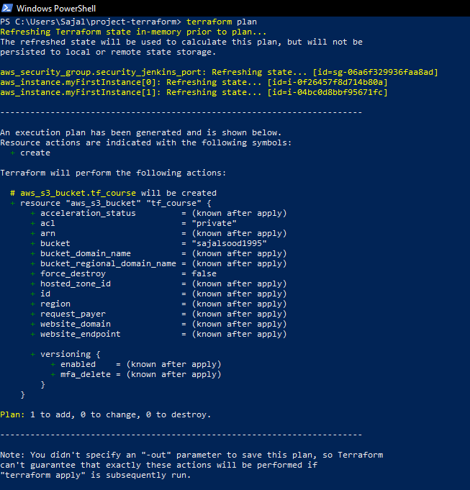

1. Now Apply, terraform apply command through which the script will run:

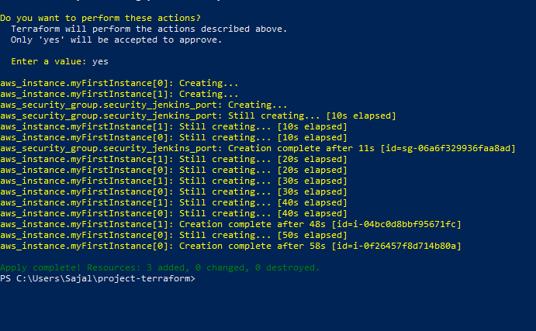

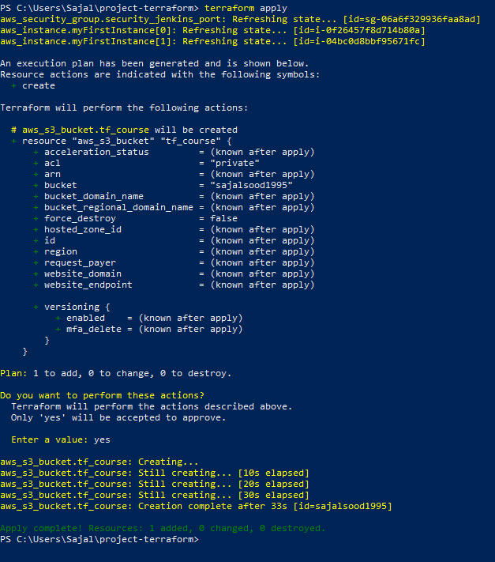

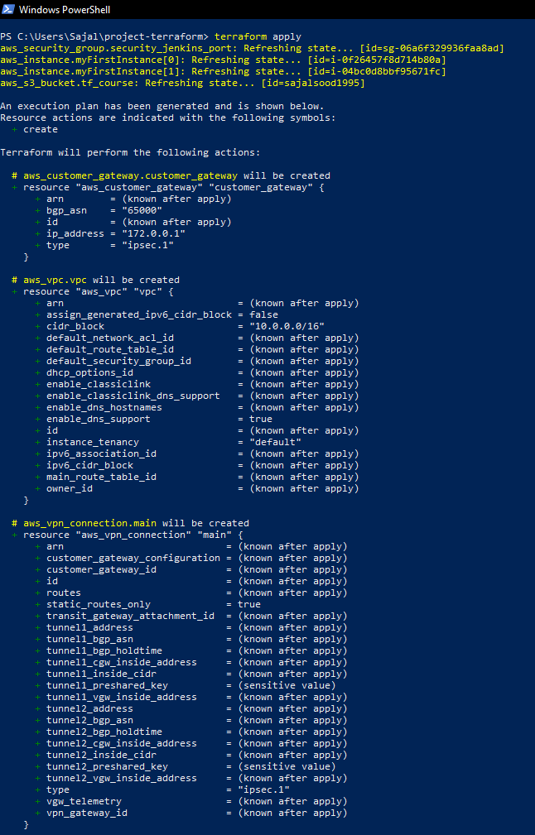

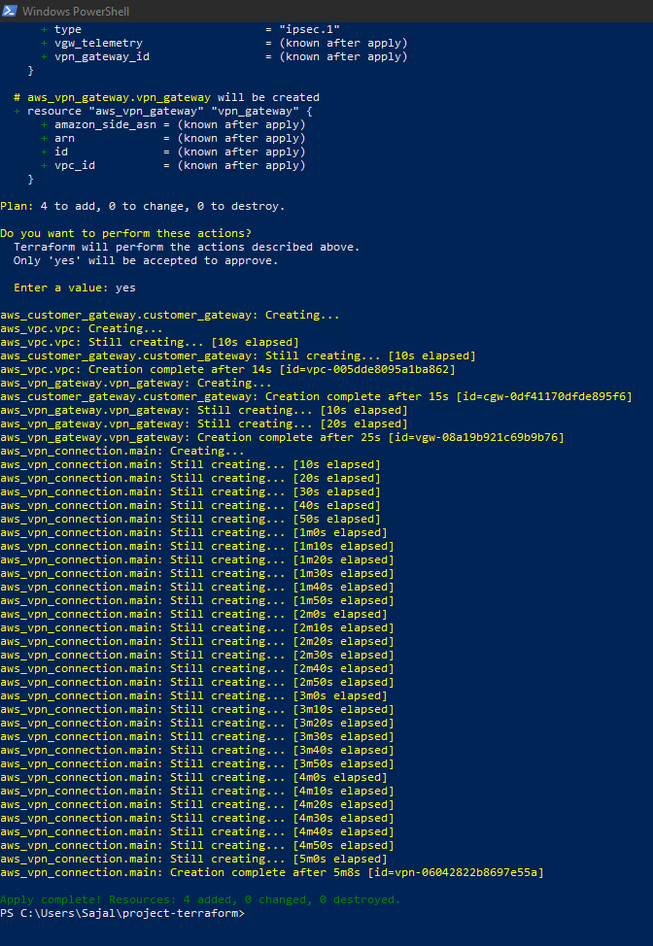

1. 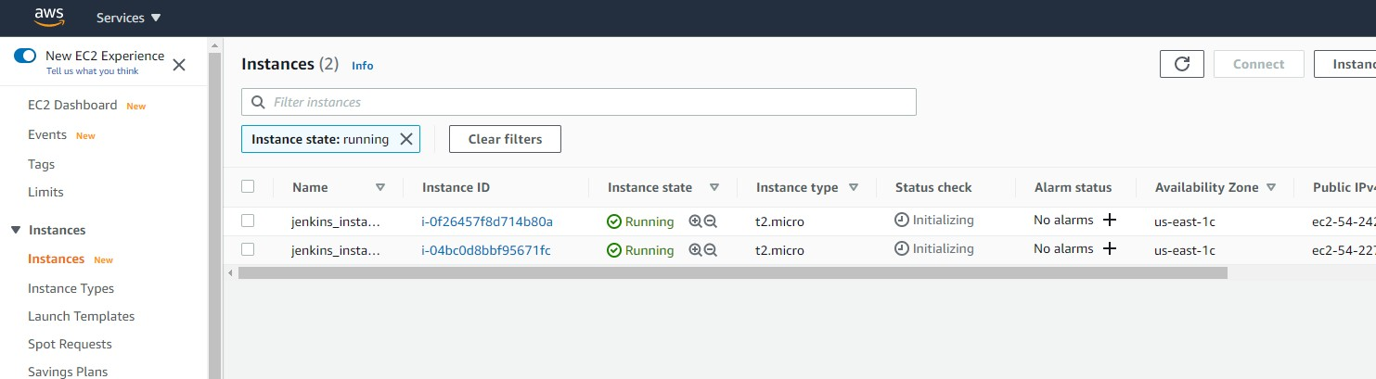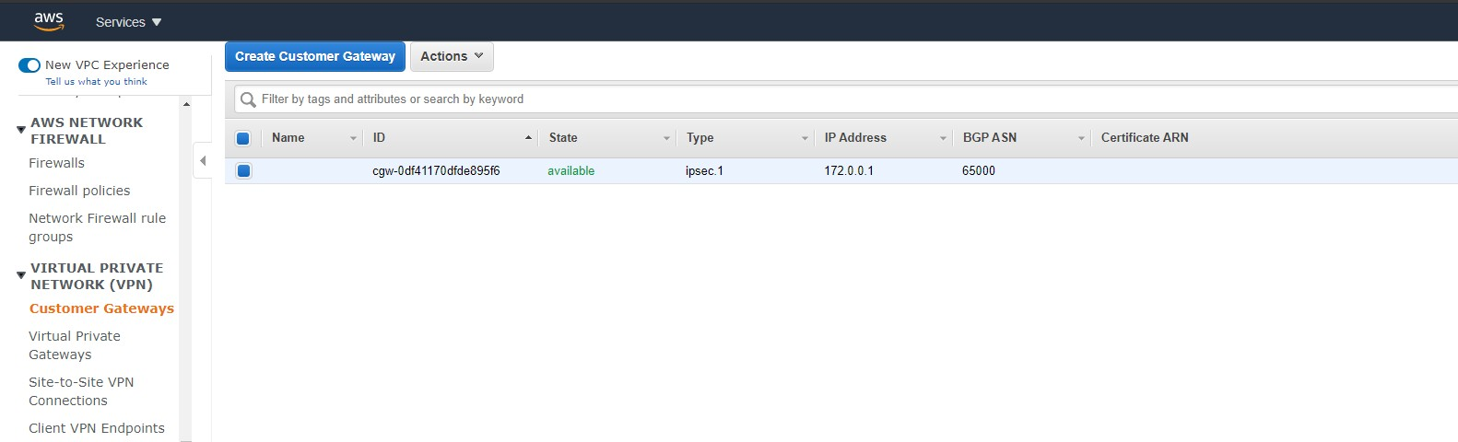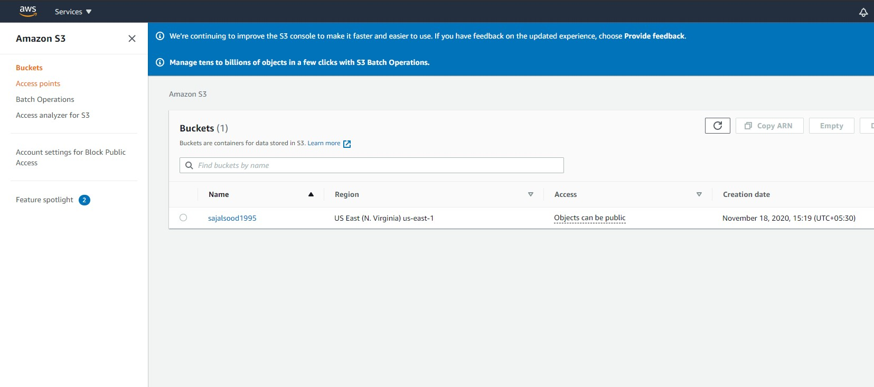Now, You can visit your aws management console and see 2 EC2 instances have been created , VPN is created and S3 bucket is also created: