1. Problem ID (Auto Selection)
2. Problem Statement (Auto Selection)
3. Synopsis Abstract (should be Minimum 200 Character and Maximum 1000 Character.)
4. Literature Review/Existing Innovation-technology to address related to your problem (should be Minimum 500 Character and Maximum 1000 Character.)
5. What would be your approach to solve the problem (should be Minimum 500 Character and Maximum 1000 Character.)
6. Road map/Flow diagram to develop final solution (1) (*Only jpg and png files allowed.)
7. Road map/Flow diagram to develop final solution (2) (*Only jpg and png files allowed.)
8. Tools and technologies to be used to solve the problem (should be Minimum 500 Character and Maximum 1000 Character.)
9. Challenges/Risk in implementing your Final prototype (should be Minimum 500 Character and Maximum 1000 Character)
10. Possible outcome of your work (should be Minimum 500 Character and Maximum 1000 Character)
11. Work done till date (should be Minimum 500 Character and Maximum 1000 Character.)
12. Image/Screenshot of Solution (1)(*Only jpg and png files allowed, Maximum File Size 5 MB)
13. Image/Screenshot of Solution (2)(*Only jpg and png files allowed, Maximum File Size 5 MB)
14. Report in PDF (Repot may contain Synopsis Content, Team Details and Other Information you needs to Submit other than synopsis details) (*Only pdf file allowed, Maximum File Size 20 MB)

//green – done

//yellow – working on it

|  |  |
| --- | --- |
| Title of the project | Krishi Solution |
| Stakeholders involved in capturing requirements | - |
| Techniques used for requirement capturing | - |
| Name of the person along with designation | - |
| Date | September, 2022 |
| Users of the system | Farmer, Agriculture Experts, Stakeholder of Agriculture, Admin |
| Version | 1.0 |
| Consolidated list of initial requirements: | |
| 1. The System User has to login first to use the system. 2. The system user should be verified with OTP before login. 3. The admin shall be able to manage areas of experts. 4. Admin shall be able to manage users. 5. Expert shall be able to update latest blog and post of crops. 6. Stakeholder shall be able to give latest prices of crops to the farmer. 7. Farmer shall be able to ask their query related crops via uploading image or message in their regional language. 8. Expert shall be able to manage query which asked by farmers. 9. Experts shall be able to update latest information about crops. 10. Expert shall be able to give answer of question which are asked by farmer. 11. Farmer shall be able to access information for farming practices. 12. Farmer shall be able to view latest technology for the production of crops. 13. Farmer shall be able to view the latest price of crops in market. 14. Farmer shall be able to view the Weather update based on their location. 15. Farmer shall be able to switch languages as per their necessity. 16. Farmer shall be able to manage their profile. 17. Farmer shall be able to talk with experts. | |

**Problem ID :** PID020

**Problem Statement :** Package of practices for crops through app in regional languages

**Synopsis Abstract :**

**Literature Review/Existing Innovation-technology to address related to your problem :**

**What would be your approach to solve the problem :**

**Road map/Flow diagram to develop final solution (1):**

**Road map/Flow diagram to develop final solution (2):**

**Tools and technologies to be used to solve the problem :**

**Challenges/Risk in implementing your Final prototype :**

**Possible outcome of your work :**

**Work done till date :**

**Image/Screenshot of Solution (1) :**

**Image/Screenshot of Solution (2) :**

**Report in PDF :**

*******************

**<3rd point Synopsis Abstract >**

INTRODUCTION:

Cultivation of the same kind of plant in a large area is known as a crop .

Crop production may be a common agricultural practice followed by

farmers to grow and produce crops to use as food and fibre.

In India there are increasing pressures from climate change, soil erosion and bio diversity loss and from consumers'

changing tastes in food and concerns about how it is produced.

BODY:

In India requirement of crop is in bulk that is why Indian farmer has to find a way in which they can do more production with good Quality without getting any dieses related to crops.

CONCLUSION:

To maximize quality crop production and make the process of cropping more effective the knowledge of improved practices is required which makes economical, ecological and environmental profit.

**<4th point >**

Farmers have always been backbone of our country but as the rate of illiteracy is high among farmers in India, they do not have latest crop practice information that goes on in the present, Due to which the farmers cannot do much production. Farmers have not much information about weather patterns, crop production techniques and improved agronomic practices that is why they cannot make much profit of their hard work sometime.

To do progress farmers need information on latest varieties of crop practices, changing weather patterns, crop production techniques and improved agronomic practices. Information technology plays a vital role in ensuring the farmers get gathering information, regardless of their agroecological location.

There are many practices like crop rotation, rainwater harvesting artificial recharge of groundwater, mulching, vermicomposting, contour farming which are helpful for market’s growth and income. Also, these practices are used based on various requirements.

**<5th point What would be your approach to solve the problem >**

Nowadays every business is being modernized with the help of information technology. As the problem statement defines that we have to provide the facility to the farmers as farmers can gain latest information of the crops and the production of crops. the most specific and well-known approach to solve the problem would be to make the use of information technology. Primarily we have chosen the brainstorming method to find the key concepts of problems. And as well as we are using some government website for collecting data of crops like price,etc..

**<6th point>**

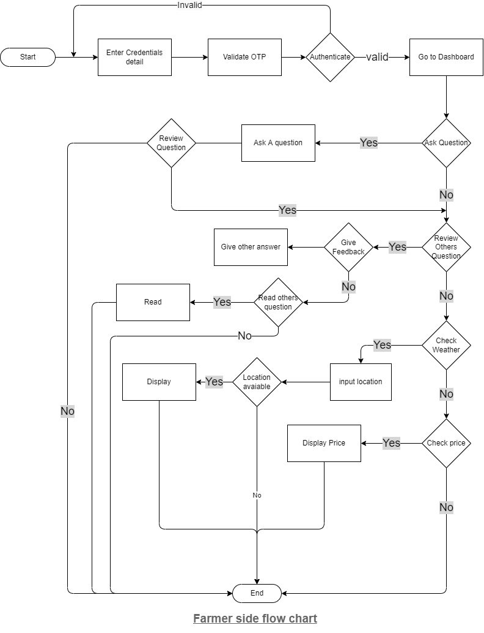

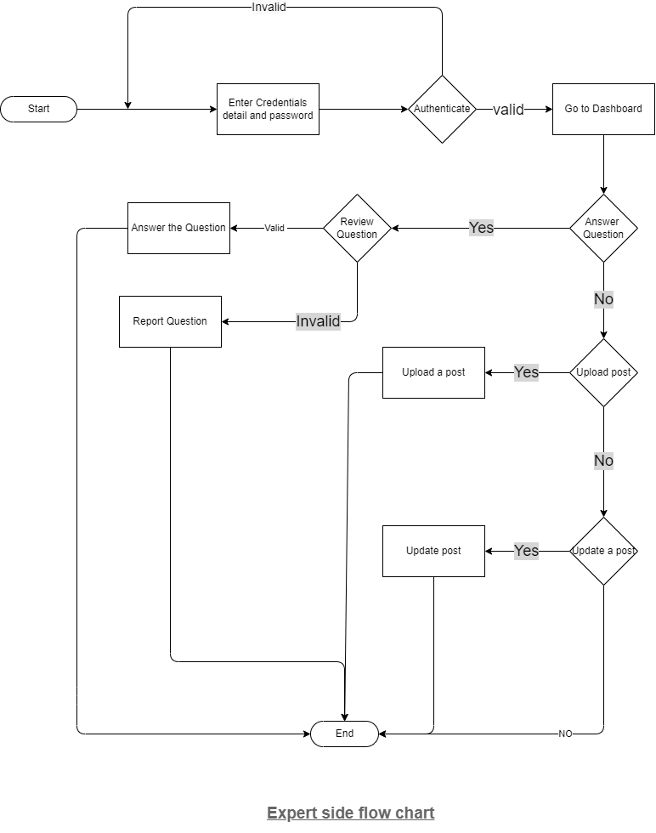

------------------------------------

**<9th Challenges/Risk in implementing your Final prototype >**

While working on the management of the crop practices, the most challenging part is to gather the precise data regarding the crops. The latest used technologies for the better production of crops and their procedure to use is most risky task, as the minor changes in the information given to the farmer will make their crops and farms harm. We need to work very efficiently with the information we provide to farmers as it would lead to great production of the crops and can lead to wealthy lifestyle for them.

The things that would let the farmers learn more can make them more experienced in farming skills. The other challenge comes is to “how to make the farmers more familiar to the system”. As our system would give facility to use it in their regional language so for farmers it will be easy to interact with system and may take an advice from the agricultural experts. Managing the experts for resolving problems faced by the farmers is one of the challenges.

// if system not allow more than 1000 character then remove Highlighted text

<8th point:--**Tools and technologies to be used to solve the problem** >

As we know this app is need to compatible with all devices so we are using these technology and tools.

Front-End Technology: Flutter

Back-End Technology: Firebase

Data Base: Firebase

RAM: 512MB or more

ROM: 200MB or more

Input Device: Microphone, Camera, Smart phone

Output Device: Hand Held Devices

As we know our mobile app is compatible with all android devices so we choose flutter for that because it provides good UI as well as supports cross-end platform so in case of future we easily use this application in different platform. And as a backend technology we are using firebase because it is easy to use and is fast as compare to other technologies. we are using firebase in database so it will be easy to communicate with backend server. We will use Microphone and camera as an input device. So, by using that farmer can easily post their query with more detail. Farmer can use portable device like smart phone. So, they can easily get answer of their query. User must have 4.1 or higher version of android so application runs smoothly on all devices.

Work done till date (should be Minimum 500 Character and Maximum 1000 Character)

Our team is working on Krishi crop solution application. Till date Our team has done with ground level research in that we have covered how this application would be useful as per farmer’s point of view as well as what other users should do. we have discussed that what would be the flow of farmer for using application. We listed out all functional requirements. Now we are moving to database schema and database table which would help us to maintain data of users. we are using advance tool like flutter and firebase for better user experience and user interface.

This message was prepared by **Pinal**

Warm greetings of the day! Krishi Crop Solutions is glad to see you here. Our application highlights empowerment of the crops. The user has to undergo few criteria's to be a part of the system. The user has to login first and get verified with OTP before login. This platform provides all the important information about crops to the users. You will be updated to the latest blog and post of crops regarding to the price, weather and much more. Also, the users will be able to drop their views as well as any queries and would be able to talk to the experts too. The experts will make sure to answer all the doubts.

Thank you!

<<10th point>>

Possible outcome of your work (should be Minimum 500 Character and Maximum 1000 Character)

We are bringing one stop solution for farmers where farmer can ask their question and other farmer will give their suggestions as well as experts. Farmer will get their solution within few minutes so they can save their time as well as resources. Farmer will get latest information of crops and diseases so they can prevent their crop from loss and get benefit in production. Farmer will get all latest market prices of crops so, every time they don’t need to go market for knowing the price of crops. Expert will update latest information about crops so it will be beneficial for farmer. Farmer can easily interact with experts so they would get quicker solution to their problems.

<<11 >>

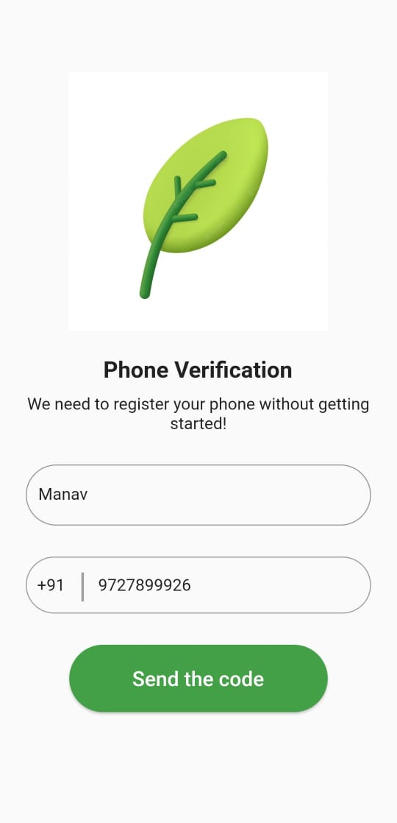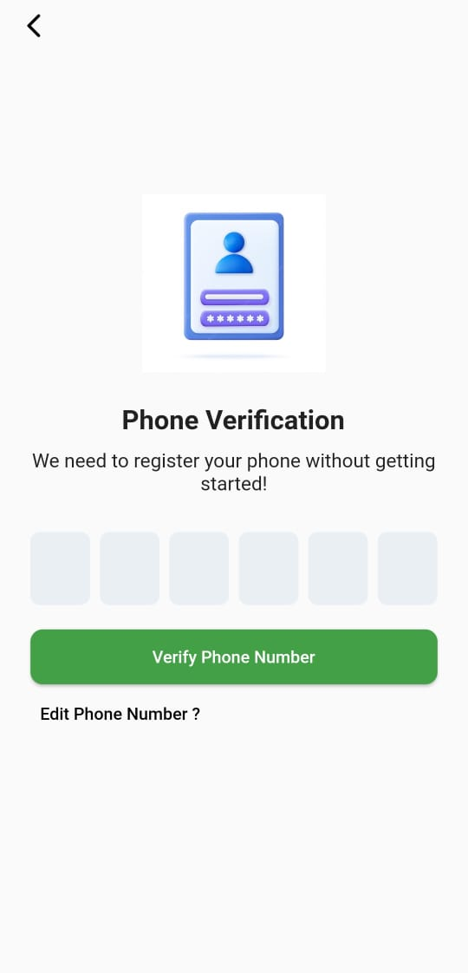

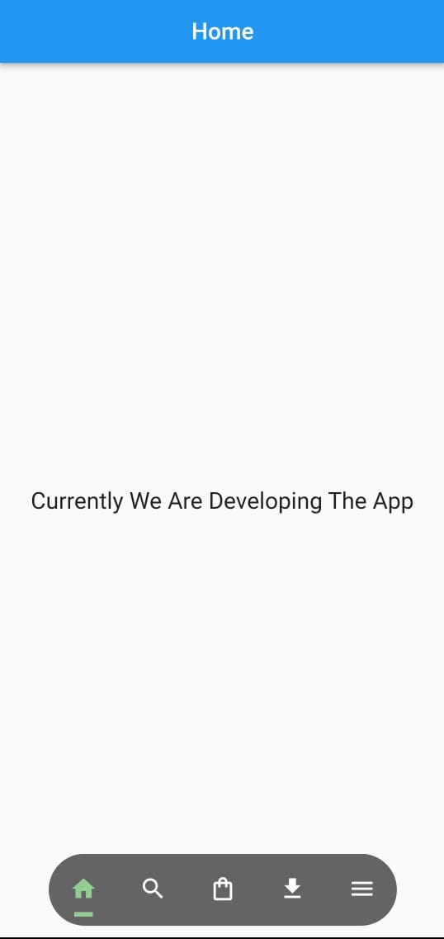

**KRISHI CROP SOLUTION**

**Synopsis Content :**

The system helps farmers to get the latest information about crop practices. While registering or logging into the system, after entering the required details an OTP will be generated via contact number. Once the user enters OTP, the system will verify entered OTP and the user will be successfully registered to the system. Authenticated users can post the information in different forms. All farmers can ask questions in form of photos, videos, or text and Experts or farmers can give solutions to other farmers' questions. Farmers can see the solution to the previously asked questions. Admin can manage the experts. Authenticated users can view and manage necessary data. Stakeholders will provide the latest price of crops and it will provide weather information for a particular city. At the end farmer will get one stop solution in this system.

**TEAM MEMBERS**

|  |  |  |  |  |
| --- | --- | --- | --- | --- |
| **No.** | **Name** | **Contact no.** | **Email** | **Gender** |
| 1. | Vatsal Arvindbhai Mangukiya | 9825296591 | 20bmiit076@gmail.com | Male |
| 2. | Yash Ashokkumar Desai | 9313100630 | 20bmiit086@gmail.com | Male |
| 3. | Manav jayeshbhai Patel | 9727899926 | 20bmiit012@gmail.com | Male |
| 4. | Utsav Manojbhai Vasani | 6351595662 | 20bmiit113@gmail.com | Male |
| 5. | Hasti Pravinbhai Ghelani | 9904488803 | 20bmiit065@gmail.com | Female |
| 6. | Hensi Rakeshbhai Limbani | 9909406092 | 20bmiit100@gmail.com | Female |
| 7. | Pinal Umeshbhai Rupavatiya | 8733030041 | 21bmiit064@gmail.com | Female |