**MIS 6382**

**Object Oriented Programming With Python**

**Fall 2019**

**Homework Five**

The following guidelines should be followed and will be used to grade your homework:

* The code for each question should be implemented and submitted as one single jupyter notebook (.ipynb) file.
* This is an individual homework assignment, no group submissions will be accepted.
* **Submit a single .ipynb file for this assignment. The file should be named using your name and the chars “hw5”. You will be penalized 15% of the grade if your submission does not follow these requirements.**
* **You will get zero points if your program has syntax errors.**

**Q1:** The attached carprices.txt contains a single column of car prices in 1000’s. Read this data into your program. The first line is the heading and should be ignored. For any line containing non-numeric data, raise a ValueError exception and print a message saying, ‘This data is invalid and will be ignored’ together with the exception object. You should divide each number by 10 and round it down to the nearest integer. Then plot a histogram that looks like the one shown below. The number of bins should be chosen so as to produce the graph shown below.

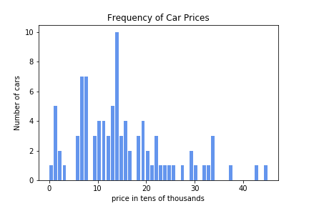

**Q2:** The attached cartype.txt contains a single columns listing the type of car (van, compact, etc). Read this data into your program. The first line is the heading and should be ignored. Then plot a piechart after computing the frequency for each car type. Your chart should look like the one shown below. Each slice should be separated from the next as shown below.

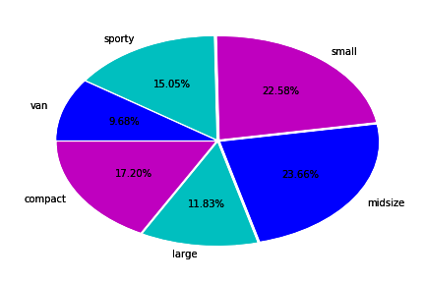

Q3: The attached wildlife.txt contains data about the population of whales, dolphins and whales over a number of years. Read this data into your program. The first line is the heading and should be ignored. Then plot a line charts displaying the population trend for each animal. Your graph should look like the one shown below.

