ShopNest Store Capstone – Power BI Dashboard Report
This document explains the Power BI dashboard developed for the ShopNest Store retail dataset. The dashboard analyzes sales performance, delivery efficiency, customer payments, product ratings, and regional trends using multiple interactive visualizations.

1. Top Categories by Total Price
Question Statement: Identify and visually represent the top 10 product categories by total sales.
Visualization:
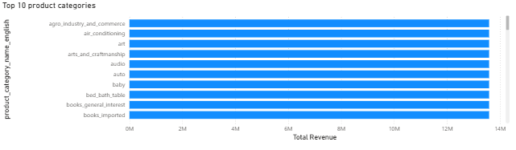 Explanation: This visualization highlights the top-performing product categories based on total revenue. Categories with the highest sales indicate strong customer demand and contribute significantly to the store's profitability.

2. Delayed Orders Analysis
Question Statement: Determine the number of delayed orders in each category.
Visualization:
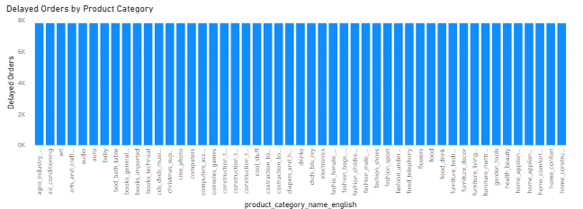
Explanation: Orders are considered delayed when the delivery date exceeds the estimated delivery date. This chart helps identify categories where logistics or fulfillment may require improvement.

3. Monthly Comparison of Delayed and On-Time Orders
Question Statement: Compare delayed and on-time orders by month.
Visualization:
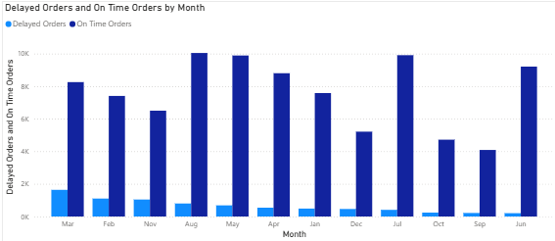

Explanation: This visual compares monthly performance of delivery timelines. It helps identify periods where delays are higher and allows deeper analysis using drillthrough features.

4. Payment Method Analysis
Question Statement: Analyze the most frequently used payment methods by customers.
Visualization:
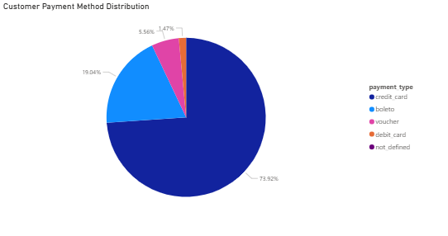
Explanation: This chart shows the distribution of payment methods used by customers. Understanding payment preferences helps optimize checkout experience and financial partnerships.

5. Product Rating Analysis
Question Statement: Identify the top 10 highest-rated products and bottom 10 lowest-rated products.

Visualization:

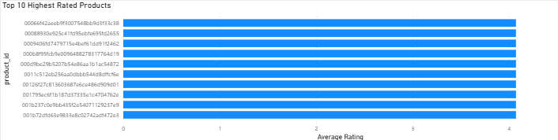

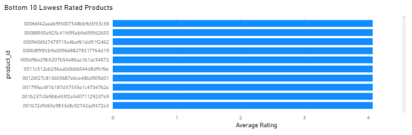

Explanation: This analysis highlights products that perform well in customer satisfaction and those that may need quality improvements.

6. State-wise Sales Analysis
Question Statement: Identify states with high and low sales.
Visualization:
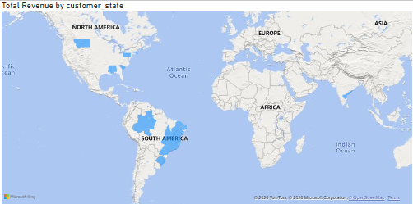
Explanation: This visualization shows regional sales distribution.

7. Seasonal Sales Patterns
Question Statement: Identify quarterly seasonal patterns in sales.
Visualization:
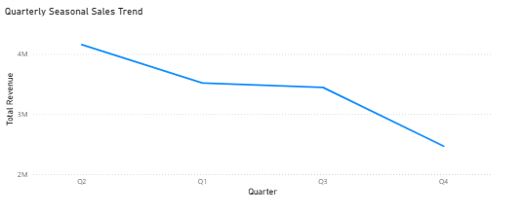
Explanation: This visual reveals seasonal trends and helps the business plan inventory and marketing strategies.

8. Revenue Analysis
Question Statement: Determine total revenue and analyze how it changes over time.
Visualization:
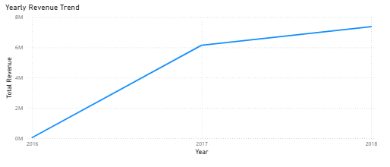

Explanation: The revenue trend highlights overall business growth and sales fluctuations across years.

Conclusion
The Power BI dashboard provides us comprehensive insights into ShopNest's sales performance, delivery efficiency, customer behavior, and product satisfaction. These insights help business stakeholders make informed decisions to improve operations and increase overall revenue.

