BEHAVIORAL ENDPOINT DETECTION & RESPONSE
Log Sentry EDR: Architecture & Working Guide
Executive operational walkthrough of the behavioral engine, DRM privacy curtain, and forensic triage pipeline.

1. Executive Summary
- Behavioral, Not Hash-Based: Detects polymorphic malware, zero-days, and AI breakouts via live OS entropy and process lineage, completely bypassing evasion techniques.
- DRM Screen Privacy Shield: Detects active meeting software (FaceTime, Zoom, Teams, Meet) and sets native AppKit NSWindowSharingNone to black out screenshares.
- Automated Forensics & Sanitization: Redacts credentials (GitHub PATs, AWS keys, JWTs) before correlating screenshots with kernel event logs.

2. System Architecture Flowchart
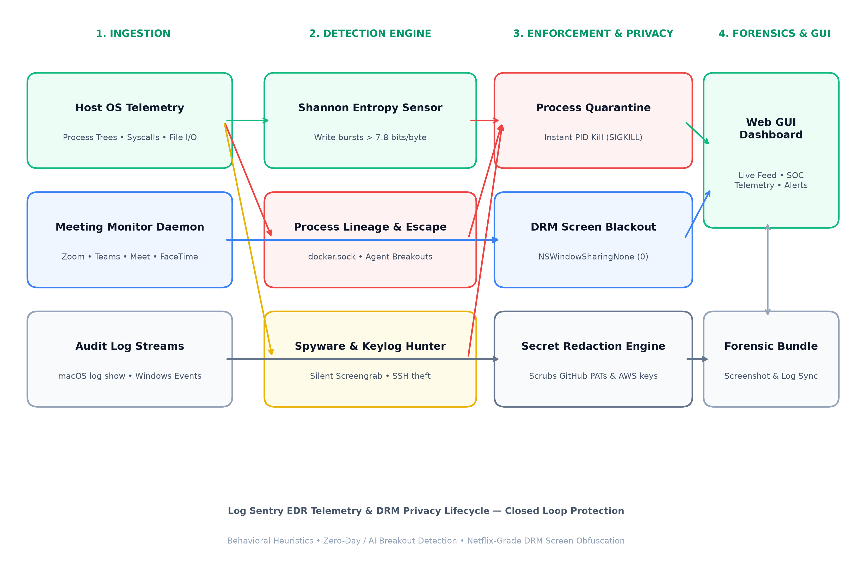
Figure 1: End-to-end telemetry lifecycle from kernel monitoring to DRM enforcement and web GUI.

3. Core Working Modules
A. Sentinel Behavioral Engine (src/main.py)
• Shannon Entropy Check: Computes write-entropy. Spikes above 7.8 bits/byte combined with backup deletion indicate active ransomware.
• AI Sandbox Breakouts: Flags interactive shells spawned by local agent runtimes (Ollama/AutoGPT) targeting /var/run/docker.sock.
• Passive Surveillance: Tracks silent screencapture commands and unauthorized credential store access.
B. Call Privacy Shield & DRM Blackout (src/privacy/call_shield.py)
• Process Monitor Daemon: Background thread continuously checks process tables for Zoom, Teams, Meet, FaceTime, and OBS.
• macOS AppKit DRM: Calls [window setSharingType:NSWindowSharingNone (0)]. Content renders normally on the host display while broadcasting 100% black pixels on conference streams.
• Blackout Curtain UI: Immediately overlays sensitive dashboards during screen-sharing events.
C. Forensic Pipeline & Log Sanitizer (src/privacy/log_sanitizer.py)
• Ingest: Pulls the last 2 minutes of OS logs or loads incident benchmark samples.
• Sanitize: RegEx entropy engines scrub GitHub tokens, AWS keys, JWTs, and private keys.
• Correlate: Synchronizes user-uploaded incident screenshots with millisecond-precision log timestamps.
D. Hybrid Operating Stack (Local Daemon vs. Cloud Web)
• Local Mode: Python 3 Flask daemon (http://localhost:5050) interacting directly with kernel APIs.
• Cloud Mode (logssentry.vercel.app): Edge serverless functions with autonomous browser-side simulation fallback.

4. Threat Detection Matrix
Threat Category | Detection Method | MITRE ATT&CK | Automated Action
Ransomware (WannaCry) | File entropy > 7.8 + shadow deletion | T1486 (Data Encrypted) | Instant SIGKILL + Rollback
AI Agent Breakout | Lineage check on /var/run/docker.sock | T1611 (Escape to Host) | Quarantine container socket
Passive Surveillance | Background screencapture / sqlite3 query | T1113 (Screen Capture) | Terminate child process
Screen Privacy Leak | Active Zoom / Teams / FaceTime stream | N/A (Data Loss Prevention) | Deploy DRM NSWindowSharingNone

