DIGITAL ASSIGNMENT 1 / REVIEW 1
Vigil
Uptime and API monitoring that explains its own outages

Name Vatsal Agrawal
Registration Number 24BAI1355
Programme B.Tech, Computer Science and Engineering (AI & ML)
Campus Vellore Institute of Technology, Chennai
Repository github.com/vatsal-agra/vigil
Date 31 July 2026

Contents
1. Vision Document 3
2. Twenty-Five User Stories (GitHub Issues and Projects) 7
3. MoSCoW Prioritisation and Wireframes 12
4. Architecture Diagram 19
5. Development Setup 21
6. Proof That Everything Works 29
Deliverables 1 to 4 are reproduced in full below. Deliverable 5 includes screenshots captured from the live environment: the running Docker stack, the application in the browser on localhost, and the GitHub repository, issues and project board.

1. Vision Document
As required, this vision document is committed as Markdown in the repository's README.md. Its full content is reproduced here.

1.1 Project Name and Overview
Vigil is a self-hosted uptime and API monitoring platform. You give it a URL; it checks that URL on a schedule from a background worker, records every response, and opens an incident on its own when the service stops answering. When the service recovers, it closes the incident and writes a one-sentence explanation of what happened.
It ships as five containers — a Next.js frontend, a FastAPI backend, a probe worker, PostgreSQL, and Redis — that come up together with a single docker compose up.
The name is literal. A vigil is a watch kept through the night, when nobody else is looking. That is the entire job.

1.2 The Problem It Solves
A developer ships a side project, a client site, or an internal API. Then it breaks at 3am, and they find out at 11am from a message that starts with “hey, is your site down?”
The existing options each fail this person in a specific way:
Option | Why it does not fit
Pingdom, Better Uptime, Datadog | Priced for companies. Free tiers cap at 1–10 monitors and put the status page behind a paid plan.
UptimeRobot free tier | Five-minute check interval and retention measured in days. You learn about the outage after it has ended.
A cron job running curl | No history, no trend, no incident record, nothing to show a client. Answers “is it up now”, never “how often does this break”.
Uptime Kuma (self-hosted) | Genuinely good and the closest comparison. But a single monolithic process on SQLite: no separate worker, no cache tier, no plain-language incident narrative.
The gap Vigil aims at: an operator who owns three to twenty services and needs history, incident records, and a customer-facing status page, without a per-monitor subscription.

1.3 Target Users (Personas)

Persona 1 — Rhea, the solo founder (primary)
Twenty-one, final-year CS, runs a small paid SaaS with about 400 users out of her hostel room. Deploys to a single VPS. Ships on Friday nights.
- Goal: find out about an outage before a customer does, and have something to point customers at that is not a personal apology on WhatsApp.
- Frustration: her monitoring is a browser tab she forgets to look at. She has twice discovered downtime from a refund request.
- Needs from Vigil: instant setup, a public status page on her own domain, and email the moment something breaks.
- Success looks like: she never again learns about downtime from a customer.

Persona 2 — Arjun, backend engineer at a twelve-person startup (secondary)
Twenty-seven, owns eight internal services, on call every third week.
- Goal: distinguish “the API is down” from “the API got four times slower after this morning's deploy”.
- Frustration: their alerting fires on single failed checks, so the channel is full of false alarms and everyone has muted it.
- Needs from Vigil: per-endpoint response-time history, a flap guard so one blip is not an incident, and Slack alerts he can trust.
- Success looks like: the alert channel becomes worth reading again.

Persona 3 — Meera, freelance web developer (tertiary)
Twenty-four, maintains fifteen client WordPress and Next.js sites on a retainer.
- Goal: prove she is providing the uptime her contract promises.
- Frustration: paying per monitor across fifteen client sites costs more than one retainer earns.
- Needs from Vigil: unlimited monitors on hardware she already pays for, and a monthly uptime figure per client.
- Success looks like: renewal conversations that start from a number instead of a feeling.

1.4 Vision Statement
For developers and small teams who run services they cannot afford to babysit, who need to know about failures immediately and explain them afterwards, Vigil is a self-hosted monitoring platform that detects outages automatically, records them as incidents in plain language, and publishes a status page your users can read. Unlike hosted monitoring priced per endpoint, or a cron job that leaves no history, Vigil runs entirely on your own hardware, costs nothing per monitor, and treats the incident narrative — not the raw check — as the thing that matters.

1.5 Key Features and Goals

Shipping in this release
- Automatic detection. A dedicated worker probes each monitor on its own interval. Two consecutive failures open an incident; the next success closes it. The flap guard is deliberate — one bad check is noise.
- Response-time history. Every check is stored with its latency, so slow is visible, not just down.
- Plain-language incidents. Each resolved incident carries a sentence a non-engineer can read: what broke, how long, and where it stands now.
- Public status page. An unauthenticated page per account, served from cache, showing only the services you explicitly publish.
- One-command setup. docker compose up gives a working system with seeded demo data.

Explicit non-goals for version 1
- No log aggregation, APM, or tracing. Vigil answers “is it up and how fast”, nothing deeper.
- No multi-region probing. A single vantage point is honest about what it can measure.
- No mobile app. The dashboard is responsive; that is enough.
- No multi-tenant SaaS billing. It is self-hosted software, not a product to resell.

1.6 Success Metrics
# | Metric | Target | How it is measured
1 | Time to first monitor | Under 90 seconds from docker compose up to a monitor being checked | Manual stopwatch on a clean machine, recorded per release
2 | Detection latency | Incident opens within twice the configured interval of the first real failure | Integration test that kills a target container and asserts on incidents.started_at
3 | False-incident rate | Fewer than one spurious incident per monitor per week | Incidents shorter than 60s with no corresponding target-side failure, counted weekly
4 | Dashboard response time | p95 under 200 ms for the monitor list at 50 monitors | Locust run against a seeded database; the Redis cache is what makes this pass
5 | Cold-start reliability | Ten consecutive down -v / up cycles reach healthy with no manual steps | Scripted in CI
6 | Backlog completion | 100% of Must-have stories closed by milestone M1 | GitHub Project board

1.7 Assumptions and Constraints

Assumptions
- Users are comfortable with a terminal and Docker. This is developer software and it does not apologise for that.
- The host has a stable outbound network. A probe failure caused by the host's own connection is indistinguishable from a target failure — a known limitation, documented rather than hidden.
- Users own the endpoints they monitor. There is no consent workflow.
- HTTP and HTTPS checks cover the overwhelming majority of need. TCP, ICMP, and DNS checks are deferred.
- A minimum thirty-second interval is acceptable. Anything faster is a load test, not monitoring.

Constraints
Kind | Constraint
Time | One academic semester, one developer. This is the binding constraint, and it is what the MoSCoW prioritisation in Section 3 exists to manage.
Hardware | Must run on a Raspberry Pi 5 (8 GB). Every image is slim or alpine; no image exceeds 400 MB. This rules out Elasticsearch-class dependencies.
Cost | Zero recurring spend. GitHub Actions free tier, Cloudflare free tier, self-hosted everything.
Data | Checks accumulate at roughly 1,440 rows per monitor per day at a sixty-second interval. Retention and downsampling are required before this is production-grade — currently a documented debt item.
Security | Self-hosted means the operator owns their own TLS and secrets. Vigil ships no default credentials in production mode and refuses to start with the default JWT secret when ENV=production.
Skill | Solo build across Python, TypeScript, SQL, and Docker. Anything needing a fifth stack was cut, which is why alerting uses plain SMTP rather than a message queue.
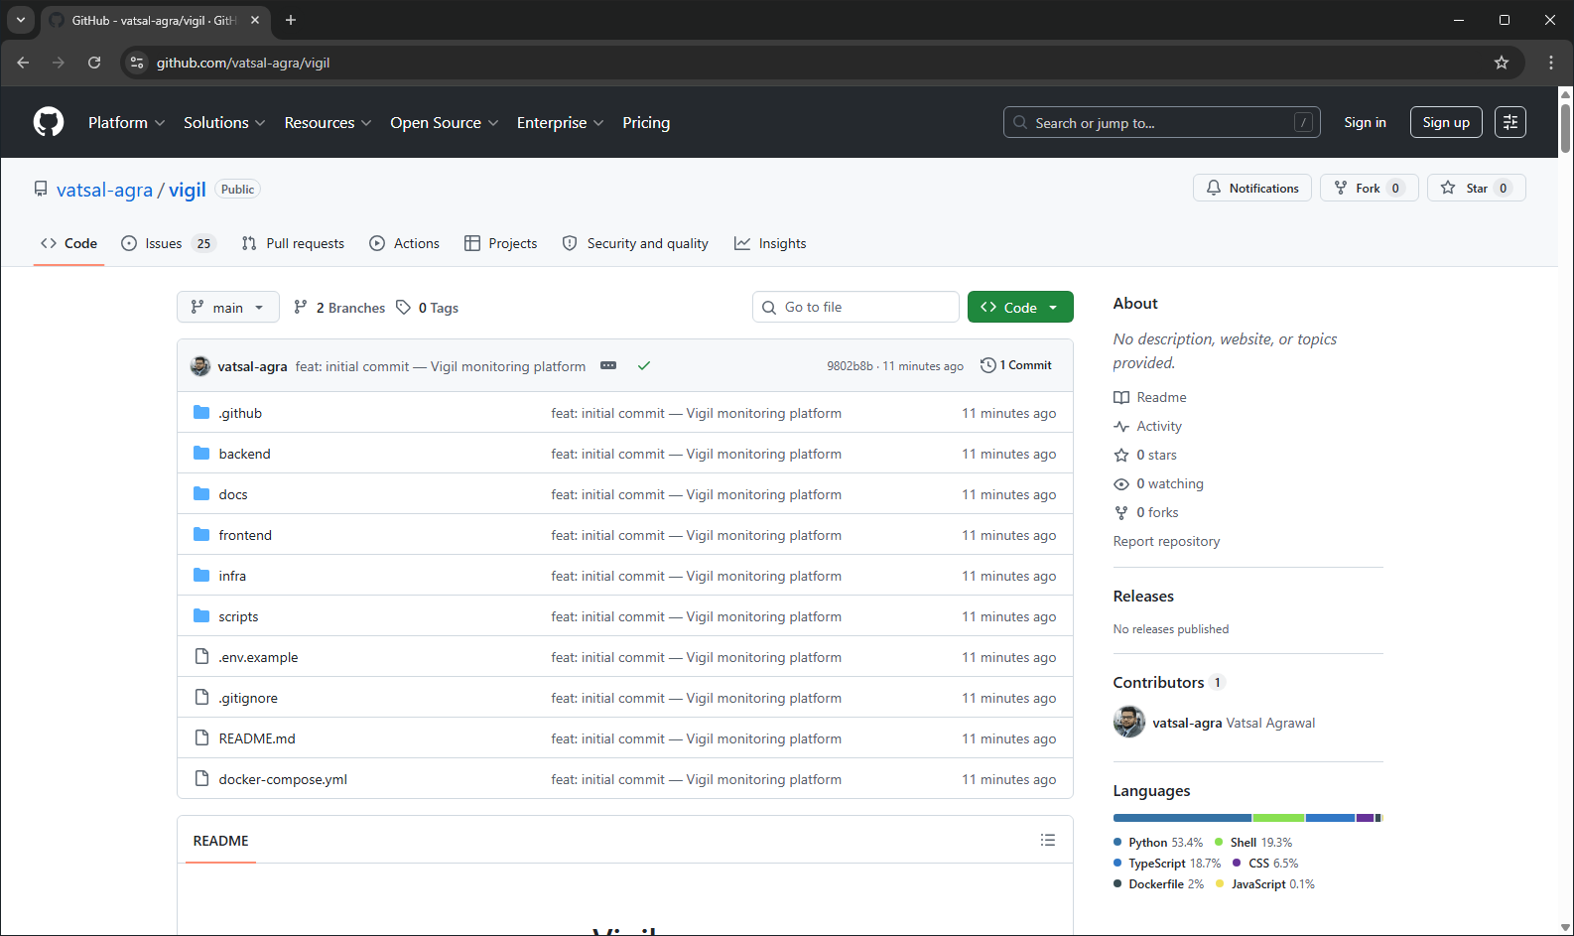
Screenshot 1 — The vision document rendering as README.md on the repository landing page.

2. Twenty-Five User Stories
The backlog is twenty-five stories across six epics, each written in role/capability/benefit form with three acceptance criteria and a story-point estimate on a modified Fibonacci scale (1, 2, 3, 5, 8).
All twenty-five exist as GitHub Issues and are tracked on a GitHub Project board with MoSCoW, Epic, and Points fields. Creation is scripted rather than hand-clicked, so the backlog is reproducible:
$ gh auth login
$ gh auth refresh -s project,read:project
$ ./scripts/bootstrap-github.sh

Labels 15 created (6 epic, 4 MoSCoW, 5 discipline)
Issues 25 created
Project Vigil - Product Backlog
Fields MoSCoW (select) - Epic (select) - Points (number)
Items 25 added, all field values set from labels
scripts/stories.sh is the single source of truth for the backlog. The issue seeder, the project-board script, and this document are all generated from it, so they cannot drift apart.
Total | Must have | Should have | Could have | Won't have (this release)
25 stories, 91 points | 16 stories, 58 pts | 6 stories, 22 pts | 2 stories, 6 pts | 1 story, 5 pts

Epic — Accounts and access (4 stories, 11 points)
ID | User story | Acceptance criteria | MoSCoW | Pts
US-01 | Create an account  As a developer running side projects, I want to sign up with an email and password so that my monitors are private to me. | • A valid email and an 8+ character password creates the account and signs me in  • A duplicate email returns 409 with 'That email already has an account.'  • Passwords are stored as salted PBKDF2-SHA256 hashes | Must | 3
US-02 | Sign in  As a returning user, I want to sign in so that I can reach my dashboard. | • Correct credentials return a JWT valid for 24 hours  • Wrong credentials return 401 without revealing whether the email exists  • The token is sent as a Bearer header on every API call | Must | 3
US-03 | Stay signed in, and sign out on demand  As a user, I want my session to survive a refresh and a sign-out button that ends it so that I am not retyping my password all day. | • A page refresh keeps me signed in until the token expires  • Sign out clears the token and redirects to /login  • An expired or tampered token redirects to /login rather than showing a blank screen | Must | 2
US-04 | Never see another account's data  As a user, I want hard isolation between accounts so that self-hosting for a small team is safe. | • Every monitor and incident query filters by owner_id  • Requesting a monitor I do not own returns 404, not 403  • A request with no Authorization header returns 401 | Must | 3

Epic — Monitors (8 stories, 26 points)
ID | User story | Acceptance criteria | MoSCoW | Pts
US-05 | See everything I watch on one screen  As a developer, I want a single dashboard listing every monitor so that I know whether anything is broken in under five seconds. | • Each row shows name, URL, status, 24h uptime, average response time, and last-checked time  • Status is conveyed by label as well as colour  • Zero monitors shows an empty state with a path to add one | Must | 5
US-06 | Add a monitor in under ten seconds  As a developer, I want to add a URL with just a name so that setup is not a chore. | • Only name and URL are required; method, expected status, and interval have defaults  • The monitor appears immediately with status pending  • The worker picks it up next cycle without a restart | Must | 3
US-07 | Configure how a check is made  As a backend developer, I want to set method, expected status, and interval so that I can monitor API health endpoints, not just web pages. | • Method, expected status, and interval are editable on create and edit  • Interval is clamped server-side to 30-3600s with a readable 422  • A response status differing from expected counts as a failure | Must | 3
US-08 | Judge health from the list, not the detail page  As a user, I want uptime and average response time on each row so that I can spot a service that is up but getting slower. | • Uptime is successful checks over total checks in the trailing 24h, to two decimals  • Average latency uses successful checks only  • A monitor with no checks shows an em dash, not 0% | Must | 3
US-09 | Watch the dashboard update itself  As a user with the dashboard on a second screen, I want it to refresh itself so that it works as an ambient status display. | • The dashboard re-fetches every 15 seconds  • The poll is cancelled on unmount so timers do not leak  • A failed poll shows an inline error and keeps retrying | Should | 2
US-10 | Read the response-time history of one service  As a developer investigating slowness, I want a 24-hour response-time chart so that I can tell a spike from a trend. | • The chart plots every successful check in the window, oldest to newest  • Failed checks are drawn as vertical markers so gaps are explained  • Fewer than two samples shows 'Not enough samples yet' | Must | 5
US-11 | Read the raw check log  As a developer, I want the last ten checks with status code, latency, and error so that I can see exactly what the server returned. | • Each row shows relative time, status or error, and latency  • Errors are phrased for humans, not as exception class names  • Successes and failures are visually distinguishable | Must | 2
US-12 | Pause or remove a monitor  As a user decommissioning a service, I want to pause or delete a monitor so that a retired service stops paging me. | • Pausing sets is_active false and the worker skips it  • Deleting cascades to checks and incidents  • Deletion asks for confirmation first | Must | 3

Epic — Checking engine (3 stories, 16 points)
ID | User story | Acceptance criteria | MoSCoW | Pts
US-13 | Have outages detected without me watching  As a developer asleep at 3am, I want the system to notice failures on its own so that monitoring is not something I have to remember. | • A dedicated worker container probes every active monitor whose interval has elapsed  • Two consecutive failures flip the monitor to down and open an incident  • A single failed check does not open an incident | Must | 8
US-14 | Have recoveries detected too  As a user, I want incidents to close themselves so that the incident list reflects reality without manual filing. | • The first success after a failure resolves the open incident  • The incident gets a plain-English summary with cause, duration, and current latency  • The failure counter resets on success | Must | 5
US-15 | See the incident history  As a team lead, I want a reverse-chronological incident feed so that I can answer 'how often does this break?' | • The feed shows monitor, cause, start time, duration, and state  • I can filter to open incidents only  • Results are capped at 100 per request | Must | 3

Epic — Public status (3 stories, 10 points)
ID | User story | Acceptance criteria | MoSCoW | Pts
US-16 | Publish a status page my users can read  As a solo founder, I want a public page showing which services are healthy so that customers stop emailing me during an outage. | • /status/<handle> is readable with no authentication  • An overall banner is derived from the worst individual status  • Monitor URLs and internal errors are never exposed | Should | 5
US-17 | Choose what is public  As a user, I want a per-monitor visibility toggle so that internal services stay internal. | • Monitors default to private  • Toggling updates the public page within one cache TTL  • A page with no public monitors renders an empty state, not an error | Should | 3
US-18 | Acknowledge an incident  As an on-call developer, I want to acknowledge an incident so that teammates know someone is on it. | • Acknowledging is one click from the incident feed  • The state persists and is visible to everyone on the account  • Acknowledging does not resolve the incident | Should | 2

Epic — Alerting (4 stories, 16 points)
ID | User story | Acceptance criteria | MoSCoW | Pts
US-19 | Get an email when something breaks  As a developer, I want an email when an incident opens so that I do not need the dashboard open to find out. | • Email is sent on incident open and close, never per failed check  • SMTP config comes from env vars and the feature disables cleanly when unset  • A failed send retries twice then logs, never crashing the worker | Should | 5
US-20 | Get alerts in Slack  As a small team, we want incidents posted to Slack so that alerts land where we already talk. | • A webhook URL is configurable per account  • The message names the service, the cause, and links to the monitor  • Slack being down does not affect probing | Could | 3
US-21 | Read a plain-English explanation of an outage  As a non-technical founder, I want the incident described in a sentence I understand so that I can decide whether to tell customers. | • Every resolved incident carries a summary with service, duration, trigger, and current latency  • The summary is generated at resolution and stored  • No jargon in user-facing error text | Could | 3
US-22 | Quiet hours  As a developer who needs sleep, I want to suppress non-critical alerts overnight so that a flaky staging box does not wake me. | • A per-account quiet window with timezone is configurable  • Suppressed alerts still record incidents and appear in a morning digest  • Monitors flagged critical bypass quiet hours | Won't | 5

Epic — Operations (3 stories, 12 points)
ID | User story | Acceptance criteria | MoSCoW | Pts
US-23 | Run the whole stack with one command  As a new contributor, I want docker compose up to give me a working system so that I am productive on day one. | • One command starts db, cache, api, worker, and web with no manual steps  • The API waits for Postgres health before starting  • Demo data seeds on an empty database | Must | 5
US-24 | Check whether Vigil itself is healthy  As an operator, I want a health endpoint reporting its own dependencies so that Docker and my proxy can make routing decisions. | • GET /health reports api, database, and cache individually  • It returns 200 with status degraded when a dependency is down  • The container HEALTHCHECK uses it | Must | 2
US-25 | Ship changes without breaking main  As a maintainer, I want CI to run tests and build images on every PR so that main stays deployable. | • Every PR runs pytest, next build, and docker build for both services  • A failing job blocks the merge  • Merging to main publishes tagged images | Should | 5

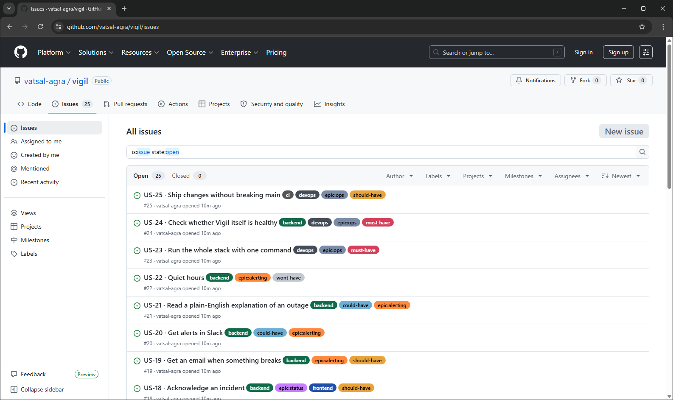
Screenshot 3 — The twenty-five user stories as GitHub Issues, labelled by epic and MoSCoW priority.
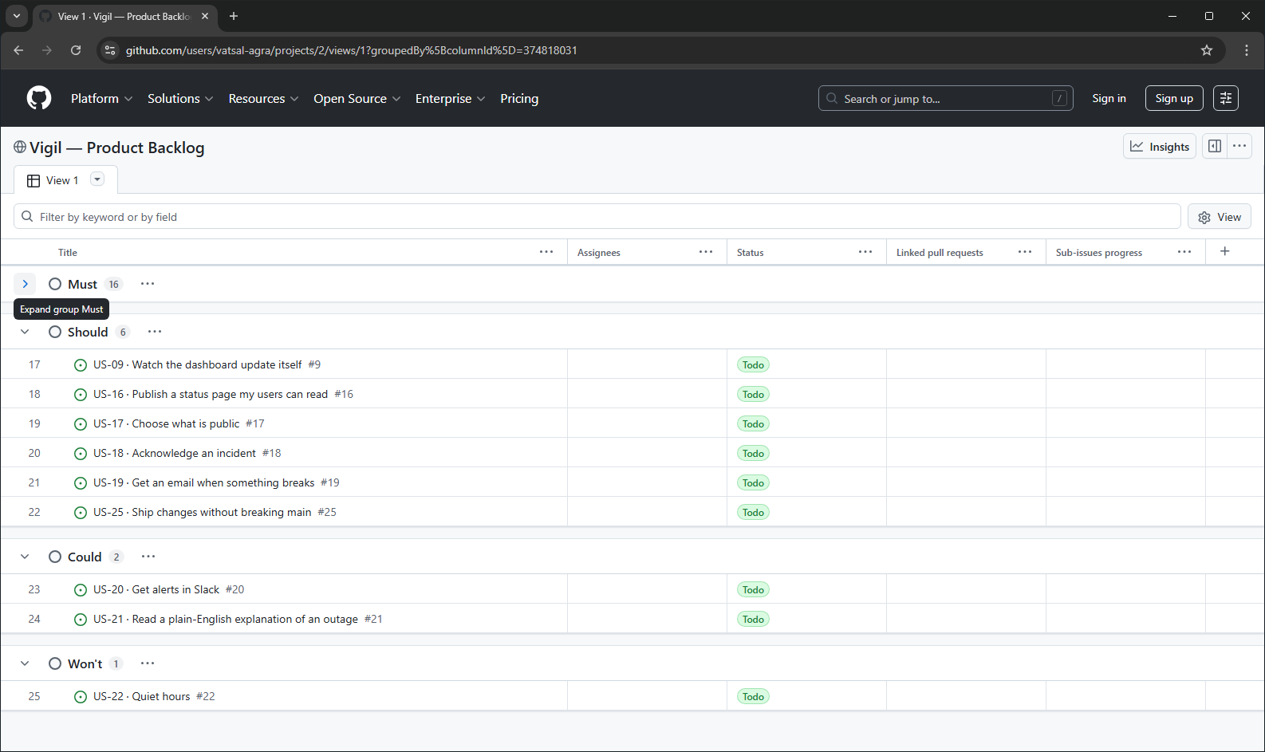
Screenshot 4 — The GitHub Project board, grouped by the MoSCoW single-select field.

3. MoSCoW Prioritisation and Wireframes

3.1 MoSCoW Prioritisation
Priority | Stories | Points | % of backlog | Story IDs
Must have | 16 | 58 | 64% | US-01, 02, 03, 04, 05, 06, 07, 08, 10, 11, 12, 13, 14, 15, 23, 24
Should have | 6 | 22 | 24% | US-09, 16, 17, 18, 19, 25
Could have | 2 | 6 | 7% | US-20, 21
Won't have (this release) | 1 | 5 | 5% | US-22
Total | 25 | 91 | 100%

Why these are the Must haves
The core loop is: sign in → add a URL → the system checks it → the system tells you when it broke. Every Must-have story is load-bearing for that sentence. Remove any one of them and Vigil is not a monitoring tool.

Why the status page is only a Should have
It is the strongest differentiator against a cron job and a curl, but a developer monitoring their own side projects gets full value without it. It ships in milestone M2.

Why quiet hours is a Won't have
It needs per-account timezone handling and a scheduler, and it only matters once alerting is heavily used. Deferring it entirely is cheaper than half-building it.

A note on the 64% Must-have share
Sixty-four percent is high; sixty percent is the usual ceiling for a commercial backlog. It is defensible here because this is a version 1 with no existing users: there is no working product to fall back on if a Must slips, so the walking skeleton genuinely is all-or-nothing. The mitigation is that the M1 stories are small — the median is three points and only one story is an eight.

Release plan
Milestone | Contents | Size
M1 — Walking skeleton | All Must-have stories. A user can sign up, add a URL, and see it go down. | 16 stories, 58 pts
M2 — Usable product | Should have. Status page, alerting, auto-refresh, CI. | 6 stories, 22 pts
M3 — Polish | Could have. Only if the semester allows. | 2 stories, 6 pts
Deferred | Won't have this release. | 1 story, 5 pts

3.2 Wireframes — Six Screens
Six screens were produced covering the complete primary journey: sign in, see everything, add something new, drill into one service, triage an incident, and publish status externally. Each screen carries numbered annotations in the gutter explaining the design decision behind it, and cross-references the user stories it satisfies.
The wireframes are committed as SVG in docs/wireframes/ and import into Figma as editable frames via File → Import. They are generated by scripts/make_wireframes.py, which is why spacing, type scale and component styling are identical across all six.
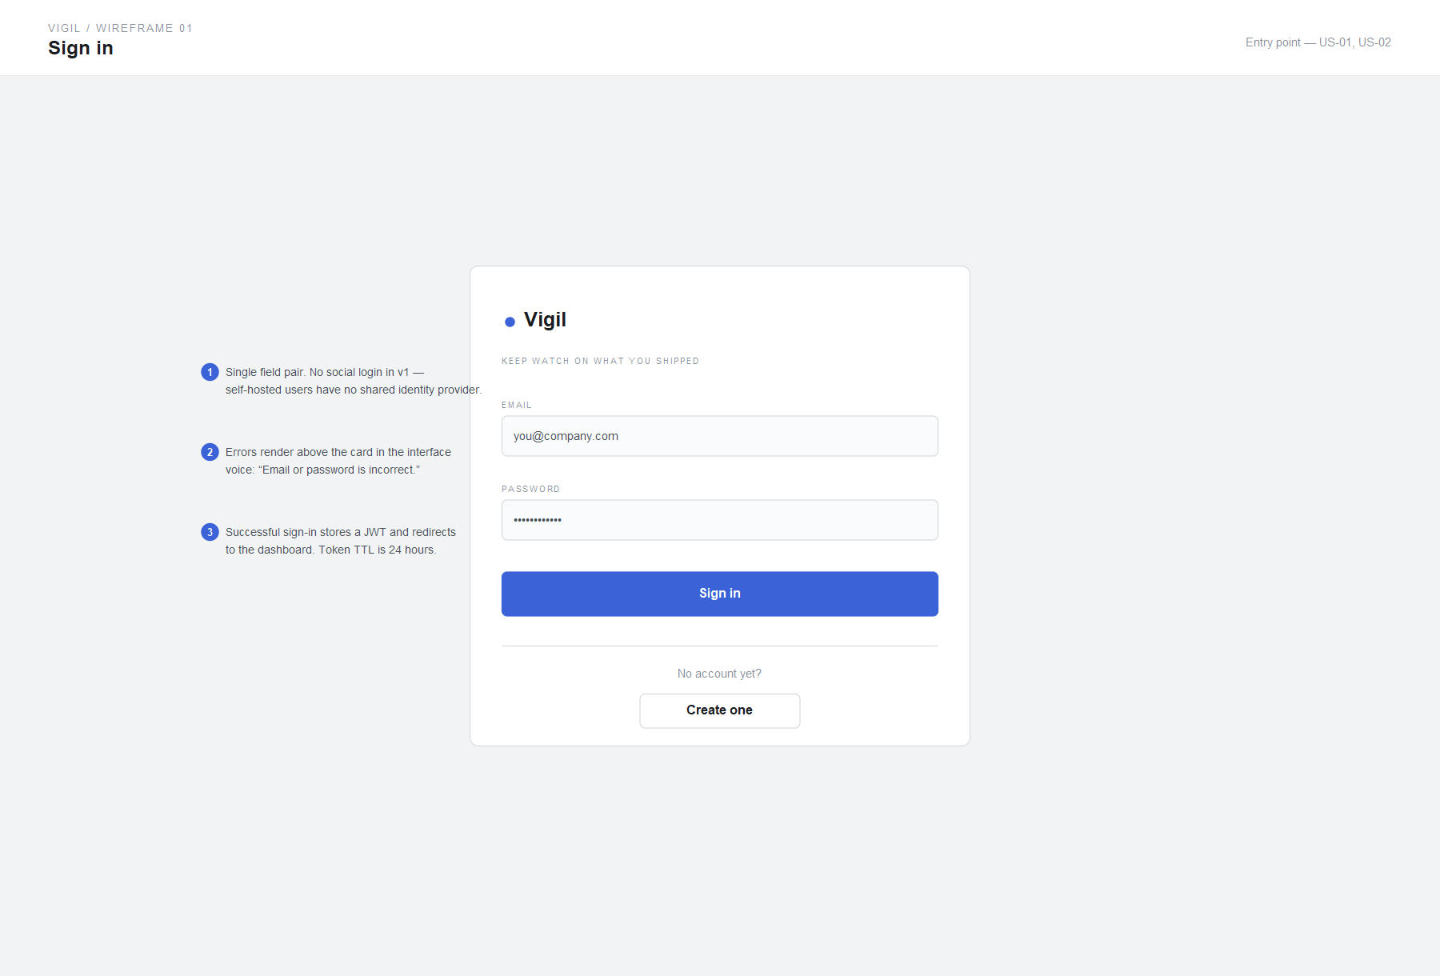
Wireframe 1 — Sign in.
Entry point, satisfying US-01 and US-02. A single field pair: no social login in version 1, because self-hosted users have no shared identity provider. Errors render above the card in the interface voice.
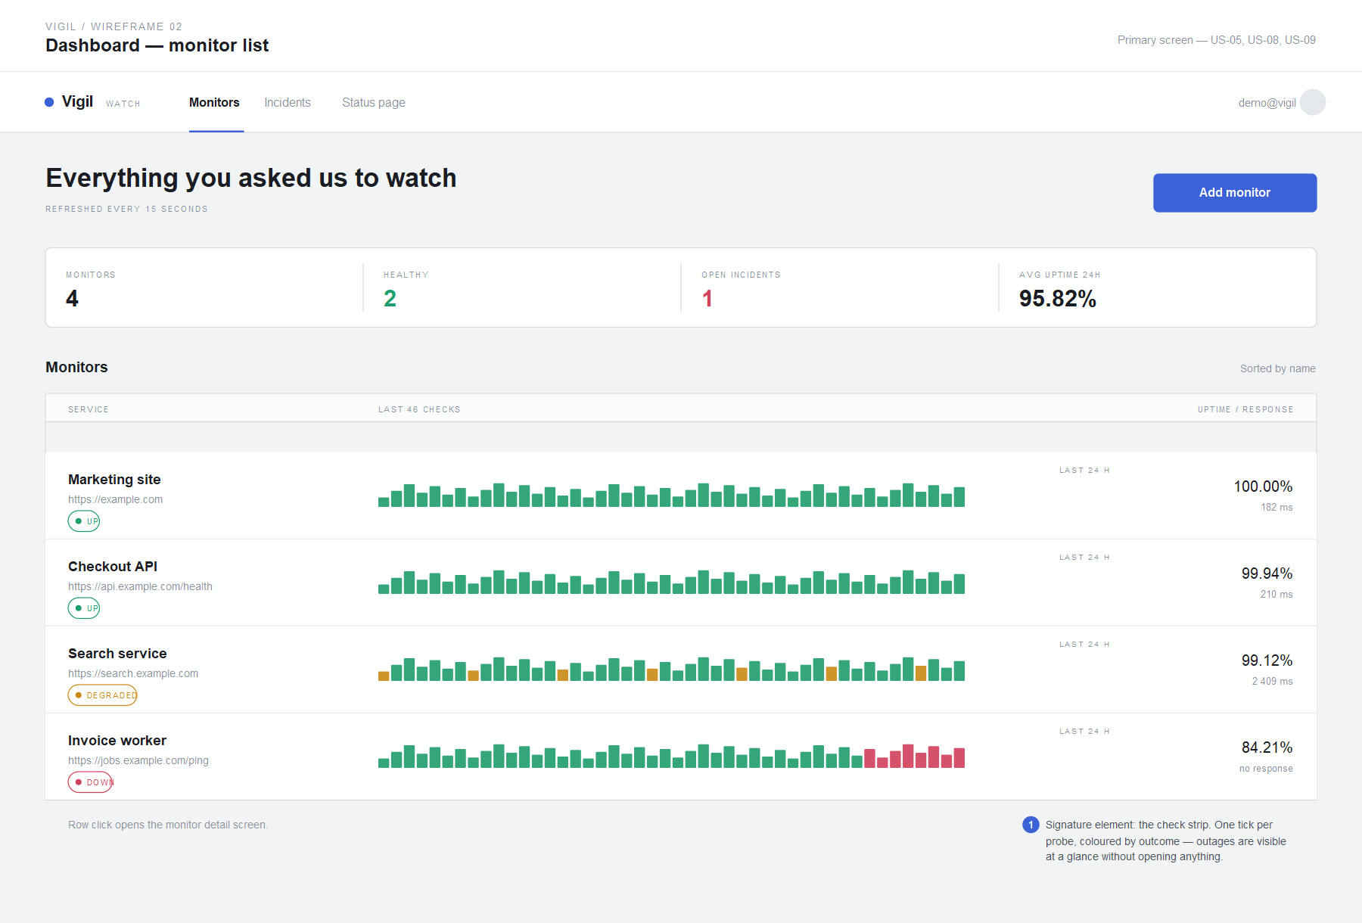
Wireframe 2 — Dashboard, the monitor list.
The primary screen, satisfying US-05, US-08 and US-09. The signature element is the check strip: one tick per probe, coloured by outcome, so an outage is visible without opening anything.

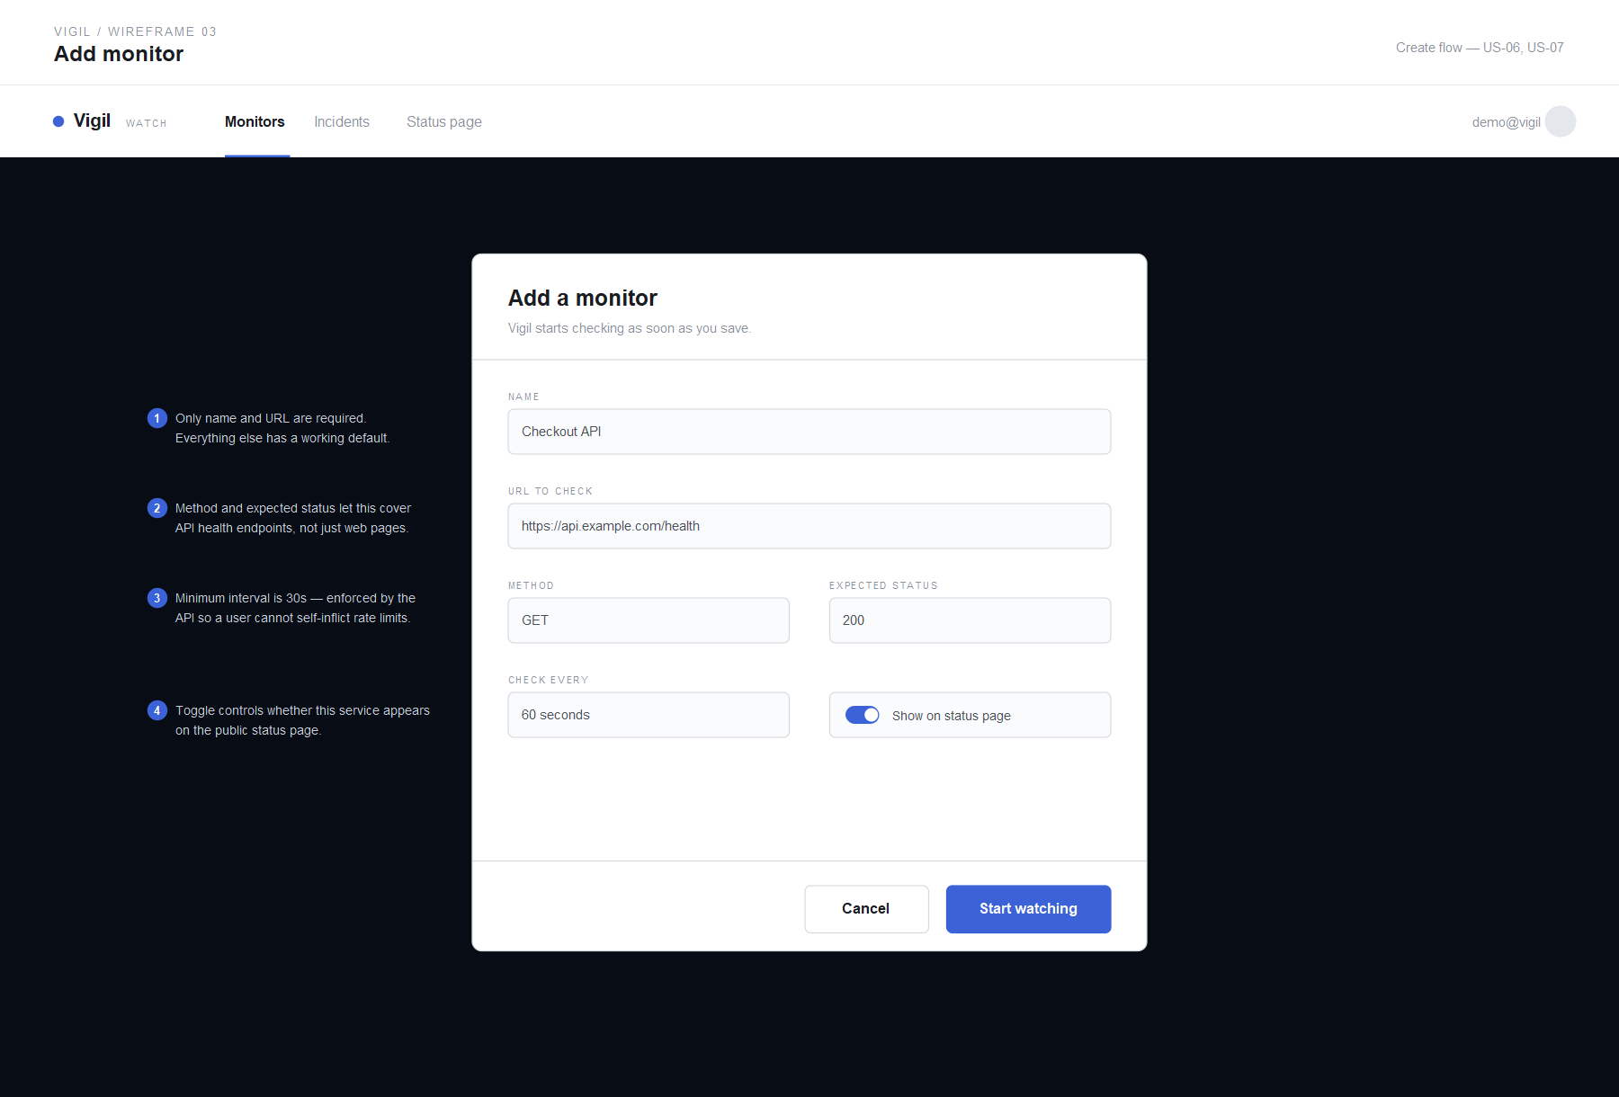
Wireframe 3 — Add monitor.
Creation flow, satisfying US-06 and US-07. Only name and URL are required; method, expected status and interval have working defaults. The minimum interval is enforced server-side so a user cannot self-inflict rate limits.
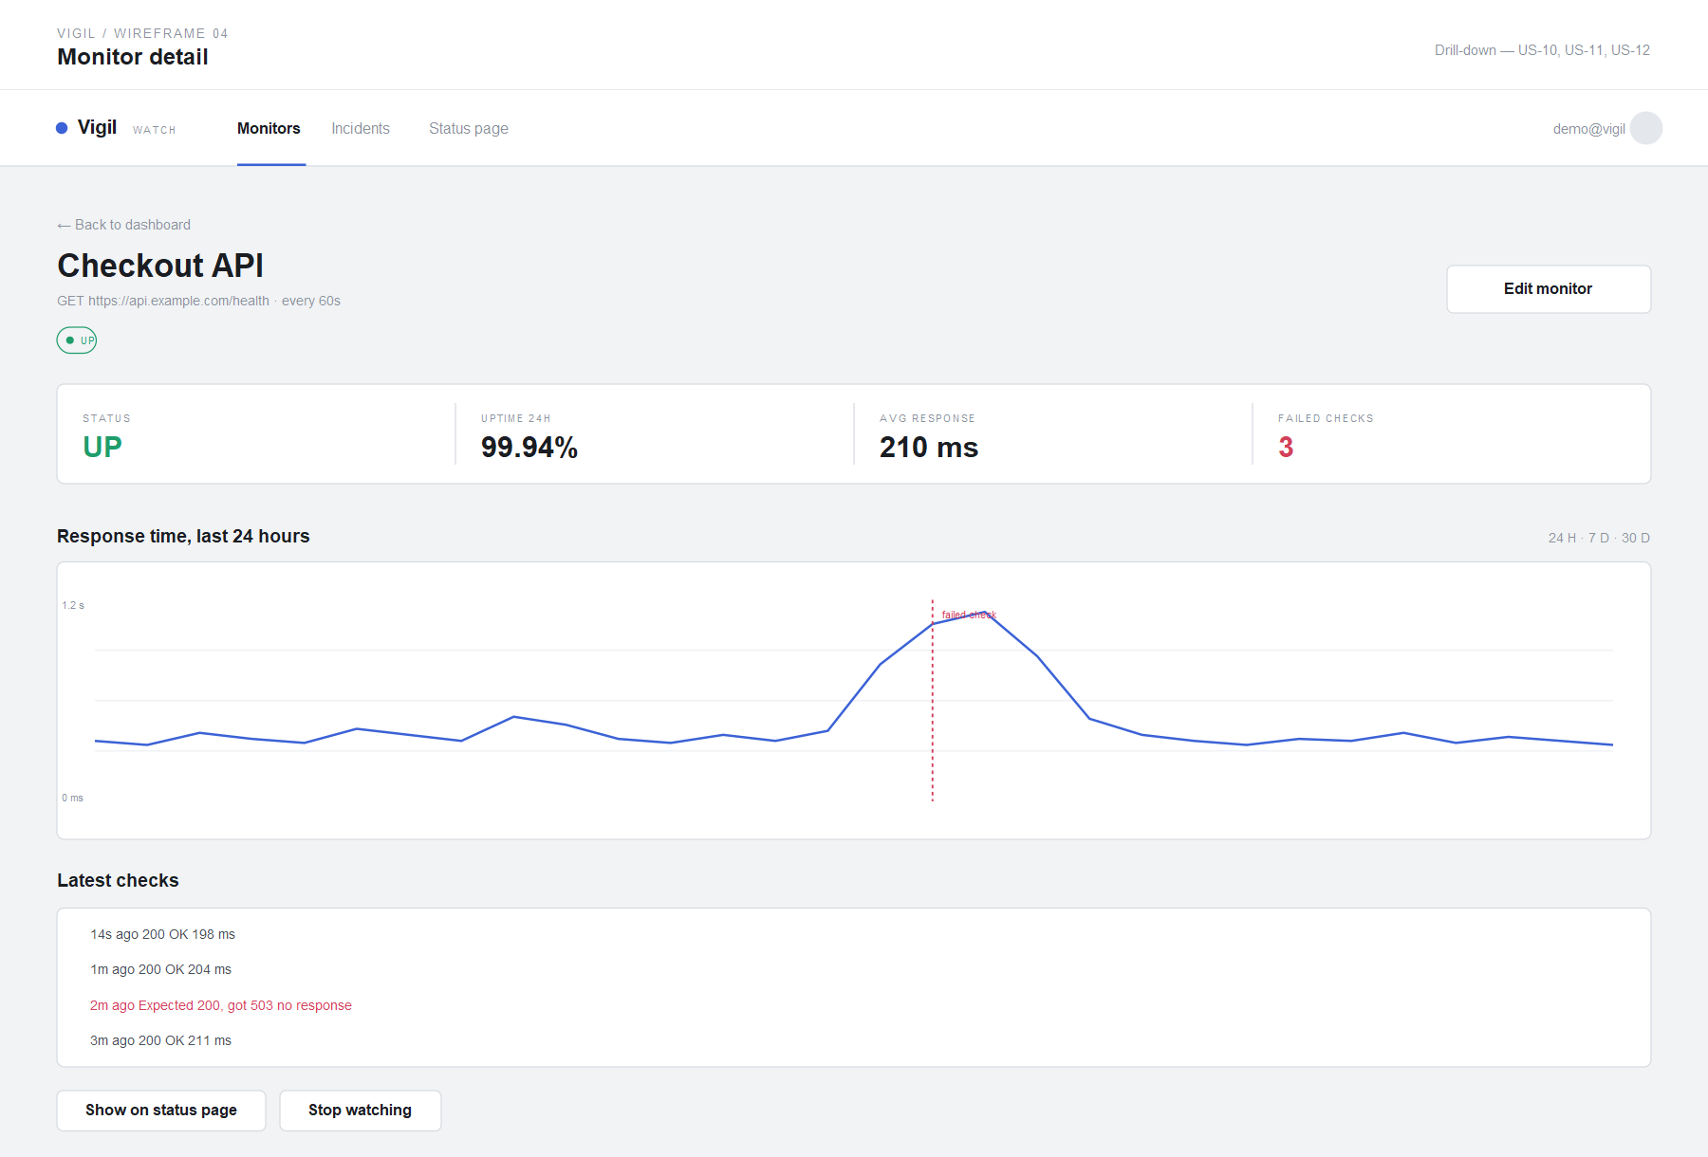
Wireframe 4 — Monitor detail.
Drill-down, satisfying US-10, US-11 and US-12. Failed checks are drawn as vertical markers on the chart so gaps are explained rather than merely absent.

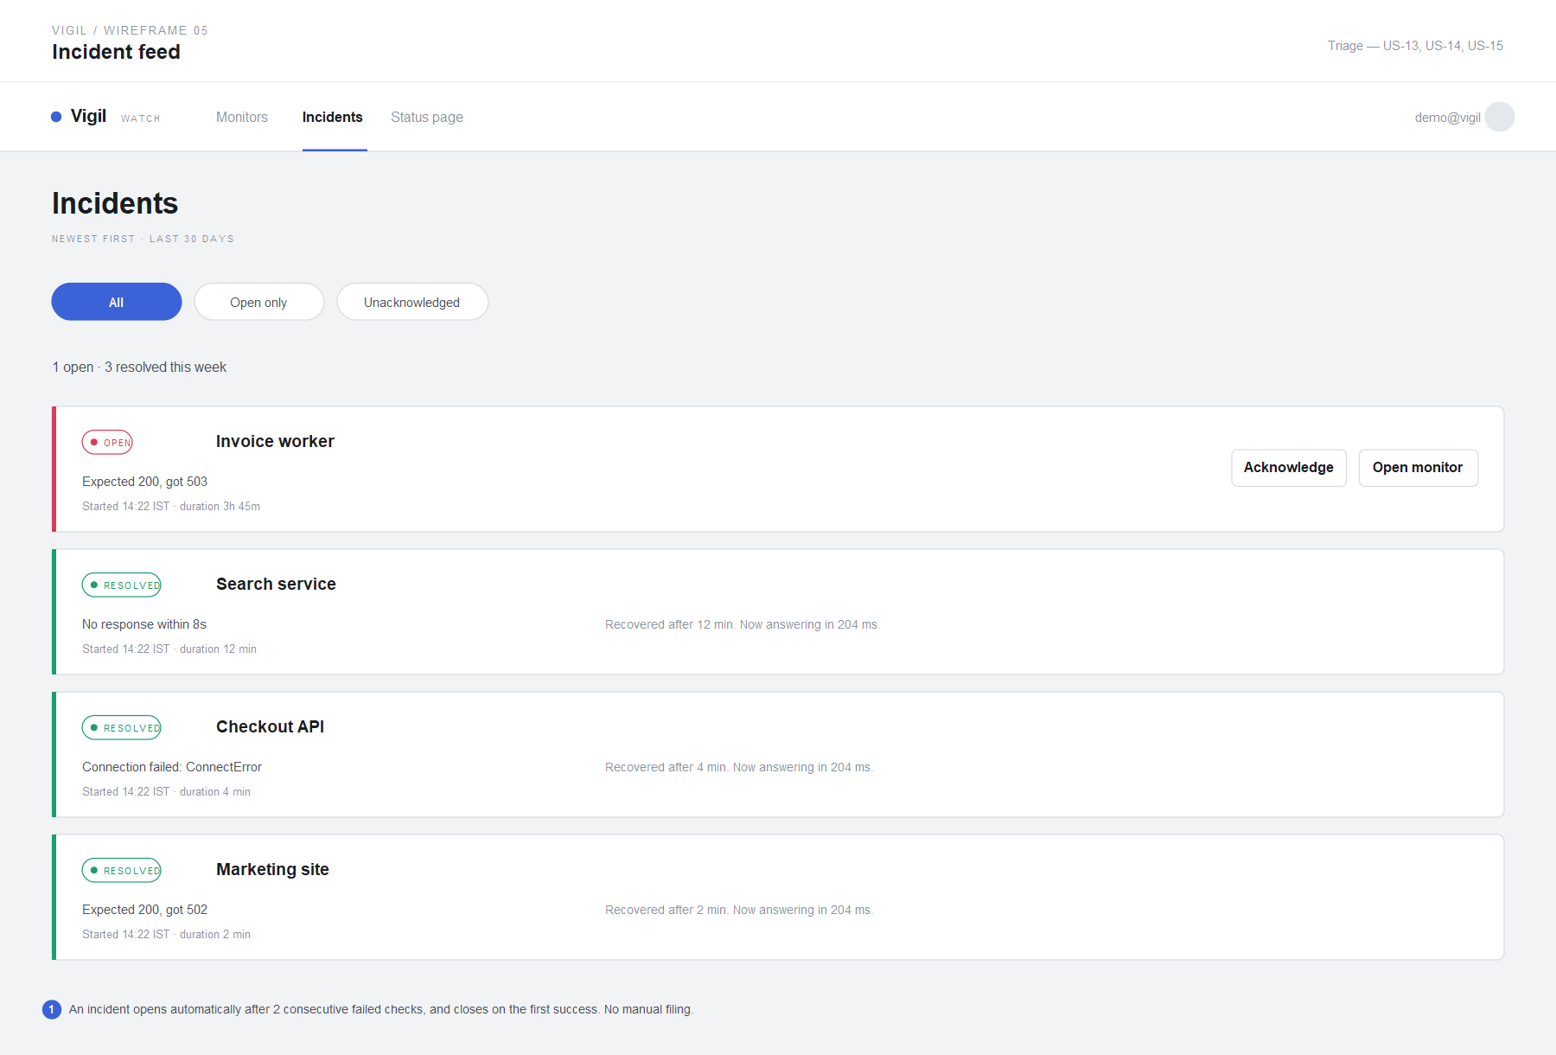
Wireframe 5 — Incident feed.
Triage, satisfying US-13, US-14 and US-15. An incident opens automatically after two consecutive failed checks and closes on the first success, so nothing is filed by hand.
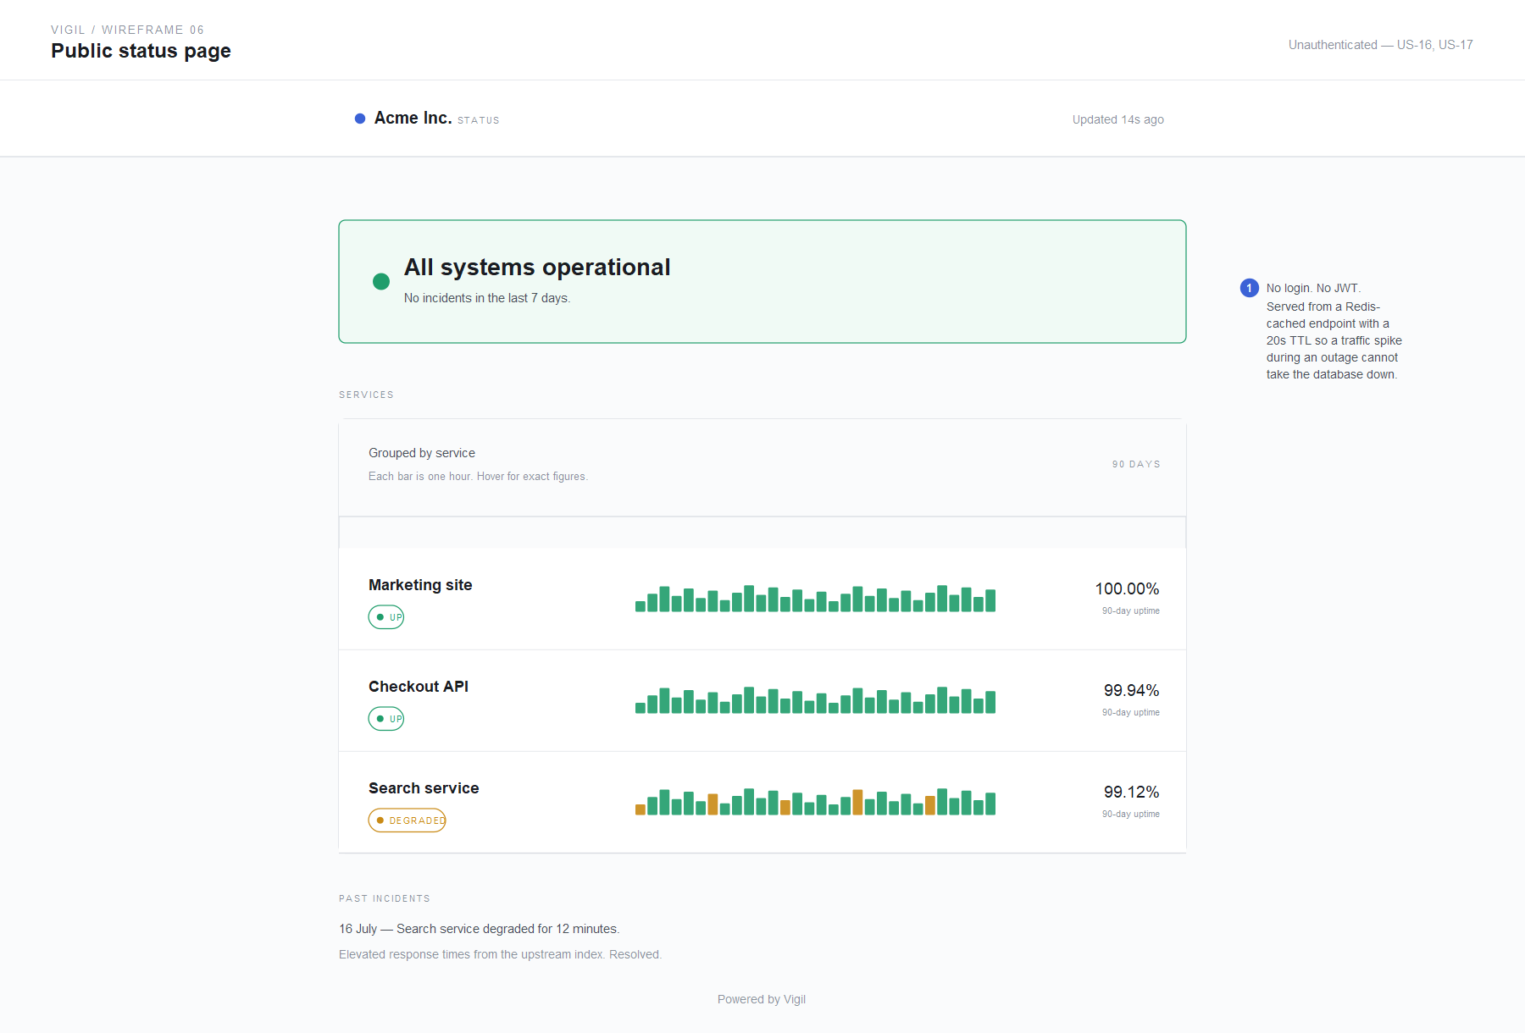
Wireframe 6 — Public status page.
Unauthenticated, satisfying US-16 and US-17. Served from a Redis-cached endpoint with a twenty-second TTL, so a traffic spike during an outage cannot take the database down.

4. Architecture Diagram
Single page, landscape orientation. The diagram shows the complete flow from frontend through backend to data and cache tiers, the containerisation boundary, and the deployment path. Arrows carry labels; a legend keys the tier colours and distinguishes synchronous request paths from asynchronous and deployment paths.
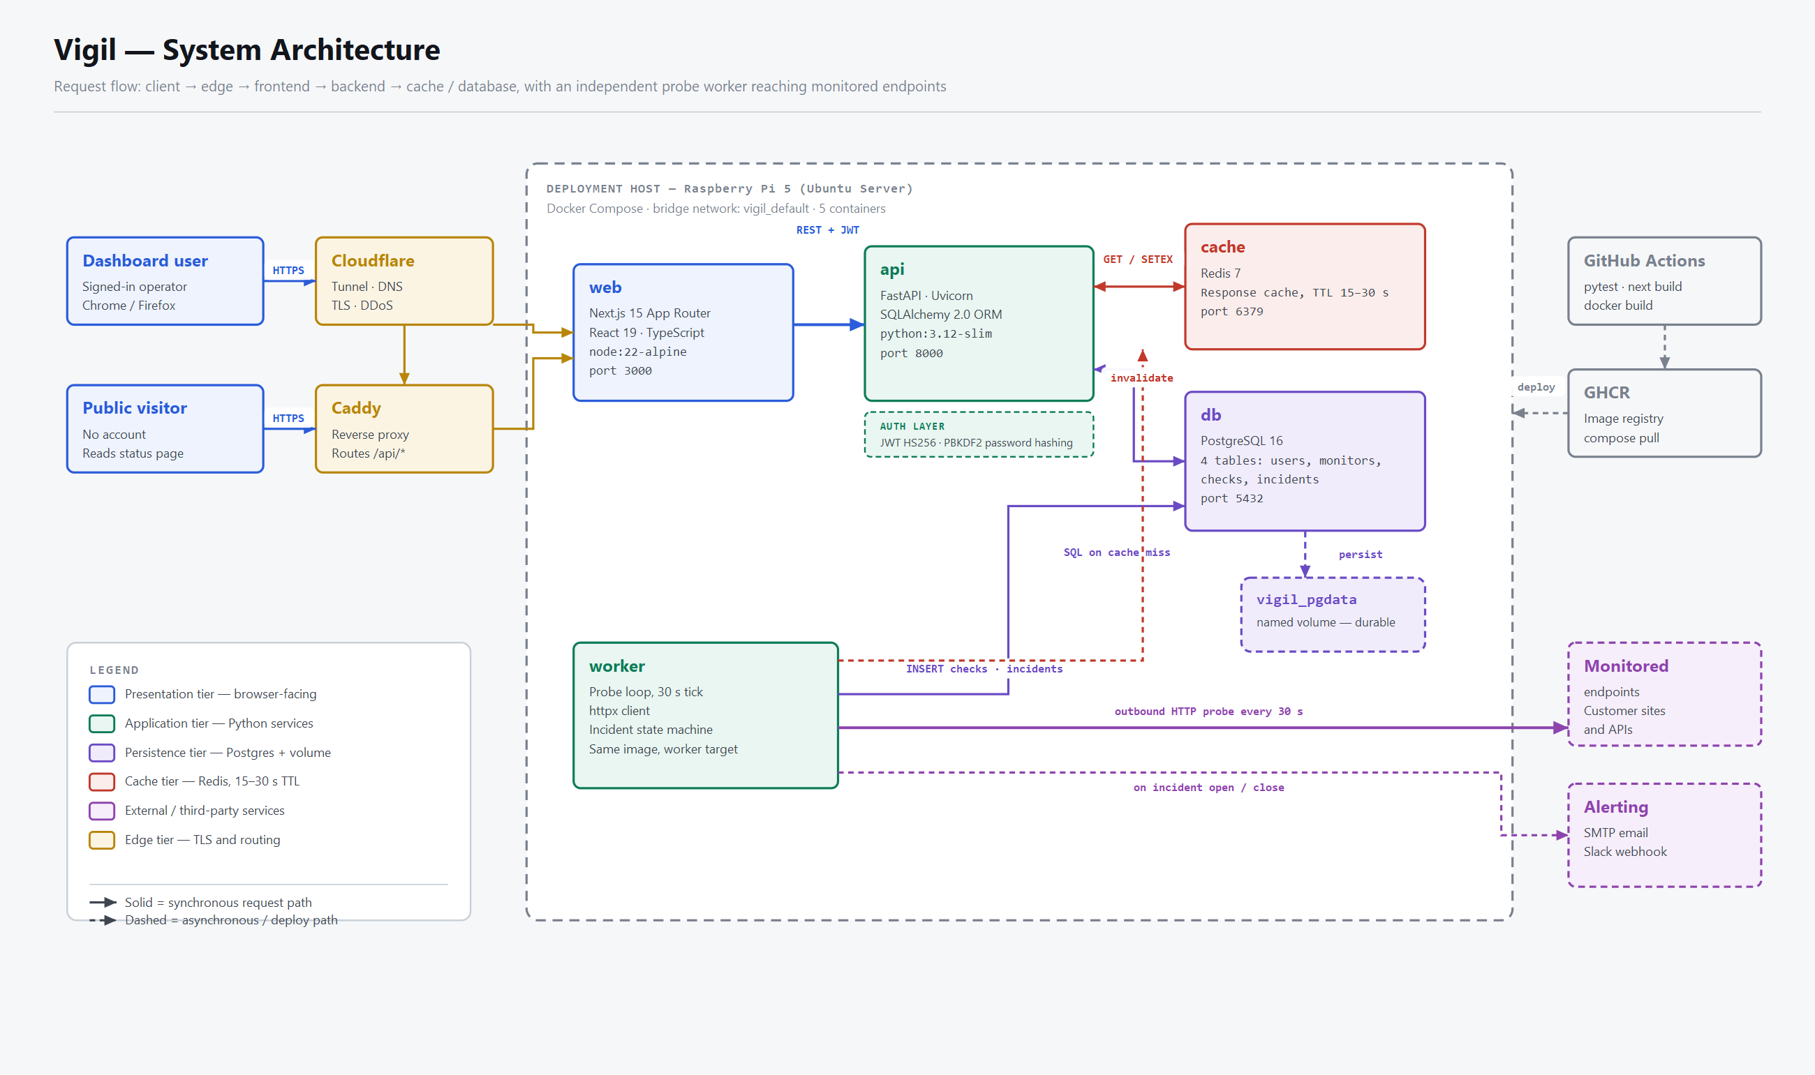
Figure 1 — Vigil system architecture. Editable source: infra/architecture.drawio (open at diagrams.net).

4.1 Why Each Component Is There
Decision | Reasoning
A separate worker container | Probing is slow, blocking I/O — a monitor that times out occupies a thread for eight seconds. Inside the API process that would make the dashboard slow during an outage, which is exactly when people are reloading it. Splitting them means an outage never degrades the tool reporting the outage.
Redis as a real cache tier | The public status page is the one endpoint that spikes precisely when the system is already unhealthy. A twenty-second TTL means a thousand worried customers produce three database queries a minute. The worker deletes the affected keys on write, so the cache is never stale by more than one probe cycle.
PostgreSQL rather than SQLite | Two processes write to the checks table concurrently. SQLite's writer lock makes that a correctness problem, not merely a performance one.
A named volume, not a bind mount | Database files in a bind mount on a Pi's SD card are a data-loss story waiting to happen.
Cloudflare Tunnel in front of Caddy | Gives TLS and DDoS protection without forwarding a port on a home router or exposing a public IP.

4.2 Request Path for the Dashboard
- The browser sends GET /api/monitors with a Bearer token.
- The dependency security.current_user verifies the JWT and loads the user.
- The router checks Redis for monitors:list:<user_id>. On a hit it returns immediately.
- On a miss it queries Postgres, computes the twenty-four-hour rollup per monitor, writes the result to Redis with a fifteen-second TTL, and returns.
- Meanwhile the worker writes new checks and deletes those keys, so the next read is fresh.

5. Development Setup

5.1 Repository Structure
vigil/
├── .github/
│ ├── ISSUE_TEMPLATE/ user-story and bug-report forms
│ ├── workflows/ci.yml pytest · next build · docker build
│ └── pull_request_template.md
├── backend/
│ ├── app/
│ │ ├── main.py FastAPI app, lifespan, /health
│ │ ├── config.py environment-driven settings
│ │ ├── db.py engine and session factory
│ │ ├── models.py User · Monitor · Check · Incident
│ │ ├── schemas.py Pydantic request/response contracts
│ │ ├── security.py PBKDF2 hashing, JWT issue and verify
│ │ ├── cache.py Redis helpers, degrade gracefully
│ │ ├── services.py shared queries, uptime rollups, slugs
│ │ ├── probe.py checking engine, incident state machine
│ │ ├── seed.py demo account and backfilled history
│ │ └── routers/ auth · monitors · incidents · status
│ ├── tests/
│ ├── worker.py probe loop entrypoint
│ ├── requirements.txt
│ └── Dockerfile targets: base · dev · prod · worker
├── frontend/
│ ├── app/
│ │ ├── page.tsx dashboard
│ │ ├── login/ sign in and register
│ │ ├── monitors/[id]/ detail and response-time chart
│ │ ├── status/[handle]/ public status page
│ │ └── globals.css design tokens and component styles
│ ├── lib/api.ts typed fetch client, session handling
│ └── Dockerfile targets: deps · dev · builder · prod
├── infra/
│ ├── architecture.drawio the system diagram
│ └── caddy/Caddyfile production reverse proxy
├── docs/
│ ├── user-stories.md 25 stories, acceptance criteria, MoSCoW
│ └── wireframes/ six screens as SVG
├── scripts/
│ ├── bootstrap-github.sh one-shot repository setup
│ ├── stories.sh the backlog as data
│ ├── seed-issues.sh labels and issues
│ └── setup-project-board.sh project board and fields
├── docker-compose.yml
├── .env.example
├── .gitignore
└── README.md

5.2 The .gitignore
Grouped by concern rather than dumped as one list, so a contributor can see why each entry exists. Secrets first, because that is the entry that matters.
# ---------- secrets ----------
.env
.env.*
!.env.example
*.pem
*.key

# ---------- python ----------
__pycache__/
*.py[cod]
.venv/
.pytest_cache/
.mypy_cache/
.ruff_cache/
.coverage
*.sqlite3
*.db

# ---------- node / next ----------
node_modules/
.next/
out/
dist/
*.tsbuildinfo
npm-debug.log*

# ---------- docker ----------
docker-compose.override.yml

# ---------- editors / os ----------
.vscode/
.idea/
.DS_Store
Thumbs.db

5.3 Branching Strategy — GitHub Flow
main is always deployable. There is no develop branch, no release branch, and no long-lived integration branch — with one developer those exist only to create merge conflicts with yourself.
main ──●────────●────────────●────────●──▶ always deployable, protected
\ / \ /
●────● ●────●
feat/us-13-probe-worker feat/us-16-status-page
- Branch off main for every unit of work. One branch per issue.
- Name the branch after the story: <type>/us-<id>-<slug> — for example feat/us-13-probe-worker, fix/us-08-uptime-excludes-timeouts, chore/us-25-ci-pipeline.
- Commit in Conventional Commits form, referencing the issue — feat(engine): open an incident after two consecutive failures, followed by a blank line and Refs #13.
- Open a pull request early. The description links the issue with Closes #13, so merging closes the story and moves the board card.
- CI must be green. pytest, next build, and both docker builds run on every pull request. main is branch-protected against direct pushes and failing checks.
- Squash-merge, then delete the branch. One story, one commit on main, readable history.
Working a story end to end:
$ git switch main && git pull
$ git switch -c feat/us-16-public-status-page

... work, committing as you go ...

$ git commit -m "feat(status): serve a cached public status page

Refs #16"
$ git push -u origin feat/us-16-public-status-page
$ gh pr create --fill --base main
$ gh pr merge --squash --delete-branch
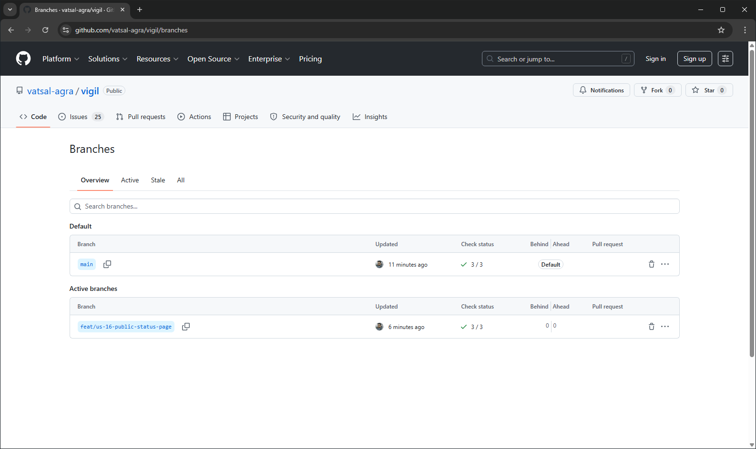
Screenshot 2 — The repository branch list showing main alongside the feature branch.

5.4 Docker Setup for Local Development
Both Dockerfiles are multi-stage with named targets, so the same file produces the development image, the production image, and — for the backend — the worker image. The target is selected by an environment variable rather than a second file.

backend/Dockerfile
FROM python:3.12-slim AS base
ENV PYTHONDONTWRITEBYTECODE=1 PYTHONUNBUFFERED=1 PIP_NO_CACHE_DIR=1
WORKDIR /app
RUN apt-get update && apt-get install -y --no-install-recommends curl \
&& rm -rf /var/lib/apt/lists/*
COPY requirements.txt .
RUN pip install --no-cache-dir -r requirements.txt
COPY . .
RUN useradd --create-home --uid 1001 vigil && chown -R vigil:vigil /app
USER vigil
EXPOSE 8000
HEALTHCHECK --interval=20s --timeout=4s --start-period=25s --retries=5 \
CMD curl -fsS http://localhost:8000/health || exit 1

FROM base AS dev # hot reload on save
CMD ["uvicorn", "app.main:app", "--host", "0.0.0.0", "--port", "8000", "--reload"]

FROM base AS prod # multiple workers, no reloader
CMD ["uvicorn", "app.main:app", "--host", "0.0.0.0", "--port", "8000", "--workers", "2"]

FROM base AS worker # probe loop, no HTTP server
HEALTHCHECK NONE
CMD ["python", "worker.py"]

frontend/Dockerfile
FROM node:22-alpine AS deps
WORKDIR /app
COPY package.json package-lock.json* ./
RUN npm ci || npm install

FROM node:22-alpine AS dev
WORKDIR /app
COPY --from=deps /app/node_modules ./node_modules
COPY . .
EXPOSE 3000
CMD ["npm", "run", "dev"]

FROM node:22-alpine AS builder
WORKDIR /app
COPY --from=deps /app/node_modules ./node_modules
COPY . .
RUN npm run build

FROM node:22-alpine AS prod # standalone output, no node_modules
WORKDIR /app
RUN addgroup -g 1001 -S nodejs && adduser -S nextjs -u 1001
COPY --from=builder /app/public ./public
COPY --from=builder --chown=nextjs:nodejs /app/.next/standalone ./
COPY --from=builder --chown=nextjs:nodejs /app/.next/static ./.next/static
USER nextjs
EXPOSE 3000
CMD ["node", "server.js"]

docker-compose.yml — the five services
Startup is health-gated: the API will not start until Postgres passes pg_isready, so first boot does not race. Both application services bind-mount their source, so code edits reload live without a rebuild.
Service | Image | Role
db | postgres:16-alpine | Persistence. Healthcheck on pg_isready. Data in the named volume vigil_pgdata.
cache | redis:7-alpine | Response cache. Persistence disabled — everything in it is derivable.
api | built, target dev | FastAPI on port 8000. Depends on db and cache being healthy.
worker | built, target worker | Probe loop. No exposed port. Same image as api.
web | built, target dev | Next.js on port 3000.

5.5 Quick Start — Local Development
This section is reproduced verbatim from README.md, where the assignment requires it to live.

Prerequisites
Tool | Version | Check with
Docker Desktop (or Engine + Compose v2) | 24+ | docker --version && docker compose version
Git | 2.40+ | git --version
Nothing else. Python and Node run inside the containers — neither is needed on the host.

Run it
$ git clone https://github.com/vatsal-agra/vigil.git
$ cd vigil
$ cp .env.example .env # optional; compose has working defaults
$ docker compose up --build
The first build takes two to four minutes. Subsequent starts take a few seconds. When it is ready:
What | Where
Dashboard | http://localhost:3000
Public status page | http://localhost:3000/status/demo
API documentation (Swagger) | http://localhost:8000/docs
Health check | http://localhost:8000/health
A demo account is seeded automatically on an empty database:
email: demo@vigil.dev
password: vigil-demo-2026
It arrives with four monitors and twenty-four hours of backfilled check history, so the dashboard, the chart and the incident feed are all populated the moment you sign in.

Everyday commands
$ docker compose up # start, after the first build
$ docker compose up --build # rebuild after a Dockerfile or dependency change
$ docker compose down # stop, keep the database
$ docker compose down -v # stop and wipe the database (re-seeds next start)
$ docker compose logs -f api worker # follow specific services
$ docker compose restart worker # restart one service

$ docker compose exec api pytest -q # backend tests
$ docker compose exec db psql -U vigil -d vigil # SQL shell
$ docker compose exec cache redis-cli KEYS 'monitors*' # inspect the cache

Production images
$ BACKEND_TARGET=prod FRONTEND_TARGET=prod docker compose up --build

Troubleshooting
Symptom | Cause | Fix
port is already allocated | Something else holds 3000, 5432, 6379 or 8000 | lsof -i :5432, stop it, or remap the left-hand side in docker-compose.yml
Dashboard shows “Could not reach the API” | NEXT_PUBLIC_API_URL is a container hostname | It must be browser-reachable: http://localhost:8000, not http://api:8000
relation “monitors” does not exist | Volume from an older schema | docker compose down -v && docker compose up
Worker restarts in a loop | Postgres was not ready | Handled by wait_for_db; if it persists check docker compose logs db
No demo data | The database was not empty | docker compose down -v, then start again

5.6 Local Development Tools
Reproduced from README.md. Each entry states why it is in this project rather than simply that it exists.
Tool | Version | Why it is in this project
Docker Desktop | 24+ | Runs all five services. The only host dependency.
Docker Compose v2 | bundled | Service graph, health-gated startup ordering, named volumes.
VS Code | latest | Editor. Extensions: Python, Pylance, Ruff, ESLint, Prettier, Docker, GitLens.
Dev Containers | optional | Attaches VS Code directly to the api container for a debugger against the real environment.
Git | 2.40+ | Version control. GitHub Flow, one branch per issue.
GitHub CLI (gh) | 2.x | Creates issues, pull requests and the project board from the terminal. The repository scripts depend on it.
pytest | 8.3 | Backend tests. Runs in CI and inside the container.
Ruff | latest | Python lint and format — ruff check backend && ruff format backend.
TypeScript | 5.7 | Compile-time contract between lib/api.ts and every component. next build fails on a type error, so drift cannot ship.
Swagger UI | via FastAPI | Auto-generated from the Pydantic schemas at /docs. Used to exercise endpoints before the UI exists.
psql / redis-cli | in-container | Inspect database and cache state directly during debugging.
draw.io (diagrams.net) | web | The architecture diagram. Source committed as .drawio, so it stays diffable.
Figma (free tier) | web | The six wireframes. SVG sources import as editable frames.
GitHub Actions | hosted | CI on every pull request: pytest, next build, and both docker builds.

6. Proof That Everything Works
The assignment requires screenshots of a successful Docker build, the application running in a browser on localhost, and the GitHub repository page showing branches and README. Screenshots 1 and 2 appear in Sections 1 and 5 respectively; screenshots 3 and 4 in Section 2. The remainder follow.
Each screenshot below was captured from the live environment: the terminal running the stack, and the application in the browser on localhost. docs/screenshots/README.md in the repository documents how each capture was produced.
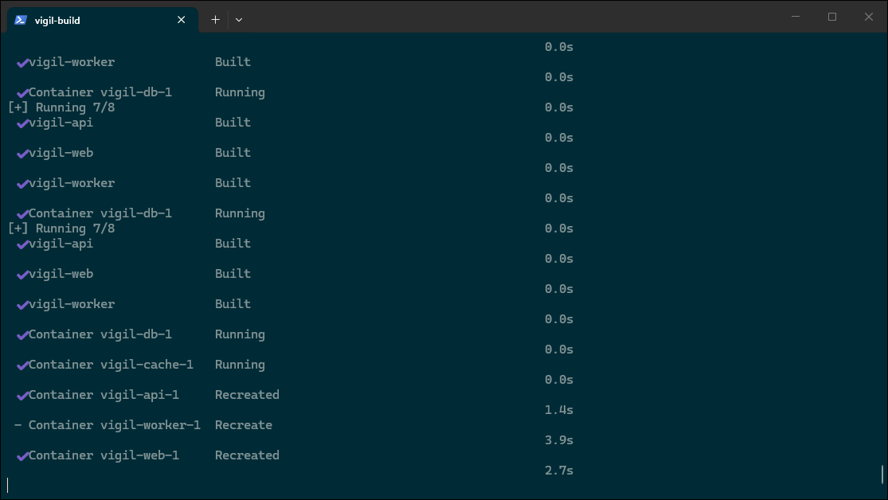
Screenshot 5 — Terminal: docker compose up --build completes successfully, all five containers started.
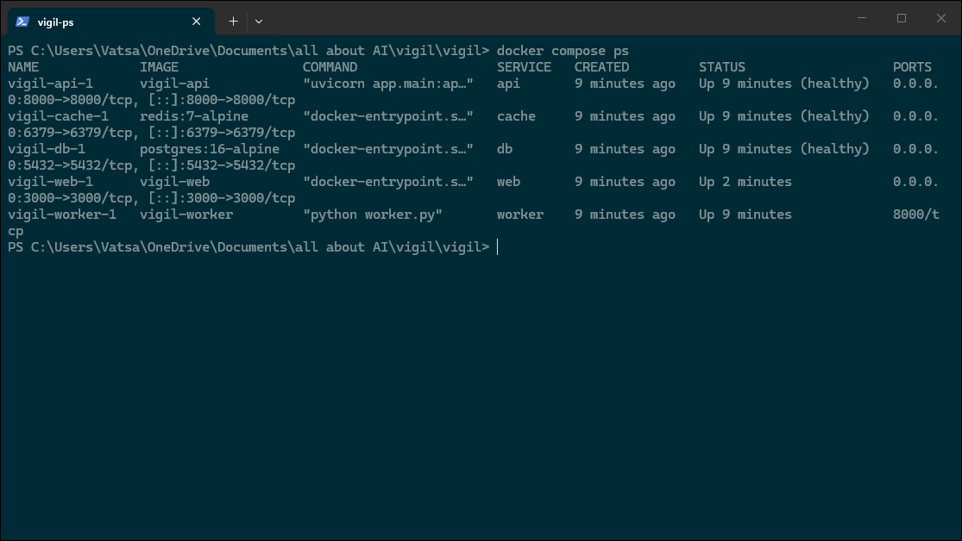
Screenshot 6 — Terminal: docker compose ps showing all five containers up, with db, cache and api healthy.
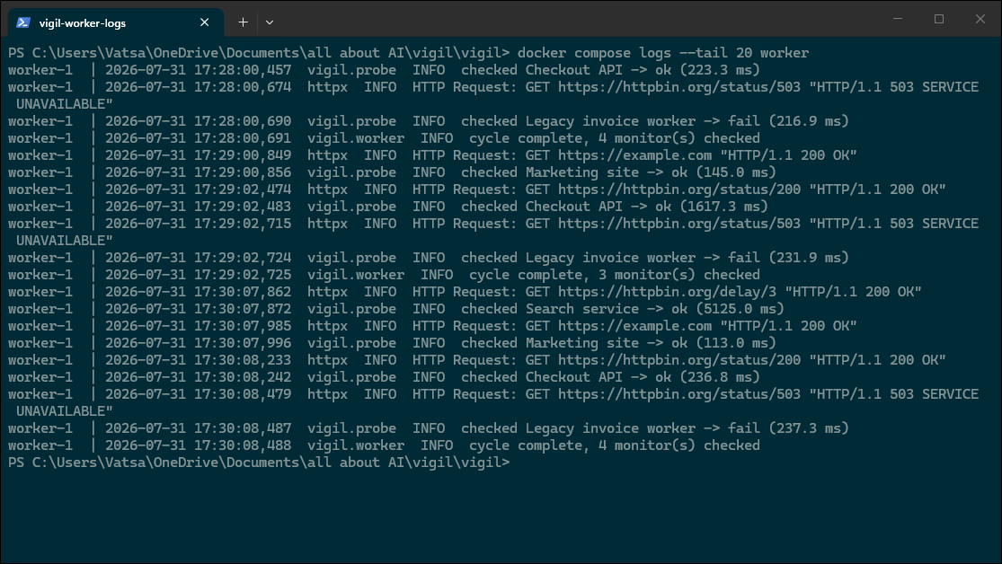
Screenshot 7 — Terminal: the probe worker completing a check cycle.
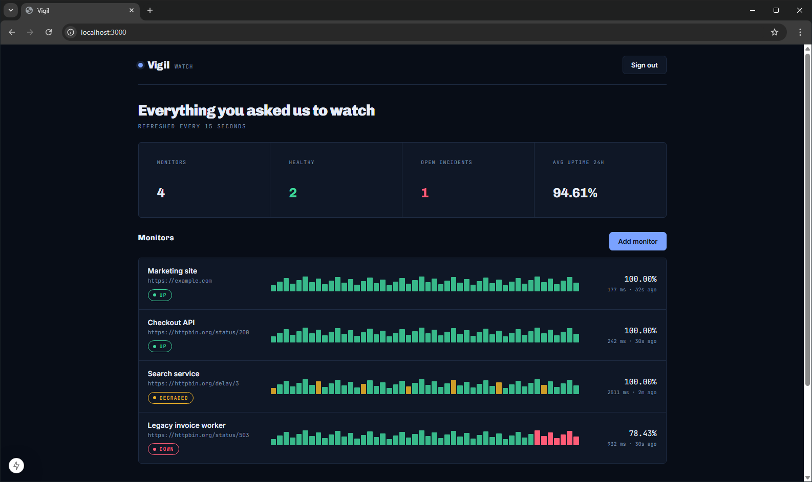
Screenshot 8 — Browser: the application running on http://localhost:3000.
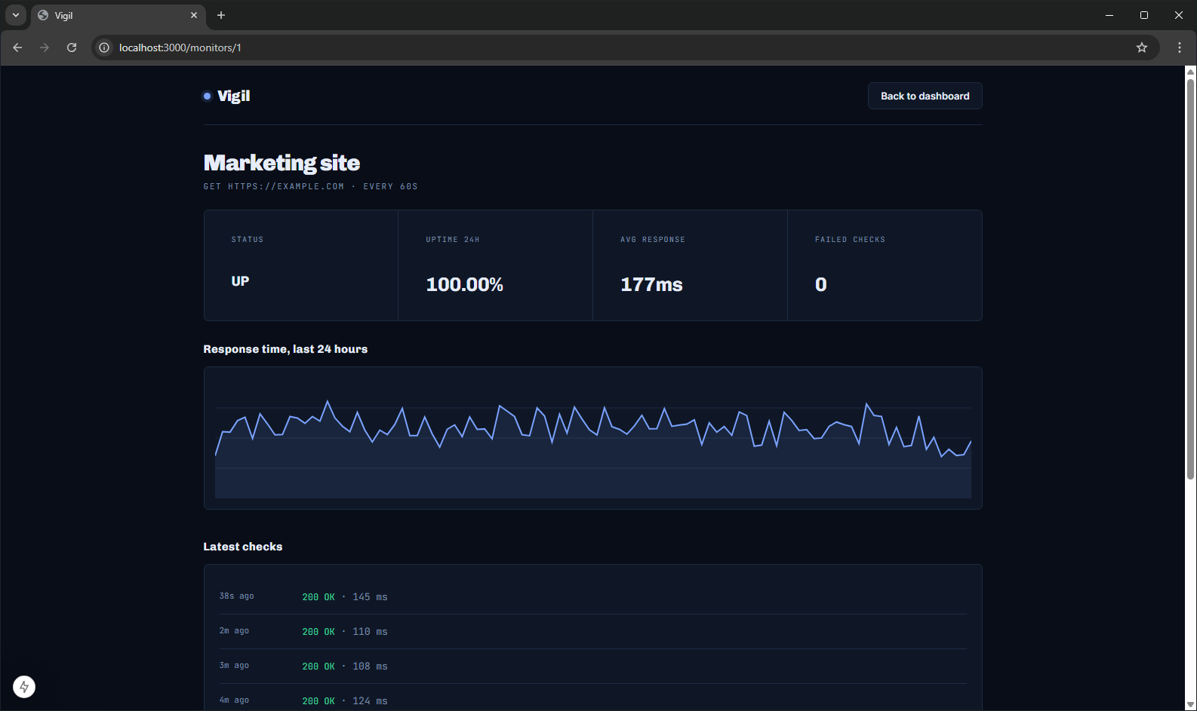
Screenshot 9 — Browser: monitor detail with the twenty-four-hour response-time chart.
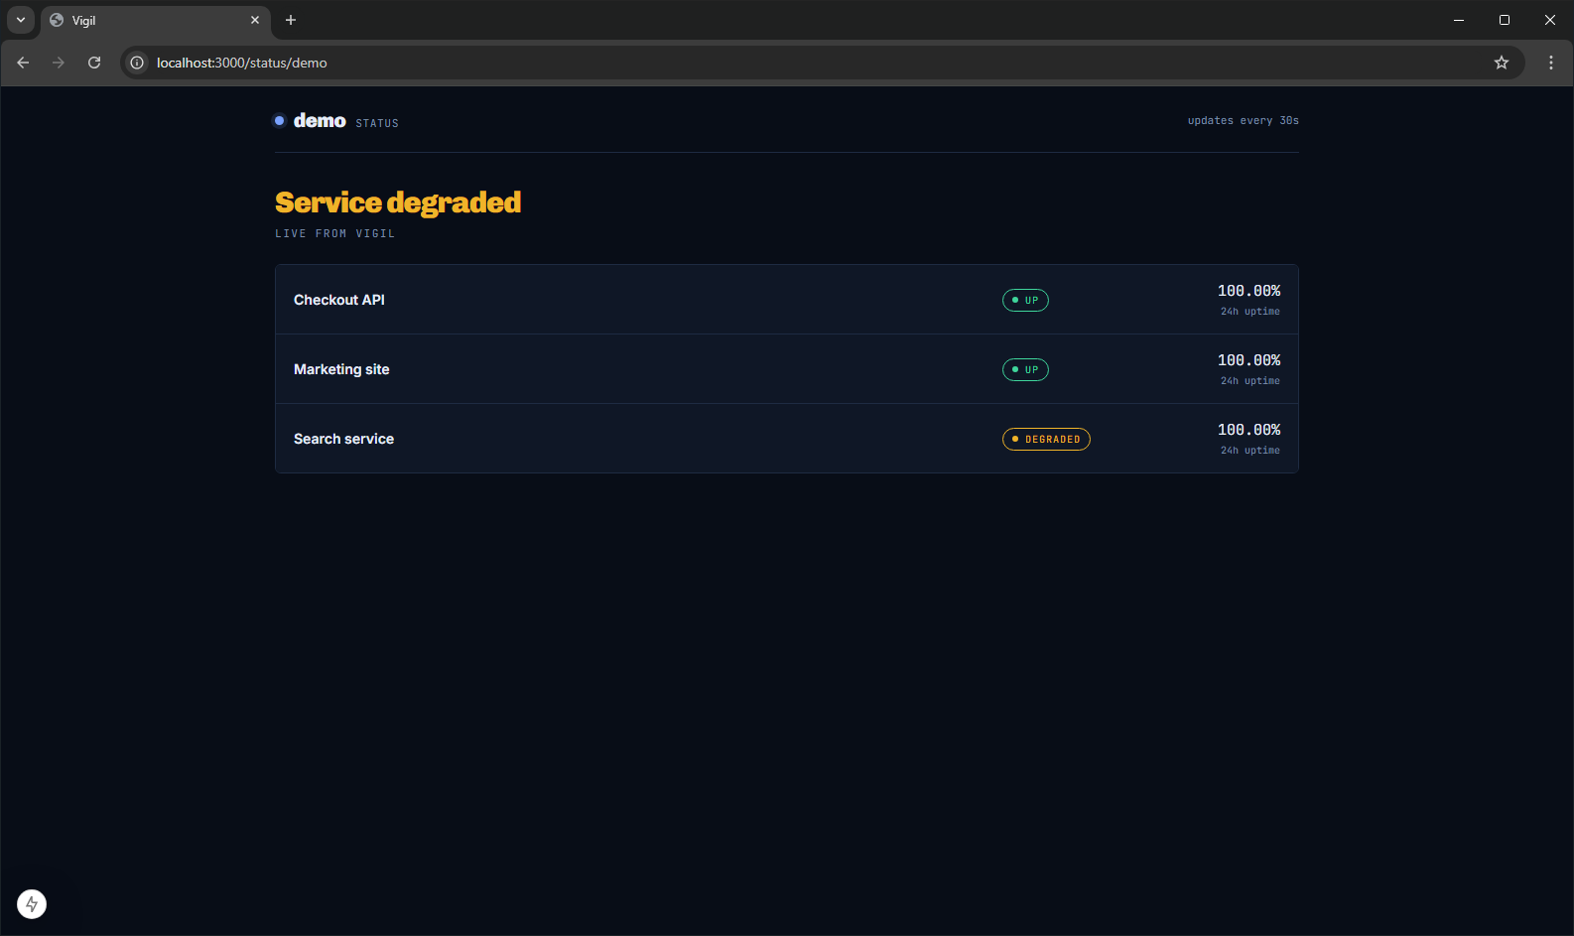
Screenshot 10 — Browser: the public status page, requiring no authentication.

Verification summary
Requirement | Evidence
Proper folder structure | Section 5.1 and Screenshot 1
A good .gitignore | Section 5.2
Branching strategy explained in README | Section 5.3
At least one feature branch, shown in a screenshot | Screenshot 2 — feat/us-16-public-status-page
Dockerfile(s) in the repository | Section 5.4 — backend and frontend, multi-stage
Quick Start section in README | Section 5.5
Local development tools documented in README | Section 5.6
Terminal showing successful build and compose up | Screenshots 5, 6 and 7
App running in the browser on localhost | Screenshots 8, 9 and 10
GitHub repo page showing branches and README | Screenshots 1 and 2

