Lab 4 Report

Vatsal Patel AU2040043

Digant Patel AU2040086

Original file type: Mp4

Original file size: 13.29 MB

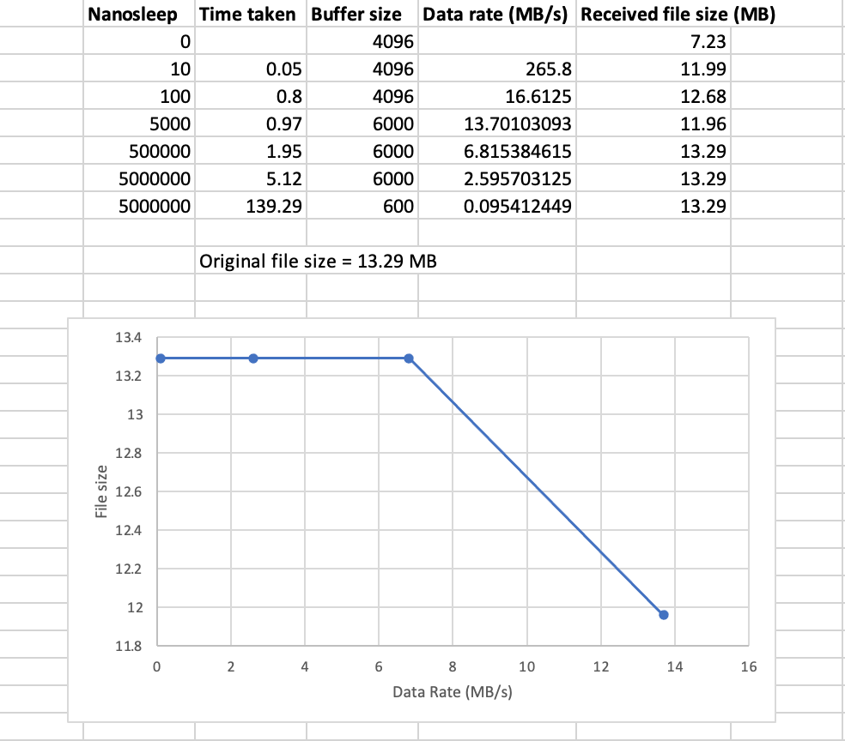

* Without nanosleep, received file size keeps changing even though buffer size is same because of packet loss.
* Without nanosleep, there is large amount of packet loss.
* As nanosleep delay increases, packet loss decreases.
* As buffer size decreases, time taken increases.