**PYTHON MINI PROJECT**

**Snake Game using Tkinter**

**USER MANUAL**

**REPORT**

***Neeraj Naik 1811027***

***Vatsal Pathak 1811033***

***A2 Batch***

Description:

The user controls a snake which continuously moves in the direction its’ head is facing. If the snake runs into one of the outer boundary walls or its’ own body, it will result in fatal injury to the snake and the player will lose the game as a result. An apple will always be spawned on the map, at a randomly generated location. The snake can eat apples by running over them. When the snake eats the apple that is on the map, the snake will grow 1 unit longer and another apple will appear in another randomly generated location. The goal of the game is to control the snake in such a way that it eats as many apples as possible (i.e. the snake grows as long as possible) without dying. This gets harder the larger the snake gets, because there will be less available space for the snake to move in its’ environment and the speed of the snake is increased, so the game gets very strategic as the snake approaches longer lengths..

Controls

Arrow Keys

Pressing an arrow key will make the snake’s head face the respective location of the arrow key.

Up arrow : Snake’s head will face upward.

Down arrow : Snake’s head will face downward.

Left arrow : Snake’s head will face to the left.

Right arrow :Snake’s head will face to the right.

Note:

The snake cannot instantly turn backwards; it must go around in a

semi circle. (The snake cannot backtrack over its body)

1. The game starts by clicking on the “Start Game” button on the screen.

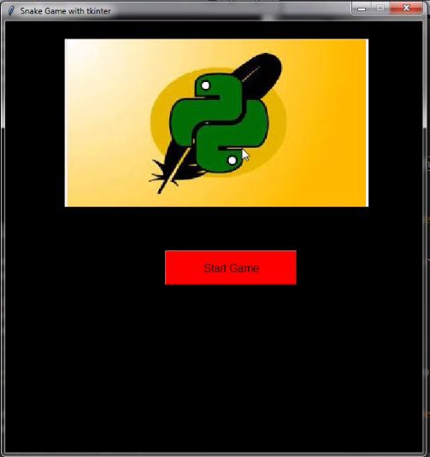

1. The snake can be controlled by the arrow keys. Depending on where you point them, the snake will go towards that direction.

The snake has to eat the food that appears on screen , which will increment the snake’s length and the user’s score.

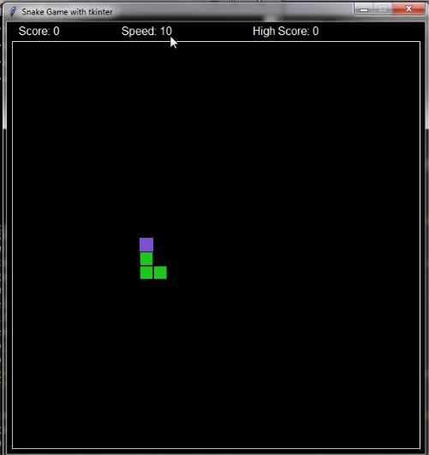

1. The speed of the snake is set to be initially 10 but as the game goes on for every increase of 5points the speed gets incremented by “1”.

Eg. If score is 5 the speed is 11

Similarly if score is 10 the speed becomes 12 and so on..

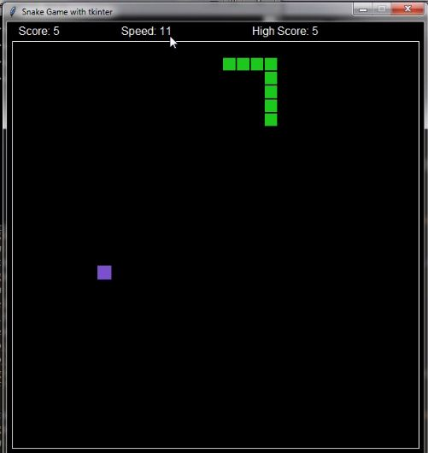

1. The game will come to an end if either the snake hits the wall or it hits itself.

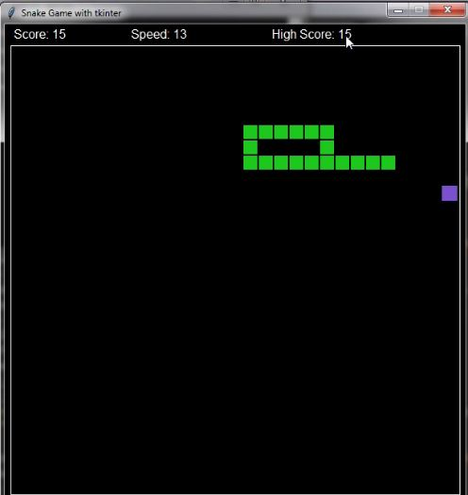

1. Once the game ends you’ll get a screen with your current score and the high score of that game session. Your high-score will be UPDATED if your current

score greater than your previous high-score. You will get two options either to restart or to end the game.

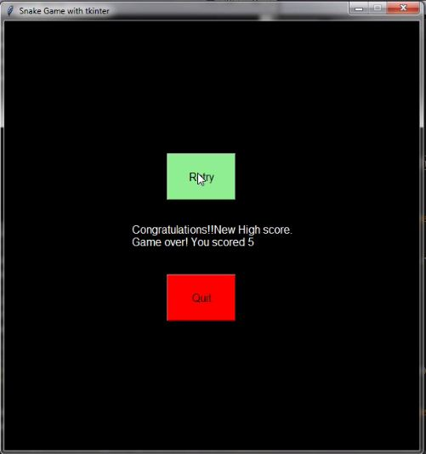

1. Once you decide to end the game you can click on quit option.

