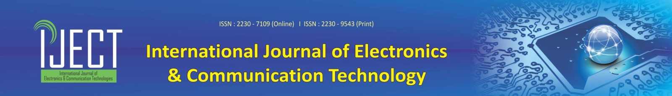
ISSN –2230-7109 (Online) ISSN- 2230-9543 (Print)
Copyright Transfer and Declaration for the IJECT
- I hereby transfer the Copyright of the paper:

__________________________________________________________________________________
By (Authors):
__________________________________________________________________________________
To
The Editor-in-Chief
IJECT
Cosmic Journals,
Zirakpur, Punjab, India.
2. I understand that the Editor-in-Chief may transfer the Copyright to a publisher at his discretion.
3. The author(s) reserve(s) all proprietary rights such as patent rights and the right to use all or part of the article in future works of their own such as lectures, press releases, and reviews of textbooks. In the case of republication of the whole, part, or parts thereof, in periodicals or reprint publications by a third party, written permission must be obtained from the Editor-in-Chief IJECT, or his designated publisher.
4. I am authorized to execute this transfer of copyright on behalf of all the authors of the article named above.
5. I hereby declare that the material being presented by me in this paper is our original work, and does not contain or include material taken from other copyrighted sources. Wherever such material has been included, it has been clearly indented or/and identified by quotation marks and due and proper acknowledgements given by citing the source at appropriate places.
6. The paper, the final version of which I enclose, is not substantially the same as any that I/we have already published elsewhere.

7. I/we have not sent the paper or any paper substantially the same as the enclosed one, for publication anywhere else.
8. The submitted/enclosed camera-ready paper is thoroughly proofread by me and in conformity with the instructions to authors communicated to me
(as per IJECT submission guidelines at http://www.iject.org).

Author's Signature
(The author who asserts the statements above):
__________________________________________________________________________________
Name in Block Letters
(The author who asserts the statements above)
Date and Place : ___________________________________________________________________

* Kindly send scanned copy of completed and duly signed form by email to the Editor-in-Chief, IJECT

