# Automobile Temperature Monitor

* **By Vatsal Shah**

# Table of contents

Description

* 1. Features
  2. SWOT Analysis

4. 5W’s & 1H Requirements

1. High level requirements
2. Low level requirements

Block Diagram and Blocks explanation

1. Block Diagram
2. Sensors
3. Actuators
4. Micro controller and memory Architecture
5. Block Diagram
6. Flow Chart Test plan and output
7. High level test plan
8. Low level test plan Application

Output

# About the Temperature Monitoring System

## Description

Tracking is one of the fundamental matters of our task. on this generation, it's miles used to determine the presence of the passenger and if the passenger exists then our device starts off evolved the functionality. So these days the whole lot is becoming computerized and everyone is seeking out new merchandise to make life less difficult. In our mission, the precept goal is to format and expand a device that is capable of tracking the passenger's existence and warmth monitoring and displaying

## Features

It’s able to figuring out climate the consumer is exist or now no longer with inside the automobile.

If passenger turned into existed with inside the automobile it's going to offers the indication.

After the indication it's going to decide the heat.

Driver and the passenger could have the get entry to to changing the temperature with inside the automobile.

The passenger can alternate the temperature via way of means of looking the show because the show is given with inside the system

## S.W.O.T Analysis

### Strengths

Easy to adjust the temperature value. The machine is robust.

Low cost.

Modular Based Programs. User Friendly.

### Weakness

It's handiest beneficial for the international locations which might be having low temperature.

### Opportunities

It can be practiced by replacing heater by air conditioners so that it will be useful in all the countries

### Threats

Not suitable for average or high temperature environment.

## 5Ws And 1H

WHAT : Temperature Monitoring System WHERE : Used in Automotive Industries WHEN : At low Temperature

# Requirements

## High Level Requirements

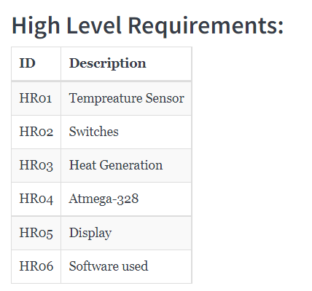

* 1. **Low Level Requirements**

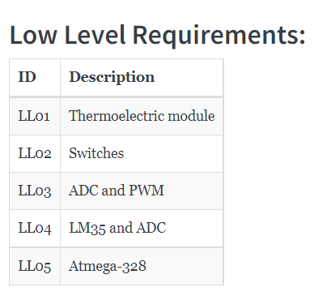

# Block Diagram and Blocks explination

## BLOCK DIAGRAM

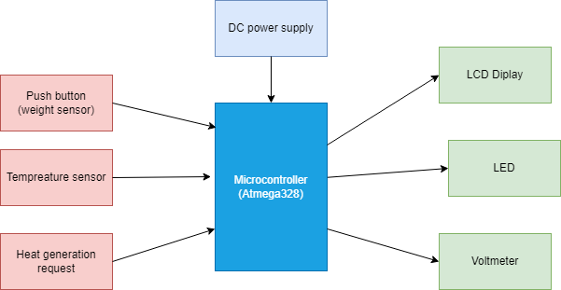

* 1. **SENSORS**

### Temperature Sensor (Thermistor)

Thermistors are a very accurate and cost- effective sensor for measuring temperature.it is the NTC thermistor that is commonly used to measure temperature

Resistance produces change in voltage, this voltage is taken as input to micro controller.

## ACTUATORS

### LCD Display:

Displays each and every value we enter in our keypad along with Temperature.

### LED:

A light-emitting diode is a semiconductor light source that emits light when current flows through i

## MICRO CONTROLLER

An integrated circuit that contains a microprocessor along with memory and associated circuits and that controls the whole system. Power Supply

The DC Power supply powers Microcontroller and other components in the system. Here I am using 5V Dc supply to power the circuit.

## Push Button Switch

Push button switch is connected to the microcontroller through a switch in order to limit the flowing current.

# Architecture

## 4.1 Block Diagram



**4.1.1 Flow Chart**

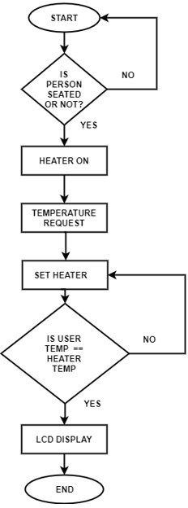

# Test plan and output

* 1. **HIGH LEVEL TEST PLAN**

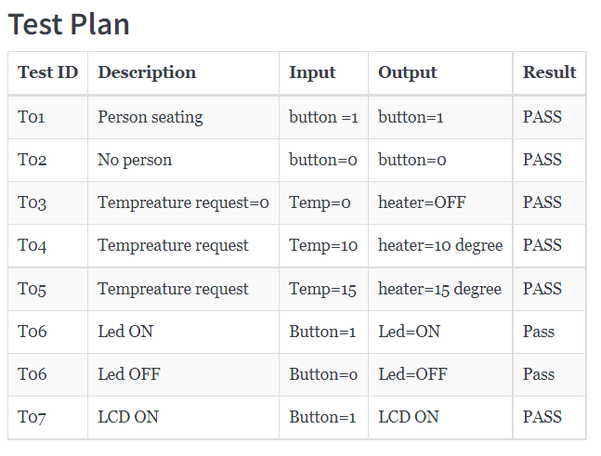

# Application

* It’s able to figuring out climate the consumer is exist or now no longer with inside the automobile.
* If Passenger turned into existed with inside the automobile it's going to offers the indication.
* After the indication it's going to decide the heat.
* Driver and the passenger could have the get entry to to changing the temperature with inside the automobile.
* The passenger can alternate the temperature via way of means of looking the show because the show is given with inside the system

**Simulation Diagram:**

