# **PROJECT REPORT**

# **ON**

# **Tourism Website**

# **Carried Out at**



**CENTRE FOR DEVELOPMENT OF ADVANCED COMPUTING ELECTRONIC CITY,**

**BANGALORE.**

**UNDER THE SUPERVISION OF**

**[Mr Phaniraj B. N]**

**C-DAC**

**Bangalore**

**Submitted By:-**

**Aishwarya V. Chimmalagi(200251920008)**

**Kushal Minachi (200251920046)**

**Shashank Shekhar Pandey (200251920093)**

**Vatsala Tamrakar(200251920112)**

**PG DIPLOMA IN ADVANCED COMPUTING**

**C-DAC, BANGALORE**

**CERTIFICATE**

This is to certify that the work titled **Tourism Website (ASP.NET Framework)** is carried out by

1. Aishwarya V. Chimmalagi(200251920008)
2. Kushal Minachi (200251920046)
3. Shashank Shekhar Pandey (200251920093)
4. Vatsala Tamrakar(200251920112)

the bonafide students of Diploma in Advanced Computing, of Centre for Development of Advanced Computing, Electronic City, Bangalore from February 18th , 2020 to January 28th, 2021. The course end project work is carried out under my direct supervision and is **85%** completed.

**Mr Phaniraj B. N**

Name of Supervisor

C-DAC, #68, Electronic City,

Bangalore-560100, India

**Candidate’s Declaration**

We hereby certify that the work being presented in the report entitled **Tourism Website**, in partial fulfilment of the requirements for the award of PG Diploma Certificate and submitted in the department of PG-DAC of the C-DAC Bangalore, is an authentic record of our work carried out during the period, 18thFebruary 2020 - 28th January 2021 under the supervision of **Mr Phaniraj B.N**, C-DAC Bangalore.

The matter presented in the report has not been submitted by me for the award of any degree of this or any other Institute/University.

**(Name and Signature of Candidate)**

Aishwarya V. Chimmalagi(200251920008)

Kushal Minachi (200251920046)

Shashank Shekhar Pandey (200251920093)

Vatsala Tamrakar(200251920112)

**Counter Signed by**

**Mr Phaniraj B. N**

**ACKNOWLEDGMENT**

I take this opportunity to express my gratitude to all those people who have been directly and indirectly with me during the competition of this project.

I pay thanks to **Mr Phaniraj B. N** who has given guidance and a light to me during this major project. His versatile knowledge about “Tourism Website” has eased me in the critical times during the span of this Final Project.

I acknowledge here out debt to those who contributed significantly to one or more steps. I take full responsibility for any remaining sins of omission and commission.

**Student Name**

Aishwarya V. Chimmalagi(200251920008)

Kushal Minachi (200251920046)

Shashank Shekhar Pandey (200251920093)

Vatsala Tamrakar(200251920112)

**ABSTRACT**

A Web-based intelligent tourism website, in which users can view Tourist spots and its destination details, the system also displays photographs, destination facts, hotels, activities, timings, necessary belongings to keep, means of transport available nearby, and food information. Allow the users to search the destination by location. System display maps of destination by linking with Google Maps and Picture regarding that searched destination. Users can give some detailed information about the tourism spots he visited through the blogging feature provided but to use this blogging feature the user needs to signup/login. Complete web-based site administration for managing state, destination, accommodation and other information. The proposed system maintains a centralized repository to make necessary travel arrangements and to retrieve information easily.

**TABLE OF CONTENT**

|  |  |
| --- | --- |
| **Serial No.** | **Title** |
| **1.** | **Introduction** |
| **2.** | **Requirement Specification** |
|  | * **Hardware Requirements** |
|  | * **Software Requirements** |
| **3.** | **Architecture Design** |
|  | * **Outline of Project** |
|  | * **ER Diagram** |
|  | * **Use Case Diagrams** |
|  | * **Relational Database Schema** |
|  | * **Flow Diagram** |
|  | * **Snapshots** |
| **4** | **Advantages of MVC Architecture** |
| **5.** | **Conclusion and Future Scope** |
| **6.** | **References** |

**INTRODUCTION**

Tourism has turned out to be an economic booster contributing to the economic development of many countries over the last few decades. People see holidays as a necessity, and not as luxury in the present scenario. Tourism calls for coordination and cooperation between travel agents, tour operators, and tourists. Tourism has a few major elements − destinations, accommodation, and all ancillary services. The need for a robust and dynamic tour and travel management application has been around since the advent of the tourism concept.

Thus we have developed a web-based application to provide the best travelling services to the customers. The Tourism Website provides a search platform where a tourist can find the best tour places from our tailored tour packages. This project is developed to replace the currently existing system, which helps in keeping records of the customer details of destination. The proposed system is highly automated and makes the travelling activities much easier and flexible. The users can get the very right information at the very right time. This will increase the trust of the customer into the tourism company as well.

This project is designed with SQL Server as back end. All the data will be stored in the server and in case of any data losing situation, a backup will be available maintained by admin to ensure no data loss and security of user’s confidential data.

**REQUIREMENT SPECIFICATIONS**

**HARDWARE REQUIREMENTS**

|  |  |
| --- | --- |
| * Processor | Intel i3 or higher, 2 Ghz or higher |
| * RAM | 1 GB or higher |
| * HARD DISK | 3 GB of available hard-disk for installation, additional free space is required during installation. |
| * STORAGE | 1 GB to 2 GB |

**SOFTWARE REQUIREMENTS**

|  |  |
| --- | --- |
| * Operating System | Windows. |
| * Technology | C#, .NET, MVC |
| * Web Technologies | Html, JavaScript, CSS, Bootstrap |
| * IDE | Visual Studio 2019 |
| * Web Server | IIS/Express |
| * Database | SQL Server |

**ARCHITECTURE DESIGN**

**OUTLINE OF THE PROJECT**

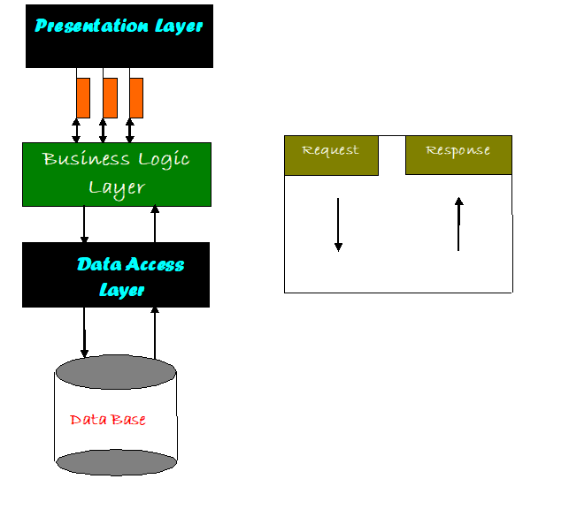

The whole software is divided into multiple parts – Presentation layer, Business Logic layer, Data Access layer and Database.

**Presentation Layer:**

Also called as client layer, comprises of components that are dedicated to presenting the data to the user. For example: Windows/Web Forms and buttons, edit boxes, Text boxes, labels, grids, etc.

**Business Logic Layer:**

This layer encapsulates the Business rules or the business logic of the encapsulations. To have a separate layer for business logic is of a great advantage. This is because any changes in Business Rules can be easily handled in this layer. As long as the interface between the layers remains the same, any changes to the functionality/processing logic in this layer can be made without impacting the others. A lot of client-server apps failed to implement successfully as changing the business logic was a painful process.

**Data Access Layer:**

This layer comprises of components that help in accessing the Database. If used in the right way, this layer provides a level of abstraction for the database structures. Simply put changes made to the database, tables etc. do not affect the rest of the application because of the Data Access layer. The different application layers send the data requests to this layer and receive the response from this layer.

**Database Layer:**

This layer comprises of the Database Components such as DB Files, Tables, Views, etc. The Actual database could be created using SQL Server, Flat files, etc. In an n-tier application, the entire application can be implemented in such a way that it is independent of the actual Database. For instance, you could change the Database Location with minimal changes to Data Access Layer. The rest of the Application should remain unaffected.

**Entity-Relationship Diagram**

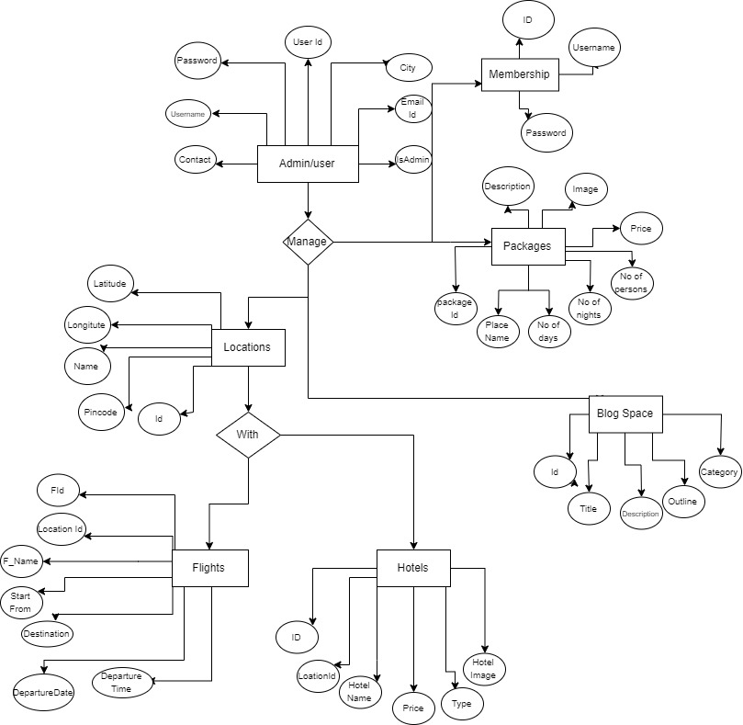

**Use Case Diagram**

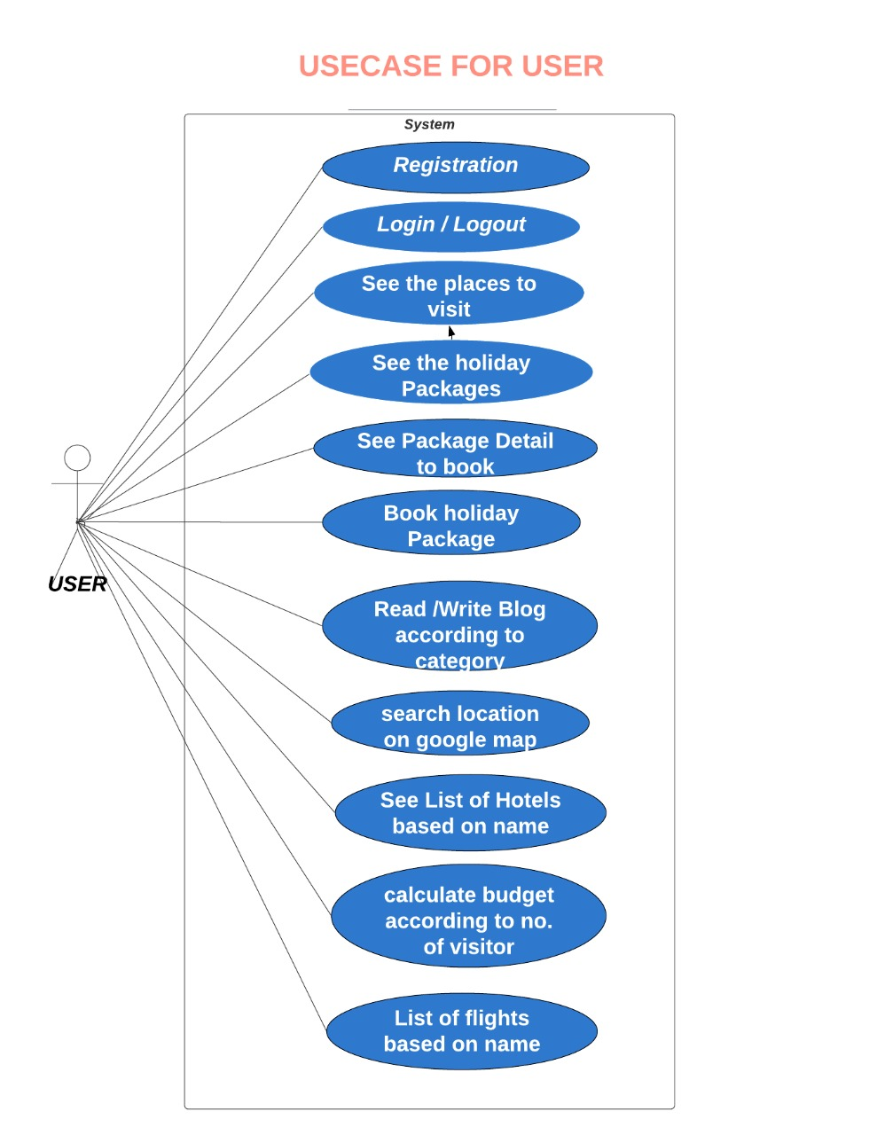

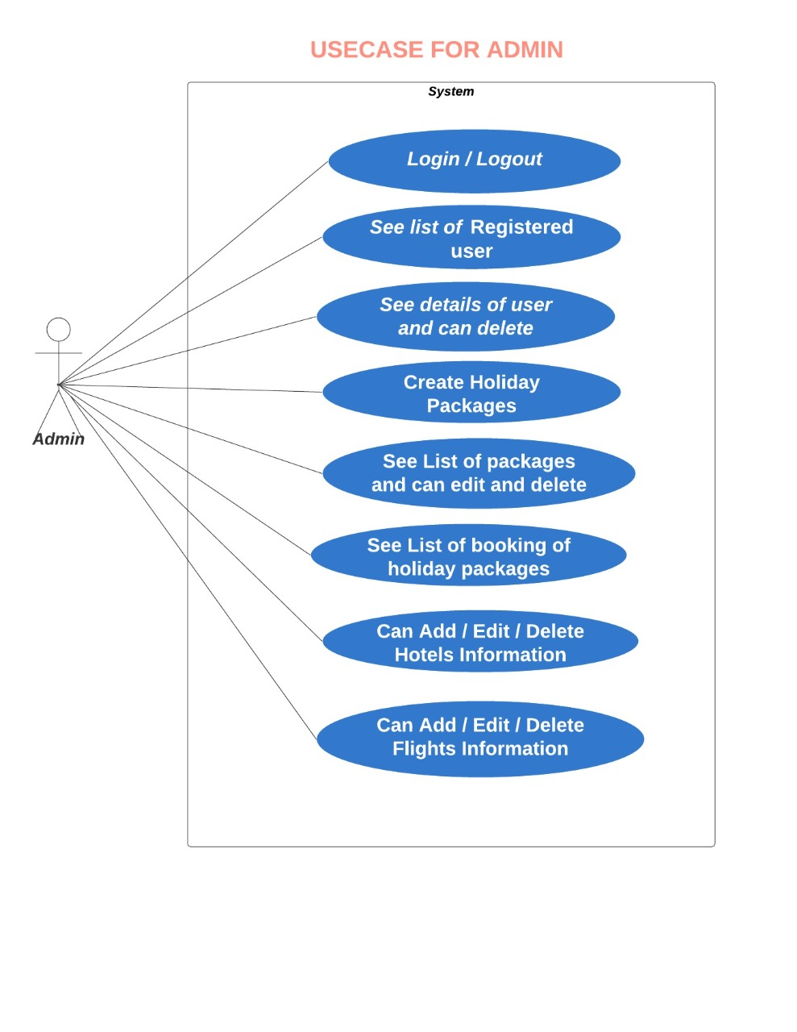

**Relational Database Schema**

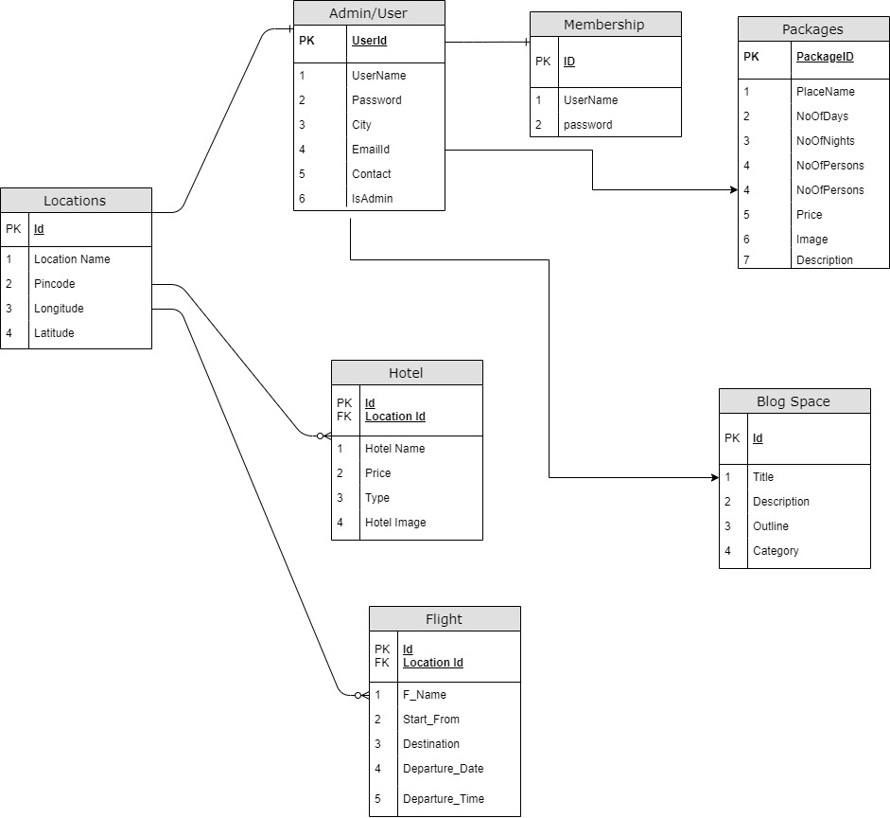

**FLOW DIAGRAM**

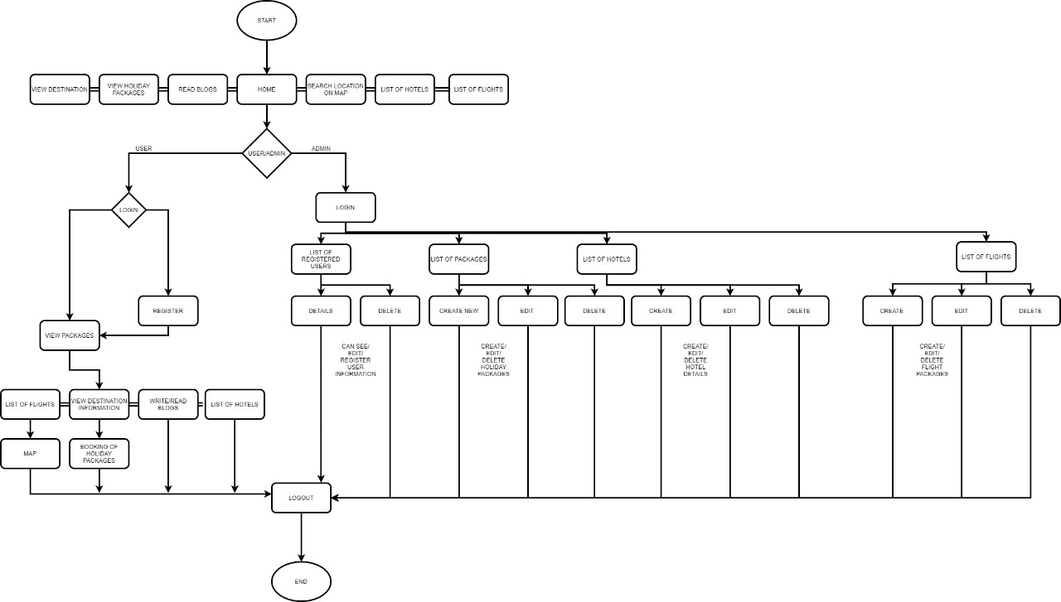

**Snapshots**

1. **Home Page**

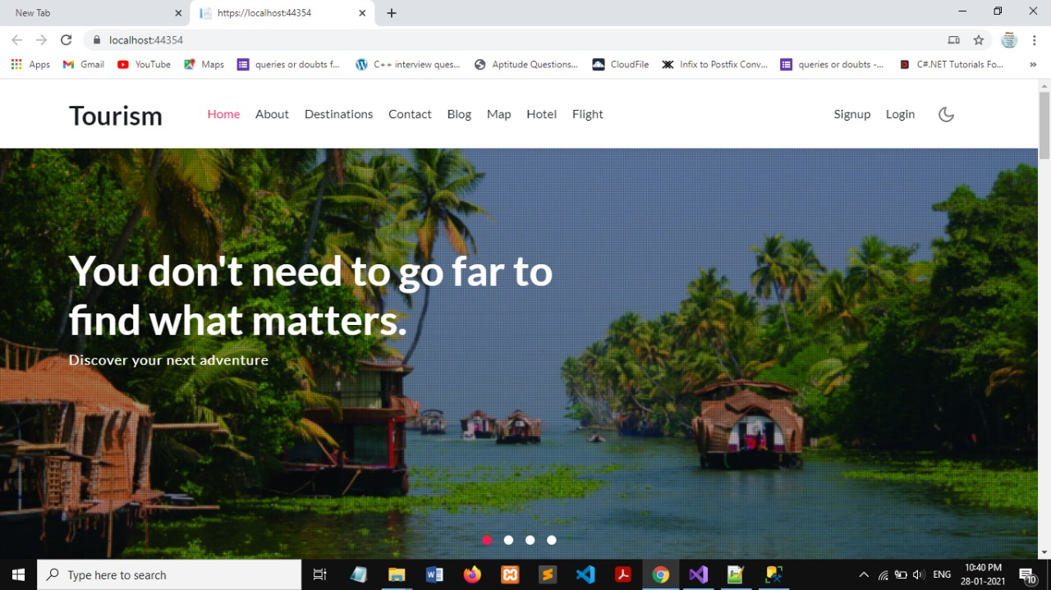

1. **Login Page**

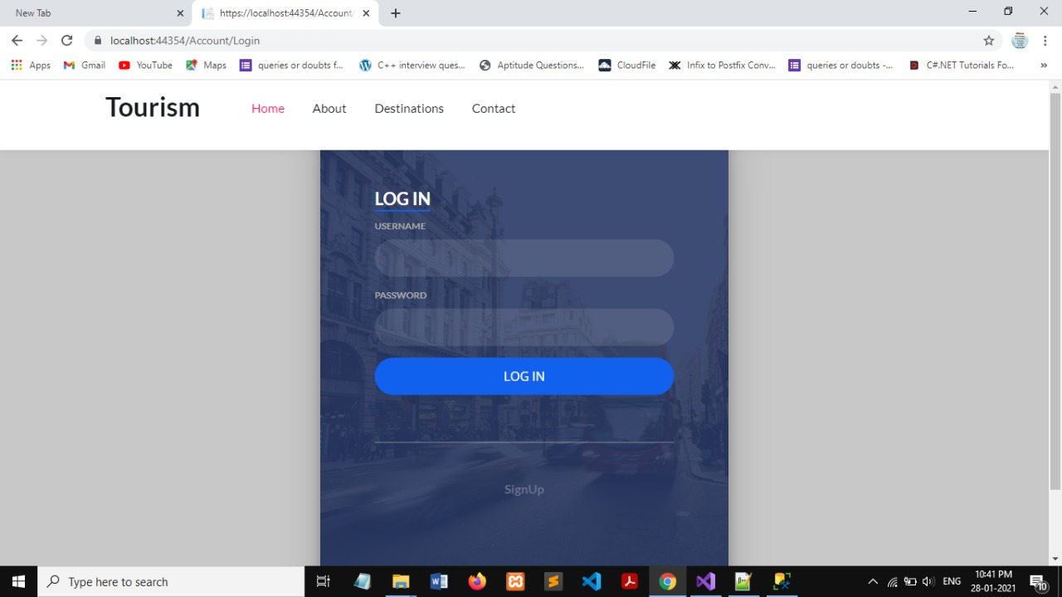

1. **Registration Form Page**

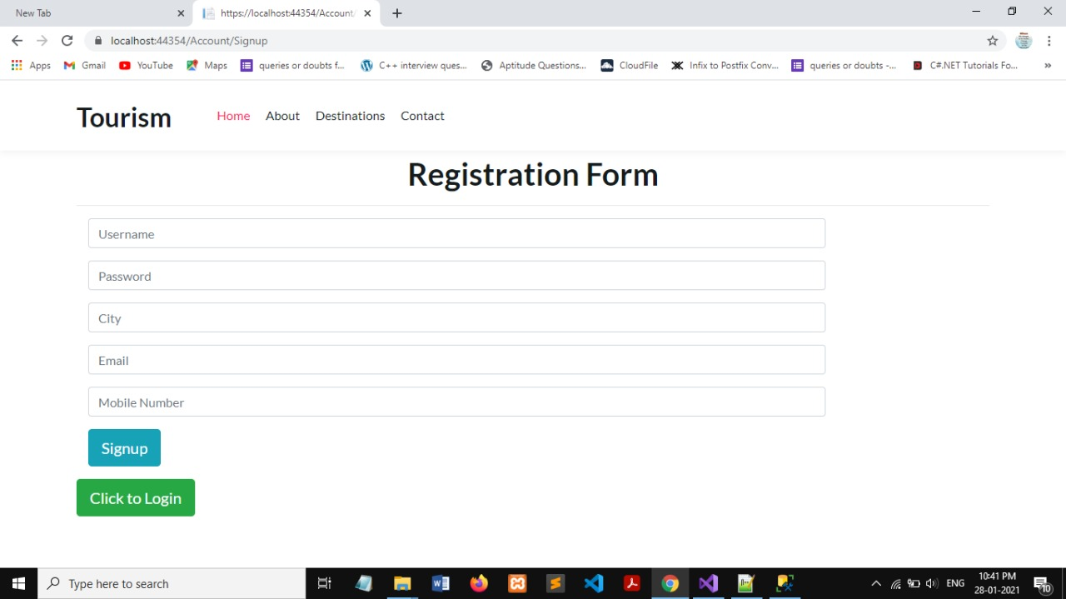

1. **Destination Page**

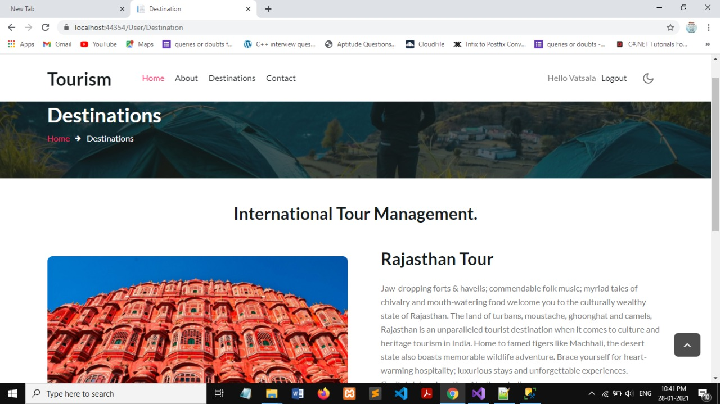

1. **Maps Page**

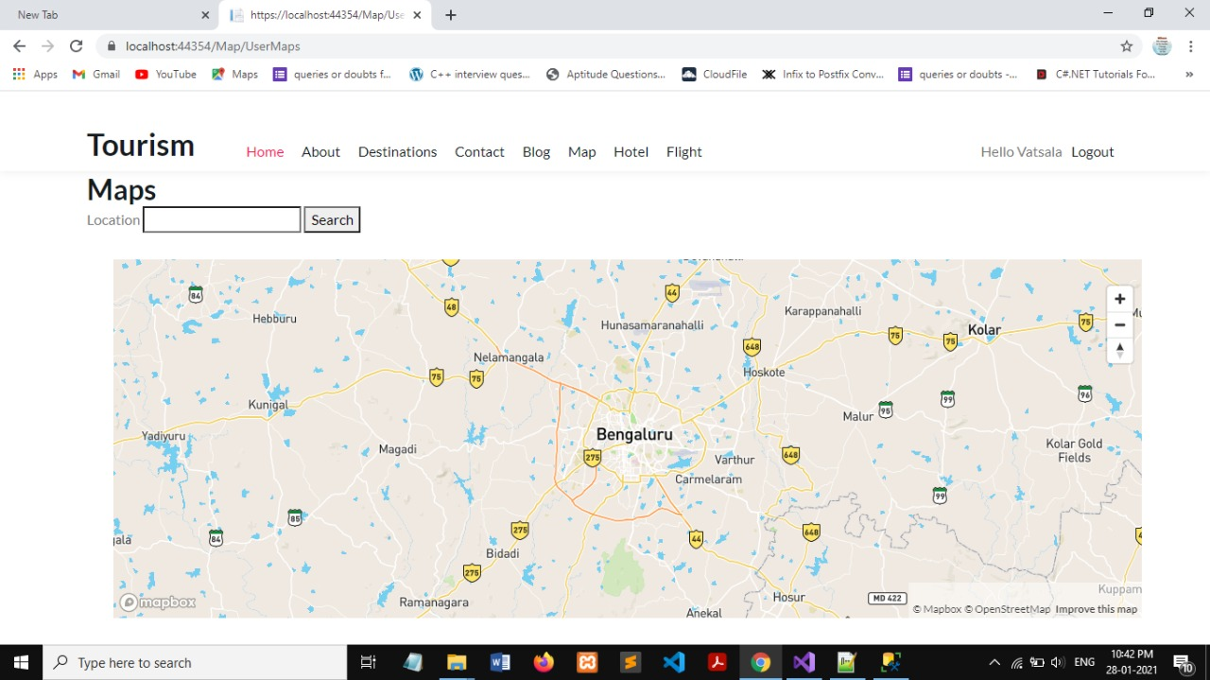

1. **Packages Page**

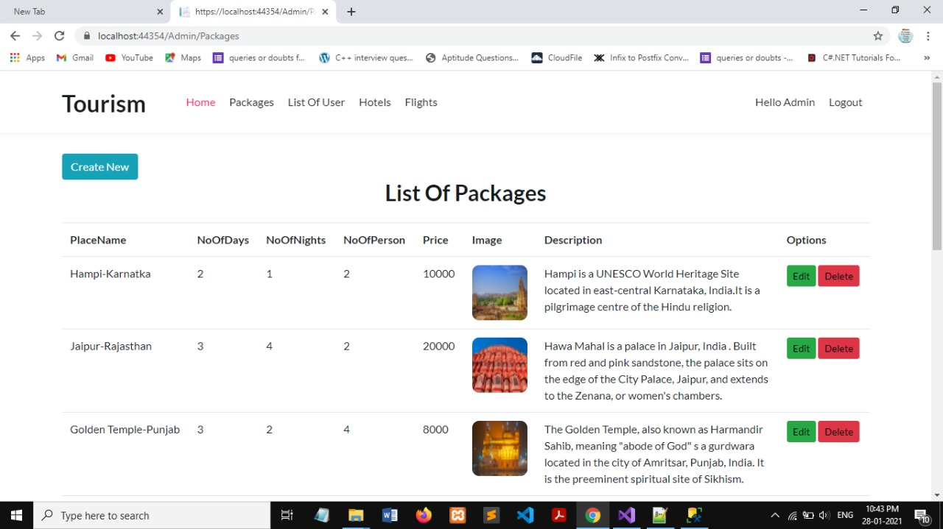

1. **Hotels Page**

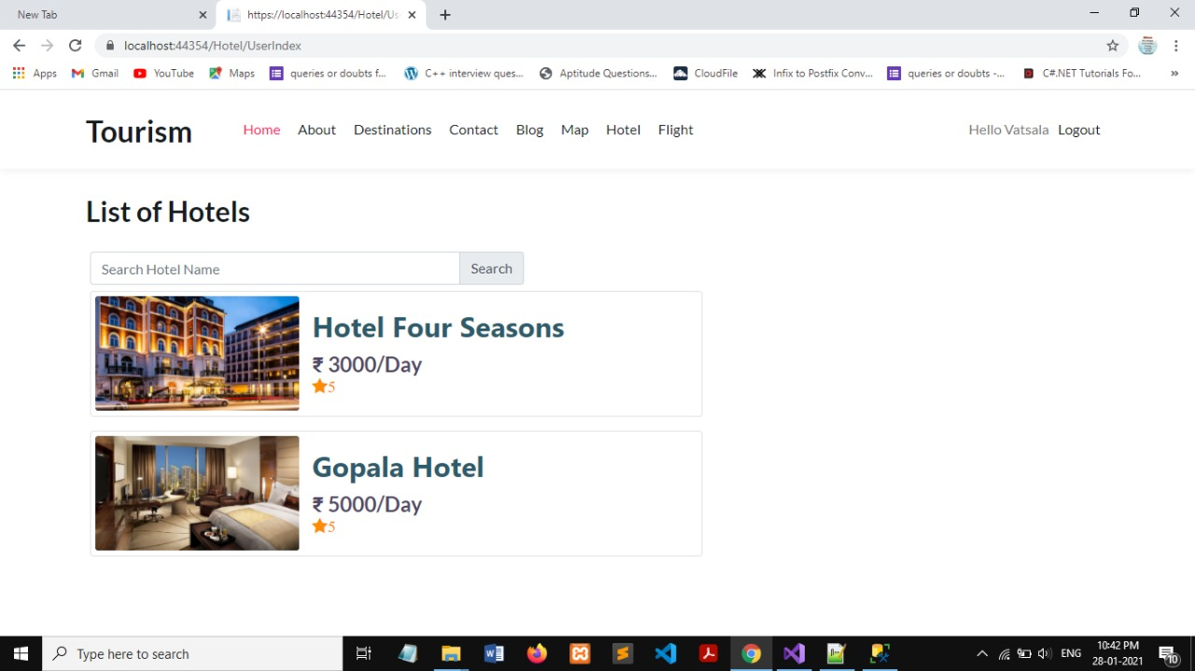

1. **Flights Page**

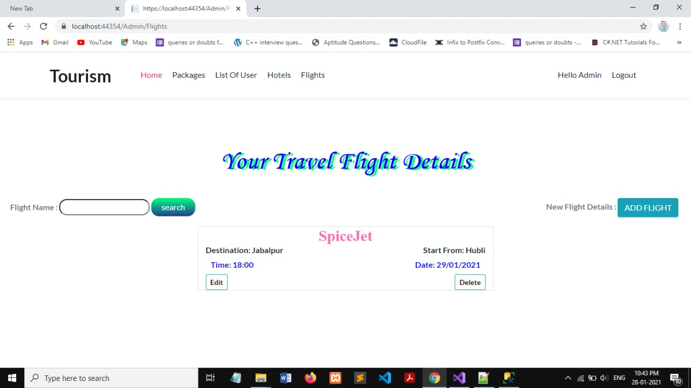

1. **Blog Page**

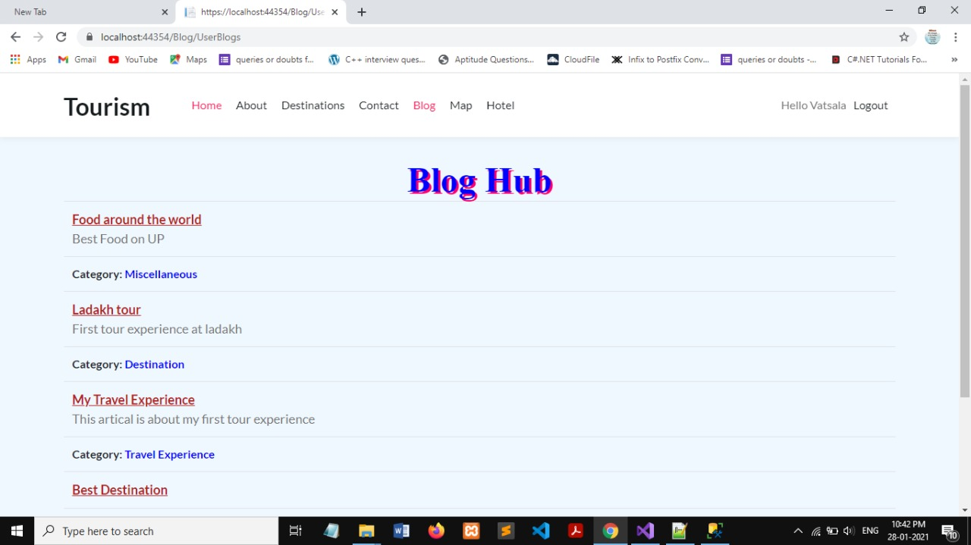

1. **Booking**

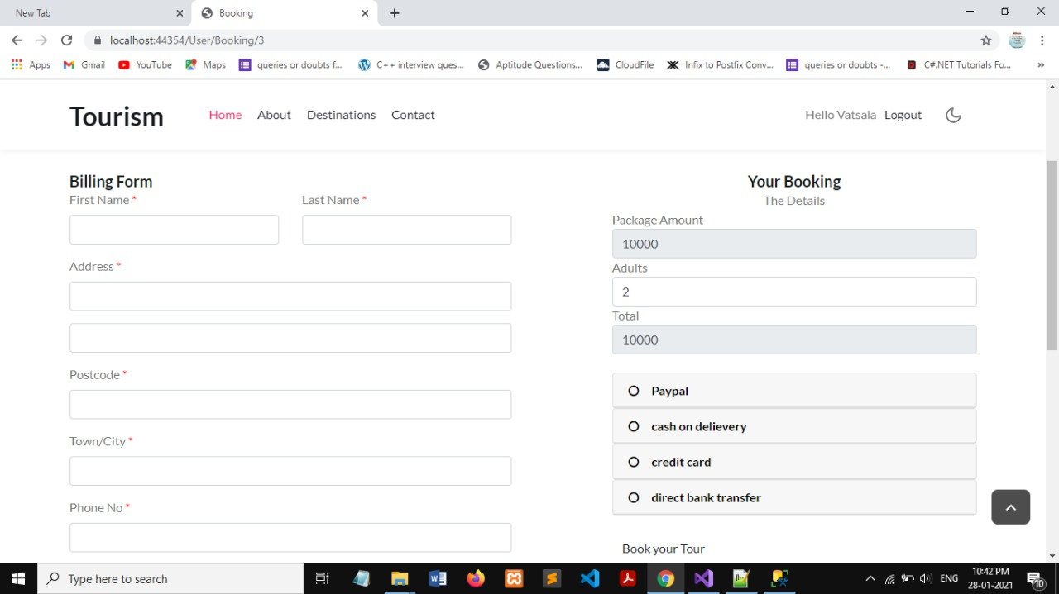

**Advantages of MVC Architecture**

**Reasons for using MVC Architecture:**

The relatively new architecture ASP MVC which was initially released in 2016 and stable release in 2018 does not possess the generic architectural problems such as Complexity ,Tightly Coupled ,Unwanted Html and JavaScript View, stateResponse , and Time.

**Advantages of using MVC Architecture:**

Separation of Concern is one of the advantages of MVC. The MVC framework provides a clean separation of the UI, Business Logic, Model or Data. On the other hand we can say it provides Separation of Program logic from the User Interface. Framework provides more control over the HTML, JavaScript and CSS than the traditional Web Forms. Also it provides better testability of the Web Application and good support for the test driven development too. It doesn’t use View State and thus reduces the bandwidth of the requests to an extent. Also, it is built on top of ASP.NET framework and hence most of the features of the ASP.NET like membership providers, roles etc. can still be used.

**CONCLUSION AND FUTURE SCOPE**

Tourism is currently recognized as a global industry which is growing at a high rate like any other industry. Access to relevant and accurate information is at the heart of tourism. Here, the proposed project on Tourism Website tries to bridge the gap by noting what a tourist perceives as relevant. Hence, the aim of this project entails the design and implementation of a platform that will assist tourists in gaining access to travel to various tourist locations. The project also helped to provide knowledge about the latest technology used in developing web enabled application.

It is worth mentioning that this project work is open for further enhancement, with the expectation that it becomes more robust and better enhanced; covering every single tourist sites. For a modified system, the user need to just login into the application and can find the routes, costs, hotels, adventure sports, transportations and book immediately and complete the booking process for a successful transaction.

In the aspect of tourism, Internet and web technologies have made more readily available information on tourist locations, accommodations, transportation, shopping, food, festivals, and other attractions, thus improving the whole tourism experience.

**REFERENCES**

1. [**https://dotnet.microsoft.com/apps/aspnet/mvc**](https://dotnet.microsoft.com/apps/aspnet/mvc)
2. [**https://docs.microsoft.com/en-us/sql/ssms/tutorials/ssms-configuration?view=sql-server-ver15**](https://docs.microsoft.com/en-us/sql/ssms/tutorials/ssms-configuration?view=sql-server-ver15)
3. [**https://www.c-sharpcorner.com/UploadFile/abhikumarvatsa/database-first-approach-in-entity-framework/**](https://www.c-sharpcorner.com/UploadFile/abhikumarvatsa/database-first-approach-in-entity-framework/)
4. [**https://www.journaldev.com/10365/android-google-maps-api**](https://www.journaldev.com/10365/android-google-maps-api)