**FIREFIGHTER DASHBOARD APPLICATION**

**CMPE 220**

HALAK JIGNESHBHAI VYAS

012629812

**INTRODUCTION**

The proposed product is built to aim for the firefighter’s safety and precaution against dangerous hazards that they come across on duty. The present innovation relates to sensor data monitoring which provides an automated alarm system for monitoring multiple parameters during firefighting activities and providing instructions or indications to a firefighter to inform him of possible dangerous situations. The aim of this project is to get all the telemetry data of the firefighter team members and send it to the team lead either using serial WiFi (User Datagram Protocol) UDP. The product being developed for the firefighters and their team members, keeping their requirements in mind the major market segment of the product aims to be Fire Department, but it can be extended to various communities, military and sport adventurous groups, by adding or subtracting some sensor controllers as per their requirements. In the current scenario, firefighters are not embedded with any sensor device and most of the time, firefighters must restore to manual methods of raising the alarm when they are exposed to dangerous environmental situations. These firefighters are covered with thick insulating uniforms which gives them little to no indication about the temperatures rising above the dangerous limits, the heat may get accumulated in these uniforms without any warning to the firefighters, adding further risk to their lives. Hence it becomes difficult to keep track of all the firefighters by the team lead or the firefighter marshal, so with the help of this product, the team lead, or the firefighter marshal shall be able to monitor the firefighter’s health, position and their surrounding areas. As this product is initially targeted for local firefighter department, so after completion of the product, this prototype will be experimented to monitor the product’s efficiency, we can expand the domain to medical applications where blood pressure sensor, sensor to measure glucose, etc can be integrated and monitored by the doctors.

*“Our product promises to deliver safety to our safety providers!!”*

The product provides the following key differentiate features and benefits to the potential customer:

* Firefighter’s location and health monitoring
* Push-to-talk service in extreme situations
* Easy maintenance and low cost
* Interactive Dashboard

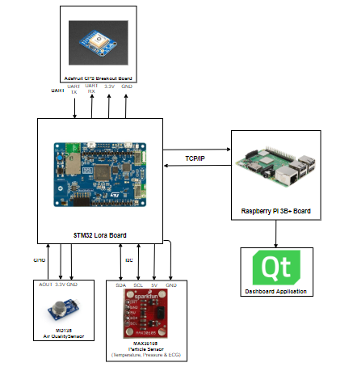

Block Diagram

**RELATED WORK**

The existing competitive technology allows firefighters to carry the wearable device and an additional walkie-talkie. Sometimes carrying this additional device may seem difficult to manage during the extreme fire situations. To avoid this shortcoming, our proposed product shall implement a built-in push-to-talk feature, which will prevent the firefighters to carry an additional device. This feature will help firefighters to talk to each other and firefighter marshal at ease. Another technological hurdle that these current states of the art products have includes lack of providing the position of the firefighters. Our proposed product will help the firefighter marshal to monitor the GPS coordinates of the team and accordingly provide the instructions to those who are stuck in dangerous surroundings using push-to-talk service. The GPS coordinates can also be monitored over dashboard in real time by the marshal, who guides other firefighters about the whereabouts of each other. In the worst-case scenario, if the firefighter stops responding or acknowledging, the firefighter marshal can summon a rescue team for the firefighter in danger based on their GPS coordinates in real time scenario. Our proposed product involved interfacing STM32 board with Raspberry Pi 3 B+, implementing a push-to-talk service using Raspberry Pi and designing interactive GUI considering QT framework as a platform. Due to such a low scale implementation, our total product cost shall be less than the existing market products. In case of any pitfall in the device, the faulty controllers and sensor modules are easily replaceable aiding low and easy product maintenance. After successful completion of this product, the firefighting team lead shall monitor the telemetry data and accordingly provide instructions to its team members using push-to-talk service preventing any life casualty/injury.

Some market risk this product can face includes, insufficient technical knowledge of using the modules at time of technical failure of module on scene. This can cause life hazard of firefighter.

In summary, our product highlights 2 new transformative and original feature compared to current state of the art products available in the market:

1. Our product incorporated a push-to-talk feature which helps firefighters communicate with each other at ease. This push-to-talk feature works on pressing a switch which could prove better than handling an additional device such as walkie talkie.
2. GPS Positioning and real-time tracking on the dashboard helps marshal to get the position of the other firefighters, who can provide appropriate instructions, thus ensuring firefighter’s safety.

**INNOVATION & DESIGN**

**FOCUS:**

Establish a Network Communication using WiFi based protocol, User Datagram Protocol. This protocol is used to send all the Sensors and Audio data from STM32L475VG board to Raspberry Pi3 being the receiver. In later stage I have planned to use a more secured connection using MQTT instead of UDP, as UDP does not provide connection oriented data transmission whereas MQTT does.

**APPLICATION:**

WiFi was used in the product to establish wireless communication for transmission and reception of telemetry data on both ends. Firefighter Marshall will be equipped with Raspberry Pi module who has the facility to receive and monitor all the sensor data of all the respective Firefighters present at the Fire Scene. He can also send the audio via push to talk which will be transmitted via UDP to STM32L475VG board, equipped by the firefighter team. Each firefighter has their individual STM32 board and hence individual IP addresses are assigned to them by the server, which in our case will be mobile hotspot. Any router or WiFi server can be used to establish the connection. On Firefighter side, Temperature, Air Quality, GPS, Audio & Heartbeat data are collected in a buffer and send to UDP enabled Raspberry Pi3 module on a particular assigned IP and ports (fixed port and local port).

**TECHNICAL CHALLENGES:**

Some technical difficulties which I faced during the development of this driver are as follows,

* After establishing a connection, I was not able to receive continuous data. Instead only once data would send and it would stopped.
* Difficulties in sending all the sensor data at an instance as WiFi was only able to send unsigned 8 bit data and all sensors data needed more space than 8 bit.

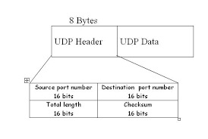

Image displaying 8 bit data size of UDP packet

**SOLUTIONS:**

* The first problem was solved by closing the connection each time after sending data once, as I noticed that if we do not close the connection then it would open connection each time when task was called resulting in failing the connection establishment.
* This problem was solved by using a structure to store all the received sensor value and type casting the struct to unsigned 8 bits then receiver end would decode it from 8 to their respective types.

**TECHNICAL DISCUSSION AND R&D**

**BACKGROUND INFORMATION:**

The basic WiFi driver is adapted from STM32 tutorial available online at : <https://os.mbed.com/teams/ST/code/mbed-os-example-wifi/?platform=ST-Discovery-L475E-IOT01A>

The code available online was modified and programmed to work for UDP protocol. The environment used to run and develop code is STM Workbench, configured in STM Cube MX software.

STM32L475VG complaint Inventek Systems (ISM43362-M3G-L44) based WiFi module, working on IEEE 802.11b/g/n, which can be configured using SPI or UART protocol. I have used SPI over UART as it’s faster and all other sensors were consuming UART ports.

The main features of the Inventek ISM43362-M3G-L44 module are:

• Based on the Broadcom BCM43362 MAC/Baseband/Radio device

• Supports Broadcom WICED SDK

• CPU Arm® Cortex®-M3 32-bit RISC core from ST Microelectronics

• IEEE 802.11n D7.0 -OFDM-72.2 Mbps -single stream w/20 MHz, Short GI

• IEEE 802.11g (OFDM 54 Mbps)

• IEEE 802.11b (DSSS 11 Mbps)

• IEEE 802.11i (Security)

– WPA (Wi-Fi Protected Access) –PSK/TKIP

– WPA2 (Wi-Fi Protected Access 2)- AES/CCMP/802.1x Authentication

• GPIO, 5 ADC (SPI interface utilizes ADC pins)

• Power-saving mode allows the design of low-power applications

• Lead Free Design which is compliant with ROHS requirements

• EMI/EMC Metal Shield for best RF performance in noisy environments and to accommodate for lower RF emissions/signature for easier FCC compliance.

• FCC/CE compliance certification.

**KEY COMPONENTS:**

As STM32L475 IOT board has WiFi module inbuilt, the only component required to configure and establish UDP based WiFi communication was STM32L475VG IoT discovery Kit.

For integrating WiFi with other Sensor, we used following hardware components:

* MAX 30105 BPM sensor
* MQ 135 air quality sensor
* GPS Module
* STM32 IoT kit

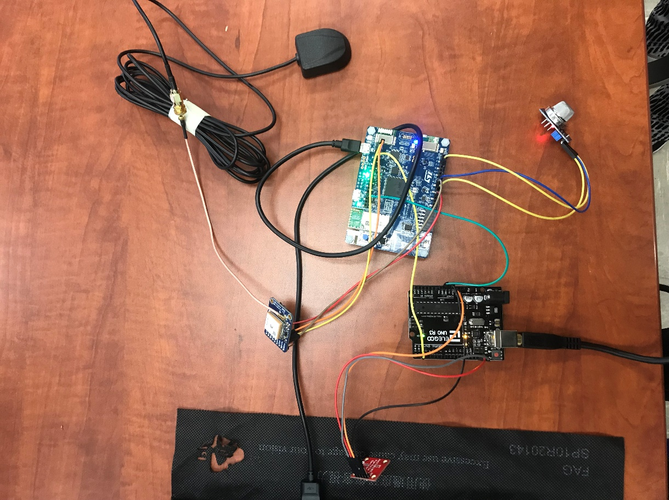

Environmental Setup

**INNOVATION:**

The existing competitive technology allows firefighters to carry the wearable device and an additional walkie-talkie. Sometimes carrying this additional device may seem difficult to manage during the extreme fire situations. To avoid this shortcoming, our proposed product shall implement a built-in push-to-talk feature, which will prevent the firefighters to carry an additional device. This feature will help firefighters to talk to each other and firefighter marshal at ease. Another technological hurdle that these current states of the art products have includes lack of providing the position of the firefighters. Our proposed product will help the firefighter marshal to monitor the GPS coordinates of the team and accordingly provide the instructions to those who are stuck in dangerous surroundings using push-to-talk service. The GPS coordinates can also be monitored over dashboard in real time by the marshal, who guides other firefighters about the whereabouts of each other. In the worst-case scenario, if the firefighter stops responding or acknowledging, the firefighter marshal can summon a rescue team for the firefighter in danger based on their GPS coordinates in real time scenario. Sending telemetry data wirelessly over WiFi is the most notable innovation of the product in respect to current existing devices for Firefighters safety.

**BENEFITS:**

It can help send data wirelessly over any WiFi network. The communicating devices just need to share the same network and their respective IP addresses. Knowing the above mentioned network parameters along with port number, a connectionless UDP connection can be easily established and after handshaking, data can be continuously transmitted from STM board to Raspberry Pi3.

**IMPLEMENTATION:**

Step 1: Updating the Inventek WiFi module (ISM43362-M3G-L44) Firmware using STM Utils.

Step 2: Configure WiFi pins using SPI3 pins ( PE_0 PC_10 PC_12 PC_11) and wifi_wakeup pin (PB_13), wifi_dataready pin (PE_1), wifi reset pin (PE_8).

These configurations were achieved using STM Cube MX software package.

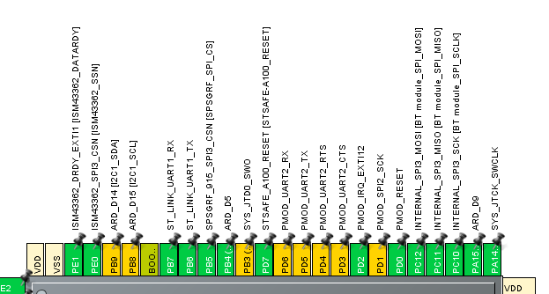

Figure showing SPI3 configurations

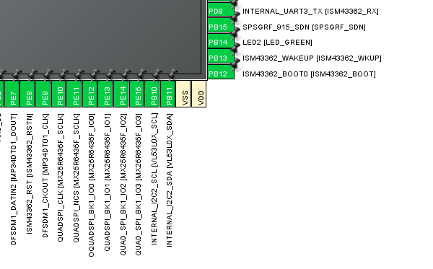

Figure showing WiFi configurations

Step 3: Import the Project in STM Workbench Eclipse based IDE.

Import the basic libraries for WiFi module, given by STM.

Use this library to first initialize WiFi connection and wite code for getting IP and MAC addresses of the board, followed by establishing UDP connection.





Once the connection is established successfully, try sending some data via buffer by first performing handshaking.

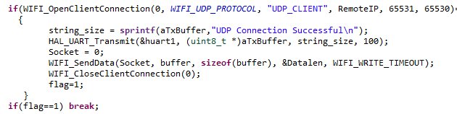

Once the data is send, close the established connection.

Repeat the process each time task is called and buffer is filled by sensor data.

**RESULT & OUTPUT**

The result was as expected, the connection was established successfully and we were able to send data as single packet over WiFi continuously without any error or data loss.

The first line of the terminal output displays that the IP address of the STM32 WiFi module which can be used by Raspberry Pi3 to listen the transmitted data. Here, STM32 is the sender and Raspberry Pi3 is the receiver.

Second line is the debug message indicating that connection has successfully established and it is therefore ready to transmit data.

The data transmission is also shown below in form of BPM, temp, Lat, Long and Air qual.

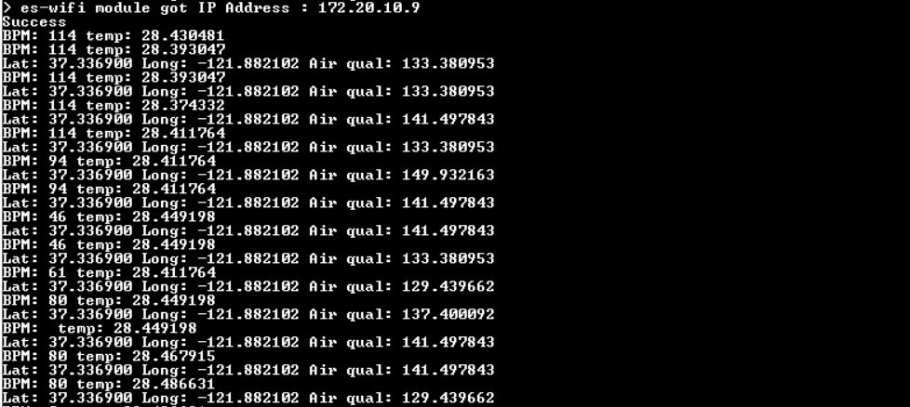

The output was initially tested on Hercules, which is shown in a video below

[Click Here to See output video](https://drive.google.com/open?id=1-FXMMGR82qJ-Z9rcsRgyPIJJ17pgrIMs)

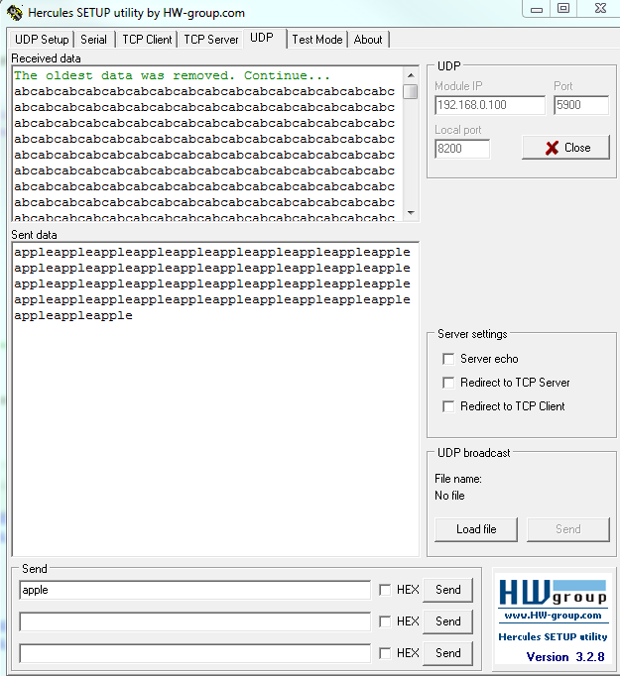

Hercules sending & receiving demo

**EVALUATION**

I came across the working of Wireless Network protocol, their working and sending data. The figure below describes the UDP based communication of Server and client.

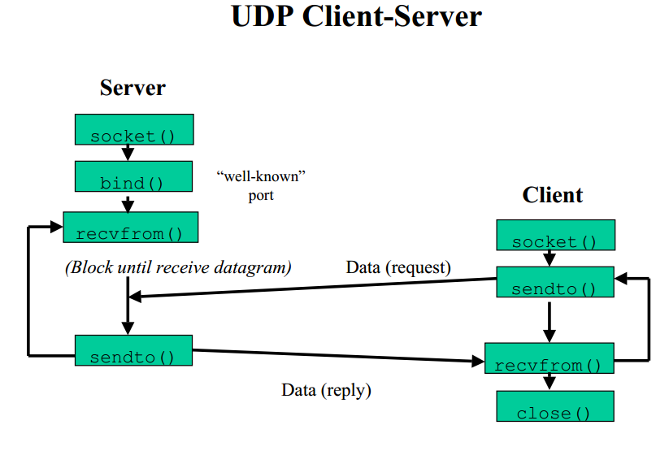

As shown in figure after establishing and binding the socket, the server send data on decided port and client receives the data without any ACK. When serves finish to send all data or client finishes to receive all data, the connection is closed by client’s request.

**CONCLUSION**

The product assures the safety of our firefighters. Necessary devices must be equipped and provided to them for their safety, as they put their life in danger to save our lives. Those in leadership positions must constantly fight for the resources needed to acquire the most advanced protection available. Could you imagine a football player today playing in a game with a helmet that was five years old? With the attention to concussions, there is no doubt they are using the best equipment possible. Firefighters deserve the same commitment to protection. So we aim to deliver a product that is light weight, easy to carry and aids firefighter team members by giving all electronic features like position detection using GPS, temperature, heartbeat and air quality data of individual along with push to talk service for verbal communication.

**README**

* Code before integrating sensors - <https://drive.google.com/open?id=1pZ1uFOGWfgEjAfRpZhr-m_p6KmEDR7Pw>
* Code after integrating sensors – <https://drive.google.com/open?id=1hwMH6rBznwylqVCbkoInPLsj1Y4glLHV>

**REFERENCES**

* <https://os.mbed.com/teams/ST/code/mbed-os-example-wifi/?platform=ST-Discovery-L475E-IOT01A>
* <https://drive.google.com/open?id=12IrpltbaHSyo5ArS5jDDK4KA37pROaK4>
* <https://drive.google.com/open?id=1b7pfiAXi_lZvT3YLuQoKmNMJ7kSkdAfg>
* <https://www.geeksforgeeks.org/user-datagram-protocol-udp/>