**Drone Assembly:**

* Drone parts and components:
  + Quadcopter frame – DJI F450 (
  + Propellers
  + LittleBee BLHeli_S 30A ESCs.
  + Pixhawk 4 Mini (Autopilot hardware)
  + GPS
  + FrSky Taranis Q X7 remote
  + FrSky X8R radio receiver
* Part list link: <https://docs.google.com/spreadsheets/d/1pdDwCoGdYpaJyZzQUwO1r9xrbfRB8_wH0QpM10nQS3c/edit#gid=0>
* Drone assembly block diagram:

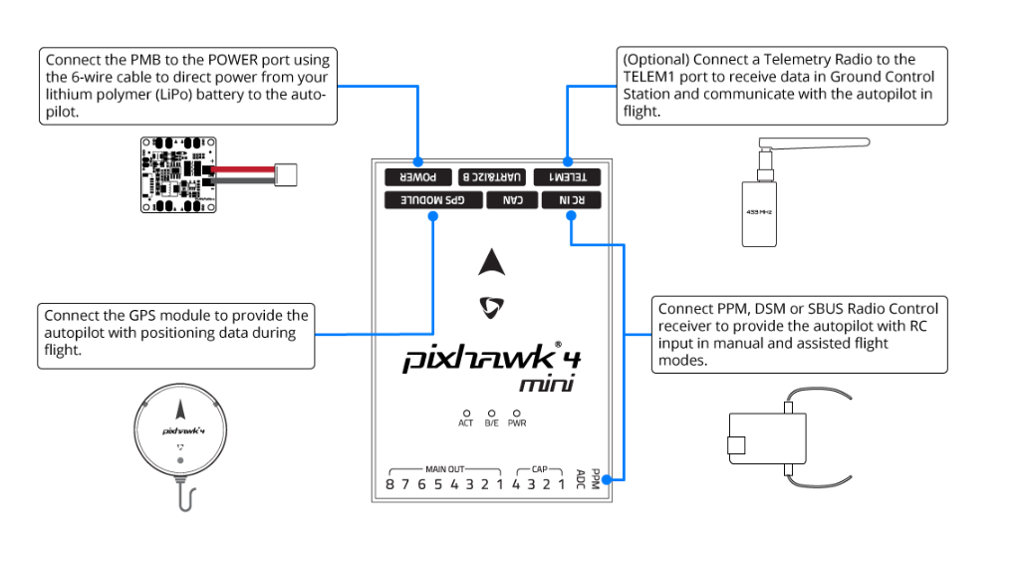

Pixhawk 4 Mini should be mounted on your frame using vibration-damping foam pads (included in the kit). It should be positioned as close to your vehicle’s center of gravity as possible, oriented top-side up with the arrow pointing towards the front of the vehicle.

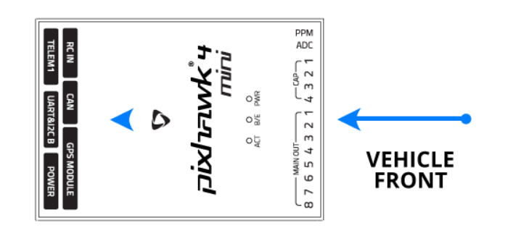

Attach the provided GPS with integrated compass, safety switch, buzzer, and LED to the **GPS MODULE** port. The GPS/Compass should be mounted on the frame as far away from other electronics as possible, with the direction marker towards the front of the vehicle (separating the compass from other electronics will reduce interference).

**GPS**

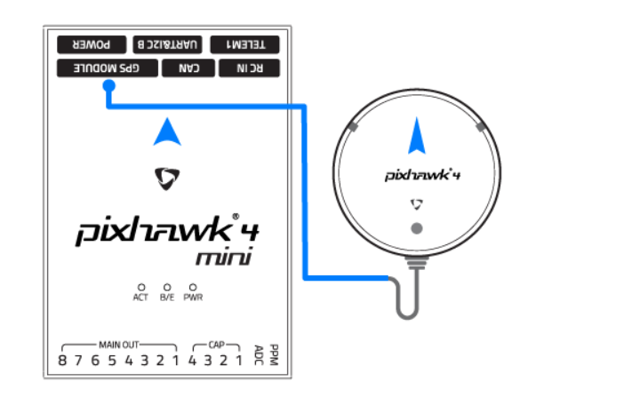

The Power Management Board (PMB) serves the purpose of a power module as well as a power distribution board. In addition to providing regulated power to *Pixhawk 4 Mini* and the ESCs, it sends information to the autopilot about the battery’s voltage and current draw.

Connect the output of the PMB that comes with the kit to the **POWER** port of the *Pixhawk 4 Mini* using a 6-wire cable. The connections of the PMB, including power supply and signal connections to the ESCs and servos, are explained in the image below.

**Power Module**

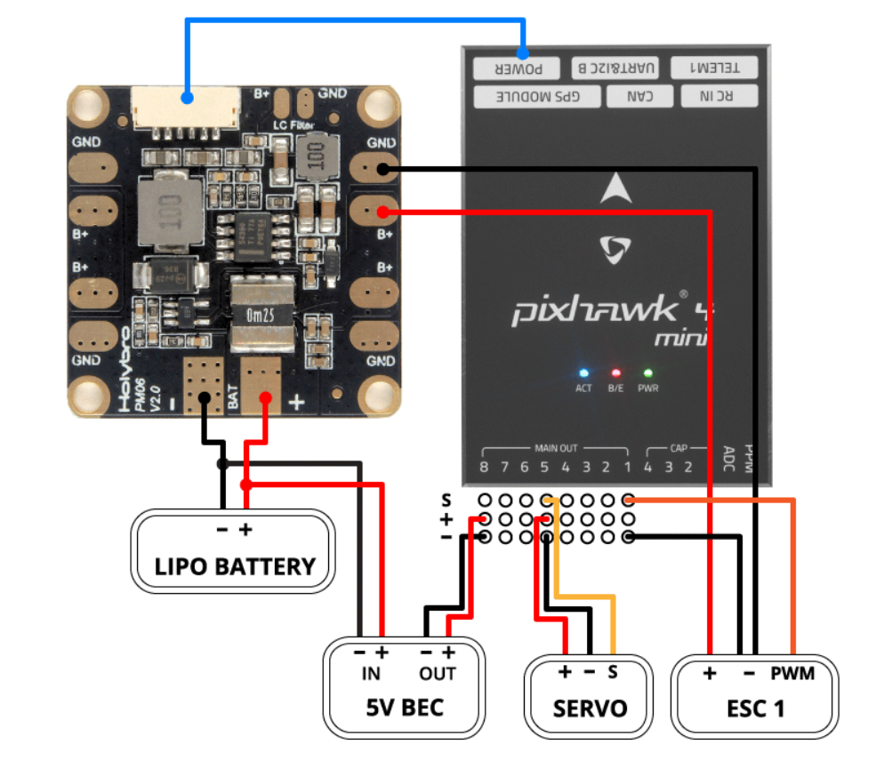

**Radio**

A remote control (RC) radio system is required if you want to manually control your vehicle (PX4 does not require a radio system for autonomous flight modes).

You will need to [select a compatible transmitter/receiver](https://docs.px4.io/v1.9.0/en/getting_started/rc_transmitter_receiver.html) and then bind them so that they communicate (read the instructions that come with your specific transmitter/receiver).

The instructions below show how to connect the different types of receivers to Pixhawk 4 Mini:

Spektrum/DSM or S.BUS receivers connect to the **DSM/SBUS RC** input.

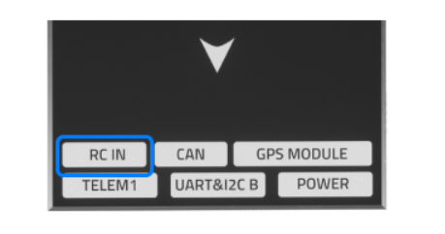

**Autopilot firmware PX4:**

* It is written in C++ language and takes care of PID control, preflight checking.
* In preflight check, it checks if all sensors are working properly, every motor are getting PWM or not and also if GPS is locked or not.
* PX4 has numerous numbers of parameters which can use to tune according to our requirements. For example, we can disable GPS preflight check if we are trying to fly indoor by CBRK_GPSFAIL = 240024.
* We can do parameter tuning easily by using ground control station (QGround Control Station).
* We can add our code and customize PX4. Detail instructions are given in this link:

<https://dev.px4.io/v1.9.0/en/setup/building_px4.html>

**Uploading PX4 firmware to Pixhawk-4 mini.**

1. Download QGround Control (QGC) from this link: <http://qgroundcontrol.com/downloads/>
2. Open QGC and then connect Pixhawk 4 Mini with laptop. QGC will automatically detect autopilot hardware in our case it is Pixhawk 4 mini.
3. After that, click on Gear icon as shown in the below image. You will be now able to see different option like Summary, Firmware etc.

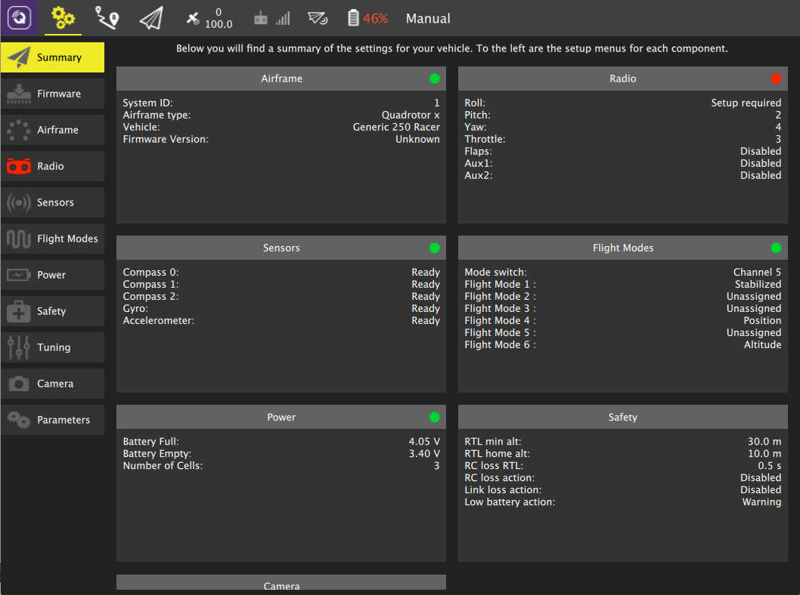

1. First from Airframe option select drone frame. In our case it is Quadcopter DJI F450 frame.
2. Now select Firmware option and follow instruction given on that screen.
3. You will ask to select autopilot firmware PX4 or Ardupilot. In our case we are using PX4.

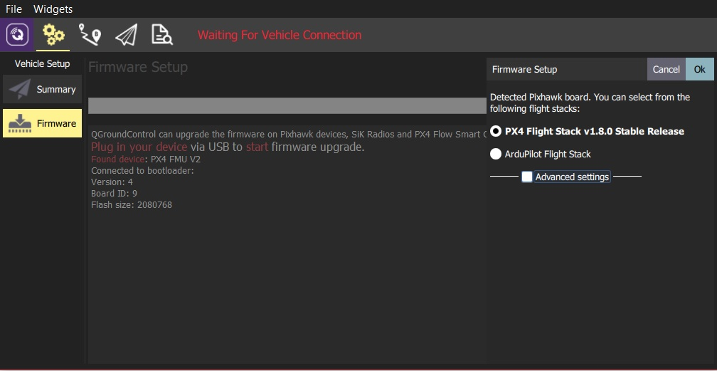

1. We can also upload our customize PX4 firmware.

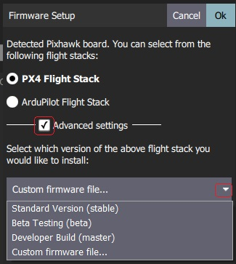

**PX4 sensor calibration:**

* Before ARMing the drone (start the motor), PX4 self-check the system in which it checks for all sensors like Magnatometer, Gyroscope, GPS and Campass. It also check if motors are getting PWM or not.
* If it finds everything ok meaning all sensors data and everything looks good than only it starts drone, otherwise it gives **preflight check** error. In that case, we have to calibrate sensors again.
* Steps to calibrate sensors are shown in below image. Also, detail explanation is given here:

<https://docs.px4.io/v1.9.0/en/config/flight_controller_orientation.html>

1. **Compass Calibration:**

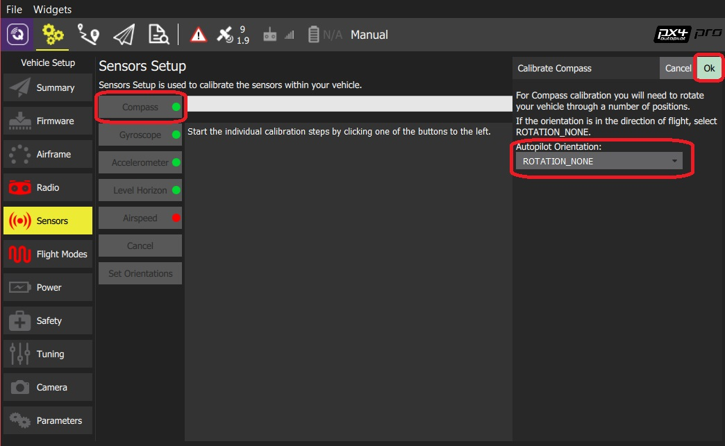

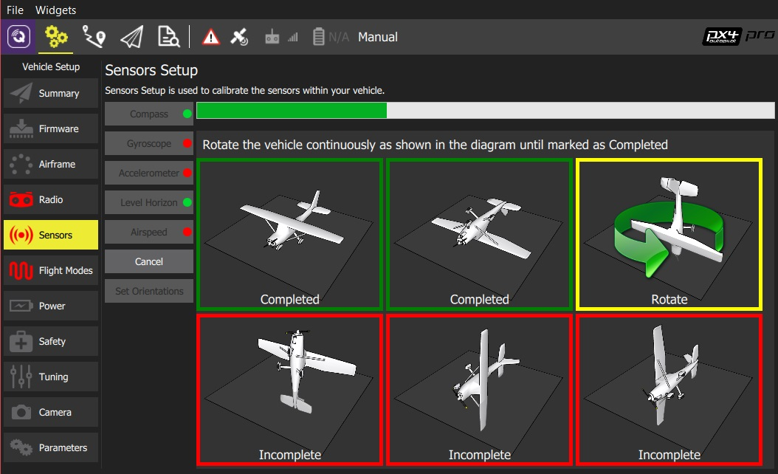

1. **Gyroscope calibration:**

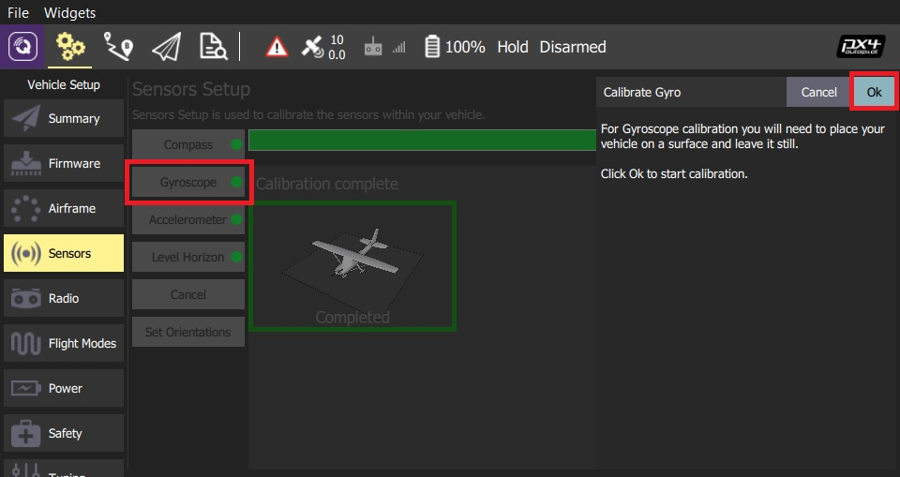

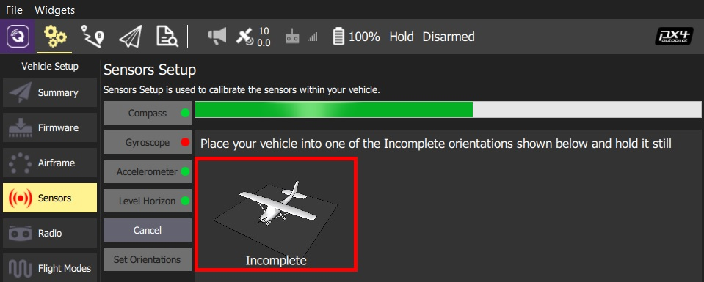

1. **Radio calibration:**
   1. Turn on your RC transmitter.
   2. Start *QGroundControl* and connect the vehicle.
   3. Select the **Gear** icon (Vehicle Setup) in the top toolbar and then **Radio** in the sidebar.
   4. Press **OK** to start the calibration.

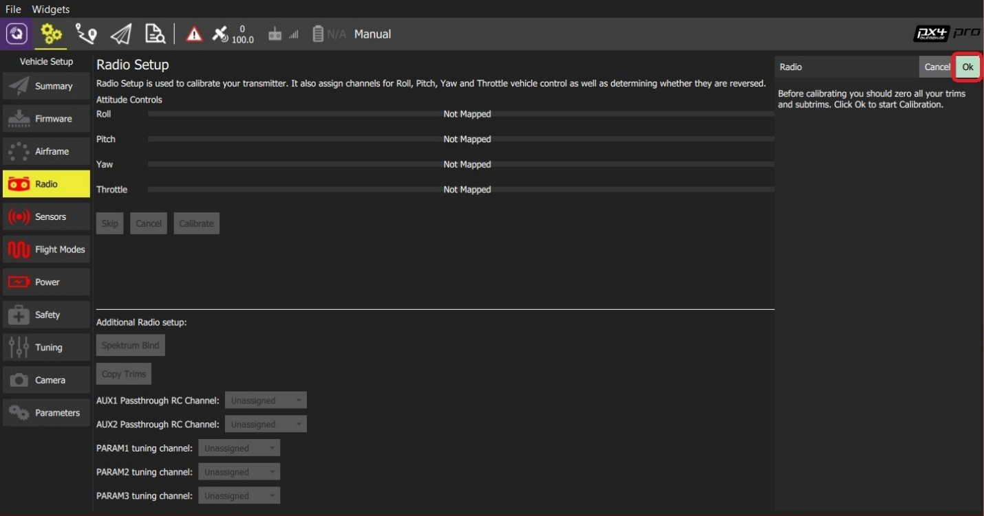

* 1. Set the [transmitter mode](https://docs.px4.io/v1.9.0/en/getting_started/rc_transmitter_receiver.html#transmitter_modes) radio button that matches your transmitter (this ensures that QGroundControl displays the correct stick positions for you to follow during calibration).

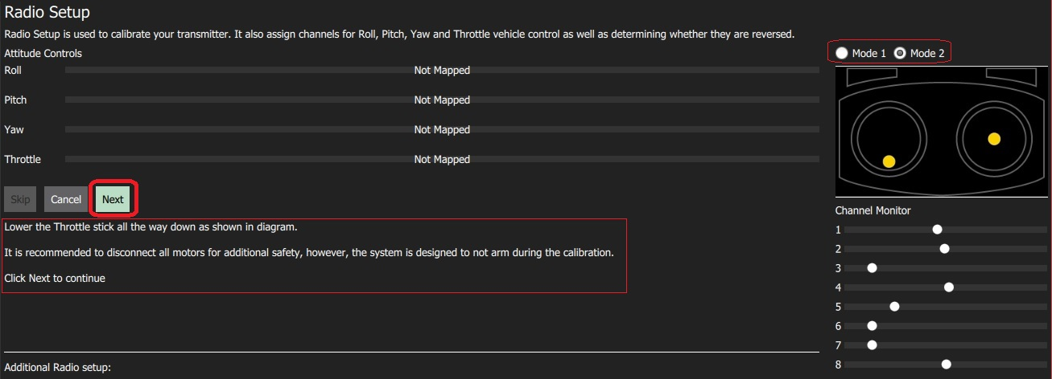

* 1. Move the sticks to the positions indicated in the text (and on the transmitter image). Press **Next** when the sticks are in position. Repeat for all positions.
  2. When prompted, move all other switches and dials through their full range (you will be able to observe them moving on the *Channel Monitor*).
  3. Press **Next** to save the settings.

**PX4 parameter reference:**

We can change parameters of PX4 according to our needs. The complete guide on parameters of PX4 is given in the below link.

<https://docs.px4.io/v1.9.0/en/advanced_config/parameter_reference.html>

**Connecting NVIDIA Jetson nano with Pixhawk 4 Mini**

Enable MAVLink on any [configurable serial port](https://docs.px4.io/en/peripherals/serial_configuration.html). In our case, **TELEM 2.**

1. Go to the **Parameters** section in vehicle setup.
2. Select the **GPS** tab (1), then open the [GPS_2_CONFIG](https://docs.px4.io/v1.9.0/en/advanced_config/parameter_reference.html#GPS_2_CONFIG) parameter (2) and select TELEM 2 from the dropdown list (3).

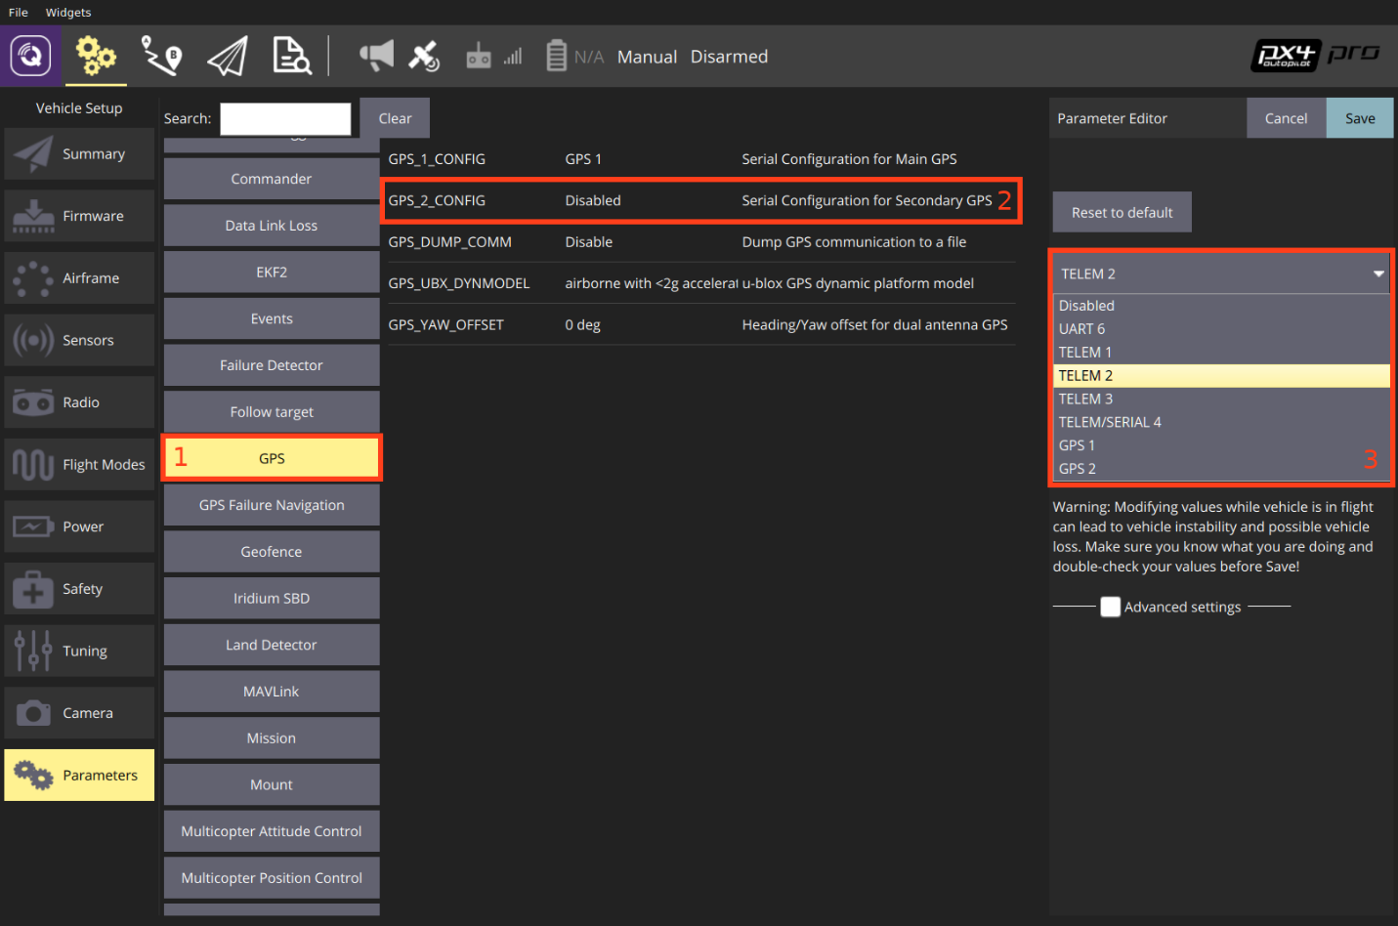

1. Reboot the vehicle in order for the other parameters to show up.
2. Select the **Serial** tab, and open the [SER_TEL2_BAUD](https://docs.px4.io/v1.9.0/en/advanced_config/parameter_reference.html#SER_TEL2_BAUD) parameter (TELEM 2 port baud rate): set it to Auto.

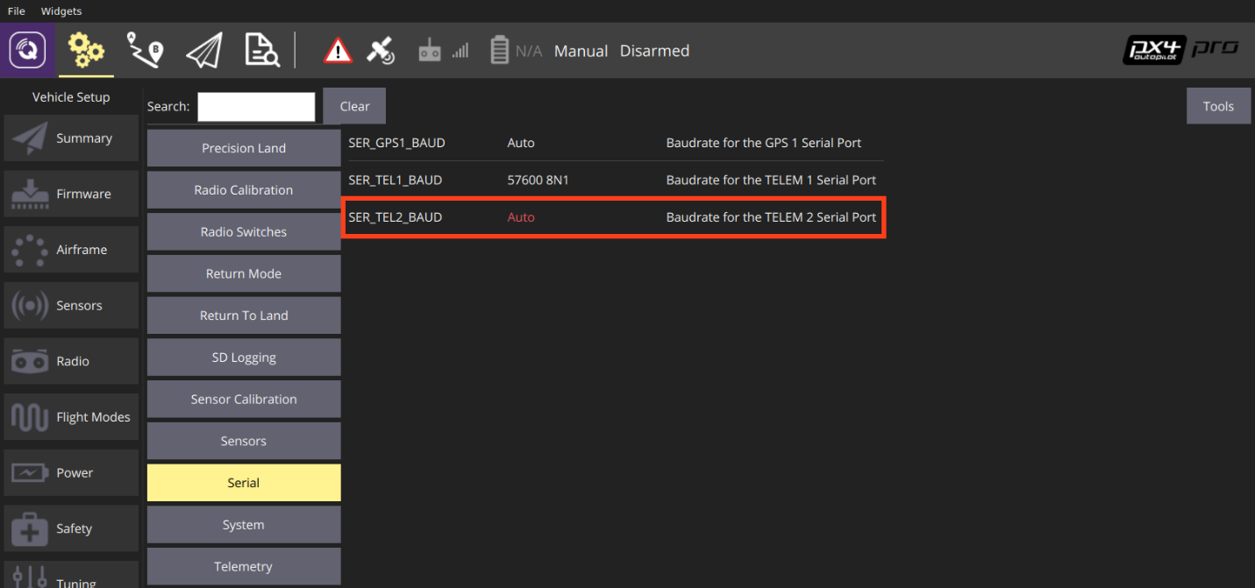

To set up the default companion computer message stream on TELEM 2, set the following parameters:

1. [MAV_1_CONFIG](https://dev.px4.io/v1.9.0/en/advanced/parameter_reference.html#MAV_1_CONFIG) = TELEM 2 (MAV_1_CONFIG is often used to map the TELEM 2 port)
2. [MAV_1_MODE](https://dev.px4.io/v1.9.0/en/advanced/parameter_reference.html#MAV_1_MODE) = Onboard
3. [SER_TEL2_BAUD](https://dev.px4.io/v1.9.0/en/advanced/parameter_reference.html#SER_TEL2_BAUD) = 921600 (921600 or higher recommended for applications like log streaming or FastRTPS)

For more detail follow this link: <https://docs.px4.io/v1.9.0/en/peripherals/mavlink_peripherals.html>

**MAVROS setup:**

* 1. Set up ROS:
     1. ROS melodic
     2. Linux Distribution: Ubuntu Xenial 16.04 LTS
     3. Follow instruction : <https://www.stereolabs.com/blog/ros-and-nvidia-jetson-nano/>
     4. Set up ROS environment and install dependencies from instructions. Maintain the order of execution of commands.
     5. Follow ROS tutorials to familiarize yourself with Packages, File Structure, Nodes, Topics and Services.
  2. MAVROS set-up
     1. Initialize an empty workspace.  
        mkdir -p ~/mavros_ws/src
     2. Follow instructions from PX4 Developers website for
     3. MAVROS installation Source Installation.
     4. Use catkin tools to build packages as opposed to catkin_make. catkin tools have better User Interface for Debug and Error messages while building.
     5. After building, find launch files to establish communication with Flight Controller over UART.

To launch ROS follow the instructions: <https://dev.px4.io/v1.9.0/en/simulation/ros_interface.html>