**VATSAL MAKANI**

Profile photo

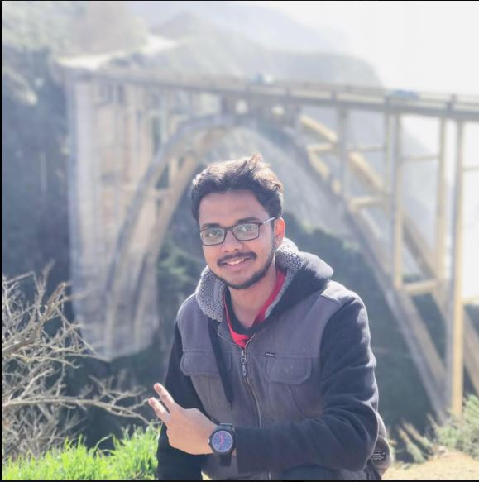

LinkedIn: <https://www.linkedin.com/in/vatsal-makani-540650b2/>

Bio:

I am Vatsal Makani currently pursuing M.S. in Computer Engineering (Embedded Systems) from San Jose State University. I have 2.5 years of experience at L&T Technology Services, India in test equipment development for performing functional testing for Aircraft Wings and Power Units and Power Electronics and done my Bachelor’s in Engineering in Electronics and Telecommunication from University of Mumbai, India. My area of interest include embedded firmware, embedded hardware development, Internet of Things, Analog circuit design and power electronics.