NAME: VATSAL MANVAR

ROLL NO: 19BCE120

SUBJECT: CLOUD COMPUTING

PRACTICAL: 10

**Aim**: Microsoft-AZURE[data science – AZURE webapp-Databricks]

1.Create an azure data bricks workspace

In this section, we create an Azure Databricks workspace using the Azure portal or the Azure CLI.

1. In the Azure portal, select Create a resource > Analytics > Azure Databricks.
2. Under Azure Databricks Service, provide the values to create a Databricks workspace and launch workspace.

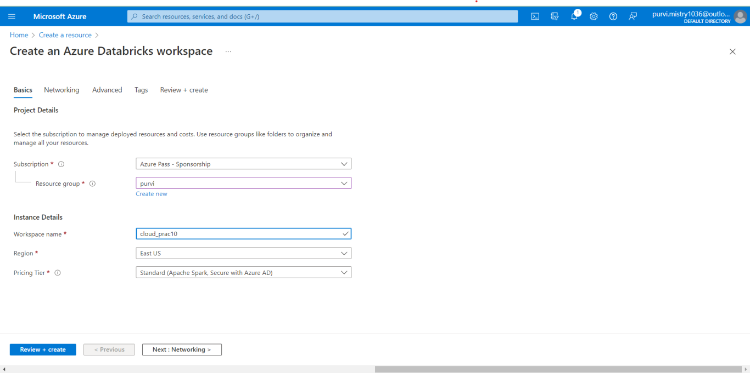

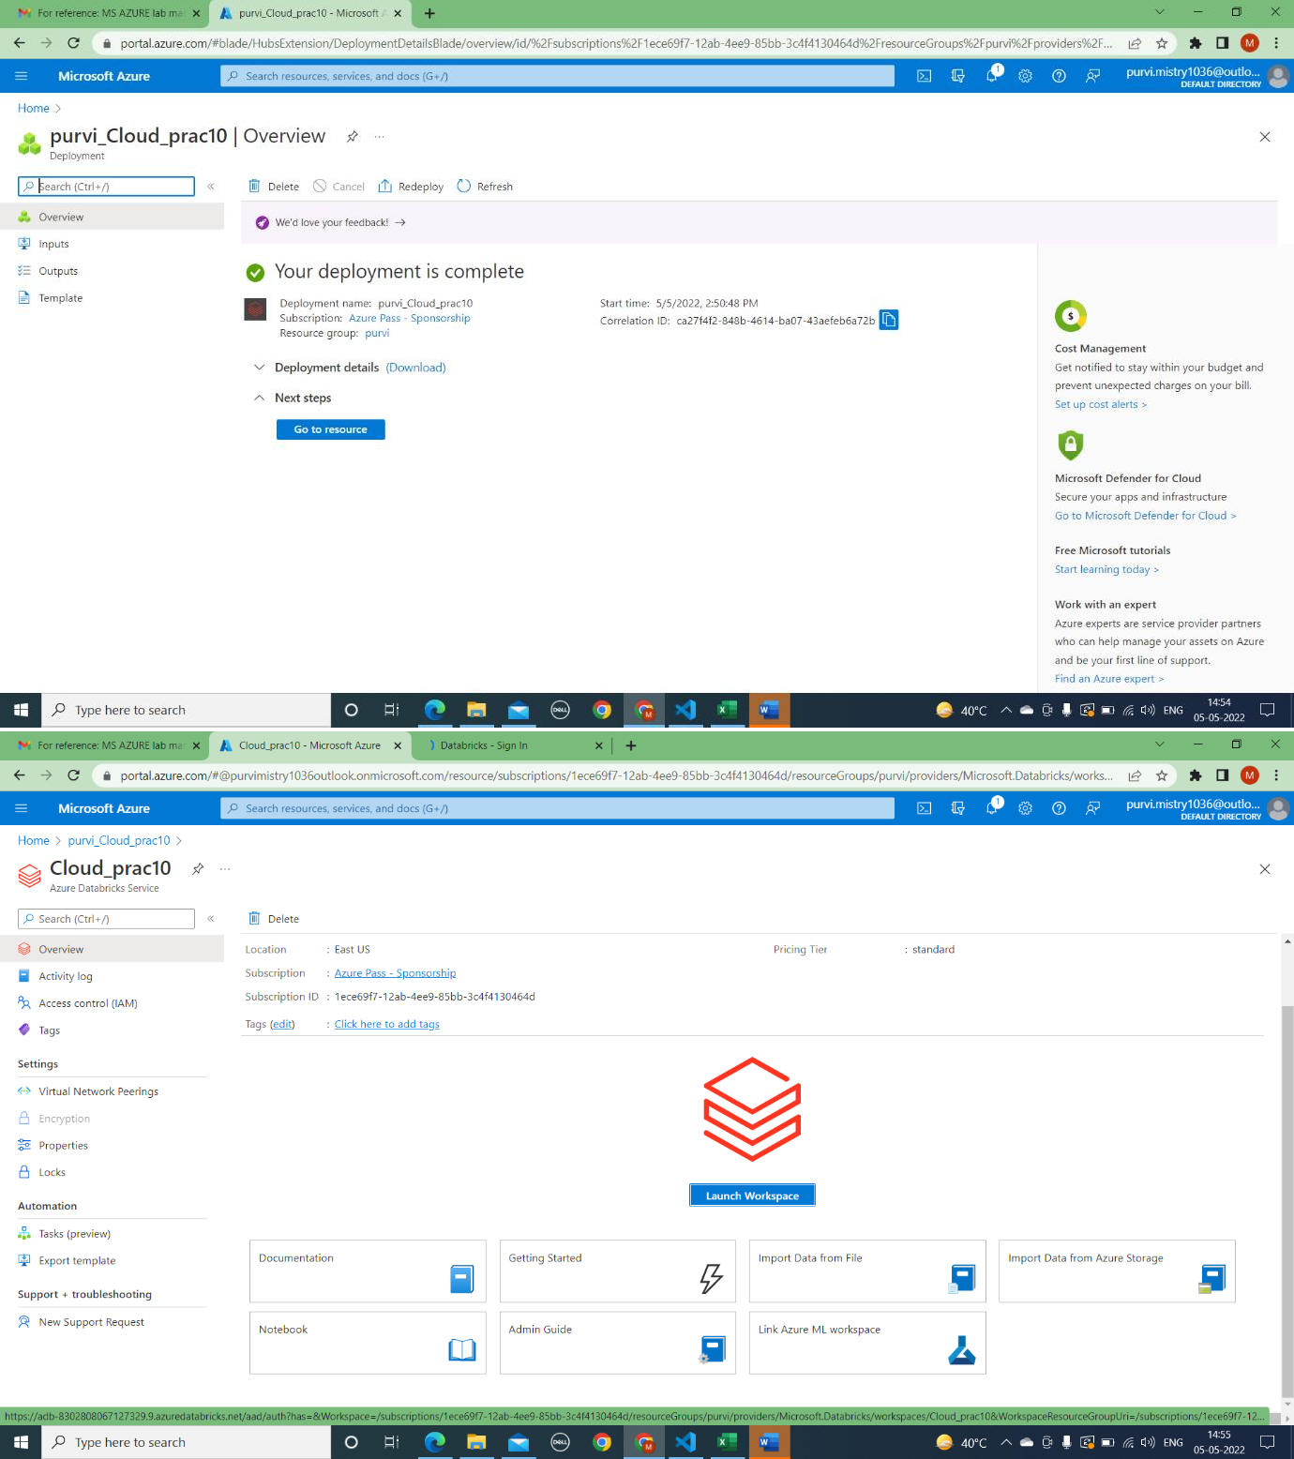

Preview of azure databricks service--->

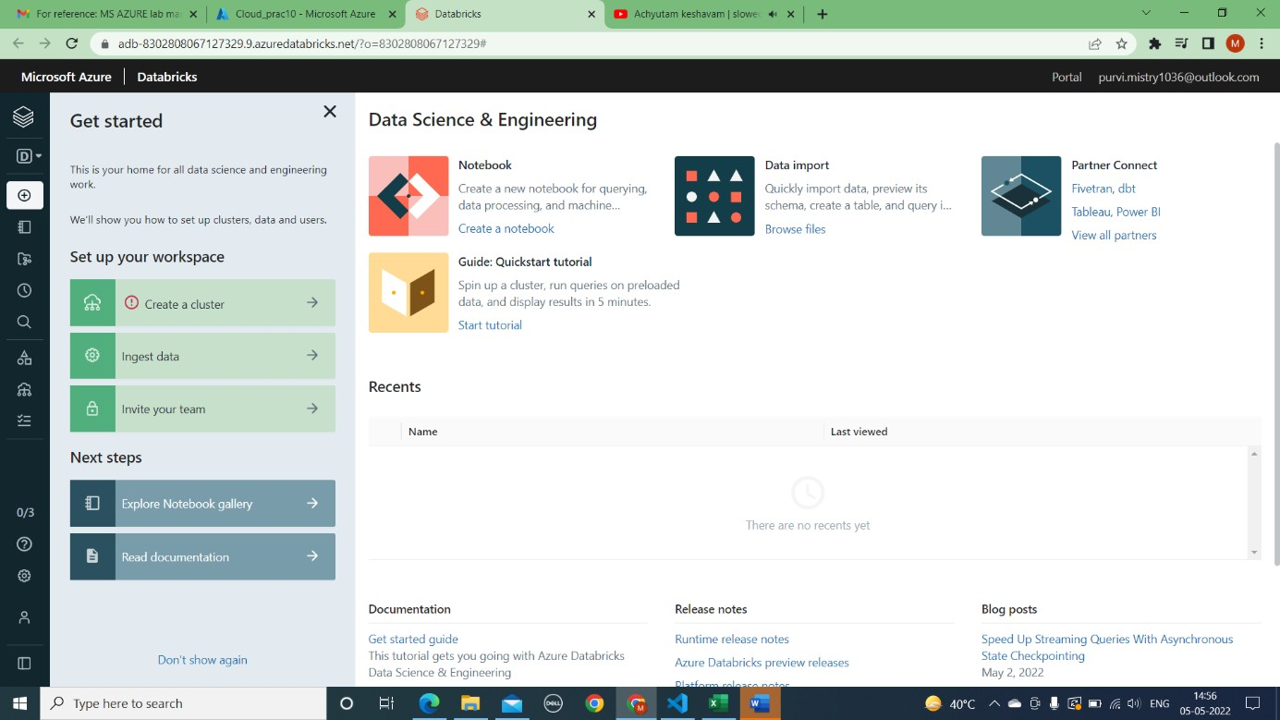

1. In the New cluster page, provide the values to create a cluster.

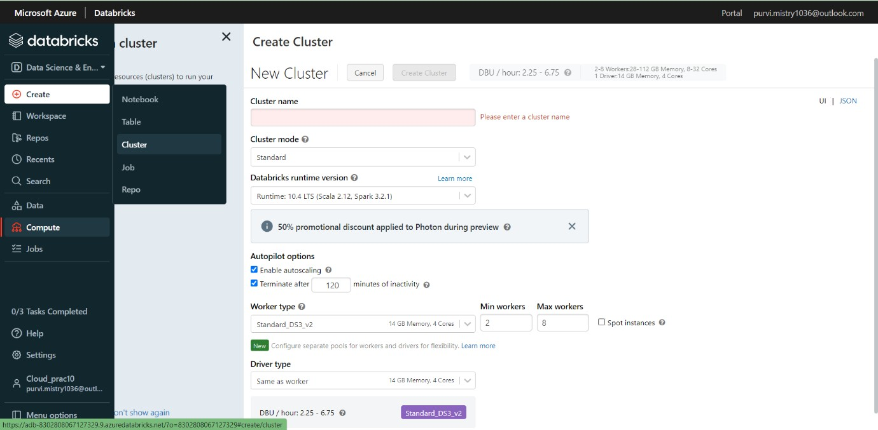

Accept all other default values other than the following: o Enter a name for the cluster.

* For this article, create a cluster with 10.4 LTS runtime.
* Make sure you select the Terminate after minutes of inactivity checkbox. Provide a duration (in minutes) to terminate the cluster, if the cluster is not being used.

Select **Create cluster**

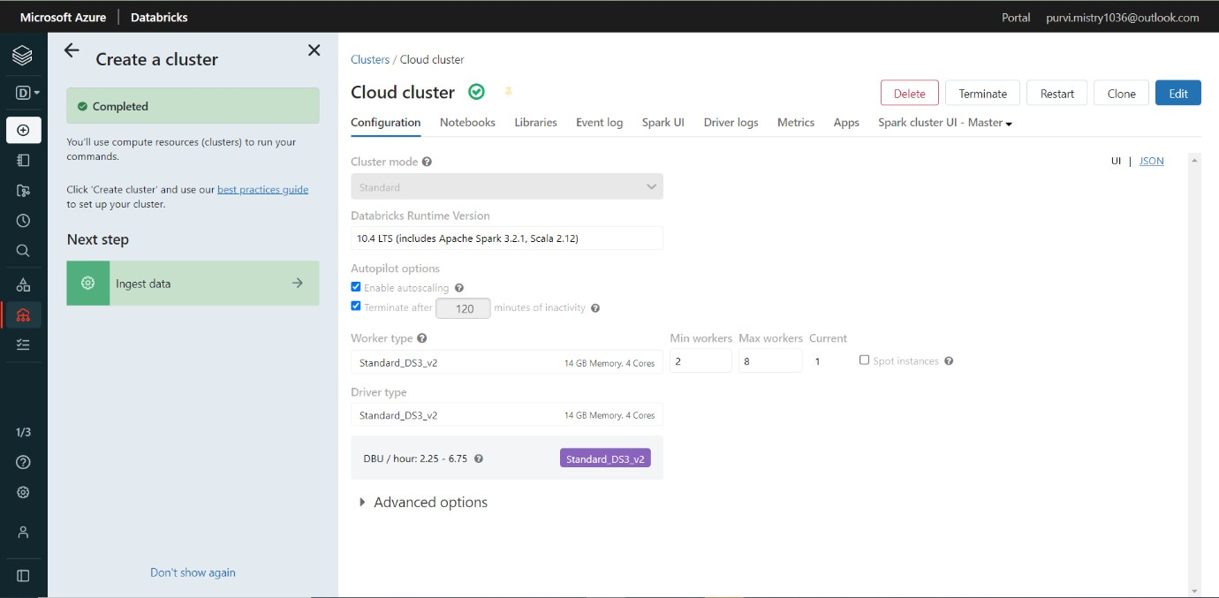

Perform the following tasks to create a notebook in Databricks:

* 1. In the left pane, select Azure Databricks. From the Common Tasks, select New Notebook.
  2. In the Create Notebook dialog box, enter a name, select Python as the language, and select the Spark cluster that you created earlier. Select Create.

