Whenever javascript looks for a property on an object and it doesn't find it on the object,

it looks for that property in its __proto__ (dunder proto) property. If it finds the property in

__proto__ property, it returns the property. It keeps doing it until it reaches

Object __proto__ property and if it still can’t find it, it returns undefined

How to create link between objects - Object.create(**objectToLink**);

Ex - const objectWithFunctions = {

increment: function() { this.score++ }

decrement: function() { this.score -- }

}

const newObj = Object.create(objectWithFunctions);

console.info(newObj);

Here Object.create returns a new object ( empty object) linked to objectWIthFunctions via __proto__ property

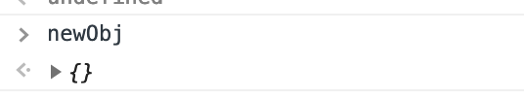

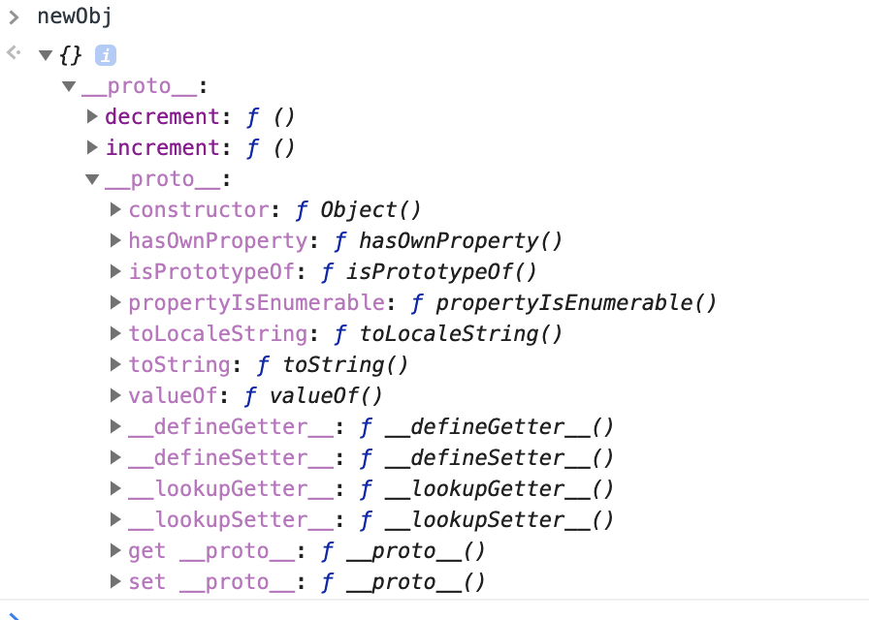

So now we can do newObj.decrement(). With this we have the advantage of having one copy of functions which are linked to the object, rather than having multiple copies of same function on every object, which is not memory efficient.