Name : Vatsal Postiwala PRN No: 26070122509 Batch : B3(2025-2029)
ASSIGNMENT No: 21
TITLE: Demonstration and exploration of JDBC classes and interfaces (DriverManager, Connection, Statement).

Problem Statement
Demonstration and exploration of JDBC classes and interfaces (DriverManager, Connection, Statement).

Learning Objectives
To understand and use the core JDBC classes for database connectivity.

Theory
The JDBC API consists of several classes and interfaces that facilitate database connectivity. The DriverManager class is responsible for loading the appropriate JDBC driver and establishing a connection with the database using a database URL, username, and password. The Connection interface represents an active session between the Java application and the database server. It provides methods to create SQL statements and manage transactions. The Statement interface executes static SQL queries and updates. These classes work together to establish communication between Java programs and databases. Understanding these core components is essential for developing database applications using Java.
Code:
package E21;
import java.lang.*;
import java.sql.Connection;
import java.sql.DriverManager;
import java.sql.SQLException;

public class E21 {

static final String DB_URL = "jdbc:mysql://localhost:3306/sit_java";
static final String USER = "root";
static final String PASS = "12345";

public static void main(String[] args) {
Connection conn = null;

try {

System.out.println("Attempting to connect to sit_java database...");

conn = DriverManager.getConnection(DB_URL, USER, PASS);

if (conn != null) {
System.out.println("Success! The database connection was established.");
}

} catch(SQLException se) {
System.out.println("Connection failed!");
se.printStackTrace();
} finally {
try {
if(conn != null) {
conn.close();
System.out.println("Connection closed.");
}
} catch(SQLException se) {
se.printStackTrace();
}
}
}
}

Output:
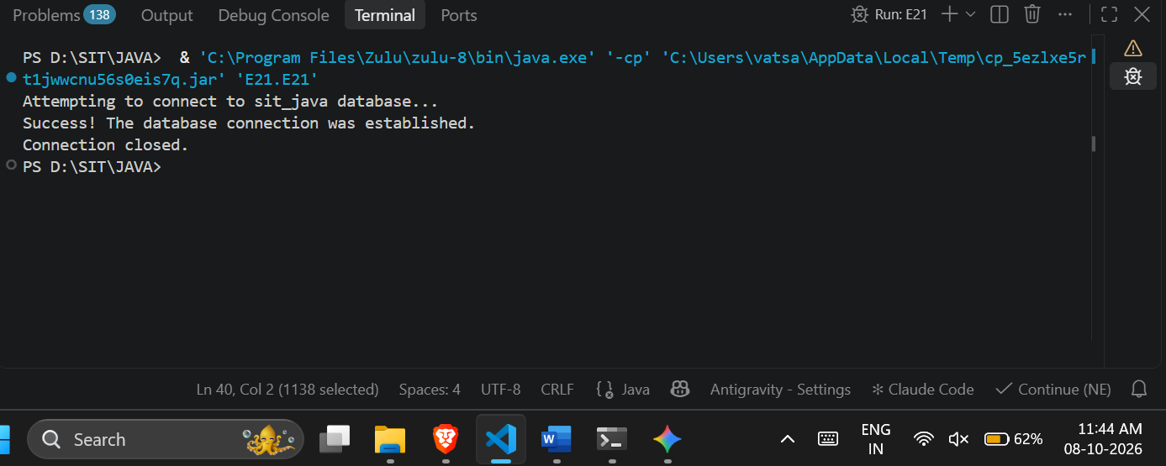

Exercise
- Create a program to connect Java with database and display database connection status.
Code:

package E21;

import java.lang.*;
import java.sql.Connection;
import java.sql.DriverManager;
import java.sql.SQLException;

public class DatabaseConnectionStatus {
static final String DB_URL = "jdbc:mysql://localhost:3306/sit_java";
static final String USER = "root";
static final String PASS = "12345";

public static void main(String[] args) {
Connection conn = null;

try {

System.out.println("Status: Attempting to establish database connection...");
conn = DriverManager.getConnection(DB_URL, USER, PASS);

if (conn != null) {
System.out.println("Status: Connection Established Successfully!");
}

} catch(SQLException se) {
System.out.println("Status: Connection Failed!");
se.printStackTrace();
} finally {
try {
if(conn != null) {
conn.close();
System.out.println("Status: Connection Closed.");
}
} catch(SQLException se) {
se.printStackTrace();
}
}
}
}

Output:
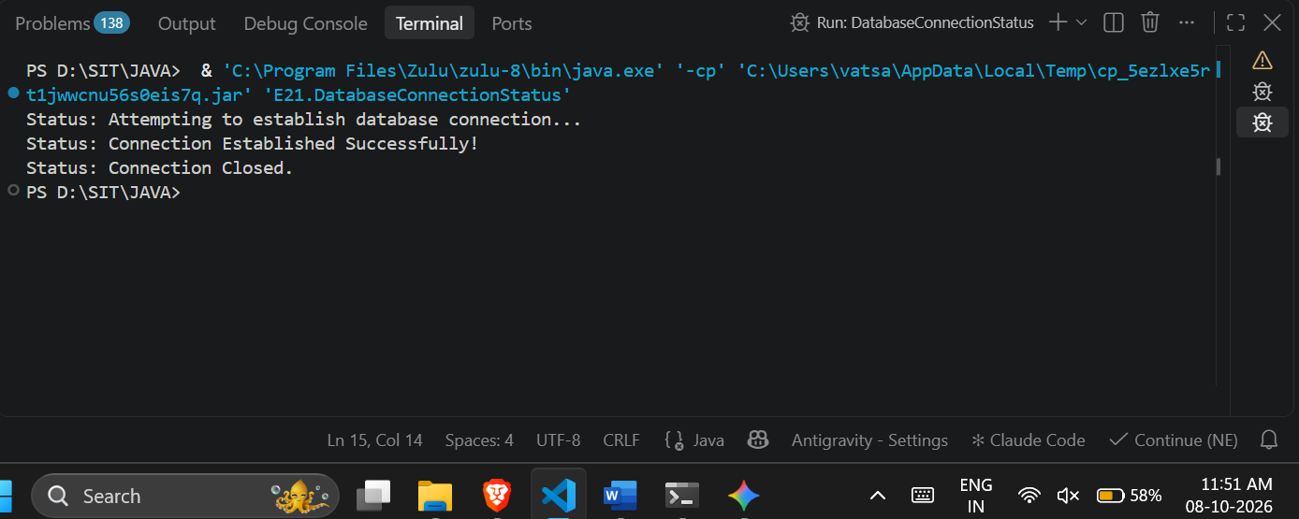
- Create a Java program to connect with a database and display the connection status. After successful connection, show a message indicating that the Student database is connected successfully.
Code:
package E21;

import java.lang.*;
import java.sql.Connection;
import java.sql.DriverManager;
import java.sql.SQLException;

public class StudentDatabaseConnection {
static final String DB_URL = "jdbc:mysql://localhost:3306/student_db";
static final String USER = "root";
static final String PASS = "12345";

public static void main(String[] args) {
Connection conn = null;

try {

System.out.println("Checking connection status...");
conn = DriverManager.getConnection(DB_URL, USER, PASS);

if (conn != null) {
System.out.println("Connection Status: ACTIVE");
// Custom message required by the exercise
System.out.println("Student database is connected successfully.");
}

} catch(SQLException se) {
System.out.println("Connection Status: INACTIVE (Failed to connect)");
se.printStackTrace();
} finally {
try {
if(conn != null) {
conn.close();
}
} catch(SQLException se) {
se.printStackTrace();
}
}
}
}
Output:
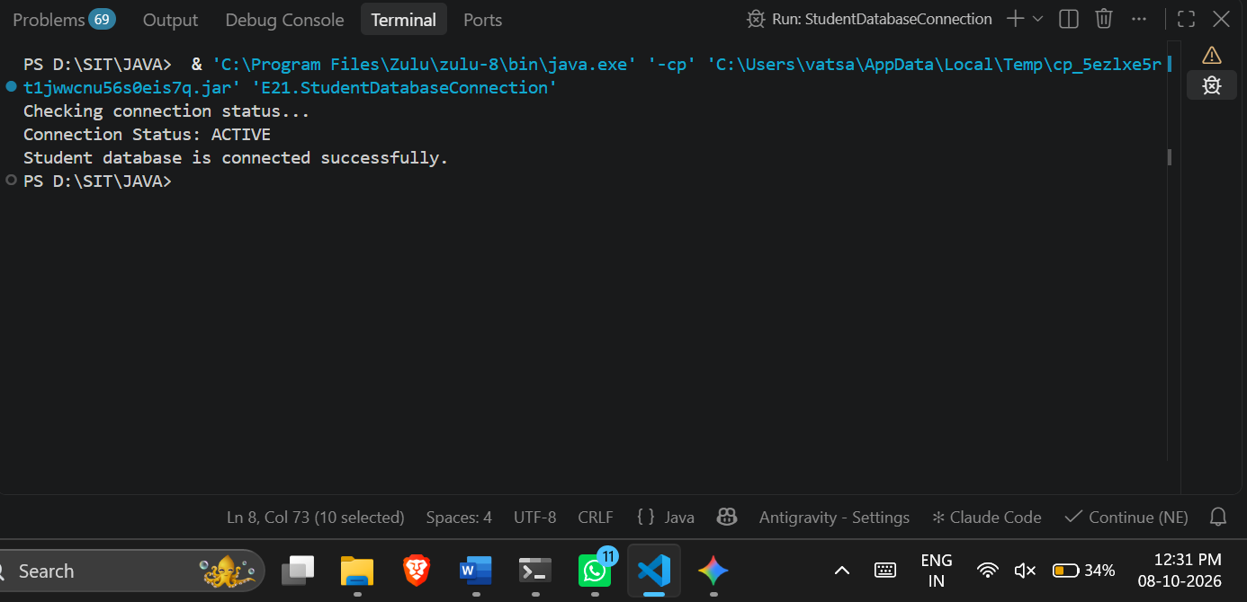

Conclusion:
I learned:
- How to connect a Java application to a MySQL database using the JDBC API.
- How to use the DriverManager class to establish the connection using a database URL and credentials.
- How to manage and verify the active session using the Connection interface.
- The necessity of using try-catch blocks to handle database errors (SQLException).
- The importance of safely closing the connection (conn.close()) in a finally block to prevent resource leaks.

