Name : Vatsal Postiwala PRN No: 26070122509 Batch : B3(2025-2029)
ASSIGNMENT No: 23
TITLE: Develop a Java application using JDBC to navigate and retrieve records from a ResultSet.

Problem Statement
Develop a Java application using JDBC to navigate and retrieve records from a ResultSet.

Learning Objectives
To navigate and retrieve records using ResultSet methods.

Theory
A ResultSet object contains data retrieved from a database after executing a SELECT query. It acts like a cursor that points to one row of the result at a time. Initially, the cursor is positioned before the first row. Various methods such as next(), previous(), first(), last(), absolute(), and relative() allow movement through the records. Data from each column can be retrieved using methods like getString(), getInt(), and getDouble(). Scrollable and updatable ResultSets provide greater flexibility for navigating and modifying retrieved data. ResultSet plays a crucial role in displaying and processing database information in Java applications.
Code:
package E23;

import java.lang.*;
import java.sql.Connection;
import java.sql.DriverManager;
import java.sql.ResultSet;
import java.sql.Statement;

public class ResultSetNavigation {
public static void main(String[] args) {
try {
Class.forName("com.mysql.cj.jdbc.Driver");
Connection con = DriverManager.getConnection("jdbc:mysql://localhost:3306/sit_java", "root", "12345");

Statement stmt = con.createStatement(ResultSet.TYPE_SCROLL_INSENSITIVE, ResultSet.CONCUR_READ_ONLY);
ResultSet rs = stmt.executeQuery("SELECT * FROM employees");

if (rs.first()) {
System.out.println("First Record: " + rs.getInt(1) + " | " + rs.getString(2) + " | " + rs.getDouble(3));
}

if (rs.last()) {
System.out.println("Last Record: " + rs.getInt(1) + " | " + rs.getString(2) + " | " + rs.getDouble(3));
}

if (rs.previous()) {
System.out.println("Previous from Last: " + rs.getInt(1) + " | " + rs.getString(2) + " | " + rs.getDouble(3));
}

if (rs.absolute(2)) {
System.out.println("Absolute 2nd Record: " + rs.getInt(1) + " | " + rs.getString(2) + " | " + rs.getDouble(3));
}

rs.close();
stmt.close();
con.close();
} catch (Exception e) {
System.out.println(e);
}
}
}
Output:
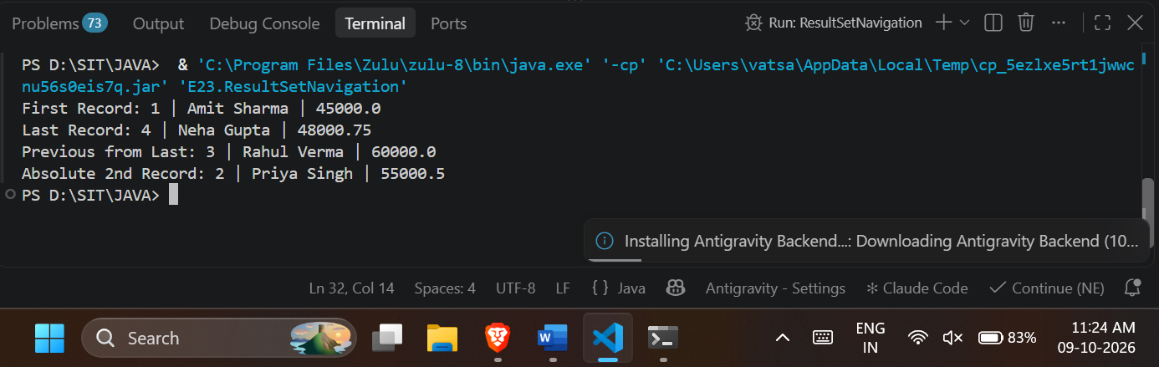

Exercise
- Create a program to display database records one by one using ResultSet.
Code:
package E23;

import java.lang.*;
import java.sql.Connection;
import java.sql.DriverManager;
import java.sql.ResultSet;
import java.sql.Statement;

public class DisplayRecords {
public static void main(String[] args) {
try {
Class.forName("com.mysql.cj.jdbc.Driver");
Connection con = DriverManager.getConnection("jdbc:mysql://localhost:3306/sit_java", "root", "12345");
Statement stmt = con.createStatement();

ResultSet rs = stmt.executeQuery("SELECT * FROM students");

System.out.println("Student Records");
while (rs.next()) {
System.out.println("ID: " + rs.getInt(1) + ", Name: " + rs.getString(2));
}

rs.close();
stmt.close();
con.close();
} catch (Exception e) {
System.out.println(e);
}
}
}

Output:
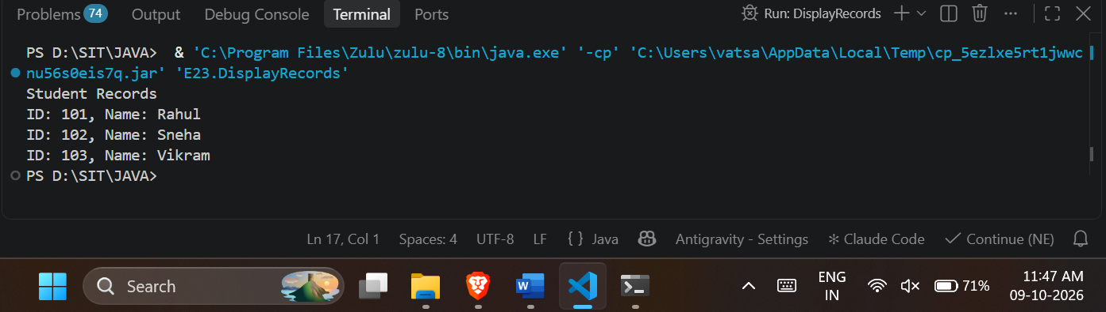
- Create a Java program that retrieves employee records from a database and displays them one by one using ResultSet. Show employee ID, name, department, and salary sequentially.
Code:
package E23;

import java.lang.*;
import java.sql.Connection;
import java.sql.DriverManager;
import java.sql.ResultSet;
import java.sql.Statement;

public class EmployeeRecords {
public static void main(String[] args) {
try {
Class.forName("com.mysql.cj.jdbc.Driver");
Connection con = DriverManager.getConnection("jdbc:mysql://localhost:3306/sit_java", "root", "12345");
Statement stmt = con.createStatement();

ResultSet rs = stmt.executeQuery("SELECT id, name, department, salary FROM employees");

System.out.println("Employee Details");
while (rs.next()) {
System.out.println("ID: " + rs.getInt("id"));
System.out.println("Name: " + rs.getString("name"));
System.out.println("Department: " + rs.getString("department"));
System.out.println("Salary: " + rs.getDouble("salary")+"\n");

}

rs.close();
stmt.close();
con.close();
} catch (Exception e) {
System.out.println(e);
}
}
}
Output:

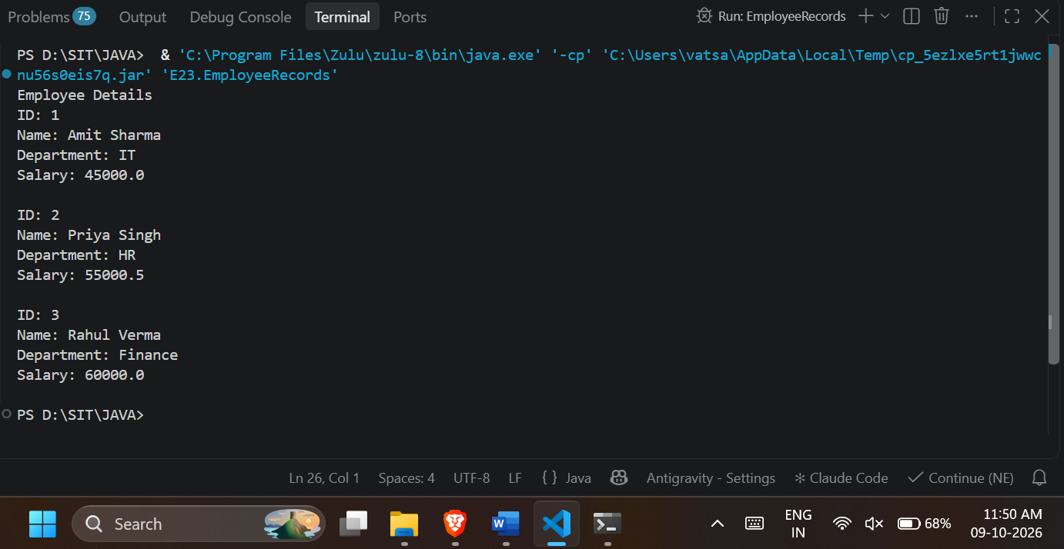

Conclusion:
I learned how to successfully connect a Java application to a MySQL database and retrieve data using JDBC. I understood the functioning of the ResultSet interface and how it acts as a cursor to hold and fetch database records row by row. I gained hands-on experience navigating forward and backward through the results using scrollable methods like first(), last(), previous(), and absolute(). Furthermore, I learned how to accurately extract specific column data using getter methods like getInt(), getString(), and getDouble(). Overall, this assignment helped me understand how to efficiently process and display database information dynamically within a Java program.

