Name : Vatsal Postiwala PRN No: 26070122509 Batch : B3(2025-2029)
ASSIGNMENT No: 24
TITLE: Develop a Java GUI application integrated with JDBC to perform database operations."

Problem Statement
Develop a Java GUI application integrated with JDBC to perform database operations."

Learning Objectives
To integrate Java GUI applications with databases using JDBC.

Theory
Java Swing provides graphical user interface components such as buttons, labels, text fields, tables, and forms, while JDBC enables database connectivity. Combining Swing with JDBC allows developers to create interactive desktop applications capable of performing database operations through a graphical interface. Users can enter information using GUI components, which is then processed and stored in the database using SQL queries. Retrieved records can be displayed in tables or text fields for easy viewing and modification. This integration improves user experience by eliminating command-line interaction and forms the foundation of desktop applications such as inventory management systems, library management systems, and student management systems.
Code:
package E24;

import java.lang.*;
import javax.swing.*;
import javax.swing.table.DefaultTableModel;
import java.awt.*;
import java.awt.event.ActionEvent;
import java.awt.event.ActionListener;
import java.sql.*;

public class DatabaseApp extends JFrame {
JTextField idField, nameField, ageField, gradeField;
JButton insertButton, viewButton;
JTable table;
DefaultTableModel tableModel;
Connection con;
PreparedStatement pst;
ResultSet rs;

public DatabaseApp() {
setTitle("Student Database Manager");
setSize(500, 500);
setDefaultCloseOperation(EXIT_ON_CLOSE);
setLayout(new BorderLayout());

JPanel inputPanel = new JPanel(new GridLayout(4, 2));

inputPanel.add(new JLabel(" ID:"));
idField = new JTextField();
inputPanel.add(idField);

inputPanel.add(new JLabel(" Name:"));
nameField = new JTextField();
inputPanel.add(nameField);

inputPanel.add(new JLabel(" Age:"));
ageField = new JTextField();
inputPanel.add(ageField);

inputPanel.add(new JLabel(" Grade:"));
gradeField = new JTextField();
inputPanel.add(gradeField);

add(inputPanel, BorderLayout.NORTH);

JPanel buttonPanel = new JPanel();
insertButton = new JButton("Insert Record");
viewButton = new JButton("View Database");
buttonPanel.add(insertButton);
buttonPanel.add(viewButton);
add(buttonPanel, BorderLayout.CENTER);

tableModel = new DefaultTableModel(new String[]{"ID", "Name", "Age", "Grade"}, 0);
table = new JTable(tableModel);
add(new JScrollPane(table), BorderLayout.SOUTH);

connect();

insertButton.addActionListener(new ActionListener() {
public void actionPerformed(ActionEvent e) {
try {
String id = idField.getText();
String name = nameField.getText();
String age = ageField.getText();
String grade = gradeField.getText();

pst = con.prepareStatement("INSERT INTO students(id, name, age, grade) VALUES(?,?,?,?)");
pst.setInt(1, Integer.parseInt(id));
pst.setString(2, name);
pst.setInt(3, Integer.parseInt(age));
pst.setString(4, grade);
pst.executeUpdate();

JOptionPane.showMessageDialog(null, "Record Added Successfully!");

idField.setText("");
nameField.setText("");
ageField.setText("");
gradeField.setText("");
} catch (SQLException | NumberFormatException ex) {
JOptionPane.showMessageDialog(null, "Error: " + ex.getMessage());
}
}
});

viewButton.addActionListener(new ActionListener() {
public void actionPerformed(ActionEvent e) {
try {
pst = con.prepareStatement("SELECT * FROM students");
rs = pst.executeQuery();

tableModel.setRowCount(0);

while (rs.next()) {
// Using basic Object array instead of Vector
Object[] rowData = new Object[4];
rowData[0] = rs.getString("id");
rowData[1] = rs.getString("name");
rowData[2] = rs.getString("age");
rowData[3] = rs.getString("grade");
tableModel.addRow(rowData);
}
} catch (SQLException ex) {
JOptionPane.showMessageDialog(null, "Error: " + ex.getMessage());
}
}
});
}

public void connect() {
try {
Class.forName("com.mysql.cj.jdbc.Driver");
// Make sure your username and password here are correct
con = DriverManager.getConnection("jdbc:mysql://localhost:3306/sit_java", "root", "12345");
} catch (ClassNotFoundException | SQLException ex) {
JOptionPane.showMessageDialog(null, "Database Connection Failed: " + ex.getMessage());
}
}

// The main method is correctly defined here
public static void main(String[] args) {
SwingUtilities.invokeLater(new Runnable() {
public void run() {
new DatabaseApp().setVisible(true);
}
});
}
}
Output:
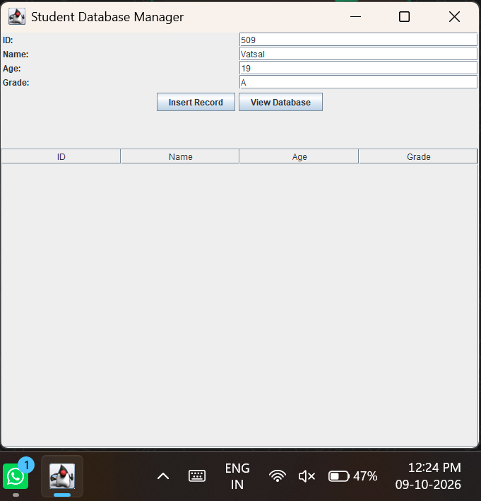

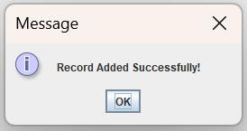
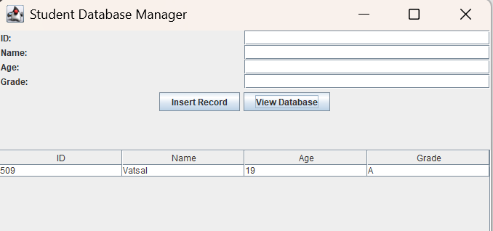

Exercise
- Create a Library Management System GUI connected with database
Code:
package E24;

import java.lang.*;
import javax.swing.*;
import javax.swing.table.DefaultTableModel;
import java.awt.*;
import java.awt.event.ActionEvent;
import java.awt.event.ActionListener;
import java.sql.*;

public class LibraryManagementSystem extends JFrame {
JTextField bookIdField, titleField, authorField, categoryField;
JButton addButton, viewButton;
JTable table;
DefaultTableModel tableModel;
Connection con;
PreparedStatement pst;
ResultSet rs;

public LibraryManagementSystem() {
setTitle("Library Management System");
setSize(600, 500);
setDefaultCloseOperation(EXIT_ON_CLOSE);
setLayout(new BorderLayout());

JPanel inputPanel = new JPanel(new GridLayout(4, 2));

inputPanel.add(new JLabel(" Book ID:"));
bookIdField = new JTextField();
inputPanel.add(bookIdField);

inputPanel.add(new JLabel(" Book Title:"));
titleField = new JTextField();
inputPanel.add(titleField);

inputPanel.add(new JLabel(" Author:"));
authorField = new JTextField();
inputPanel.add(authorField);

inputPanel.add(new JLabel(" Category:"));
categoryField = new JTextField();
inputPanel.add(categoryField);

add(inputPanel, BorderLayout.NORTH);

JPanel buttonPanel = new JPanel();
addButton = new JButton("Add Book");
viewButton = new JButton("View Books");
buttonPanel.add(addButton);
buttonPanel.add(viewButton);
add(buttonPanel, BorderLayout.CENTER);

tableModel = new DefaultTableModel(new String[]{"Book ID", "Title", "Author", "Category"}, 0);
table = new JTable(tableModel);
add(new JScrollPane(table), BorderLayout.SOUTH);

connect();

addButton.addActionListener(new ActionListener() {
public void actionPerformed(ActionEvent e) {
try {
String bookId = bookIdField.getText();
String title = titleField.getText();
String author = authorField.getText();
String category = categoryField.getText();

pst = con.prepareStatement("INSERT INTO library_books(book_id, title, author, category) VALUES(?,?,?,?)");
pst.setInt(1, Integer.parseInt(bookId));
pst.setString(2, title);
pst.setString(3, author);
pst.setString(4, category);
pst.executeUpdate();

JOptionPane.showMessageDialog(null, "Book Added Successfully!");

bookIdField.setText("");
titleField.setText("");
authorField.setText("");
categoryField.setText("");
} catch (SQLException | NumberFormatException ex) {
JOptionPane.showMessageDialog(null, "Error: " + ex.getMessage());
}
}
});

viewButton.addActionListener(new ActionListener() {
public void actionPerformed(ActionEvent e) {
try {
pst = con.prepareStatement("SELECT * FROM library_books");
rs = pst.executeQuery();

tableModel.setRowCount(0);

while (rs.next()) {
Object[] rowData = new Object[4];
rowData[0] = rs.getString("book_id");
rowData[1] = rs.getString("title");
rowData[2] = rs.getString("author");
rowData[3] = rs.getString("category");
tableModel.addRow(rowData);
}
} catch (SQLException ex) {
JOptionPane.showMessageDialog(null, "Error: " + ex.getMessage());
}
}
});
}

public void connect() {
try {
Class.forName("com.mysql.cj.jdbc.Driver");
con = DriverManager.getConnection("jdbc:mysql://localhost:3306/sit_java", "root", "12345");
} catch (ClassNotFoundException | SQLException ex) {
JOptionPane.showMessageDialog(null, "Database Connection Failed: " + ex.getMessage());
}
}

public static void main(String[] args) {
SwingUtilities.invokeLater(new Runnable() {
public void run() {
new LibraryManagementSystem().setVisible(true);
}
});
}
}
Output:
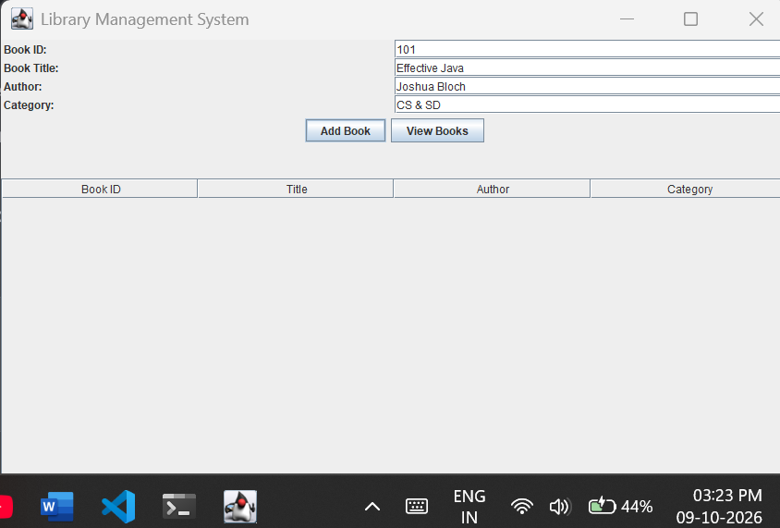
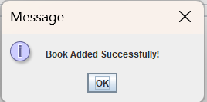
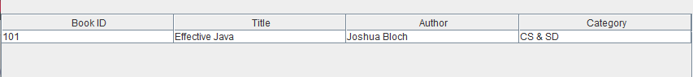

- Create a Book Issue Tracking System GUI application using Java Swing connected to a database. The system should store book ID, student name, issue date, and return date, and allow record management.

Code:
package E24;

import java.lang.*;
import javax.swing.*;
import javax.swing.table.DefaultTableModel;
import java.awt.*;
import java.awt.event.ActionEvent;
import java.awt.event.ActionListener;
import java.sql.*;

public class BookIssueTracker extends JFrame {
JTextField bookIdField, studentNameField, issueDateField, returnDateField;
JButton insertButton, viewButton;
JTable table;
DefaultTableModel tableModel;
Connection con;
PreparedStatement pst;
ResultSet rs;

public BookIssueTracker() {
setTitle("Book Issue Tracking System");
setSize(600, 500);
setDefaultCloseOperation(EXIT_ON_CLOSE);
setLayout(new BorderLayout());

JPanel inputPanel = new JPanel(new GridLayout(4, 2));

inputPanel.add(new JLabel(" Book ID:"));
bookIdField = new JTextField();
inputPanel.add(bookIdField);

inputPanel.add(new JLabel(" Student Name:"));
studentNameField = new JTextField();
inputPanel.add(studentNameField);

inputPanel.add(new JLabel(" Issue Date (DD-MM-YYYY):"));
issueDateField = new JTextField();
inputPanel.add(issueDateField);

inputPanel.add(new JLabel(" Return Date (DD-MM-YYYY):"));
returnDateField = new JTextField();
inputPanel.add(returnDateField);

add(inputPanel, BorderLayout.NORTH);

JPanel buttonPanel = new JPanel();
insertButton = new JButton("Issue Book");
viewButton = new JButton("View Records");
buttonPanel.add(insertButton);
buttonPanel.add(viewButton);
add(buttonPanel, BorderLayout.CENTER);

tableModel = new DefaultTableModel(new String[]{"Book ID", "Student Name", "Issue Date", "Return Date"}, 0);
table = new JTable(tableModel);
add(new JScrollPane(table), BorderLayout.SOUTH);

connect();

insertButton.addActionListener(new ActionListener() {
public void actionPerformed(ActionEvent e) {
try {
String bookId = bookIdField.getText();
String studentName = studentNameField.getText();
String issueDate = issueDateField.getText();
String returnDate = returnDateField.getText();

pst = con.prepareStatement("INSERT INTO book_issues(book_id, student_name, issue_date, return_date) VALUES(?,?,?,?)");
pst.setInt(1, Integer.parseInt(bookId));
pst.setString(2, studentName);
pst.setString(3, issueDate);
pst.setString(4, returnDate);
pst.executeUpdate();

JOptionPane.showMessageDialog(null, "Book Issued Successfully!");

bookIdField.setText("");
studentNameField.setText("");
issueDateField.setText("");
returnDateField.setText("");
} catch (SQLException | NumberFormatException ex) {
JOptionPane.showMessageDialog(null, "Error: " + ex.getMessage());
}
}
});

viewButton.addActionListener(new ActionListener() {
public void actionPerformed(ActionEvent e) {
try {
pst = con.prepareStatement("SELECT * FROM book_issues");
rs = pst.executeQuery();

tableModel.setRowCount(0);

while (rs.next()) {
Object[] rowData = new Object[4];
rowData[0] = rs.getString("book_id");
rowData[1] = rs.getString("student_name");
rowData[2] = rs.getString("issue_date");
rowData[3] = rs.getString("return_date");
tableModel.addRow(rowData);
}
} catch (SQLException ex) {
JOptionPane.showMessageDialog(null, "Error: " + ex.getMessage());
}
}
});
}

public void connect() {
try {
Class.forName("com.mysql.cj.jdbc.Driver");
con = DriverManager.getConnection("jdbc:mysql://localhost:3306/sit_java", "root", "12345");
} catch (ClassNotFoundException | SQLException ex) {
JOptionPane.showMessageDialog(null, "Database Connection Failed: " + ex.getMessage());
}
}

public static void main(String[] args) {
SwingUtilities.invokeLater(new Runnable() {
public void run() {
new BookIssueTracker().setVisible(true);
}
});
}
}

Output:
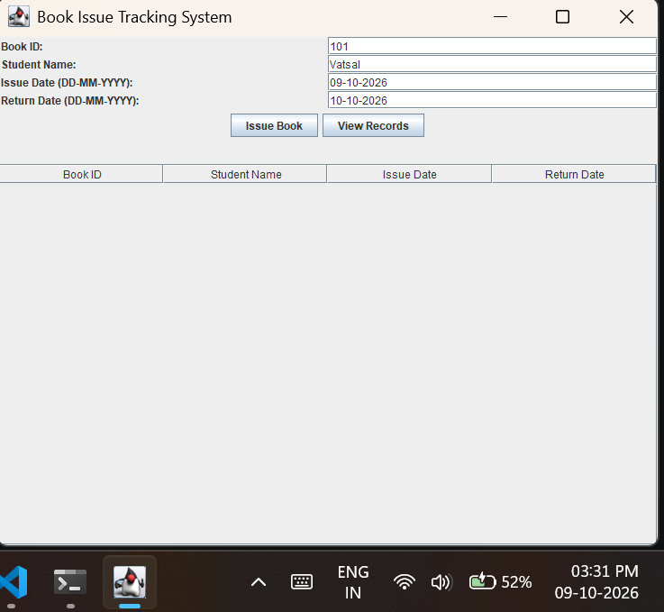
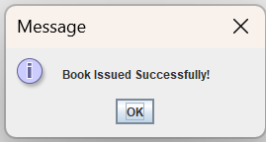
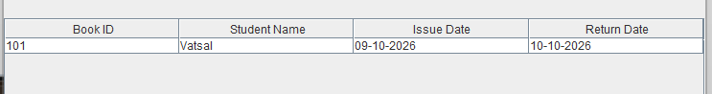
Conclusion:
I learned how to successfully integrate a Java Swing GUI application with a MySQL database using the JDBC API to build functional desktop programs like a Library Management System. During this process, I gained practical experience in securely executing SQL operations, such as INSERT and SELECT, using PreparedStatement to manage data effectively. I also learned how to seamlessly capture user input from graphical text fields, store it in the database, and dynamically display the retrieved records back to the user inside a JTable, helping me understand how to bridge frontend user interfaces with backend data management.

