Name : Vatsal Postiwala PRN No: 26070122509 Batch : B3(2025-2029)
ASSIGNMENT No: 29
TITLE: Write a JSP application to demonstrate the basic concepts of Java Server Pages.

Problem Statement
Write a JSP application to demonstrate the basic concepts of Java Server Pages.

Learning Objectives
To develop dynamic web pages using Java Server Pages.

Theory
Java Server Pages (JSP) is a server-side technology used for developing dynamic web applications. JSP allows Java code to be embedded within HTML pages using special JSP tags. When a JSP page is requested, the web server automatically translates it into a servlet, compiles it, and executes it to generate dynamic web content. JSP supports implicit objects, directives, scripting elements, expression language, and standard tag libraries. It simplifies web development by separating presentation from business logic. JSP is commonly used with Servlets and JDBC for building database-driven web applications.
Code:
<%@ page language="java" import="java.lang.*" info="package E29" %>
<html>
<body>
<h2>Basic JSP Demonstration</h2>
<%!
int PNR = 509;
String getMessage() {
return "Welcome to JSP Programming";
}
%>
<%
String user = "Vatsal";
%>
<p>Message: <%= getMessage() %></p>
<p>Hello: <%= user %></p>
<p>PNR: <%= PNR %></p>
</body>
</html>
Output:

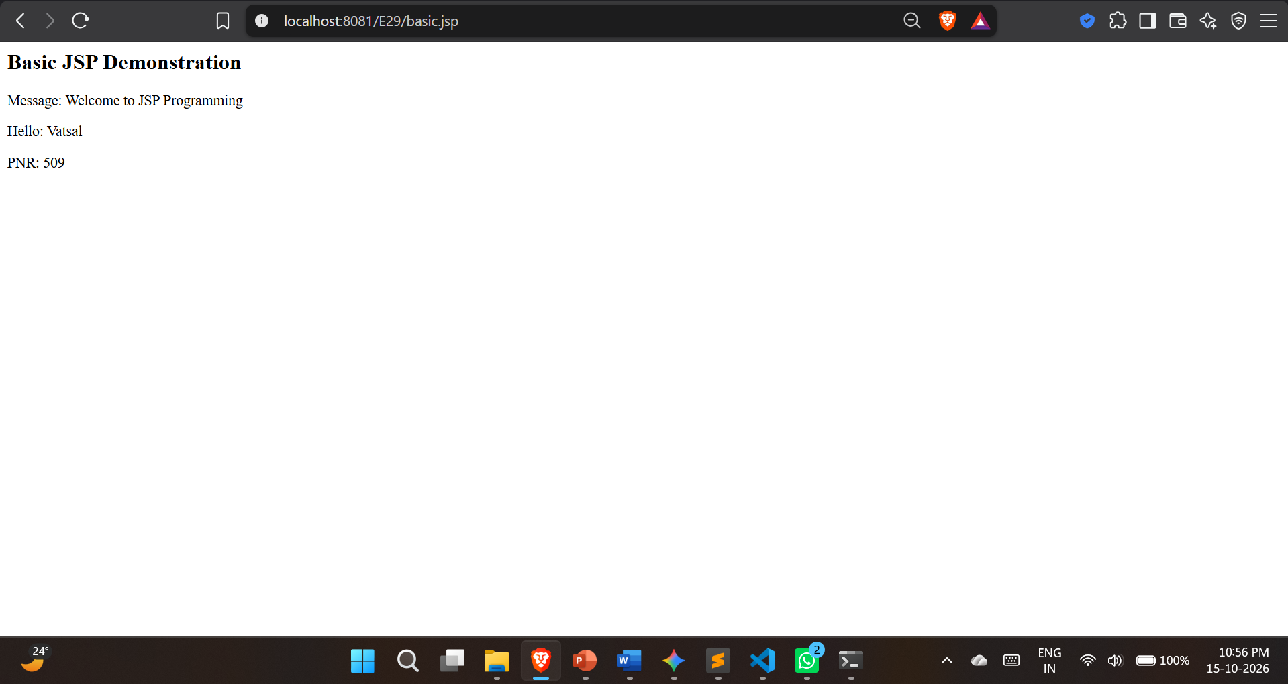

Exercise
- Create a JSP page to display student information entered by the user
Code:
student.html
<html>
<body>
<h2>Student Form</h2>
<form action="show.jsp" method="post">
Name: <input type="text" name="name"><br><br>
Roll No: <input type="text" name="roll"><br><br>
Branch: <input type="text" name="branch"><br><br>
<input type="submit" value="Submit">
</form>
</body>
</html>

show.jsp

<%@ page language="java" import="java.lang.*" info="package E29" %>
<html>
<body>
<%
String name = request.getParameter("name");
String roll = request.getParameter("roll");
String branch = request.getParameter("branch");
%>
<h2>Student Information</h2>
<p>Name : <%= name %></p>
<p>Roll No: <%= roll %></p>
<p>Branch : <%= branch %></p>
<a href="student.html">Back</a>
</body>
</html>
Output:
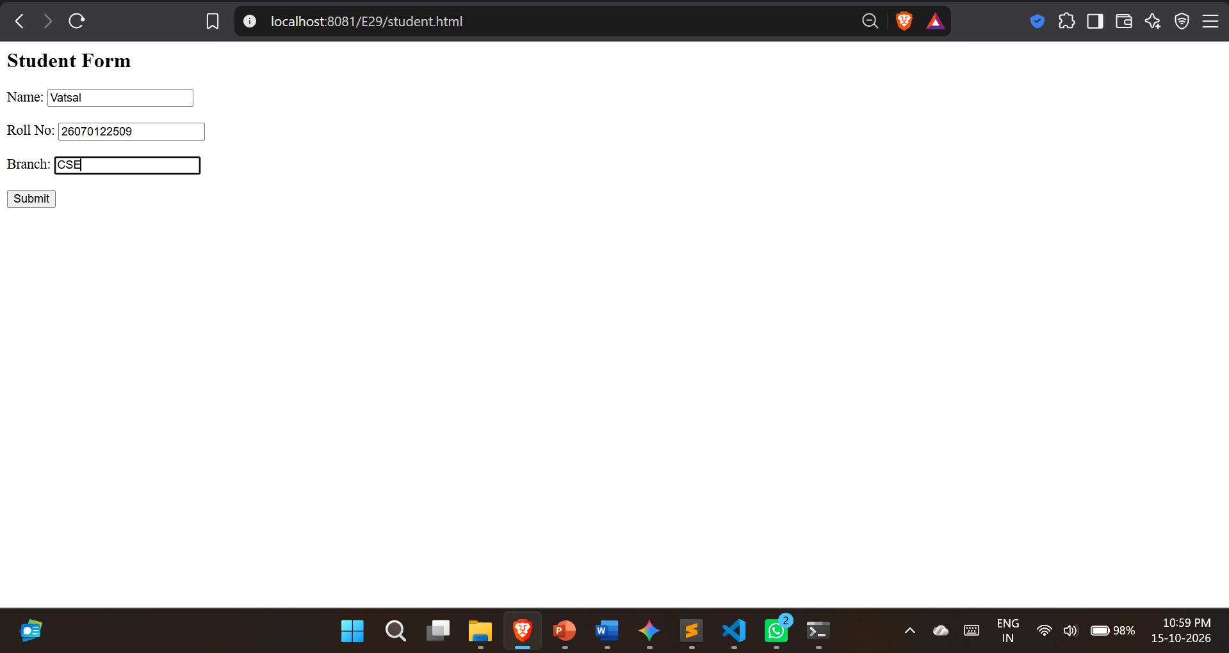
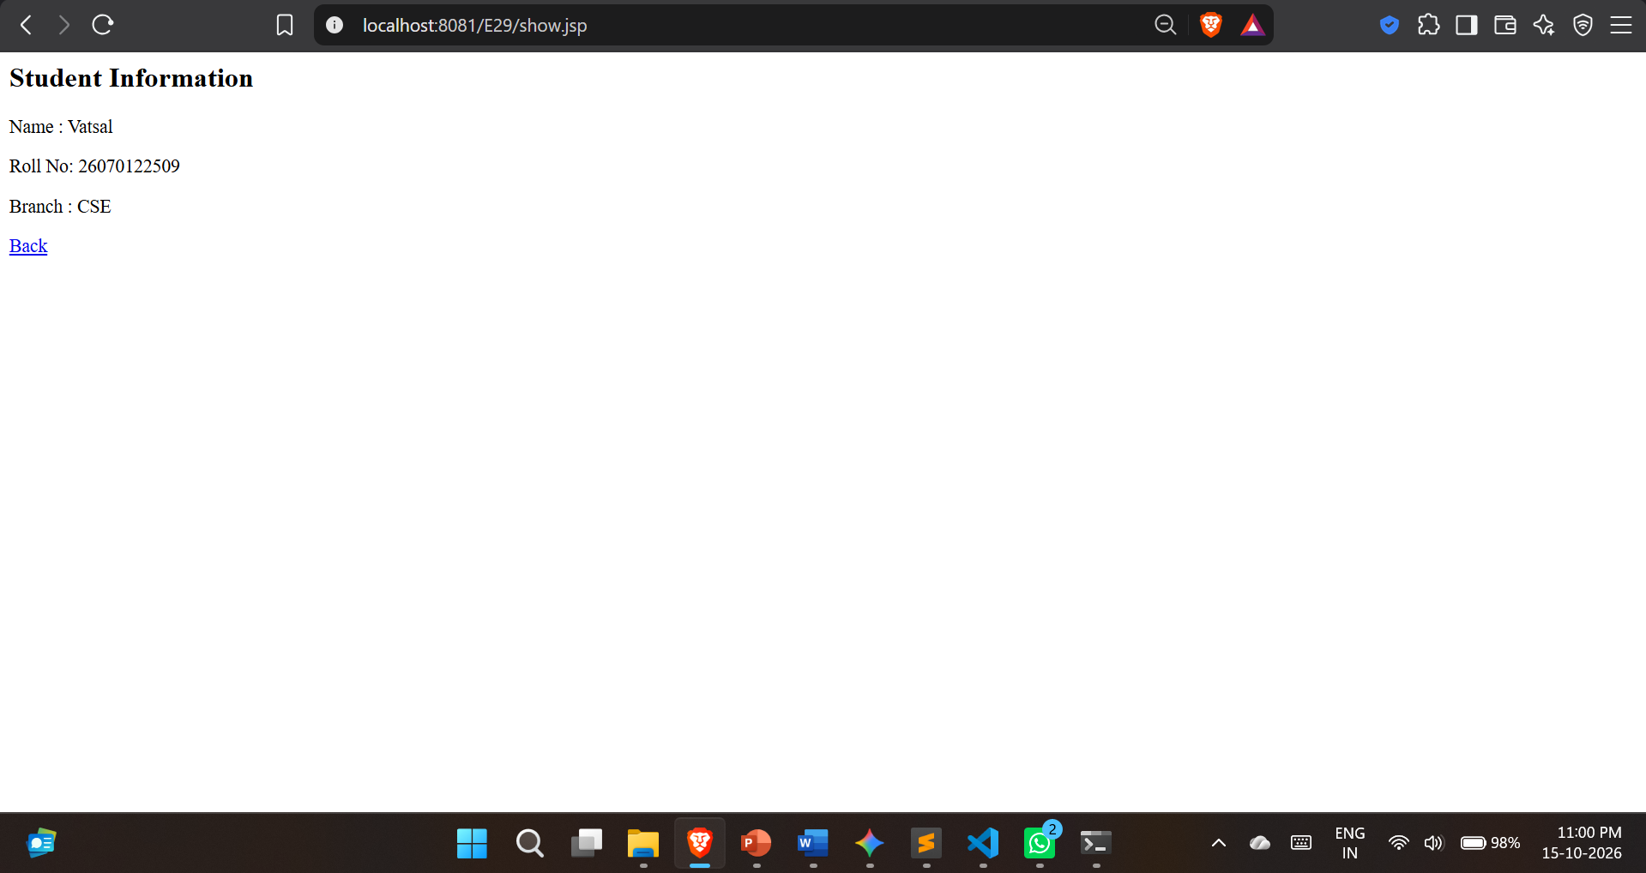

- Create a JSP application that takes user registration details such as Name, Email, Phone Number, and Password, and displays the submitted information on a result JSP page.
Code:
register.html
<html>
<body>
<h2>User Registration</h2>
<form action="result.jsp" method="post">
Name: <input type="text" name="name"><br><br>
Email: <input type="email" name="email"><br><br>
Phone: <input type="text" name="phone"><br><br>
Password: <input type="password" name="pwd"><br><br>
<input type="submit" value="Register">
</form>
</body>
</html>
result.jsp
<%@ page language="java" import="java.lang.*" info="package E29" %>
<%
String name = request.getParameter("name");
String email = request.getParameter("email");
String phone = request.getParameter("phone");
String pwd = request.getParameter("pwd");
if (name == null) {
response.sendRedirect("register.html");
return;
}
%>
<html>
<body>
<h2>Registration Successful</h2>
<p>Name : <%= name %></p>
<p>Email : <%= email %></p>
<p>Phone : <%= phone %></p>
<p>Password: <%= pwd.replaceAll(".", "*") %></p>
<a href="register.html">Back</a>
</body>
</html>
Output:
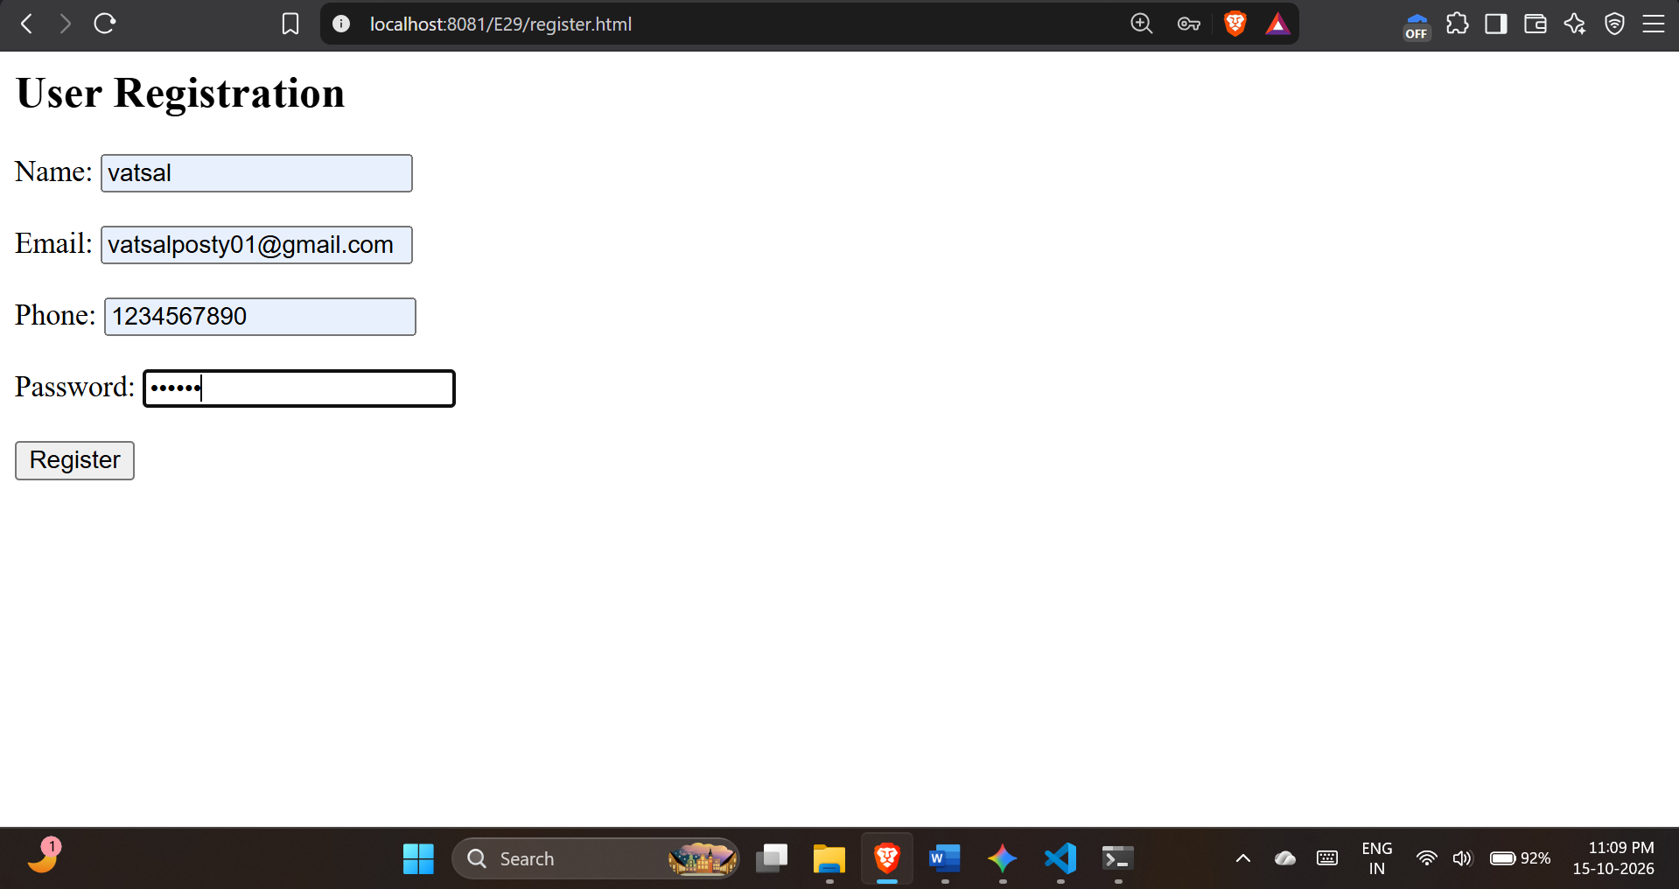
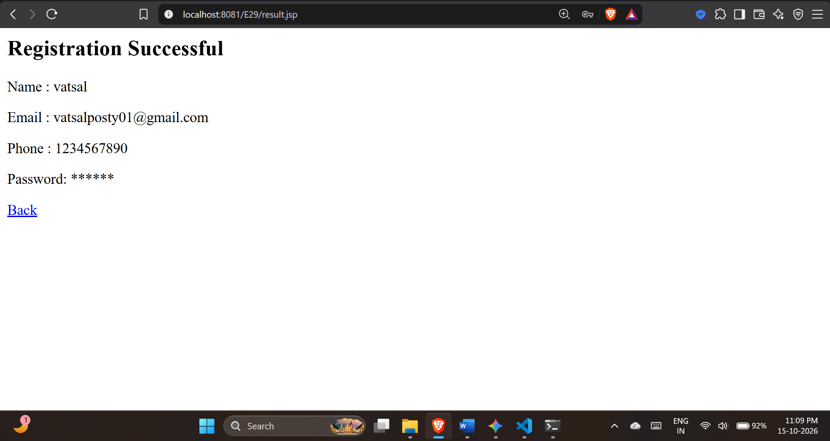
Conclusion:
I learned how to develop dynamic web pages using Java Server Pages (JSP) and deploy them on the Apache Tomcat server. Through this experiment, I understood how to embed Java code inside HTML using JSP scripting elements like scriptlets, expressions,declarations, and directives. I also learned how to use implicit objects such as request and response to capture user input from HTML forms and display the processed data dynamically on the web browser. Overall, this experiment demonstrated how JSP simplifies server-side web application development by effectively separating presentation from business logic.

