Name : Vatsal Postiwala PRN No: 26070122509 Batch : B3(2025-2029)
ASSIGNMENT No: 30
TITLE: Write a JSP application to demonstrate CRUD operations.

Problem Statement
Write a JSP application to demonstrate CRUD operations.

Learning Objectives
To implement Create, Read, Update, and Delete operations using JSP and a database.

Theory
CRUD stands for Create, Read, Update, and Delete, which represent the four basic database operations performed in web applications. JSP works together with Servlets and JDBC to implement these operations. Users interact with HTML forms created using JSP, while JDBC executes SQL statements to manipulate database records. INSERT adds new records, SELECT retrieves information, UPDATE modifies existing data, and DELETE removes unwanted records. Proper validation, exception handling, and session management improve application reliability and security. JSP CRUD applications are widely used in employee management systems, online shopping portals, hospital management systems, banking applications, and other enterprise software.
Code:
DBConnect.java
package E30;
import java.sql.Connection;
import java.sql.DriverManager;

public class DBConnect {
public static Connection getConnection() throws Exception {
Class.forName("com.mysql.cj.jdbc.Driver");
return DriverManager.getConnection("jdbc:mysql://localhost:3306/sit_java", "root", "12345");
}
}

Index.jsp
<%@ page import="java.lang.*, java.sql.*" %>
<%@ include file="db.jsp" %>
<html>
<body>
<h2>Item CRUD Operations</h2>
<a href="add.jsp">Add New Item</a><br><br>
<table border="1" cellpadding="6">
<tr>
<th>ID</th>
<th>Item Name</th>
<th>Category</th>
<th>Price</th>
<th>Action</th>
</tr>
<%
Statement st = con.createStatement();
ResultSet rs = st.executeQuery("SELECT * FROM crud_items");
while (rs.next()) {
int id = rs.getInt("id");
%>
<tr>
<td><%= id %></td>
<td><%= rs.getString("item_name") %></td>
<td><%= rs.getString("category") %></td>
<td><%= rs.getDouble("price") %></td>
<td>
<a href="edit.jsp?id=<%= id %>">Edit</a> |
<a href="delete.jsp?id=<%= id %>">Delete</a>
</td>
</tr>
<%
}
con.close();
%>
</table>
</body>
</html>
db.jsp
<%@ page import="java.lang.*, java.sql.*" %>
<%
Class.forName("com.mysql.cj.jdbc.Driver");
Connection con = DriverManager.getConnection("jdbc:mysql://localhost:3306/sit_java", "root", "12345");
%>

add.jsp
<%@ page import="java.lang.*, java.sql.*" %>
<%@ include file="db.jsp" %>
<%
if ("POST".equals(request.getMethod())) {
PreparedStatement ps = con.prepareStatement("INSERT INTO crud_items(item_name, category, price) VALUES(?, ?, ?)");
ps.setString(1, request.getParameter("item_name"));
ps.setString(2, request.getParameter("category"));
ps.setDouble(3, Double.parseDouble(request.getParameter("price")));
ps.executeUpdate();
con.close();
response.sendRedirect("index.jsp");
return;
}
%>
<html>
<body>
<h2>Add Item</h2>
<form method="post">
Item Name: <input type="text" name="item_name"><br><br>
Category: <input type="text" name="category"><br><br>
Price: <input type="text" name="price"><br><br>
<input type="submit" value="Save">
</form>
<a href="index.jsp">Back</a>
</body>
</html>

edit.jsp
<%@ page import="java.lang.*, java.sql.*" %>
<%@ include file="db.jsp" %>
<%
int id = Integer.parseInt(request.getParameter("id"));
if ("POST".equals(request.getMethod())) {
PreparedStatement up = con.prepareStatement("UPDATE crud_items SET item_name=?, category=?, price=? WHERE id=?");
up.setString(1, request.getParameter("item_name"));
up.setString(2, request.getParameter("category"));
up.setDouble(3, Double.parseDouble(request.getParameter("price")));
up.setInt(4, id);
up.executeUpdate();
con.close();
response.sendRedirect("index.jsp");
return;
}
PreparedStatement ps = con.prepareStatement("SELECT * FROM crud_items WHERE id=?");
ps.setInt(1, id);
ResultSet rs = ps.executeQuery();
rs.next();
%>
<html>
<body>
<h2>Update Item</h2>
<form method="post" action="edit.jsp?id=<%= id %>">
Item Name: <input type="text" name="item_name" value="<%= rs.getString("item_name") %>"><br><br>
Category: <input type="text" name="category" value="<%= rs.getString("category") %>"><br><br>
Price: <input type="text" name="price" value="<%= rs.getDouble("price") %>"><br><br>
<input type="submit" value="Update">
</form>
<a href="index.jsp">Back</a>
</body>
</html>

delete.jsp
<%@ page import="java.lang.*, java.sql.*" %>
<%@ include file="db.jsp" %>
<%
int id = Integer.parseInt(request.getParameter("id"));
PreparedStatement ps = con.prepareStatement("DELETE FROM crud_items WHERE id=?");
ps.setInt(1, id);
ps.executeUpdate();
con.close();
response.sendRedirect("index.jsp");
%>

Output:
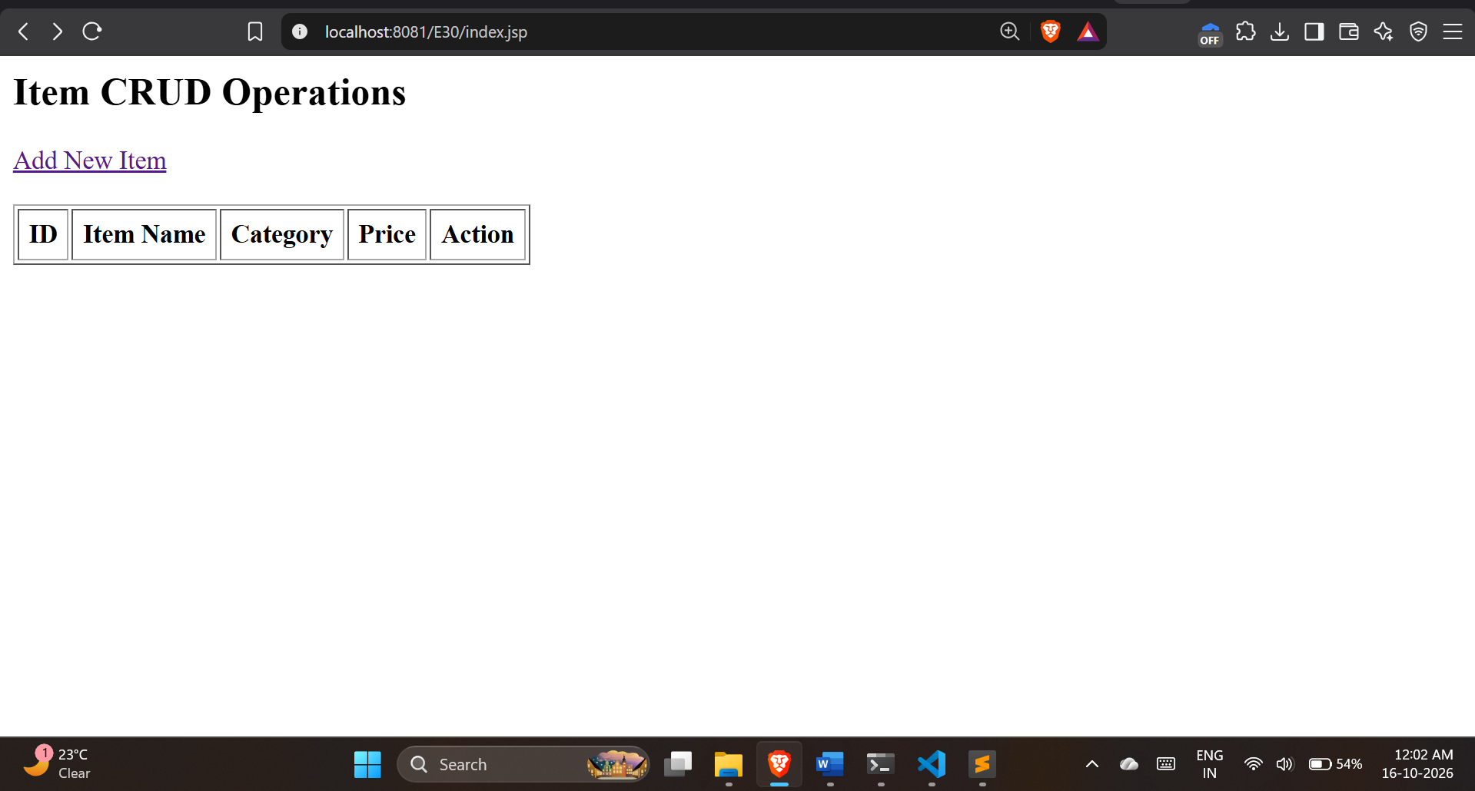
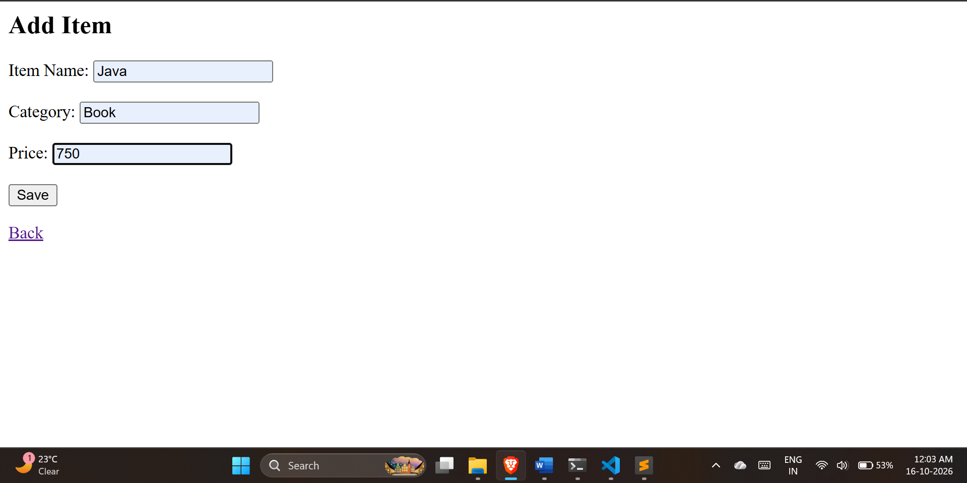
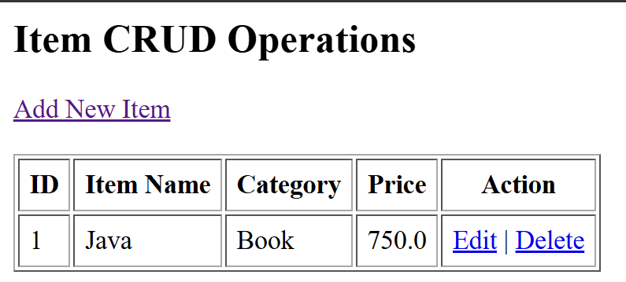
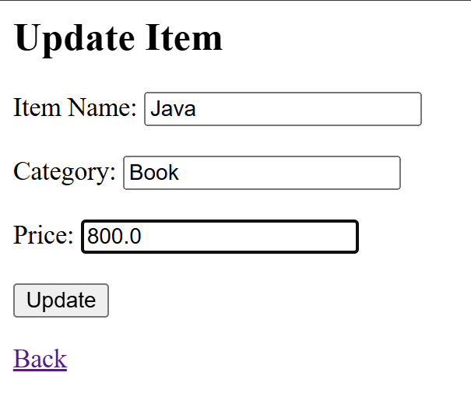
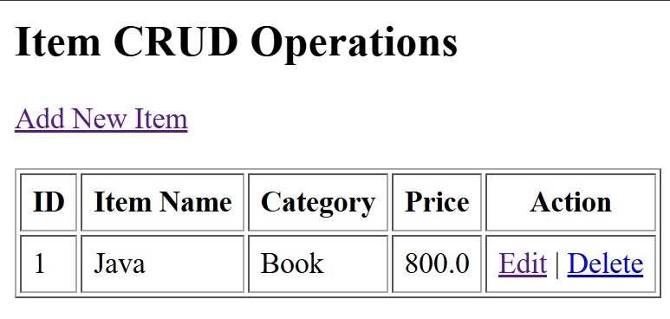
After deleted
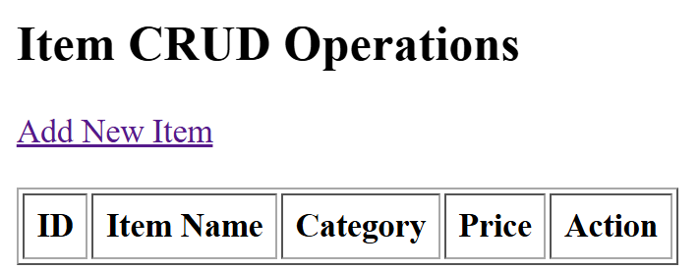

Exercise
- Create a JSP-based application to add, update, delete, and view employee details.

Code:
db_conn.jsp
<%@ page import="java.lang.*, java.sql.*" %>
<%
Class.forName("com.mysql.cj.jdbc.Driver");
Connection con = DriverManager.getConnection("jdbc:mysql://localhost:3306/sit_java", "root", "12345");
%>
Output:

- Create a JSP-based application to manage patient records using CRUD operations. Include fields such as patient ID, name, age, disease, and treatment status.
Code:
Output:

