Experiment 1

Name: - | Postiwala Vatsal D.
PRN: - | 26070122509
Batch: - | B3
Academic Year: - | 2026-27

Aim

To design a webpage using HTML5 elements such as headings, paragraphs, lists, images, tables, hyperlinks, iframe, audio, and basic formatting tags.

Learning Objectives

After completing this experiment, students will be able to:

- Understand the structure of an HTML document.
- Create webpages using HTML elements.
- Apply text formatting.
- Insert images, tables, hyperlinks, and multimedia content.
- Design a basic static webpage.

Tools Required

- Visual Studio Code
- Web Browser (Google Chrome)

Theory

HTML (HyperText Markup Language) is used to create the structure of webpages. HTML documents contain different elements represented using tags.

Basic structure:

<!DOCTYPE html>
<html>
<head>
<title>Page Title</title>
</head>

<body>

Webpage Content

</body>
</html>

Code

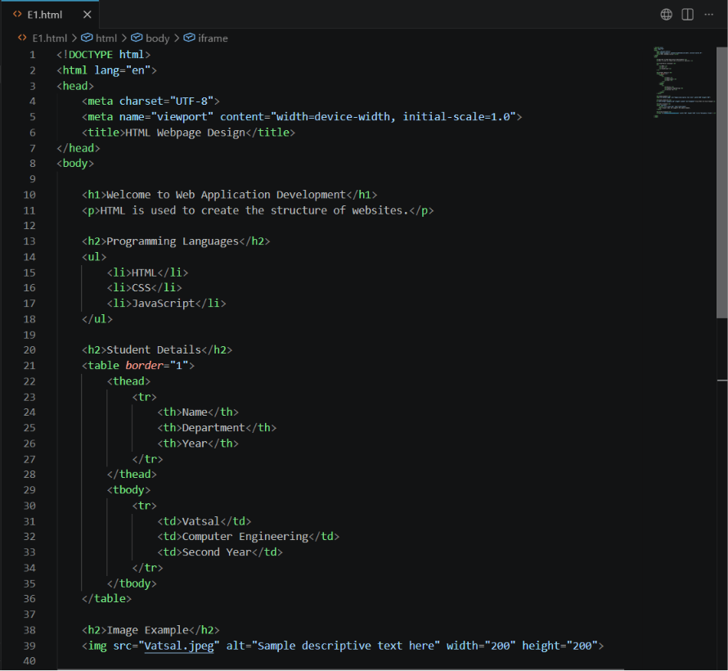

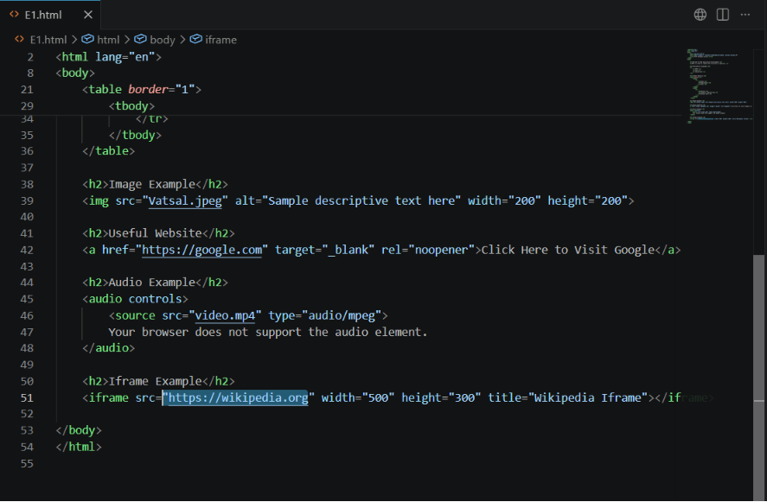

Output

The webpage displays:

  - Heading and paragraph
  - List of programming languages
  - Student information table
  - Image
  - Hyperlink
  - Audio player
  - Embedded webpage using iframe

Output Screenshot

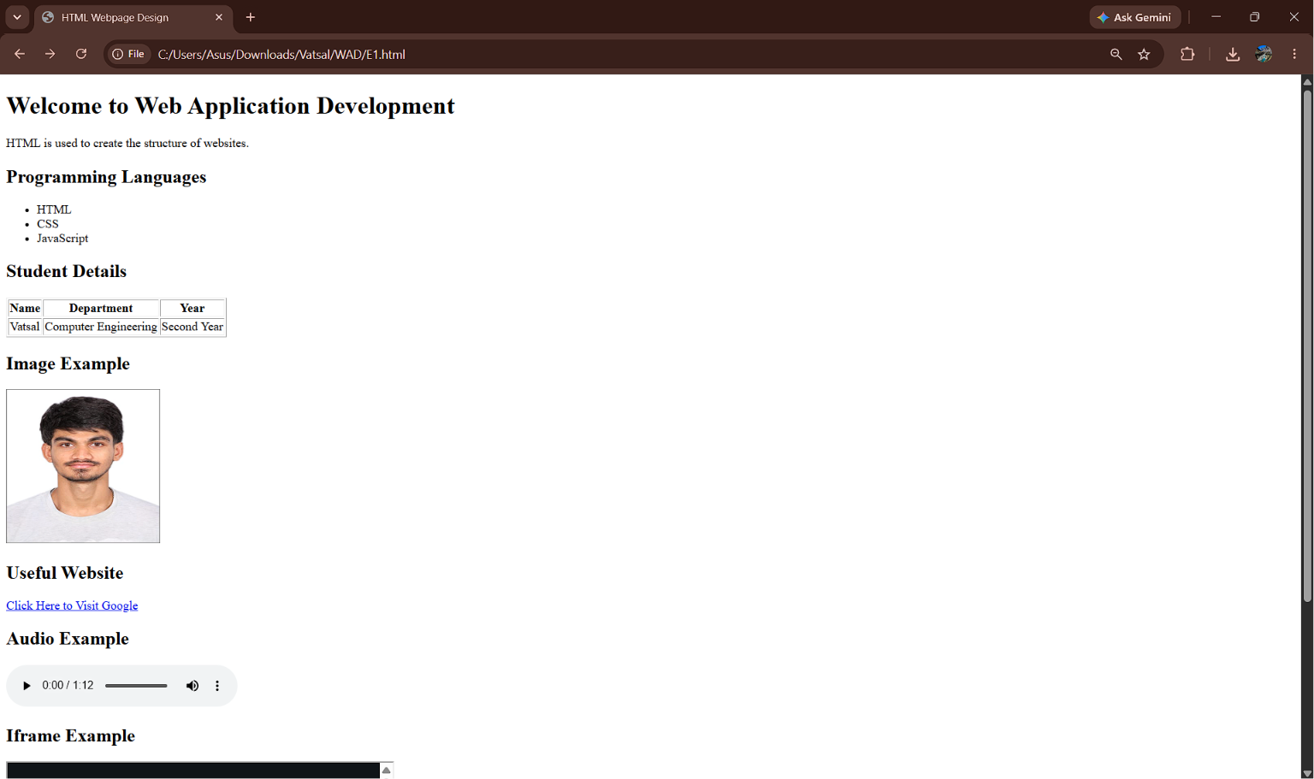

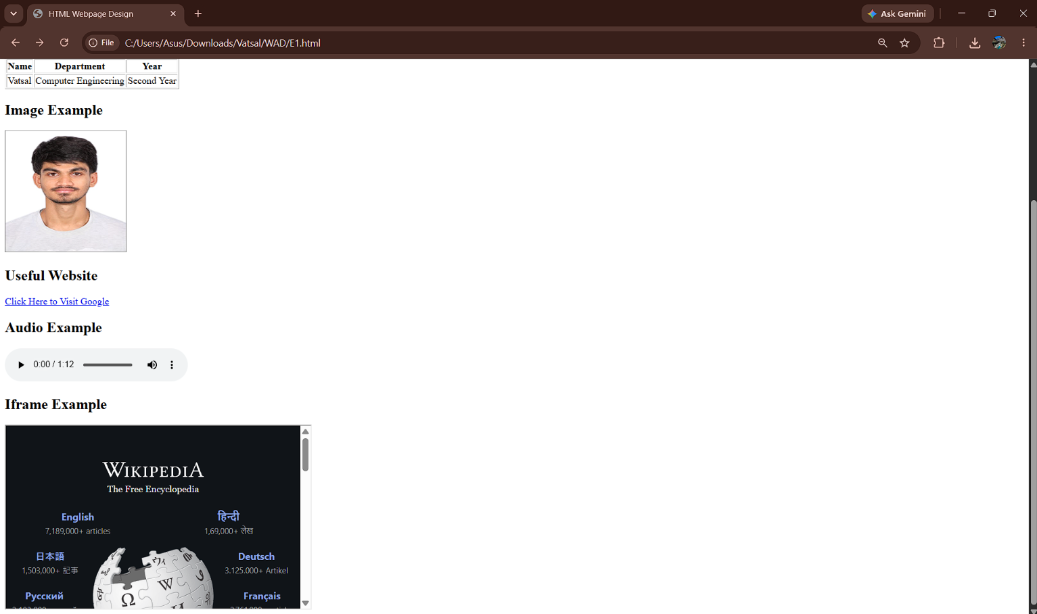

Result
The experiment was successfully completed

