Name of Student: Postiwala Vatsal Dipakbhai | PRN: 26070122509
Subject: Web Application and Development | Sem: III AY: 2026-27
EXPERIMENT No: 10 | Assignment No: 10
TITLE: To write operational database scripts executing basic atomic CRUD transactions (Create, Read, Update, Delete) on specialized user collections.

Objective
To perform CRUD (Create, Read, Update, Delete) operations on a MongoDB collection using mongosh.
Theory
CRUD operations form the core of interacting with any database. In MongoDB: Create uses insertOne()/insertMany(); Read uses find()/findOne() with optional query filters and projections; Update uses updateOne()/updateMany() with update operators like $set, $inc, $unset; Delete uses deleteOne()/deleteMany(). MongoDB queries use a flexible JSON-like syntax supporting comparison operators ($gt, $lt, $in, etc.) and logical operators ($and, $or).
Software / Hardware Requirements
MongoDB installed and running (from Experiment 10), mongosh.
Step-by-Step Procedure
1. Open mongosh and switch to a new database named storeDB.
use storeDB

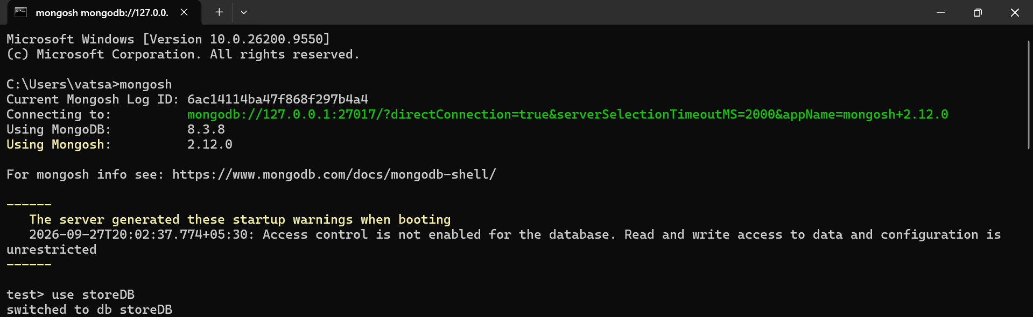
2. Create (insert) multiple product documents into a products collection using insertMany().
db.products.insertMany([
{ name: "Laptop", category: "Electronics", price: 55000, stock: 12 },
{ name: "Mouse", category: "Electronics", price: 500, stock: 100 },
{ name: "Desk Chair", category: "Furniture", price: 4500, stock: 20 },
{ name: "Notebook", category: "Stationery", price: 40, stock: 300 }
])
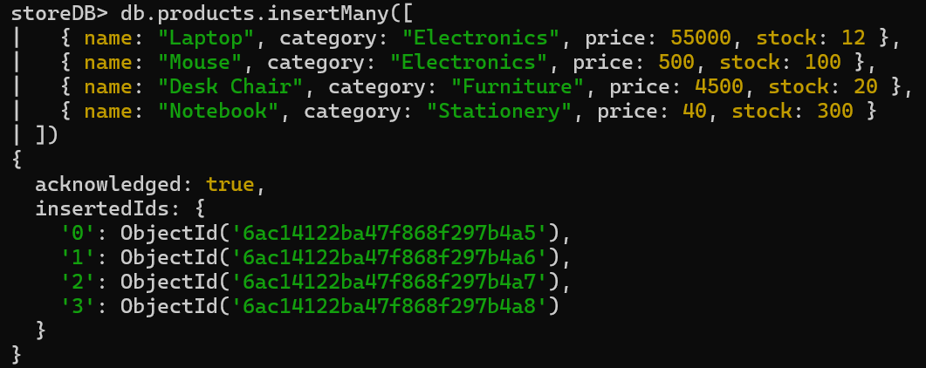
3. Read all documents using find() and pretty-print them.
db.products.find().pretty()

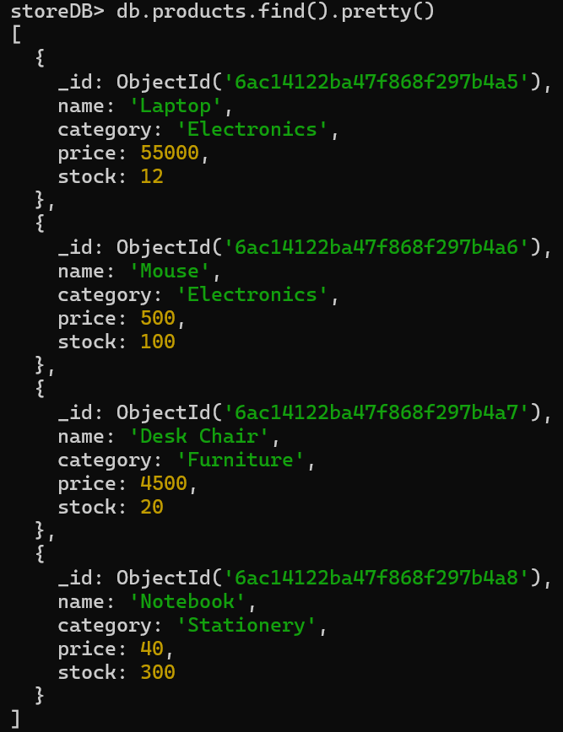
4. Read with a filter: find all products in the 'Electronics' category.
db.products.find({ category: "Electronics" })

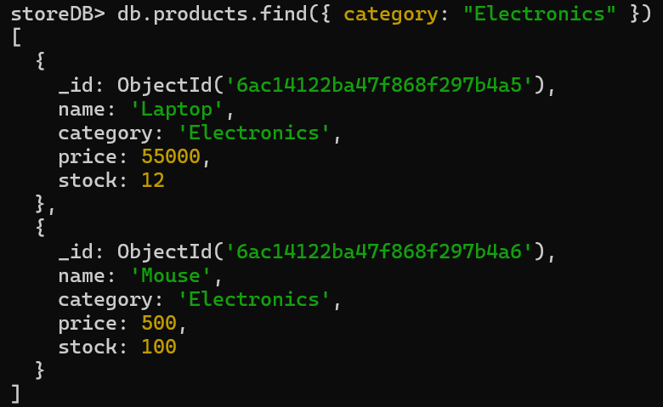
5. Use comparison operators: find all products priced above 1000.
db.products.find({ price: { $gt: 1000 } })

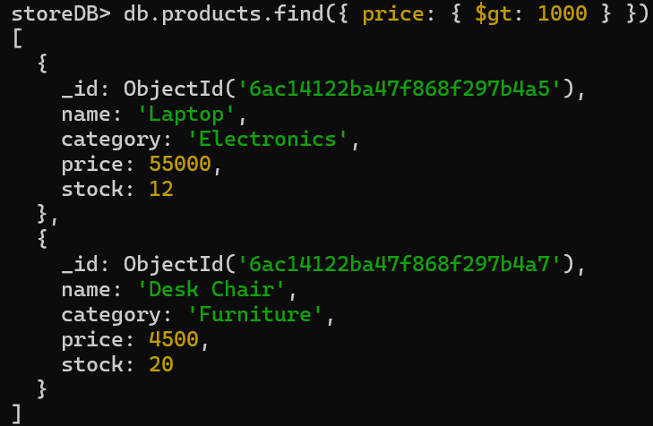
6. Use findOne() to retrieve just a single matching document, and a projection to return only selected fields.
db.products.findOne({ name: "Laptop" }, { name: 1, price: 1, _id: 0 })

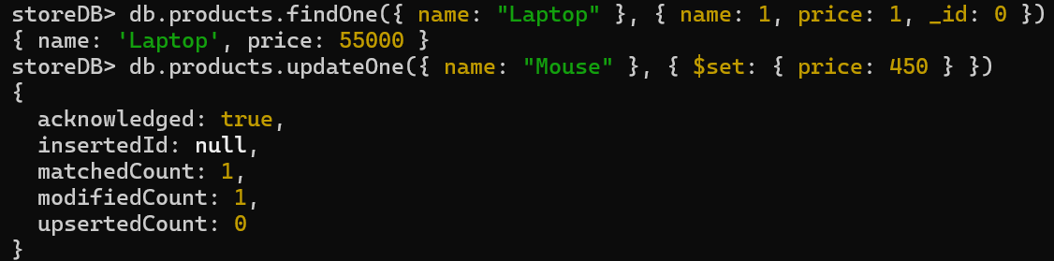
7. Update a single document: reduce the price of 'Mouse' by using the $set operator.
db.products.updateOne({ name: "Mouse" }, { $set: { price: 450 } })

8. Update multiple documents at once: increase stock by 10 for every Electronics item using $inc.
db.products.updateMany({ category: "Electronics" }, { $inc: { stock: 10 } })

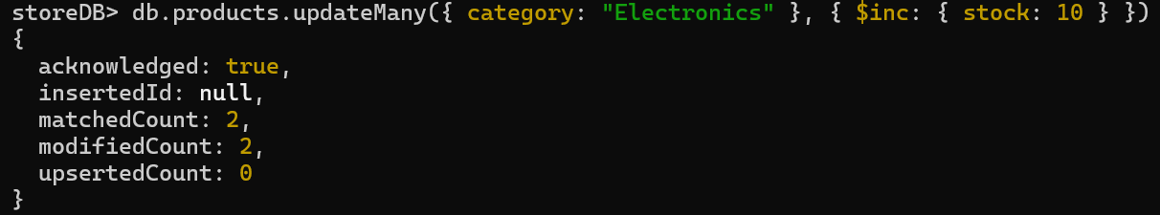
9. Delete a single document: remove the 'Notebook' product.
db.products.deleteOne({ name: "Notebook" })

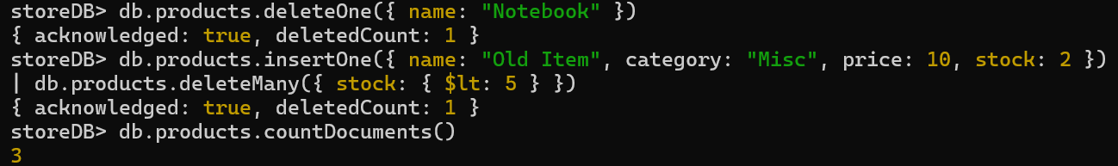
10. Delete multiple documents matching a condition: remove all products with stock less than 5 (first insert one such test document, then delete it).
db.products.insertOne({ name: "Old Item", category: "Misc", price: 10, stock: 2 })
db.products.deleteMany({ stock: { $lt: 5 } })

11. Count total remaining documents in the collection using countDocuments().
db.products.countDocuments()

12. Sort results by price descending and limit to top 2 most expensive products.
db.products.find().sort({ price: -1 }).limit(2)

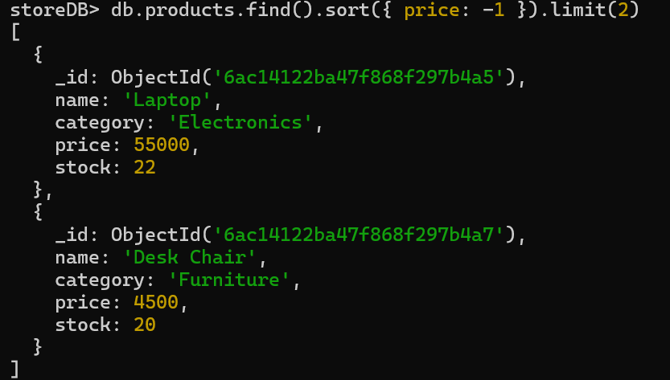

Exercise :
Volkswagen Database (volkswagenDB)
1. Switch Database

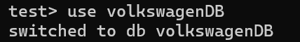

2. Create (Insert Data) Add multiple new cars to the inventory.

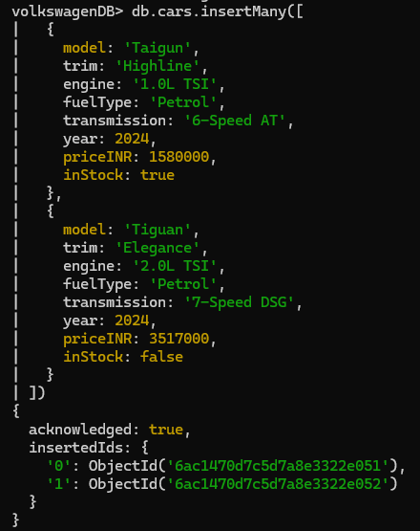

3. Read (Retrieve Data) Find all cars that are currently in stock.

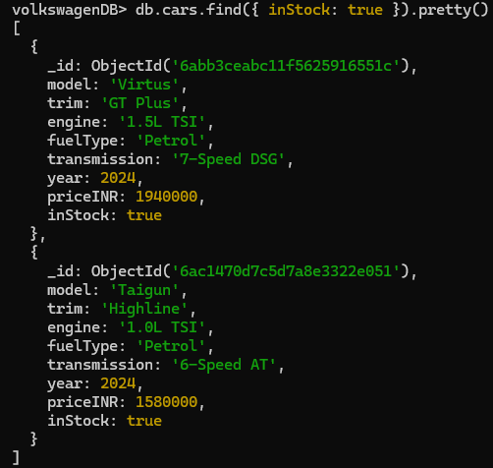
4. Update (Modify Data) Update the price of the 'Virtus' (the document you already had in the database).

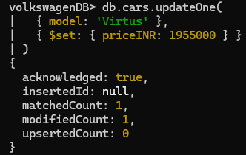

5. Delete (Remove Data) Remove the 'Tiguan' from the database.

Healthcare Database (healthcareDB)
1. Switch Database

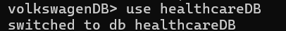

2. Create (Insert Data) Add a new patient record.

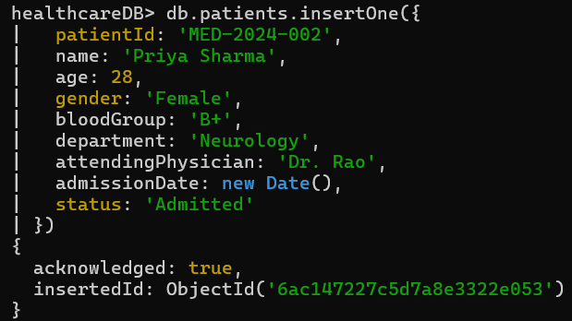

3. Read (Retrieve Data) Find all patients assigned to 'Cardiology'.

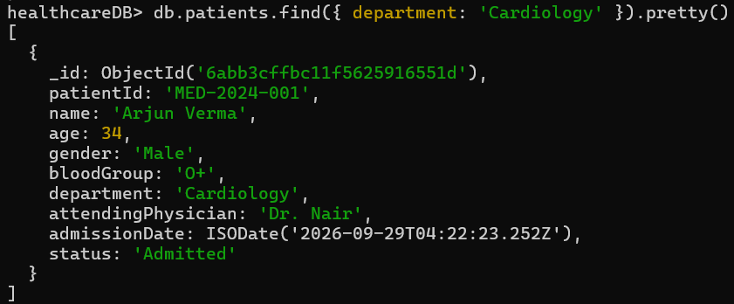

4. Update (Modify Data) Update Arjun Verma's status to 'Discharged'.

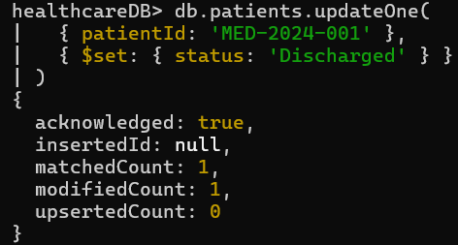

5. Delete (Remove Data) Remove Priya Sharma's record using her specific Patient ID.

