Name of Student: Postiwala Vatsal Dipakbhai | PRN: 26070122509
Subject: Web Application and Development | Sem: III AY: 2026-27
EXPERIMENT No: 12 | Assignment No: 12
TITLE: To understand the basic use of Git, Jenkins, and Apache Tomcat for managing and running a web application.

Task
Create a simple web application and perform the following:
- Create a GitHub repository and upload your application code using Git commands.
- Clone the repository and make one small change to the application.
- Use Jenkins to fetch/check the code from the GitHub repository.
- Install and start Apache Tomcat 8 or above.
- Deploy and run the web application on Tomcat.
- Open the application in a web browser and verify that it is working.
Yes. For a simple student-level assignment, I recommend using a basic HTML web application and deploying it on Tomcat as a WAR file. This avoids unnecessary Java/JSP complexity while still demonstrating Git, GitHub, Jenkins, and Tomcat.

- Create a folder :
D:\SIT\WAD\E12\GitJenkinsTomcat\MyWebApp
- Initialize Git
git init
- Now tell Git to track your file:
git add .

then
git commit -m "Initial web application"
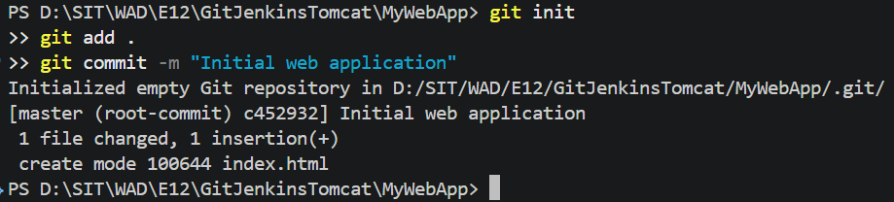

Now, Create GitHub Repository
Go to: GitHub
Login. Click: + → New repository
Give repository name: MyWebApp
Select: Public.
Connect your local project to GitHub
On your computer, on the command prompt:
git remote add origin https://github.com/vatsalposty01/MyWebApp.git
git branch -M main
Then:
git push -u origin main
GitHub may ask you to sign in.
After successful upload, refresh your GitHub repository.
You should see:
index.html
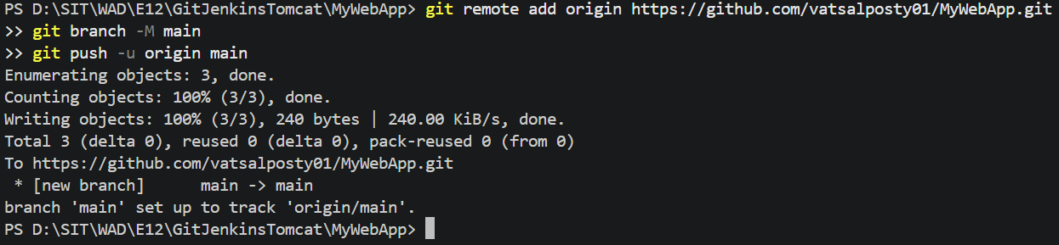

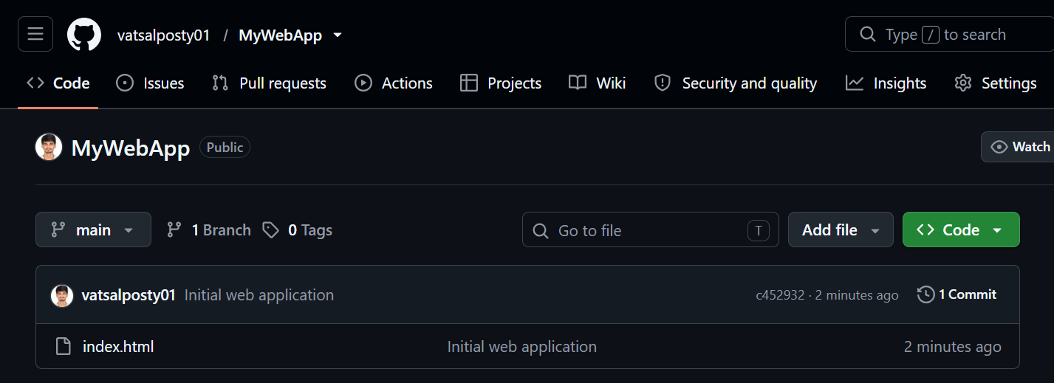

Now, lets Clone the repository
Go to your Desktop.
Open Command Prompt.
Now clone your GitHub repository:
git clone https://github.com/vatsalposty01/MyWebApp.git
You will get a new folder:
Desktop
│
└── MyWebApp
│
└── index.html

Open index.html in the original folder and make a small change into it.
Open Command Prompt in the MyWebApp folder.
git add .
git commit -m "Updated application title"
git push
Now refresh GitHub.
The updated code will be visible there.
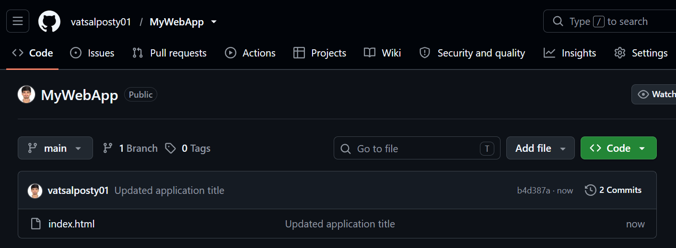

Install Jenkins
Download Jenkins from the official Jenkins website:
Jenkins
Install Jenkins using the normal/default options.
During installation, Jenkins will ask for Java/JDK. (install jdk 25 from https://www.oracle.com/in/java/technologies/downloads/#jdk25-windows)
Make sure Java is installed.
After installation, Jenkins normally runs at:
http://localhost:8080
Open Jenkins
You will see the Jenkins login/unlock screen.
Jenkins may ask for an Administrator Password during first setup.
The password is normally stored in a file similar to:
C:\ProgramData\Jenkins\.jenkins\secrets\initialAdminPassword
Open that file and copy the password.
Paste it into Jenkins.
Select:
Install suggested plugins
Wait for installation.
Create your Jenkins user.

Create a Jenkins Job
In Jenkins:
Click:
New Item
Enter:
MyWebApp

Select:
Freestyle project
Click:
OK

Tell Jenkins where the GitHub code is
In the Jenkins job:
Find:
Source Code Management
Select:
Git
In Repository URL enter add: https://github.com/vatsalposty01/MyWebApp.git
If your repository is public, you generally don't need credentials.
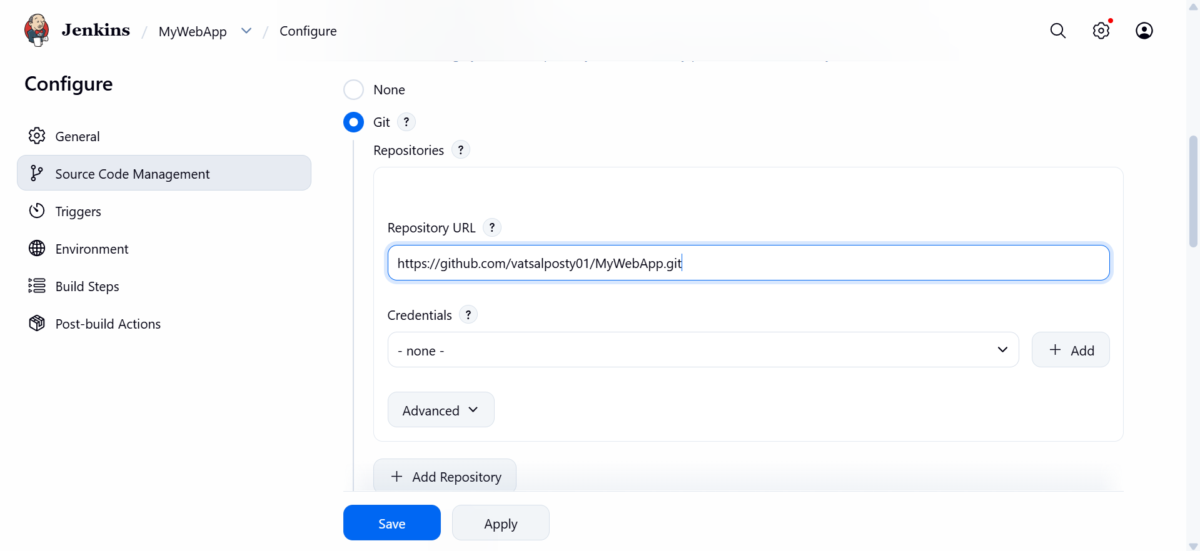
Click:
Save

Run Jenkins
Open your Jenkins project:
MyWebApp
Click:
Build Now
Jenkins will download/check the code from GitHub.
On the left side you will see something like:
Build #1
Click:
Build #1 → Console Output
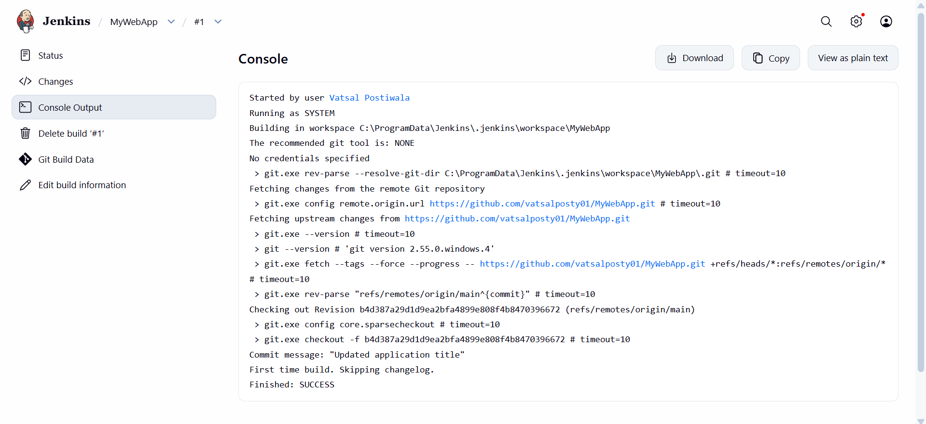
You should see messages indicating that Jenkins cloned/fetched the Git repository.
This completes:
Use Jenkins to fetch/check the code from the GitHub repository.

Install Apache Tomcat
Download Tomcat from the official Apache Tomcat website:
Apache Tomcat
For this assignment, I recommend:
Tomcat 9
Download the Windows zip version.
For example:
apache-tomcat-9.x.x.zip
Extract it.
You can put it here:
C:\Tomcat
So you have:
C:\Tomcat
│
├── bin
├── conf
├── lib
├── logs
├── webapps
└── ...
Start Tomcat
Go to Tomcat folder
Open conf
Find server.xml
Open it with notepad
Search for Connector port=”8080”
Change 8080 to 8081
Go to
C:\Tomcat\bin
You will see:
startup.bat
Double-click:
startup.bat
A command window will appear.
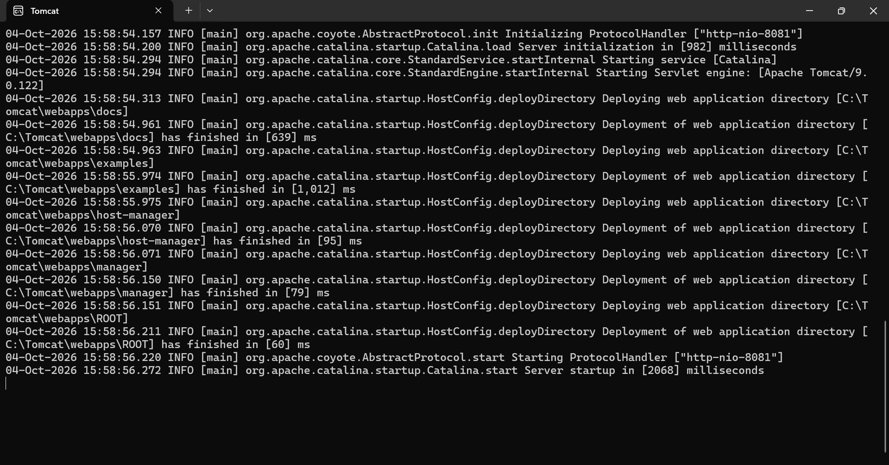
Now open Chrome:
http://localhost:8081
If Tomcat is running, you should see the Tomcat welcome page.
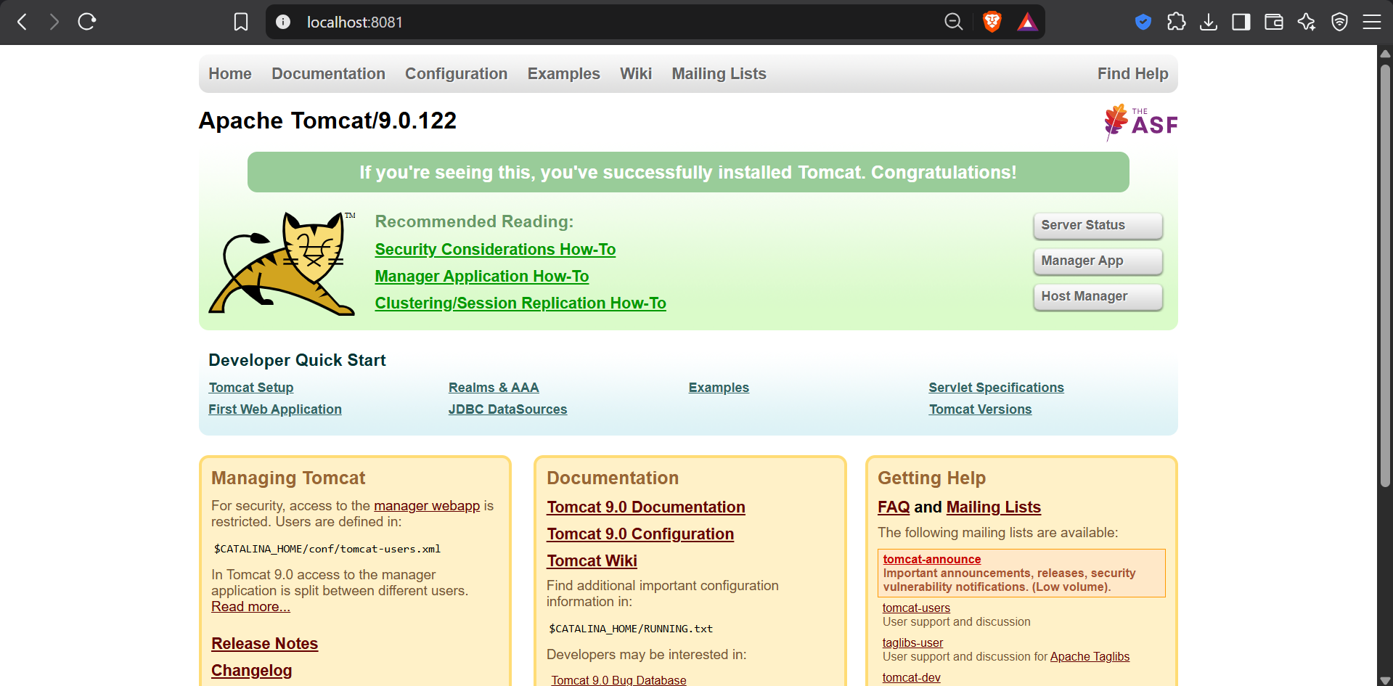
In case issues are there then check go to command prompt and
java -–version
you should get java version with this.
Again go to command prompt and write
Get-Command java | Select-Object Source
And then
java -XshowSettings:properties -version 2>&1 | Select-String “java.home”
you will get path of jdk
then copy that path and write
$env:JAVA_HOME= the copied path of jdk folder
Again run the startup.bat file in the bin folder of Tomcat by
.\startup.bat
This will start the Tomcat server

Deploy your application
This is the easiest part.
Go to:
C:\Tomcat\webapps
Create a folder:
MyWebApp
Put your:
index.html
inside it.
So the structure becomes:
C:\Tomcat\webapps\MyWebApp
│
└── index.html
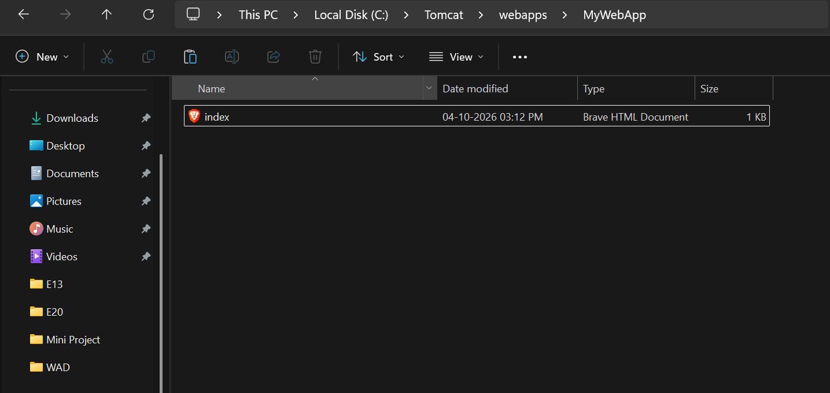

Now execute the application with:
http://localhost:8081/MyWebApp/
