Experiment 4

Aim

To apply UI design principles and create reusable components using Figma components and libraries.

Learning Objectives

Students will learn:

- Basic UI design principles.
- Component creation.
- Asset management.
- Reusing design elements.

Software Requirements
- Figma

Theory

UI Design Principles
- Consistency

Maintaining similar colors, fonts, and layouts throughout an application.

- Alignment

Arranging elements properly to improve readability.

- Hierarchy

Highlighting important information using size and placement.

- Simplicity

Creating clean and easy-to-use interfaces.

Procedure

Step 1: Set Up the Canvas and Frames
- Create a new file in Figma.
- Draw two identical rectangular frames on the canvas.
- In the Layers panel on the left, name the first frame front-card and the second frame back-card.
- Select both frames and apply a dark navy blue background color with rounded corners.

Step 2: Design the Front Card Typography
- In the front-card frame, add the main title text "MAA MODHESHWARI" in a bold, yellow font at the top left.
- Add the subtitle "TRAVELS" directly below it in a smaller yellow font.
- At the bottom left, add a "SERVICES" heading in yellow.
- Below the heading, add the service details in white text: "Service: AC & Non-AC Cars, Tempo Travellers, and Buses available on rent. Bombay Airport Dropping & Pickup".
- Below the services text, add an "ADDRESS" heading in yellow, followed by the white text: "Add. 2/A Raghuvir Socity , Opp Old Bombay Market , Surat , Gujarat - 395010".

Step 3: Add Front Card Contact Info and Graphics
- Create a pill-shaped button at the top right of the front-card using a yellow stroke outline.
- Inside the button, add a small user icon and the text "Proprietor" in yellow.
- On the left side (above the services section), create a square with a white background and rounded corners to hold the "MAA MODHESHWARI TRAVELS" logo.
- To the right of the logo, add the name "Dipakbhai Postiwala" in bold white text.
- Below the name, create three stacked rows for contact details, using yellow icons for a phone, an envelope, and the Instagram logo.
- Add the corresponding white text next to each icon: "+91 9624742600", "maamodheshwaritravels66@gmail.com", and "maa_modheshwari_travels".

Step 4: Design the Back Card
- Copy the "MAA MODHESHWARI TRAVELS" header block from the front card and paste it at the top left of the back-card.
- Create a pill-shaped button at the top right with a yellow stroke outline, containing a QR icon and the text "SCAN".
- In the upper center of the card, place a multicolored "Google" text logo, with the text "Check us out on Google" in yellow immediately below it.
- In the center of the card, create a large rectangle with a slightly lighter blue background and rounded corners to act as a container.
- Inside this container, place a white square featuring another Google logo, the text "Check us out on Google", and a scannable QR code.
- At the bottom of the central blue container, add the yellow text "SCAN TO FIND US" and the white text "Maa Modheshwari Travels - Surat".

Output :

A UI design containing:
- Front card component
- Back card component
- Reusable UI elements (such as the contact icons, QR code block, and pill-shaped buttons)

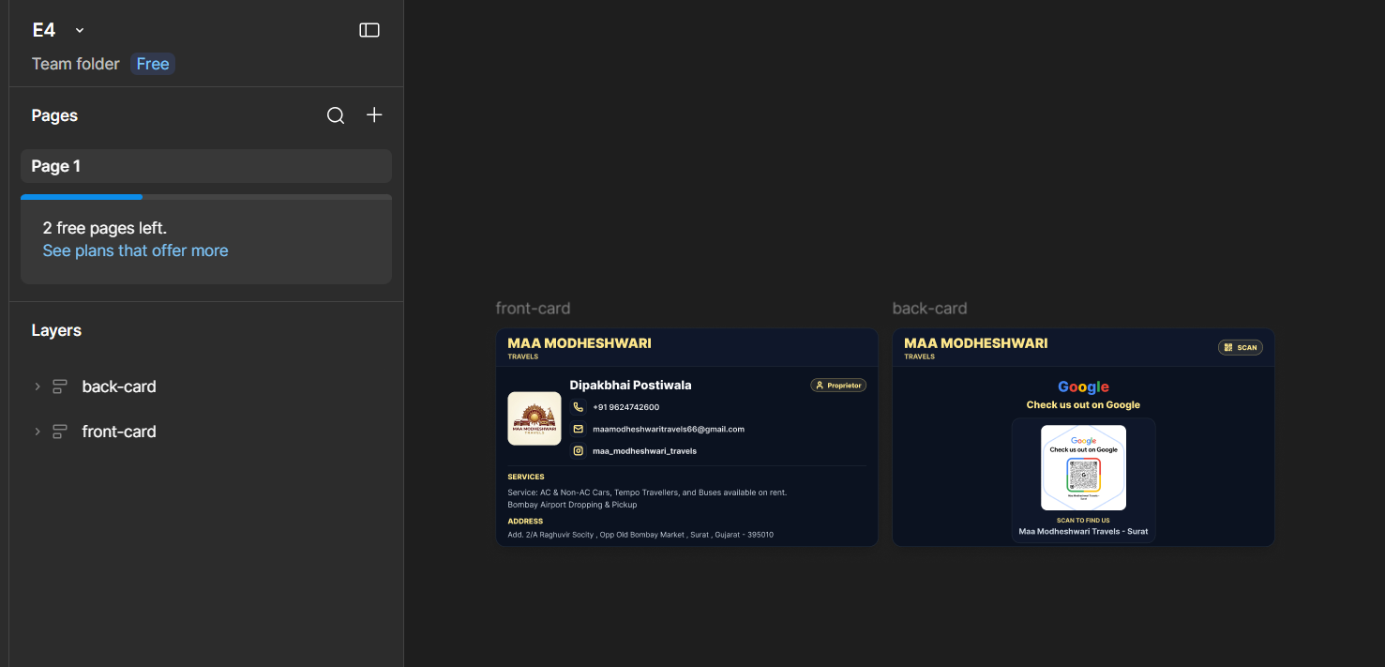

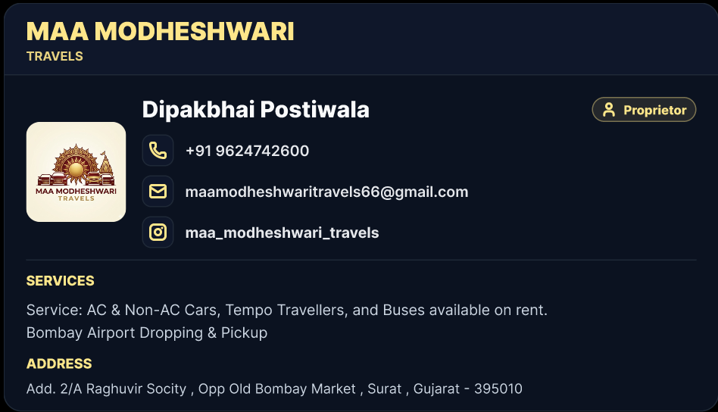
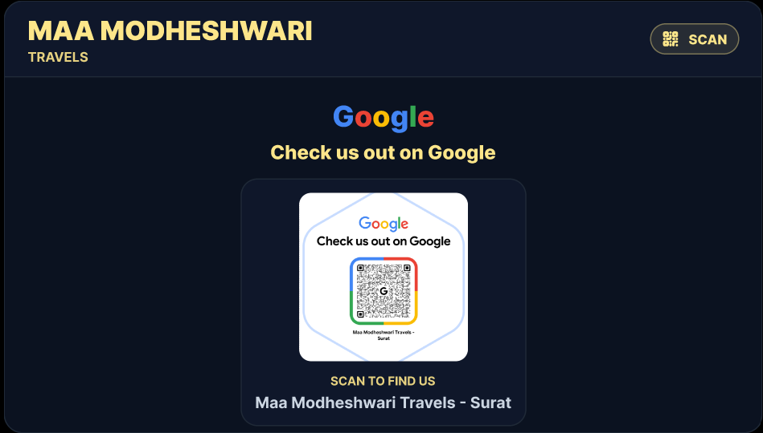

Result
The experiment was successfully completed.

