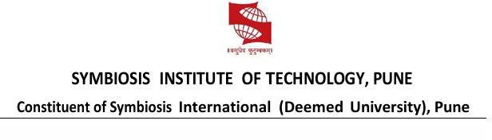

Name of Student: Postiwala Vatsal Dipakbhai | PRN: 26070122509
Subject: Web Application and Development | Sem: III AY: 2026-27
EXPERIMENT No: 5 | Assignment No: 5
TITLE: Creating an Interactive Prototype using Figma with Transitions, Animations, and Interactive States

Aim: To develop a functional high-fidelity interactive user prototype in Figma featuring micro-animations, active state changes, and live peer comments.

Learning Objectives:
Students will be able to:
- To understand the purpose and workflow of Figma's Prototype mode as distinct from Design mode.
- To learn how to create and organize multiple interconnected screens (e.g., a Login screen and a Home screen) intended for a single user flow.
- To understand how prototype connections (interactions) are created between elements using triggers, actions, and destinations.
- To learn how to configure a trigger (On Click, On Drag, While Hovering, After Delay, etc.) and pair it with an action such as Navigate To, Open Overlay, Swap State, or Scroll To.
- To understand and apply animations — instant transitions, Smart Animate, and directional movements such as Ease In, Ease Out, Slide In, and Push — and how each affects perceived interactivity.
- To learn how interactive/component states (default, hover, pressed) can be used to make elements like buttons feel responsive.
- To gain hands-on experience testing a working prototype using Figma's Present mode.
- To learn how to share an interactive prototype with others using a shareable link for feedback and review.

Tools Required:

Software Required

Figma (web or desktop app)

A modern browser — Chrome recommended for best performance

Hardware Required

Laptop or desktop (Windows/macOS/Linux)

4GB+ RAM (8GB recommended)

Stable internet connection (Figma is cloud-based)

Mouse preferred over trackpad for precise interaction mapping

Resources Required

Figma account (free plan works)

Pre-designed screens (products, product-detail, and cart) with basic e-commerce UI elements

Sample product images, descriptions, and pricing content

Icon set and standardized buttons ("View Details", "Add to Cart", "Checkout")

Project Structure

Interactive Prototype UI Design │

├── products (Screen 1)

├── product-detail (Screen 2)

├── cart (Screen 3) └── Prototype Connections

Theory

Figma's Prototype mode extends static design into a simulated, clickable experience. While Design mode is used to build the visual layout of individual screens, Prototype mode is used to define how those screens behave and connect to one another, allowing designers and stakeholders to click through a design as if it were a real, functioning application — without writing a single line of code.

Prototyping vs. Wireframing/Mockup: A wireframe defines structure and a mockup defines visual appearance, but neither is interactive on its own. Prototyping is the next stage in the design workflow — it takes finished (or near-finished) screens and links them together with defined behaviors, turning a set of static images into a navigable flow. This allows usability issues to be identified and corrected before any development work begins, saving significant time and cost.

Core prototyping concepts used:

Trigger: The event that starts an interaction, such as On Click, On Drag, While Hovering, etc. In this experiment, On Click was used on the action buttons.

Action: What happens when the trigger fires. Navigate To was used to move sequentially between the e-commerce screens.

Destination: The target frame/screen the interaction leads to (e.g., clicking "View Details" targets the product-detail frame).

Animation: Defines how the transition between screens visually occurs.

Smart Animate: An intelligent animation type that automatically interpolates matching layers between two frames, producing smooth, natural-looking transitions.

Easing: Governs the speed curve of an animation over time, such as Ease In or Ease Out.

Present Mode: Figma's built-in viewer that runs the prototype in a browser window, allowing the designer (or a reviewer) to click through the flow exactly as an end-user would.

Design workflow followed: Three static screens — products, product-detail, and cart — were first laid out with their respective UI elements. These were then linked in Prototype mode by drawing interactions from the "View Details" buttons to the product page, from the "Add to Cart" button to the cart page, and from the "Checkout" button back to the main products page. The triggers were configured as On Click with Navigate To actions.

Procedure

Open the existing Figma file (or create a new one) and ensure the required screens are ready on the canvas.

Create Screen 1 — products: Add a header, a page title ("Our Products"), and four product cards containing images, titles, prices, and blue "View Details" buttons arranged within a single frame.

Create Screen 2 — product-detail: Add a large product image, specific item details (price, description), and a green "Add to Cart" button within a second frame.

Create Screen 3 — cart: Add a "Your Cart" title, an item row with a quantity selector, an order total, and a blue "Checkout" button within a third frame.

Select the first screen (products) and switch to the Prototype tab in the right-hand panel to enable Prototype mode.

Select the "View Details" button elements on the products page.

Drag the blue connection arrows (nodes) from the edges of the "View Details" buttons to the product-detail frame to create the first set of interactions.

Select the "Add to Cart" button on the product-detail page and drag the connection arrow to the cart frame.

Select the "Checkout" button on the cart page and drag the connection arrow back to the original products frame to complete the loop.

In the interaction settings panel for each connection, configure: Trigger — On Click; Action — Navigate To; Destination — (Target Frame).

Set the Animation to Smart Animate (or standard instant/slide transitions) so that the screens transition smoothly.

Click the Present (▶) button to launch Present mode and test the prototype by clicking through the shopping flow.

Verify that the transitions flow logically from product selection to cart and back to the store.

Click Share → Copy Link to generate a shareable prototype link for feedback and review.

Output

Interactive prototype containing:

Multiple linked e-commerce screens (products, product-detail, and cart)

Functional button interactions (On Click applied to "View Details", "Add to Cart", and "Checkout")

A multi-step continuous screen transition loop

Output Screenshots:

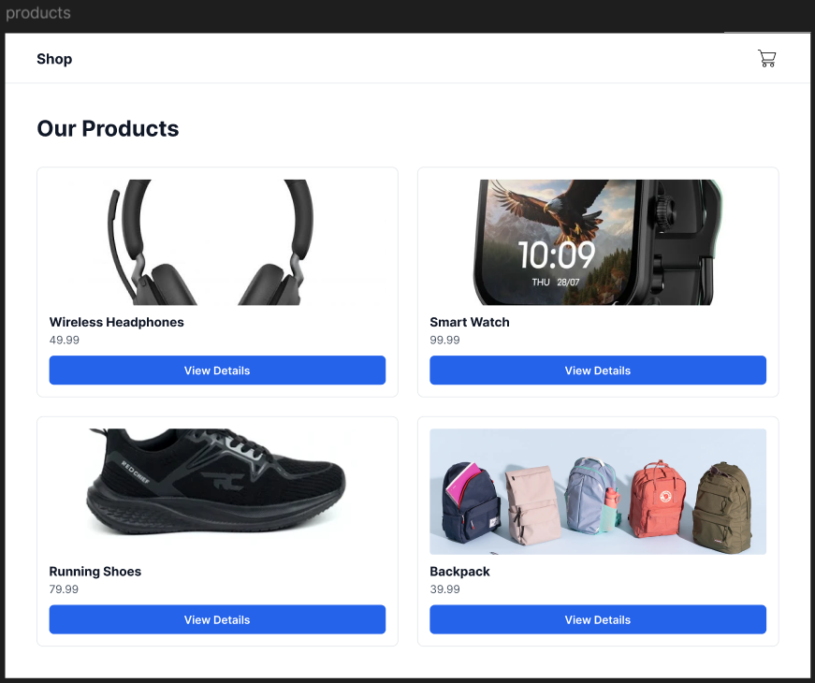
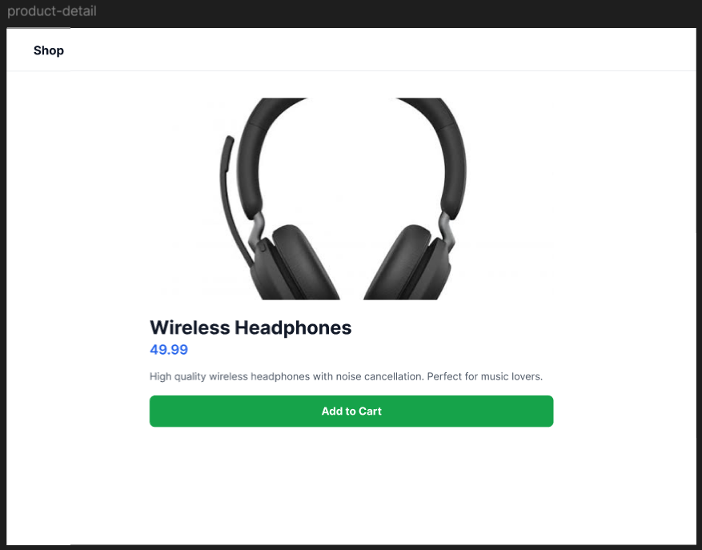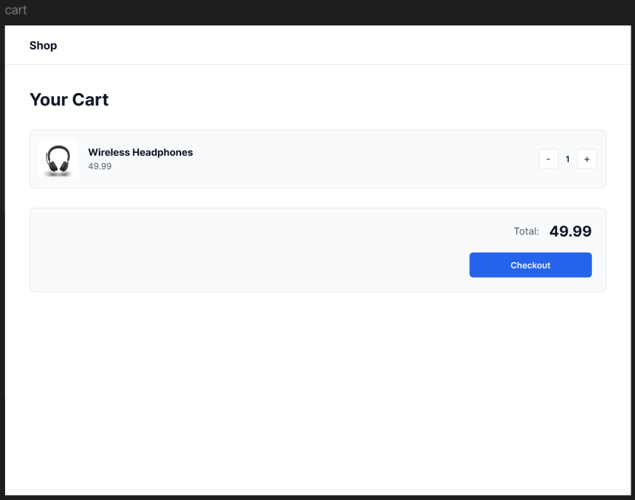

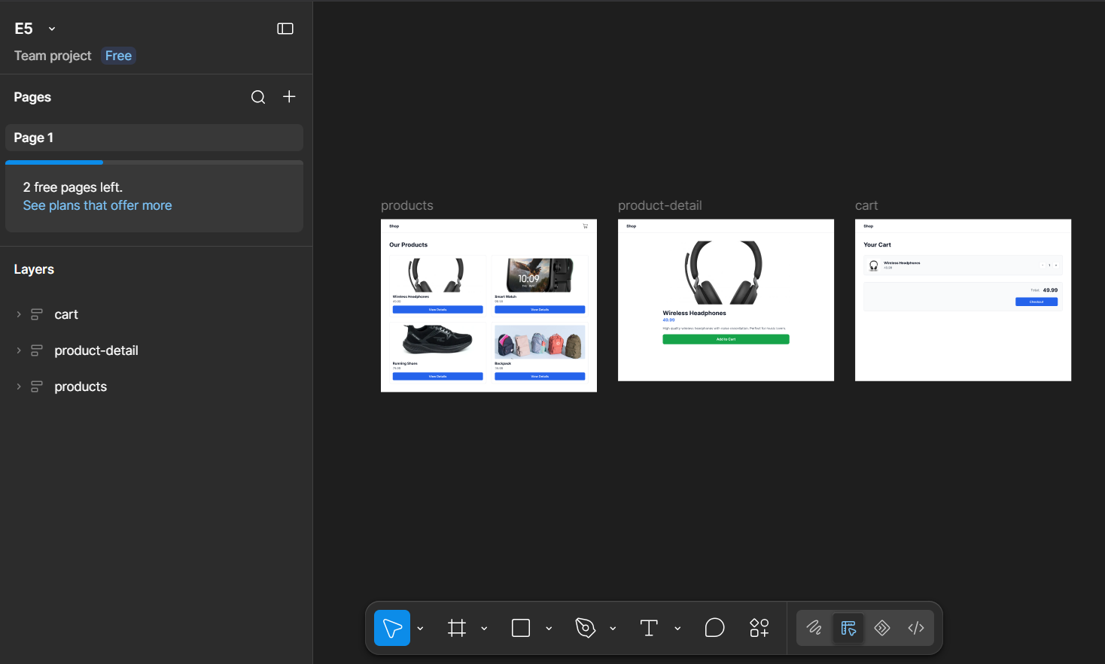

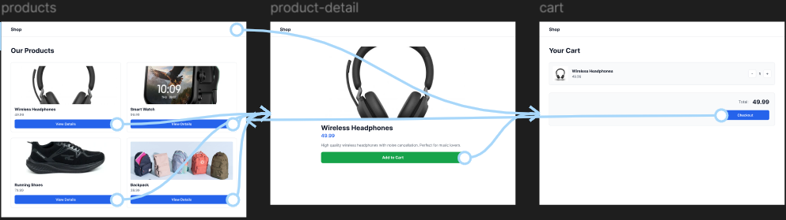

SHAREABLE LINK : https://www.figma.com/proto/4uRbXMsdz0sIIewMb3axOh/E5?node-id=4-6&p=f&t=u0WfYqoSmar00EBA-1&scaling=min-zoom&content-scaling=fixed&page-id=0%3A1&starting-point-node-id=4%3A6

Result

An interactive prototype was successfully created in Figma by connecting the products, product-detail, and cart screens into a complete shopping flow. The action buttons ("View Details", "Add to Cart", and "Checkout") were configured with On Click triggers, Navigate To actions, and Smart Animate transitions with appropriate easing, producing smooth and natural screen changes between each stage. The prototype was tested using Present mode, where clicking through the product selection and checkout process correctly navigated between the screens with the intended animations, and the completed multi-screen flow was shared via a Figma prototype link for review.

Conclusion
Through this experiment, Figma's Prototype mode was explored to convert static, designed screens into an interactive and testable user flow. The process of creating triggers, actions, and destinations demonstrated how designers can simulate real application behavior without writing code, while the use of Smart Animate and easing options showed how thoughtful motion design improves the perceived quality and usability of an interface. This experiment reinforced the importance of prototyping as a bridge between design and development, enabling usability validation, stakeholder feedback, and iterative refinement early in the product design lifecycle.

