Name of Student: Postiwala Vatsal Dipakbhai | PRN: 26070122509
Subject: Web Application and Development | Sem: III AY: 2026-27
EXPERIMENT No: 6 | Assignment No: 6
TITLE: To write client-side JavaScript components executing rigorous input validation.

Learning Objectives

After completing this experiment, students will be able to:

- Understand JavaScript syntax and programming concepts.
- Handle browser events.
- Manipulate HTML elements using DOM.
- Validate user input.
- Implement secure form handling.

Software Requirements

- Visual Studio Code
- Google Chrome Browser
- Live Server Extension

Theory

JavaScript

JavaScript is a client-side scripting language used to create dynamic and interactive webpages. JavaScript can perform:
- Form validation
- Event handling
- Dynamic content updates
- Calculations
- DOM manipulation

Project Structure Create a folder: JavaScript_Practical
├── index.html
│
└── script.js

Procedure

Step 1: Create HTML File

Create:

index.html

Add the following code:

<!DOCTYPE html>
<html>

<head>
<title>
JavaScript Form Validation
</title>

</head>

<body>

<h1>
Student Registration Form
</h1>

<form onsubmit="return validateForm()">

<label> Name:
</label>

<input type="text" id="name">

<br><br>

<label> Email:
</label>

<input type="text" id="email">

<br><br>

<label>
Mobile Number:
</label>

<input type="text" id="mobile">

<br><br>

<button type="submit"> Submit
</button>

</form>

<p id="message"></p>

<script src="script.js"></script>

</body>

</html>

Step 2: Create JavaScript File

Create:

script.js

Add:

function validateForm() {

let name = document.getElementById("name").value;

let email = document.getElementById("email").value;

let mobile = document.getElementById("mobile").value;

let namePattern = /^[a-zA-Z\s]+$/;

let emailPattern = /^[^\s@]+@[^\s@]+\.[^\s@]+$/;

let mobilePattern = /^[0-9]{10}$/;

if (!namePattern.test(name)) {
alert("Name cannot be empty and must contain only letters"); return false;
}

if (!emailPattern.test(email)) {

alert("Email cannot be empty and Enter valid email"); return false;
}

if (!mobilePattern.test(mobile)) {
alert("mobile number cannot be empty and Enter valid mobile number"); return false;
}

document.getElementById("message").innerHTML = "Form Submitted Successfully";

return false;
}

Step 3: Execute Program
- Open index.html.
- Right-click.
- Select:

Open with Live Server

- Enter student details.
- Click Submit.

Output

The webpage displays:

  - Registration form
  - Validation messages
  - Successful submission message

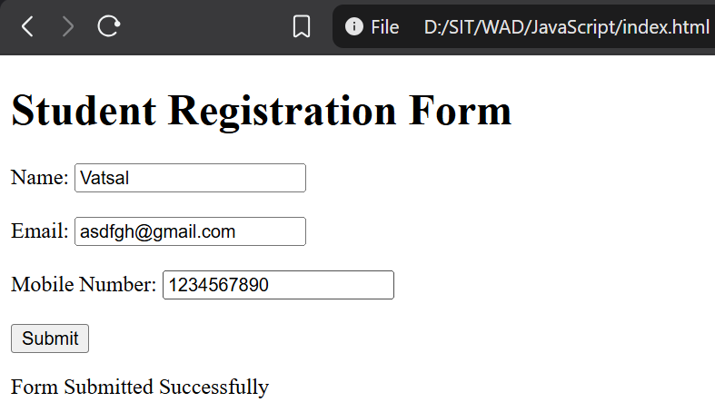

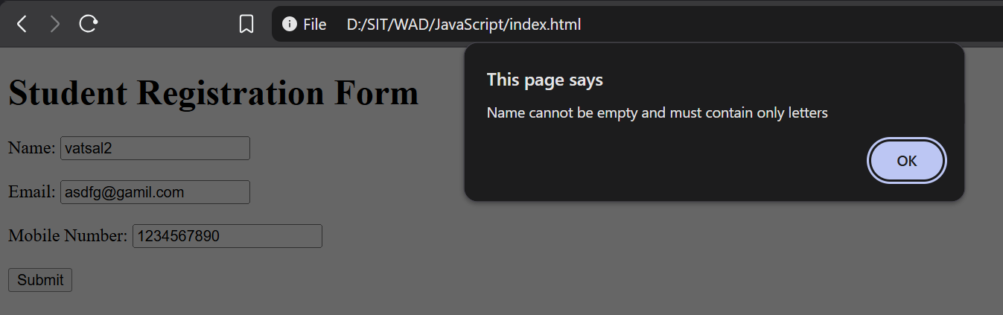

Result
The experiment was successfully completed.

Conclusion
learned how to effectively integrate JavaScript with HTML to build an interactive student registration form. Through this experiment, I gained practical experience in handling browser events, manipulating the Document Object Model (DOM) to retrieve user inputs, and applying Regular Expressions (Regex) to strictly validate data formats for names, emails, and mobile numbers. Ultimately, I now understand how to intercept form submissions to prevent invalid data entry and provide immediate, dynamic feedback to the user, ensuring better data integrity and user experience.

