Name of Student: Postiwala Vatsal Dipakbhai | PRN: 26070122509
Subject: Web Application and Development | Sem: III AY: 2026-27
EXPERIMENT No: 7 | Assignment No: 7
TITLE: To implement a backend server-side web application using Node.js incorporating modular architecture patterns and the native network HTTP module.

Objective
To install Node.js, understand its module system (built-in, local and npm modules), and build a basic multi-route web server using the core http module.
Theory
Node.js is a JavaScript runtime built on Chrome's V8 engine that allows JavaScript to run outside the browser, enabling server-side development. It uses a single-threaded, event-driven, non-blocking I/O model, making it efficient for I/O-heavy applications. Node's module system lets code be split into reusable files: built-in modules (http, fs, url, events, os, path) are available without installation; local modules are files you create and export via module.exports; npm modules are third-party packages installed via npm install. The http module's createServer() lets you build a raw web server that listens on a port and responds based on the request's method and URL.
Software / Hardware Requirements
Node.js LTS installed (verify with node -v and npm -v in terminal), VS Code.
Step-by-Step Procedure
1. Verify Node.js installation: open a terminal and run node -v and npm -v. If not installed, download the LTS installer from nodejs.org and install it.
2. Create a project folder lab7_node and initialize it as an npm project.
mkdir lab7_node && cd lab7_node
npm init -y

3. Create a file math.js as a local module exporting simple utility functions, to demonstrate the local module system.
// math.js
function add(a, b) { return a + b; }
function square(a) { return a * a; }
module.exports = { add, square };

4. Create index.js and require both a built-in module (os) and your local module (math.js) to print some info to the console, confirming the module system works.
// index.js
const os = require('os');
const math = require('./math');

console.log('Platform:', os.platform());
console.log('CPU Cores:', os.cpus().length);
console.log('2 + 3 =', math.add(2, 3));
console.log('4 squared =', math.square(4));

5. Run node index.js and verify console output shows platform info and the math results.
6. Now build the HTTP server. Require the built-in http module and use http.createServer() with a request listener that inspects req.url.
// server.js
const http = require('http');

const server = http.createServer((req, res) => {
res.setHeader('Content-Type', 'text/html');

if (req.url === '/') {
res.statusCode = 200;
res.end('<h1>Home Page</h1><p>Welcome to my Node.js server</p>');
} else if (req.url === '/about') {
res.statusCode = 200;
res.end('<h1>About Page</h1><p>This server demonstrates the HTTP module.</p>');
} else if (req.url === '/contact') {
res.statusCode = 200;
res.end('<h1>Contact Page</h1><p>Email: student@example.com</p>');
} else {
res.statusCode = 404;
res.end('<h1>404 - Page Not Found</h1>');
}
});

const PORT = 3000;
server.listen(PORT, () => console.log('Server running at http://localhost:' + PORT));

7. Run the server with node server.js and, in a browser, visit http://localhost:3000/, /about, /contact and a non-existent route (e.g. /xyz) to confirm each responds correctly, including the 404 handler.
8. Modify the server to differentiate HTTP methods: check req.method so a GET on / returns the home page while any other method returns a 405 'Method Not Allowed' status.
if (req.url === '/' && req.method === 'GET') {
res.statusCode = 200;
res.end('<h1>Home Page (GET)</h1>');
} else if (req.method !== 'GET') {
res.statusCode = 405;
res.end('Method Not Allowed');
}

9. Stop the server (Ctrl+C) and add nodemon as a dev dependency to auto-restart the server on file changes; update package.json's scripts.
npm install --save-dev nodemon

"scripts": { "start": "node server.js", "dev": "nodemon server.js" }

10. Run npm run dev, edit a route's message in server.js, save, and observe nodemon automatically restart the server without manually re-running node.

Output:
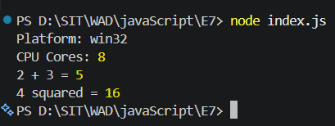
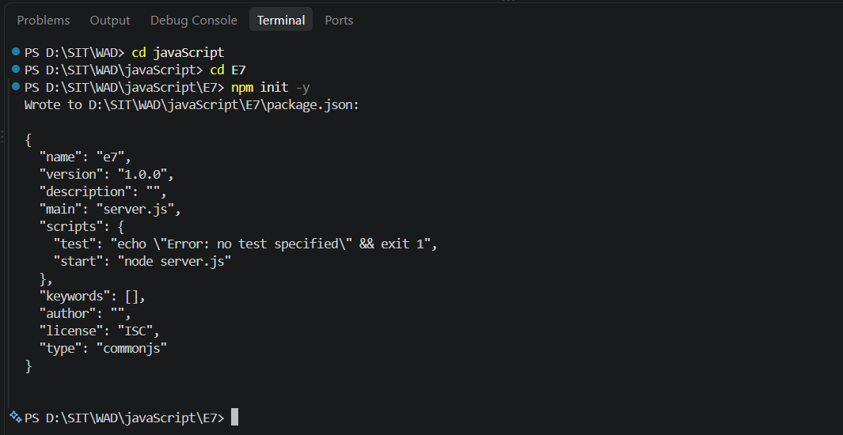
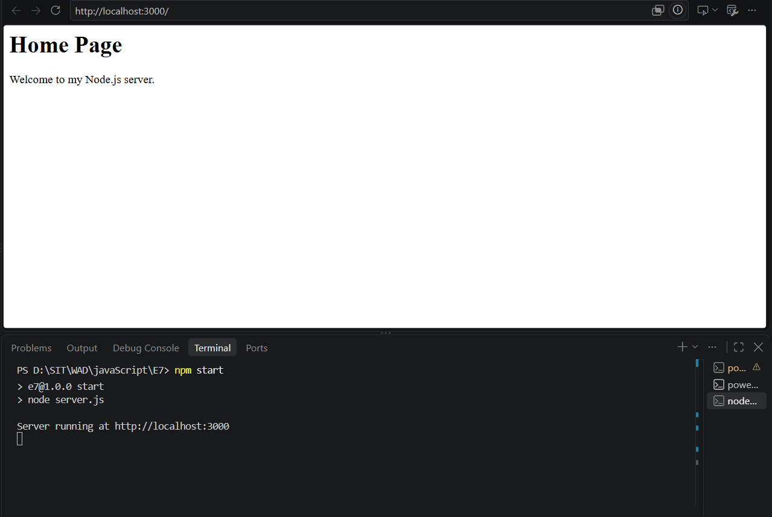
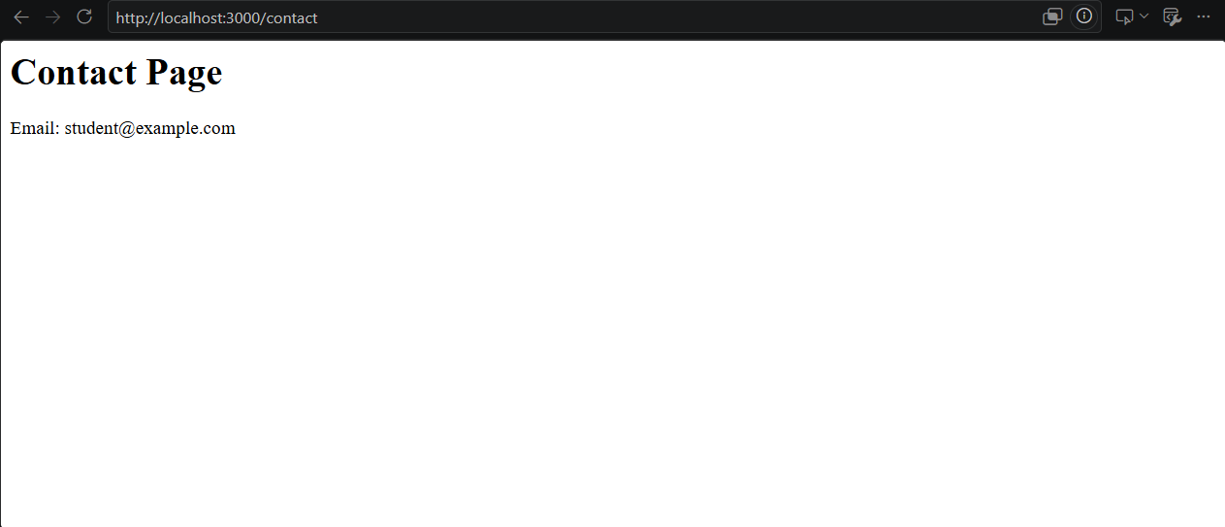
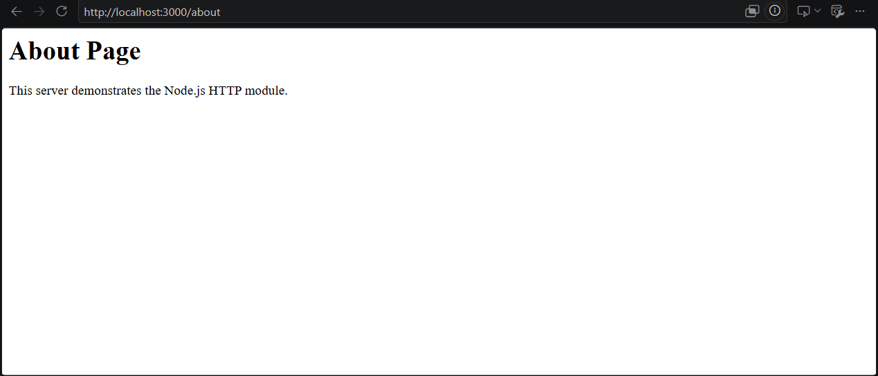
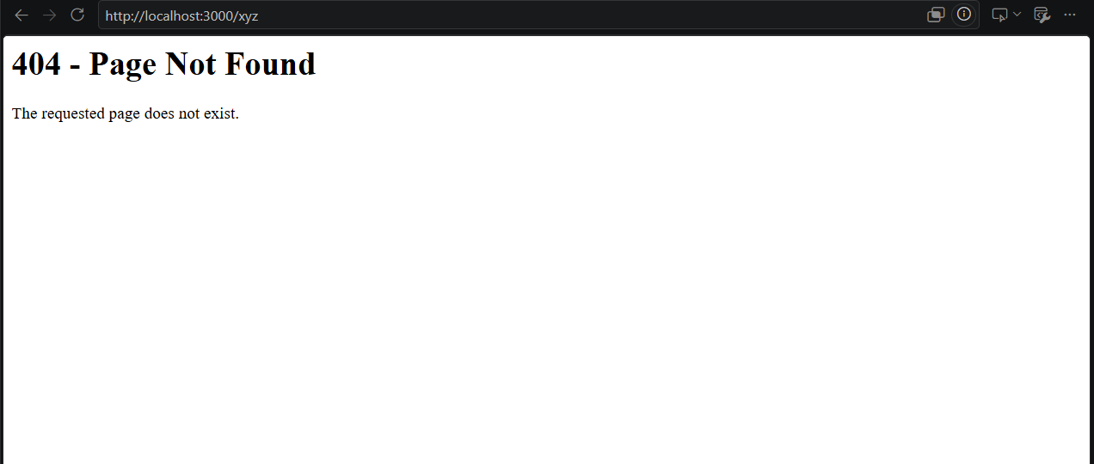

Hands-on Assignment
- Create a local module named greetings.js exporting at least 3 functions (e.g. morningGreeting, eveningGreeting, formatName) and use them inside your HTTP server responses.
- Extend the server to serve at least 5 distinct routes (Home, About, Contact, Services, 404) each returning a distinct styled HTML fragment (inline <style> is fine).
- Add a /time route that responds with the current server date and time (use the built-in Date object), and a /random route that returns a random number between 1 and 100 on every request.
- Use the os module to build a /server-info route that displays the platform, total memory, and free memory of the host machine in a formatted HTML table.
greetings.js
function morningGreeting() {
return "Good Morning! Welcome to our Node.js application.";
}

function eveningGreeting() {
return "Good Evening! Thank you for visiting our Node.js application.";
}

function formatName(firstName, lastName) {
return `${firstName} ${lastName}`;
}

module.exports = {
morningGreeting,
eveningGreeting,
formatName
};

hands_on_server.js
const http = require('http');
const os = require('os');
const greetings = require('./greetings');

const PORT = 3001;

const server = http.createServer((req, res) => {

res.setHeader('Content-Type', 'text/html');

// HOME ROUTE
if (req.url === '/') {

res.statusCode = 200;

res.end(`
<html>
<head>
<style>
body {
font-family: Arial;
background: #e3f2fd;
text-align: center;
padding: 50px;
}

h1 {
color: #1565c0;
}
</style>
</head>

<body>
<h1>Home Page</h1>
<p>${greetings.morningGreeting()}</p>
<p>Welcome to our Node.js Web Application.</p>
</body>
</html>
`);
}

// ABOUT ROUTE
else if (req.url === '/about') {

res.statusCode = 200;

res.end(`
<html>
<head>
<style>
body {
font-family: Arial;
background: #f3e5f5;
text-align: center;
padding: 50px;
}

h1 {
color: #6a1b9a;
}
</style>
</head>

<body>
<h1>About Page</h1>
<p>${greetings.eveningGreeting()}</p>
<p>This application demonstrates Node.js modules and the HTTP module.</p>
</body>
</html>
`);
}

// CONTACT ROUTE
else if (req.url === '/contact') {

res.statusCode = 200;

res.end(`
<html>
<head>
<style>
body {
font-family: Arial;
background: #e8f5e9;
text-align: center;
padding: 50px;
}

h1 {
color: #2e7d32;
}
</style>
</head>

<body>
<h1>Contact Page</h1>
<p>Contact Person: ${greetings.formatName('Vatsal', 'Student')}</p>
<p>Email: student@example.com</p>
</body>
</html>
`);
}

// SERVICES ROUTE
else if (req.url === '/services') {

res.statusCode = 200;

res.end(`
<html>
<head>
<style>
body {
font-family: Arial;
background: #fff3e0;
text-align: center;
padding: 50px;
}

h1 {
color: #ef6c00;
}

li {
margin: 10px;
}
</style>
</head>

<body>
<h1>Services Page</h1>

<ul>
<li>Web Application Development</li>
<li>Node.js Backend Development</li>
<li>HTTP Server Development</li>
<li>API Development</li>
</ul>
</body>
</html>
`);
}

// TIME ROUTE
else if (req.url === '/time') {

const currentDateTime = new Date();

res.statusCode = 200;

res.end(`
<html>
<head>
<style>
body {
font-family: Arial;
background: #ede7f6;
text-align: center;
padding: 50px;
}

h1 {
color: #4527a0;
}

.time {
font-size: 24px;
font-weight: bold;
}
</style>
</head>

<body>
<h1>Server Date and Time</h1>
<p class="time">${currentDateTime}</p>
</body>
</html>
`);
}

// RANDOM NUMBER ROUTE
else if (req.url === '/random') {

const randomNumber = Math.floor(Math.random() * 100) + 1;

res.statusCode = 200;

res.end(`
<html>
<head>
<style>
body {
font-family: Arial;
background: #fce4ec;
text-align: center;
padding: 50px;
}

h1 {
color: #c2185b;
}

.number {
font-size: 50px;
font-weight: bold;
}
</style>
</head>

<body>
<h1>Random Number</h1>
<p class="number">${randomNumber}</p>
<p>Random number between 1 and 100.</p>
</body>
</html>
`);
}

// SERVER INFO ROUTE
else if (req.url === '/server-info') {

const platform = os.platform();
const totalMemory = os.totalmem();
const freeMemory = os.freemem();

res.statusCode = 200;

res.end(`
<html>
<head>
<style>
body {
font-family: Arial;
background: #f5f5f5;
padding: 50px;
}

h1 {
text-align: center;
color: #212121;
}

table {
width: 70%;
margin: auto;
border-collapse: collapse;
background: white;
}

th, td {
border: 1px solid #999;
padding: 15px;
text-align: left;
}

th {
background: #424242;
color: white;
}
</style>
</head>

<body>

<h1>Server Information</h1>

<table>
<tr>
<th>Information</th>
<th>Details</th>
</tr>

<tr>
<td>Platform</td>
<td>${platform}</td>
</tr>

<tr>
<td>Total Memory</td>
<td>${(totalMemory / (1024 ** 3)).toFixed(2)} GB</td>
</tr>

<tr>
<td>Free Memory</td>
<td>${(freeMemory / (1024 ** 3)).toFixed(2)} GB</td>
</tr>
</table>

</body>
</html>
`);
}

// 404 ROUTE
else {

res.statusCode = 404;

res.end(`
<html>
<head>
<style>
body {
font-family: Arial;
background: #ffebee;
text-align: center;
padding: 50px;
}

h1 {
color: #c62828;
}
</style>
</head>

<body>
<h1>404 - Page Not Found</h1>
<p>The requested route does not exist.</p>
</body>
</html>
`);
}
});

server.listen(PORT, () => {
console.log(`Hands-on server running at http://localhost:${PORT}`);
});

Output:
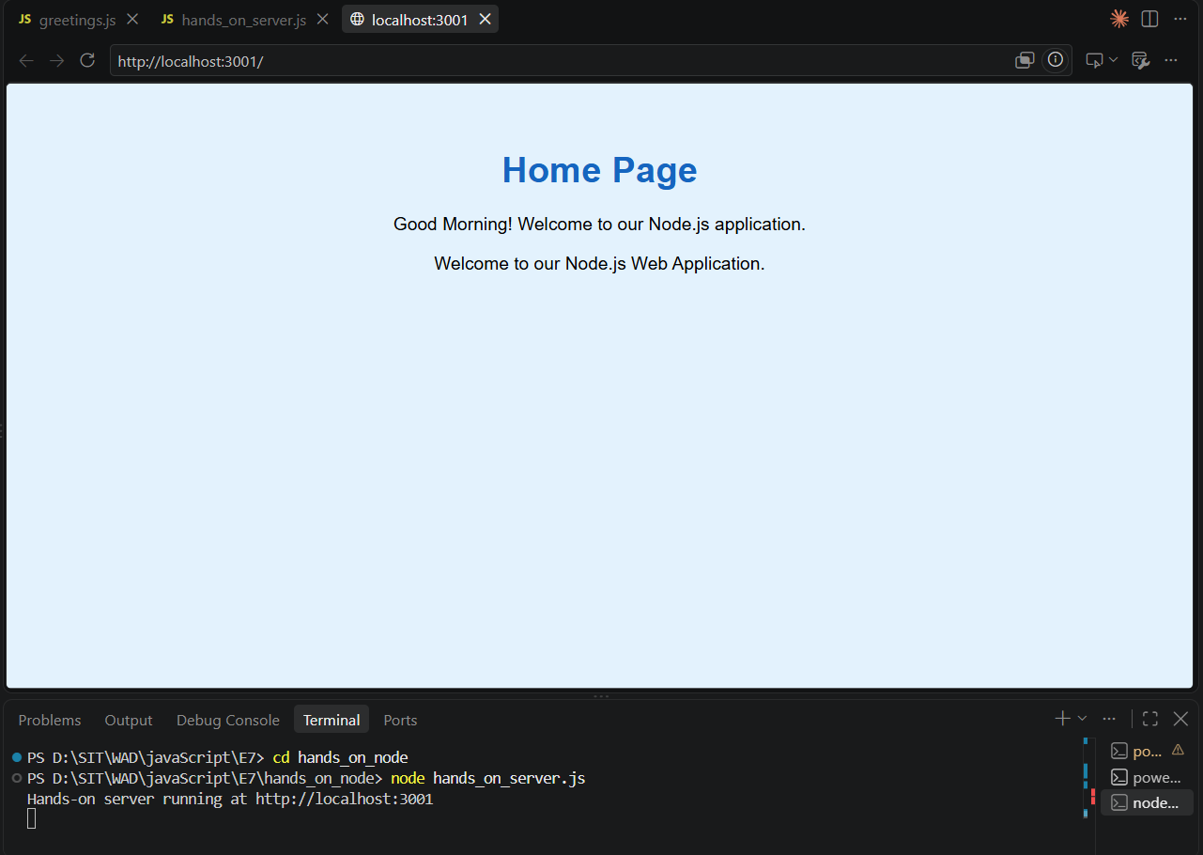
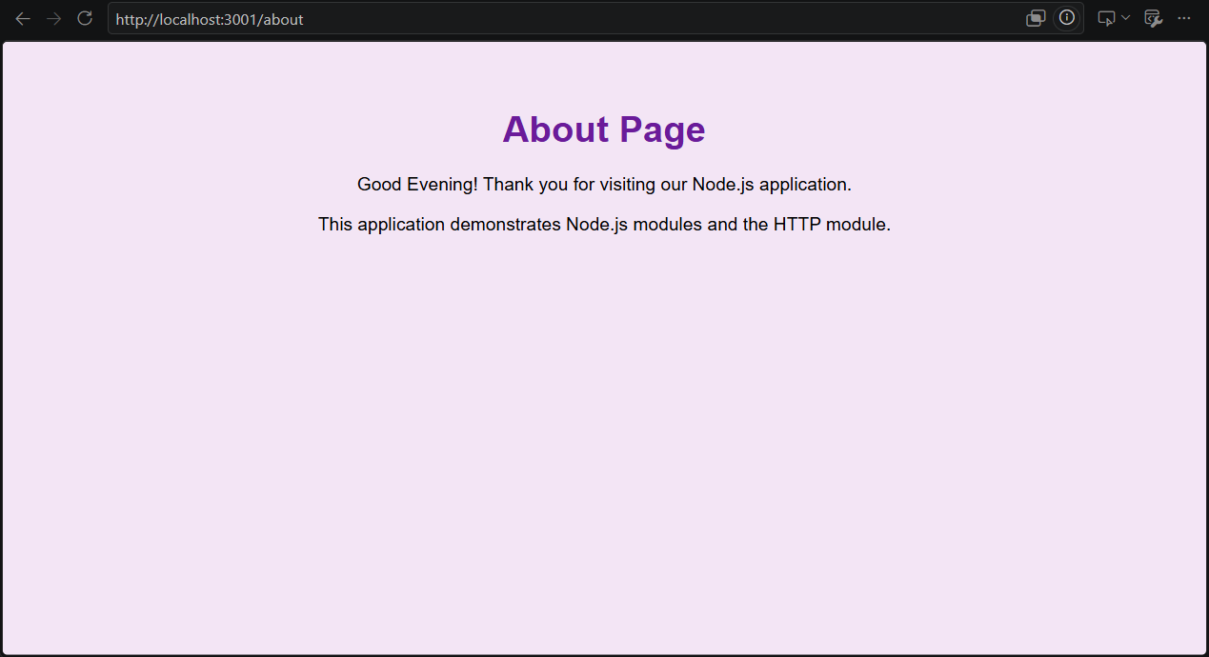
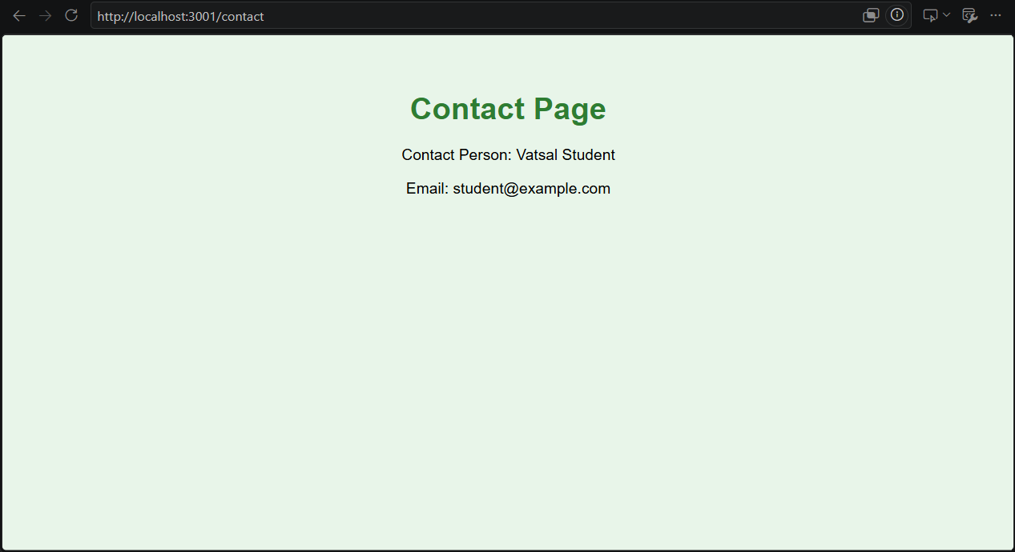

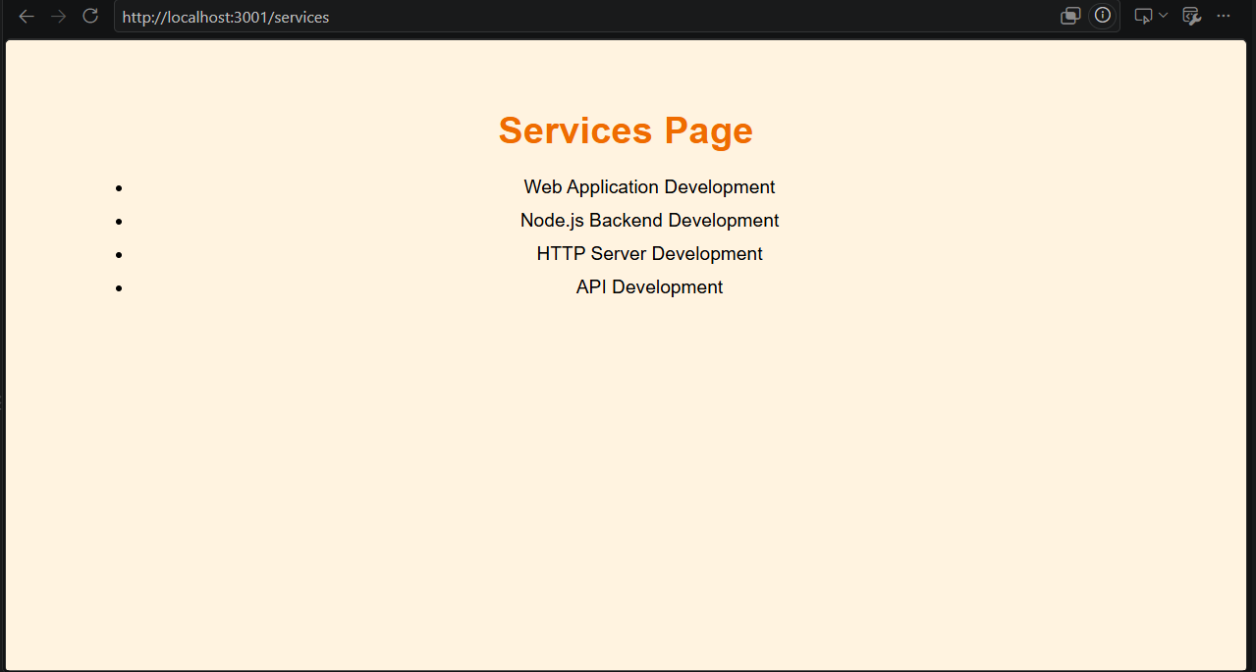
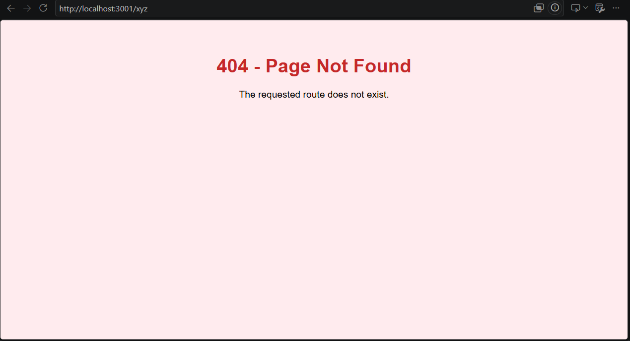
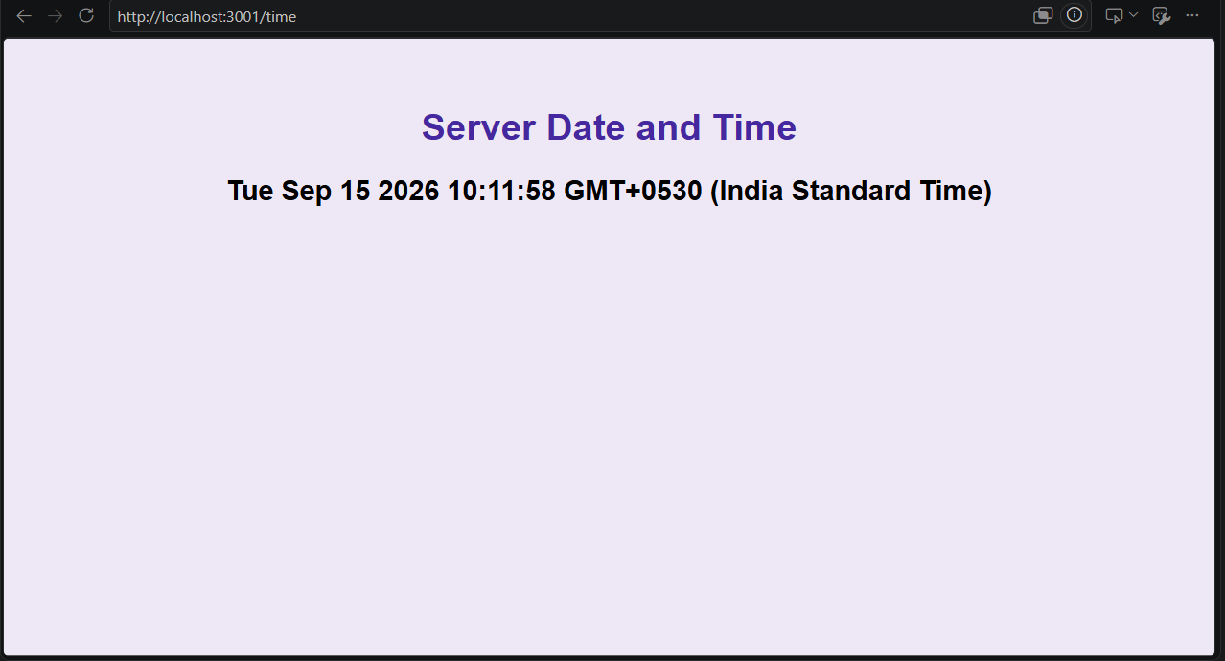
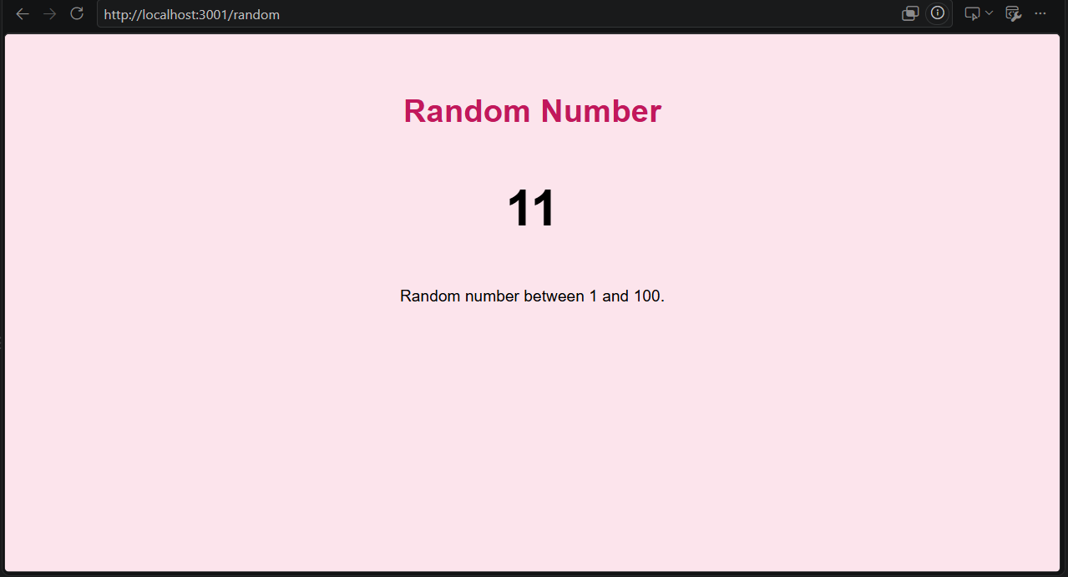
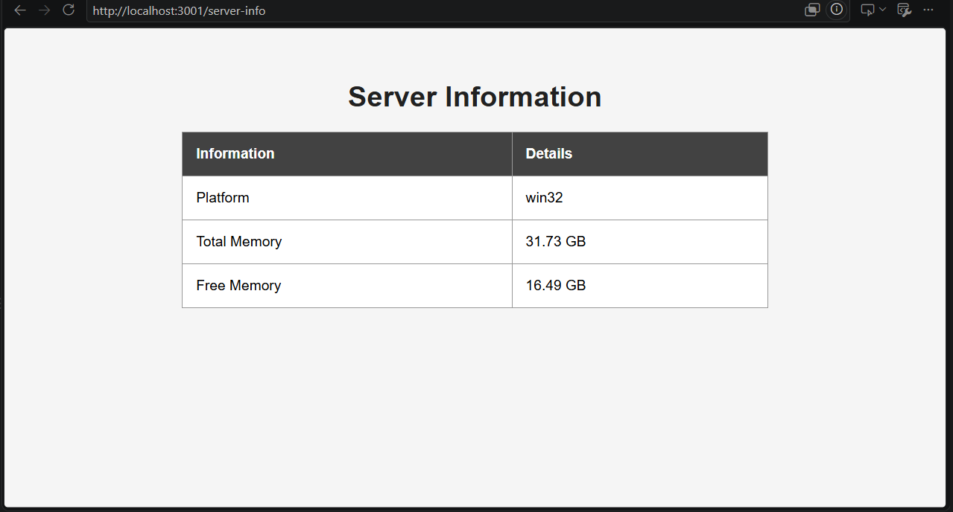

Conclusion:

I learned how to create a backend web application using Node.js and the built-in HTTP module. I also learned about local modules, routing, HTTP methods, server information using the `os` module, and dynamic responses using date and random numbers.

